**Functions that can be used with the Random module.**

1. **Shuffle**: Shuffle the elements in the list. The output will be in random order.

Random.shuffle()

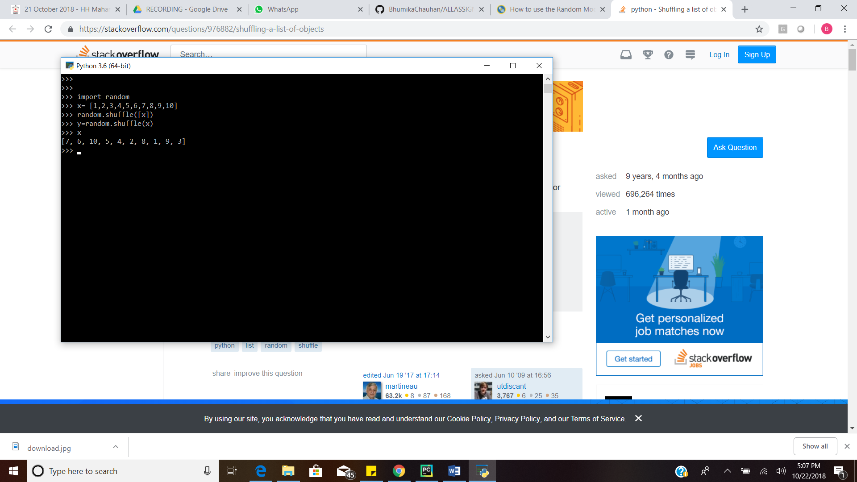

1. **Randrange**: Randrange generates the randomly selected elements from the range(start,stop,step)

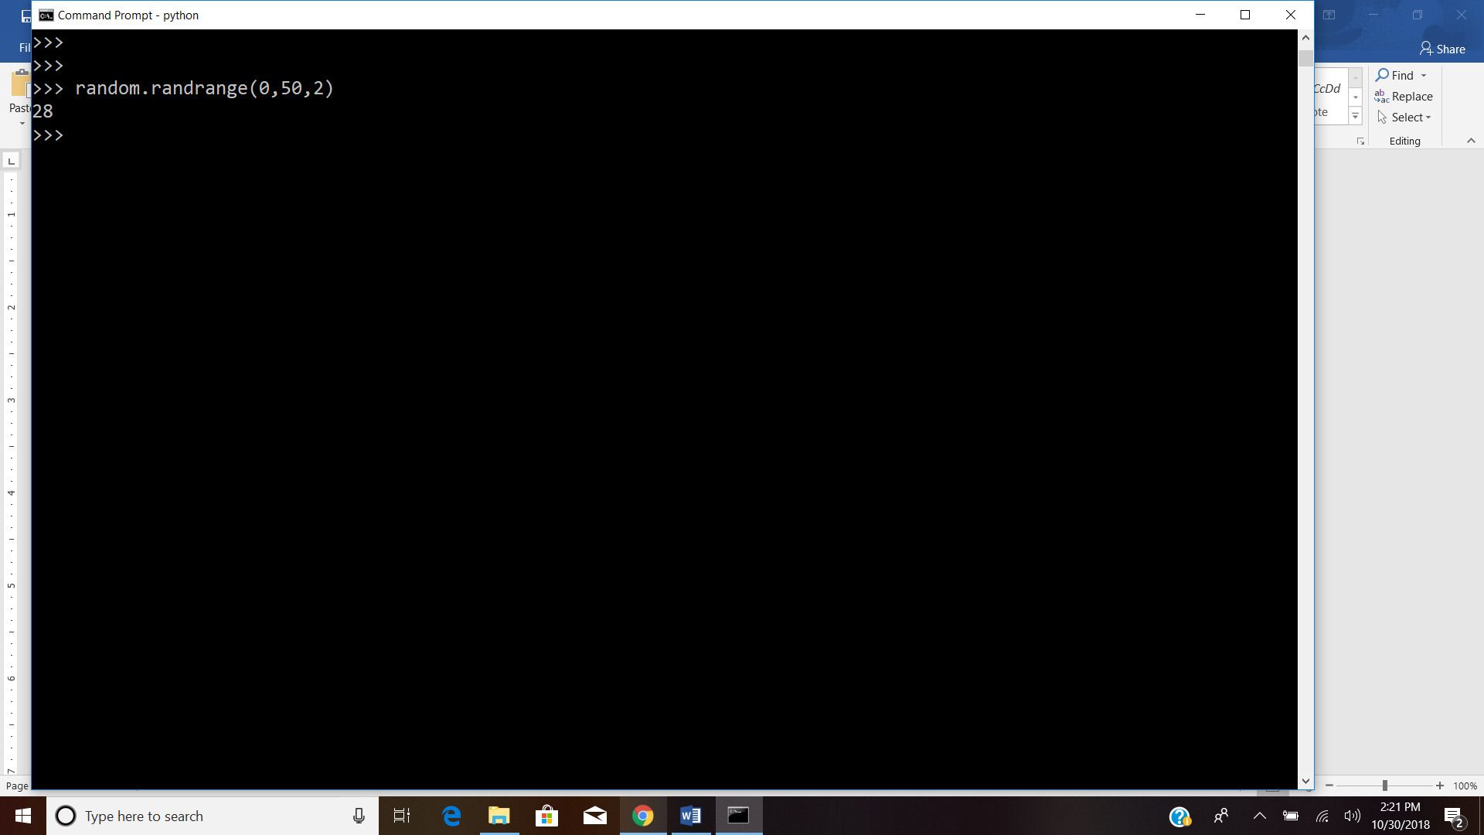

The random.randrange (start,stop) , returns interger

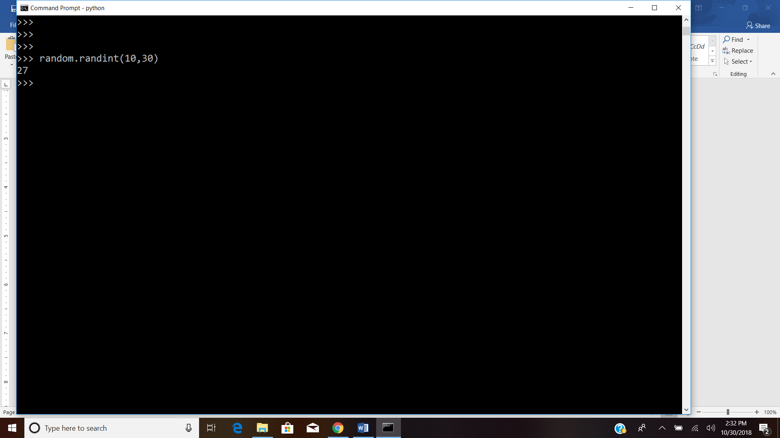

1. **Randint:** It generates the random integer. It takes 2 parameters, the lowest and the highest number. The first value should be less than second.

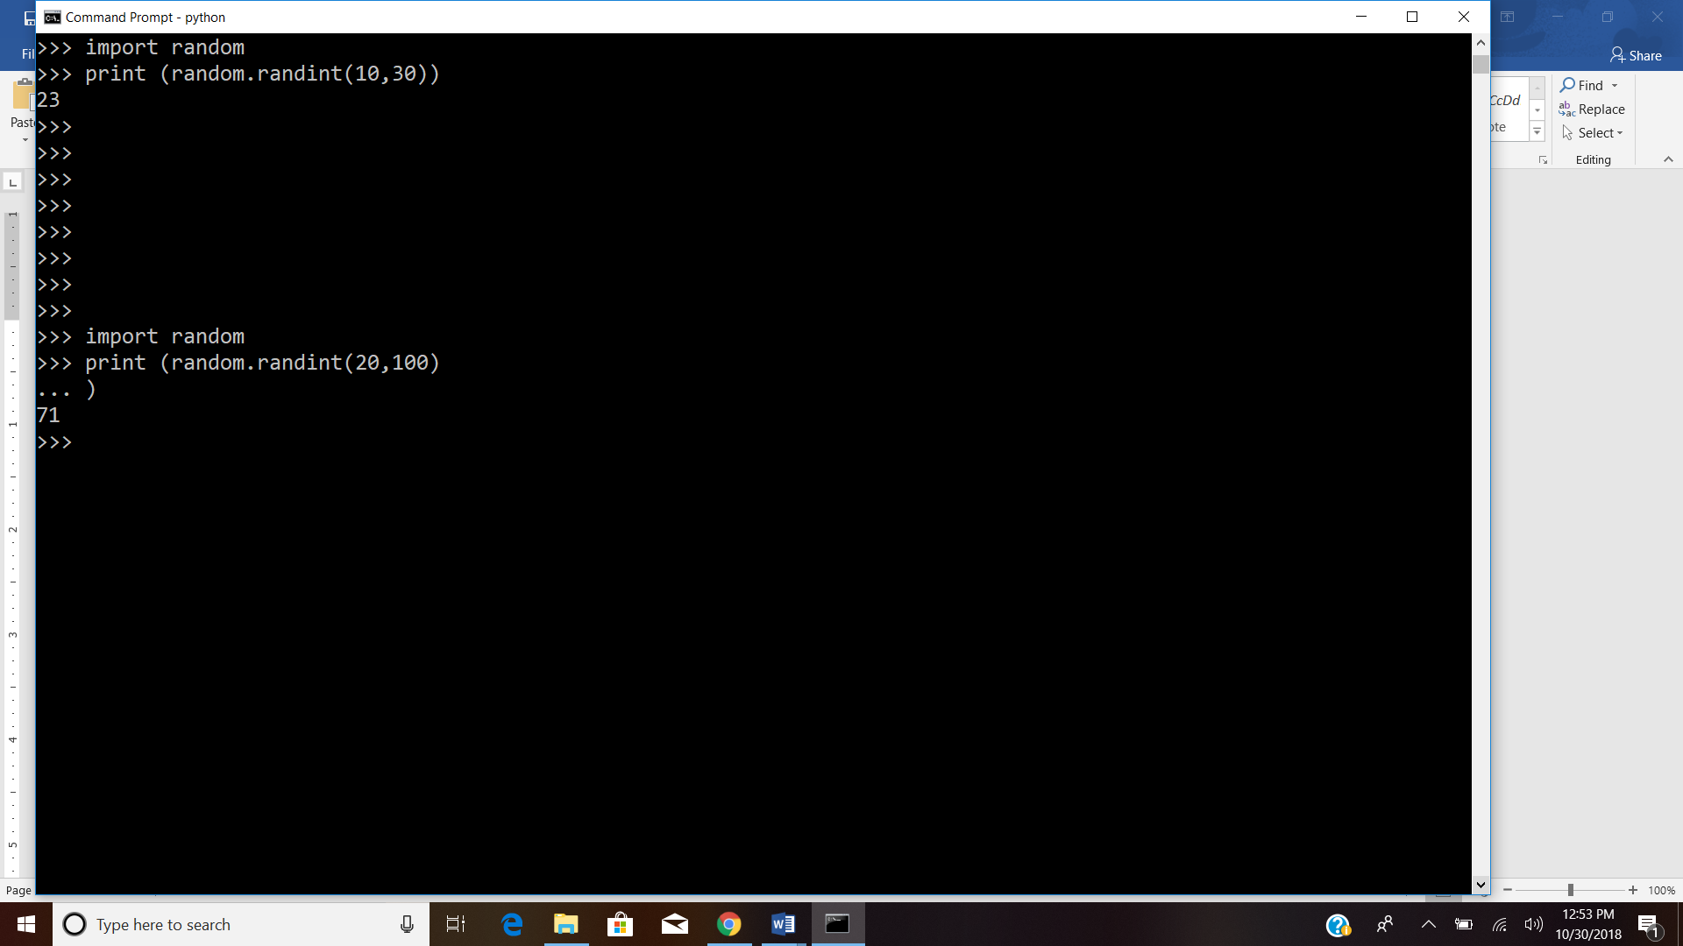

1. **Choice:** Choice function generates random value from the sequence

