**Threshold function in Pandas:**

* Thresh requires that **many non-NA values.**

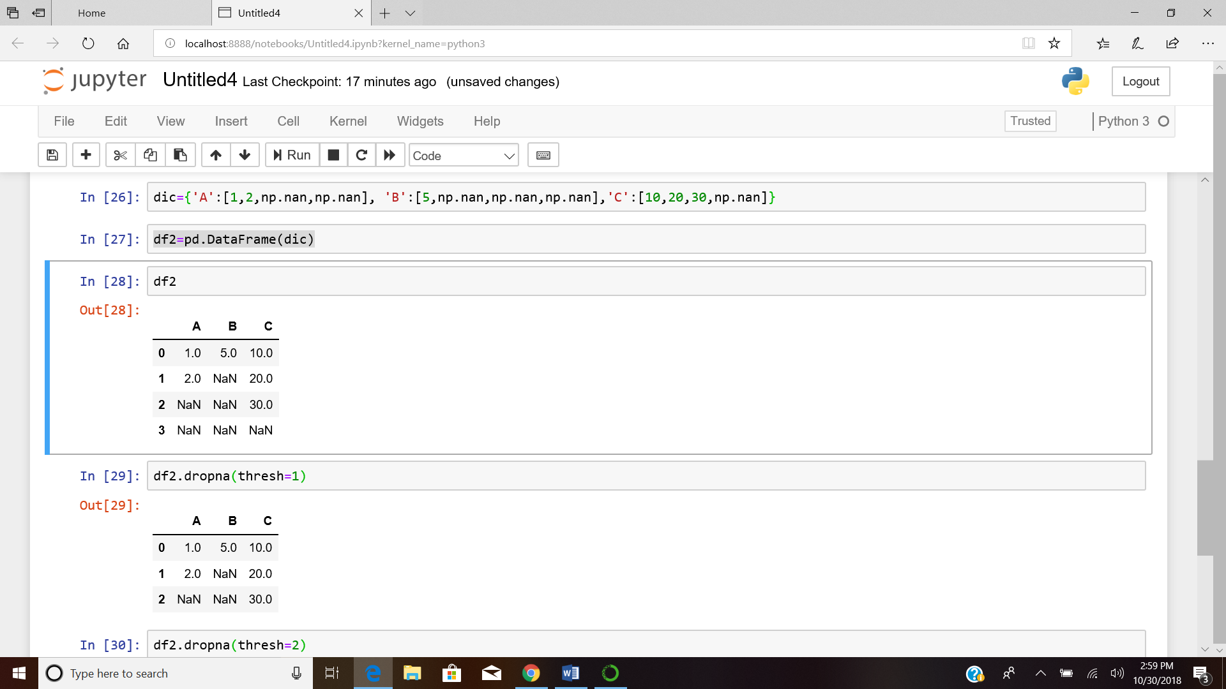

When thresh 1 was given it removed the row having all null values, as there was **no non-null value**



When thresh 2 was given, it checks for the row for 2 non-null value. If that is not found the rows are dropped.

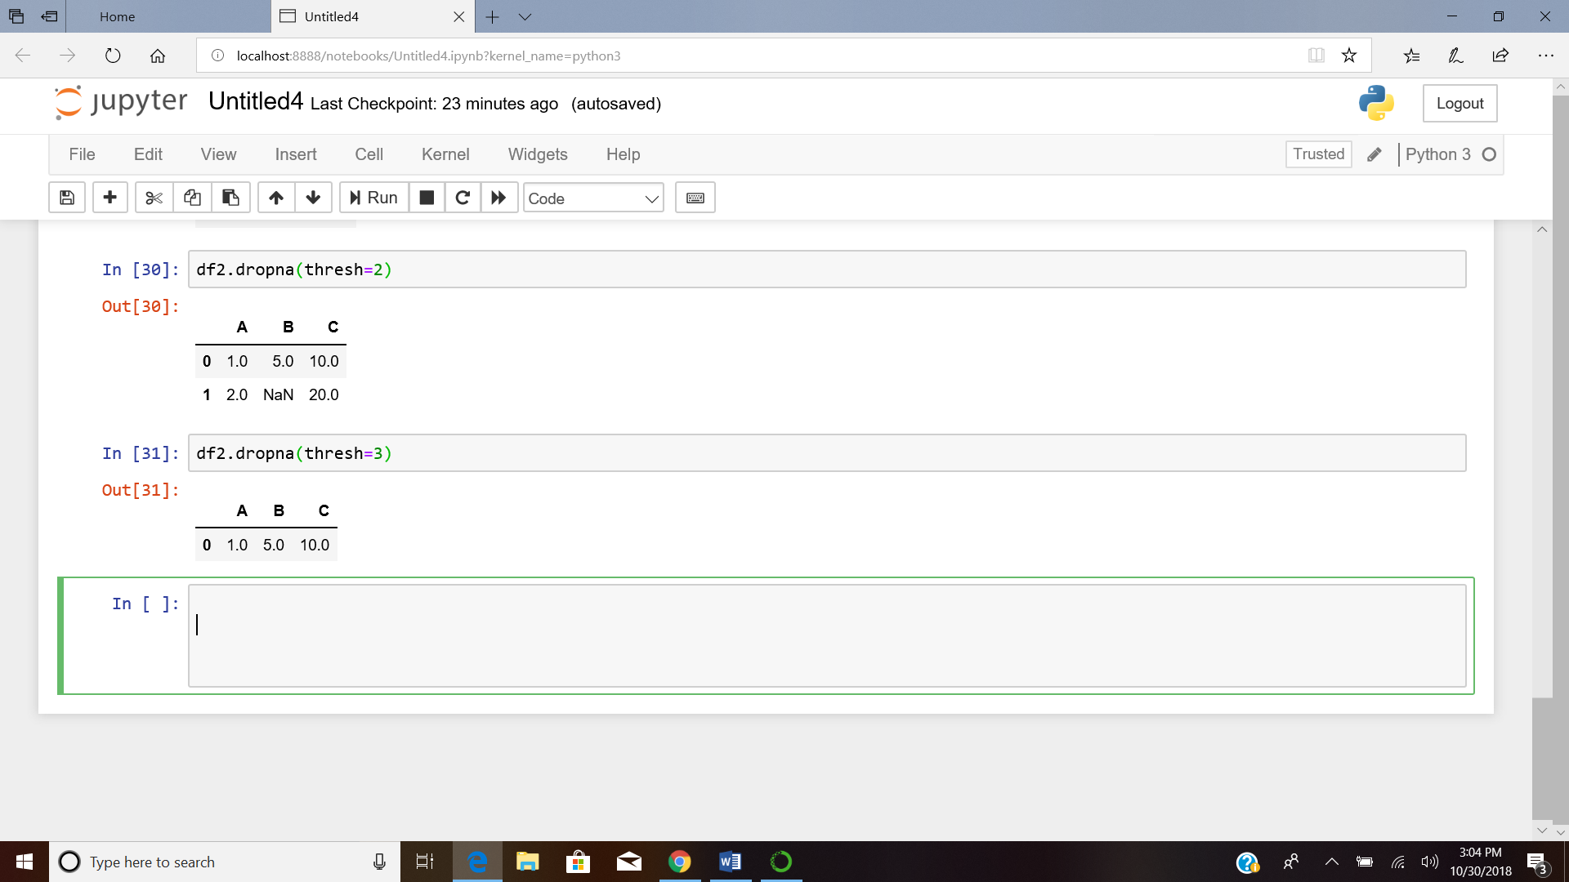

Similarly thresh = 3 retains the rows having 3 or more non-null values.