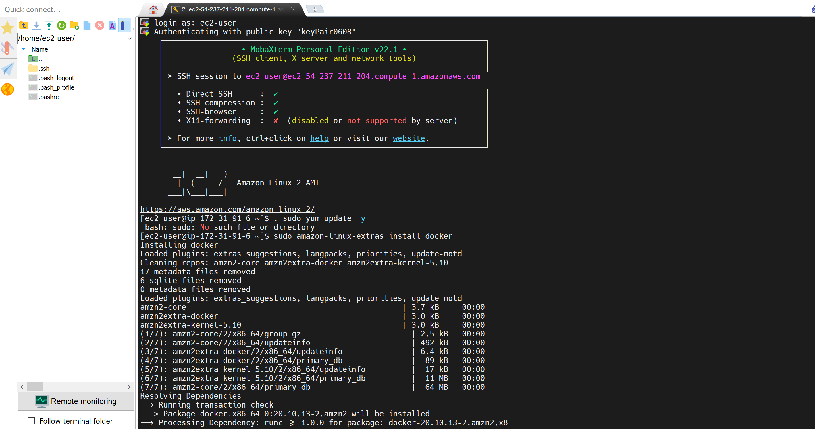

http://ec2-54-237-211-204.compute-1.amazonaws.com:8080/

