**Problem Statement:**

1) Create Project Phase1 Project

2) Add all the driver files for chrome and FF

3) Add all the selenium jar files

4) Create the packager

5) Create AmazonSearch.java class

6) open amazon.in website

7) Search iphone12 and get all the product names and their price on console

8) Make JDBC Connection with existing sql DB

9) Based on the values stored in DB, search product and display their Name & price information on console

**Git repository: https://github.com/BhumikaDureja/Phase1Project.git**

**Screenshot from Eclipse:**

**Screenshot of the project folder:**

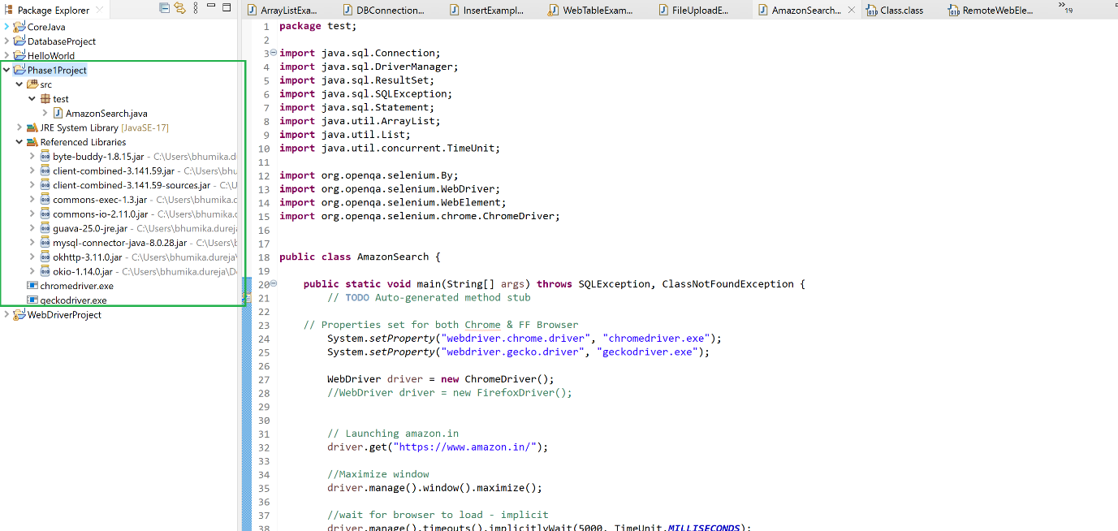

**Screenshot of Source code:**

**Screenshot of Console Result:**

**Source Code:**

**package** test;

**import** java.sql.Connection;

**import** java.sql.DriverManager;

**import** java.sql.ResultSet;

**import** java.sql.SQLException;

**import** java.sql.Statement;

**import** java.util.ArrayList;

**import** java.util.List;

**import** java.util.concurrent.TimeUnit;

**import** org.openqa.selenium.By;

**import** org.openqa.selenium.WebDriver;

**import** org.openqa.selenium.WebElement;

**import** org.openqa.selenium.chrome.ChromeDriver;

**public** **class** AmazonSearch {

**public** **static** **void** main(String[] args) **throws** SQLException, ClassNotFoundException {

// **TODO** Auto-generated method stub

// Properties set for both Chrome & FF Browser

System.*setProperty*("webdriver.chrome.driver", "chromedriver.exe");

System.*setProperty*("webdriver.gecko.driver", "geckodriver.exe");

WebDriver driver = **new** ChromeDriver();

//WebDriver driver = new FirefoxDriver();

// Launching amazon.in

driver.get("https://www.amazon.in/");

//Maximize window

driver.manage().window().maximize();

//wait for browser to load - implicit

driver.manage().timeouts().implicitlyWait(5000, TimeUnit.***MILLISECONDS***);

// The below code retrieves search results for iphone12 using xpath for product name iphone12 & their price

WebElement SearchBox = driver.findElement(By.*xpath*("//input[@id='twotabsearchtextbox']"));

SearchBox.sendKeys("iphone 12");

WebElement SearchIcon = driver.findElement(By.*xpath*("//input[@id='nav-search-submit-button']"));

SearchIcon.click();

List<WebElement> iPhone_Model = driver.findElements(By.*xpath*("//span[@class='a-size-medium a-color-base a-text-normal']"));

List<WebElement> iPhone_Price = driver.findElements(By.*xpath*("//span[@class='a-price-whole']"));

System.***out***.println("Total number of iPhone 12 model listed on screen: " +iPhone_Model.size());

**for** (**int** count=0; count<iPhone_Model.size(); count++) {

**if**(iPhone_Model.get(count).getText().toLowerCase().contains("iphone 12")) {

System.***out***.println("Product Name: " +iPhone_Model.get(count).getText() +" Price: " +iPhone_Price.get(count).getText());

}

}

// Part 2 of the project - setting up DB connection and retrieving results from database.

//External jar file for setting up the JDBC has been added

Class.*forName*("com.mysql.cj.jdbc.Driver");

Connection con = DriverManager.*getConnection*("jdbc:mysql://localhost:3306/ecommerce", "root", "root");

Statement stm = con.createStatement();

ResultSet result = stm.executeQuery("select * from eproduct");

ArrayList<String> names = **new** ArrayList<String>();

// retrieving results from DB and storing in ArrayList

**while**(result.next()) {

System.***out***.println(result.getInt("ID"));

System.***out***.println(result.getString("name"));

names.add(result.getString("name"));

}

System.***out***.println("names in array list : "+names);

// Iterating through array list

**for**(**int** index=0; index<names.size();index++)

{

System.***out***.println("Name at " +index +" : " +names.get(index));

//Storing the name value in a new String variable

String input = names.get(index);

System.***out***.println("Input value in search field is : " +input);

// Based on the results from DB, the product information for Laptop & Tablet are retrieved

**if**(input.equalsIgnoreCase("Laptop")) {

WebElement SearchBox1 = driver.findElement(By.*xpath*("//input[@id='twotabsearchtextbox']"));

SearchBox1.clear();

SearchBox1.sendKeys(input);

WebElement SearchIcon1 = driver.findElement(By.*xpath*("//input[@id='nav-search-submit-button']"));

SearchIcon1.click();

List<WebElement> Laptop_Model = driver.findElements(By.*xpath*("//div[@class='a-section a-spacing-none s-padding-right-small s-title-instructions-style']"));

List<WebElement> Laptop_Price = driver.findElements(By.*xpath*("//span[@class='a-price-whole']"));

System.***out***.println("Total number of Laptop model listed on screen: " +Laptop_Model.size());

**for** (**int** count1=0; count1<Laptop_Model.size(); count1++) {

**if**(Laptop_Model.get(count1).getText().contains("Laptop")) {

System.***out***.println("Product Name: " +Laptop_Model.get(count1).getText() +" Price: " +Laptop_Price.get(count1).getText());

}

}

}

**else** **if** (input.equalsIgnoreCase("Tablet"))

{

WebElement SearchBox2 = driver.findElement(By.*xpath*("//input[@id='twotabsearchtextbox']"));

SearchBox2.clear();

SearchBox2.sendKeys(input);

WebElement SearchIcon2 = driver.findElement(By.*xpath*("//input[@id='nav-search-submit-button']"));

SearchIcon2.click();

List<WebElement> Tablet_Model = driver.findElements(By.*xpath*("//span[@class='a-size-medium a-color-base a-text-normal']"));

List<WebElement> Tablet_Price = driver.findElements(By.*xpath*("//span[@class='a-price-whole']"));

System.***out***.println("Total number of Laptop model listed on screen: " +Tablet_Model.size());

**for** (**int** count2=0; count2<Tablet_Model.size(); count2++) {

**if**(Tablet_Model.get(count2).getText().contains("Tab")) {

System.***out***.println("Product Name: " +Tablet_Model.get(count2).getText() +" Price: " +Tablet_Price.get(count2).getText());

}

}

}

con.close();

}

driver.close();

}

}