Project Implementation steps:

1. install jenkins on local machine (via docker)

2. setup jenkins ( maven ,java)

3. start emulators

4. Create your project in eclipse = testsng +appium +.....

5. write some test cases (3)for AUT ( application under test)

6. push your code in github

7. from jenkins download your code (via git)

8. run you project from jenkins

**GITHUB Link:** https://github.com/BhumikaDureja/Phase4Project_MobileAutomation.git

**Screenshots of Project**

**Flipkart App Results**

Test 1 – Search for Laptop Bags

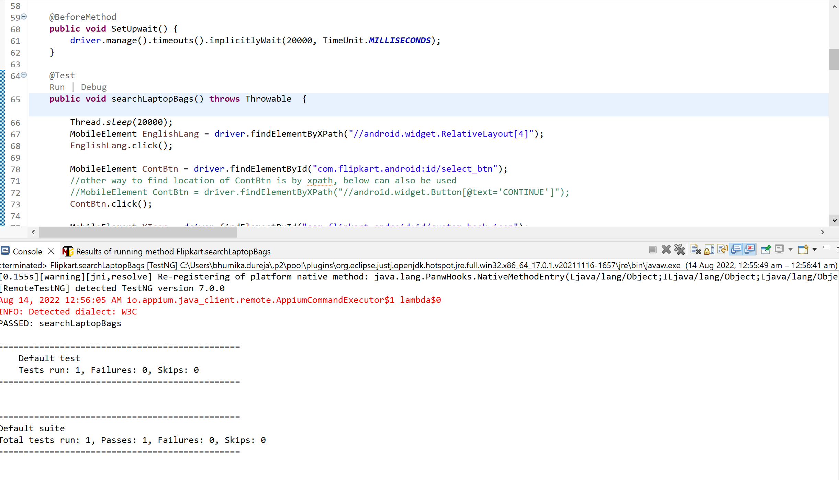

Test 2 – Add Laptop Bag to Cart

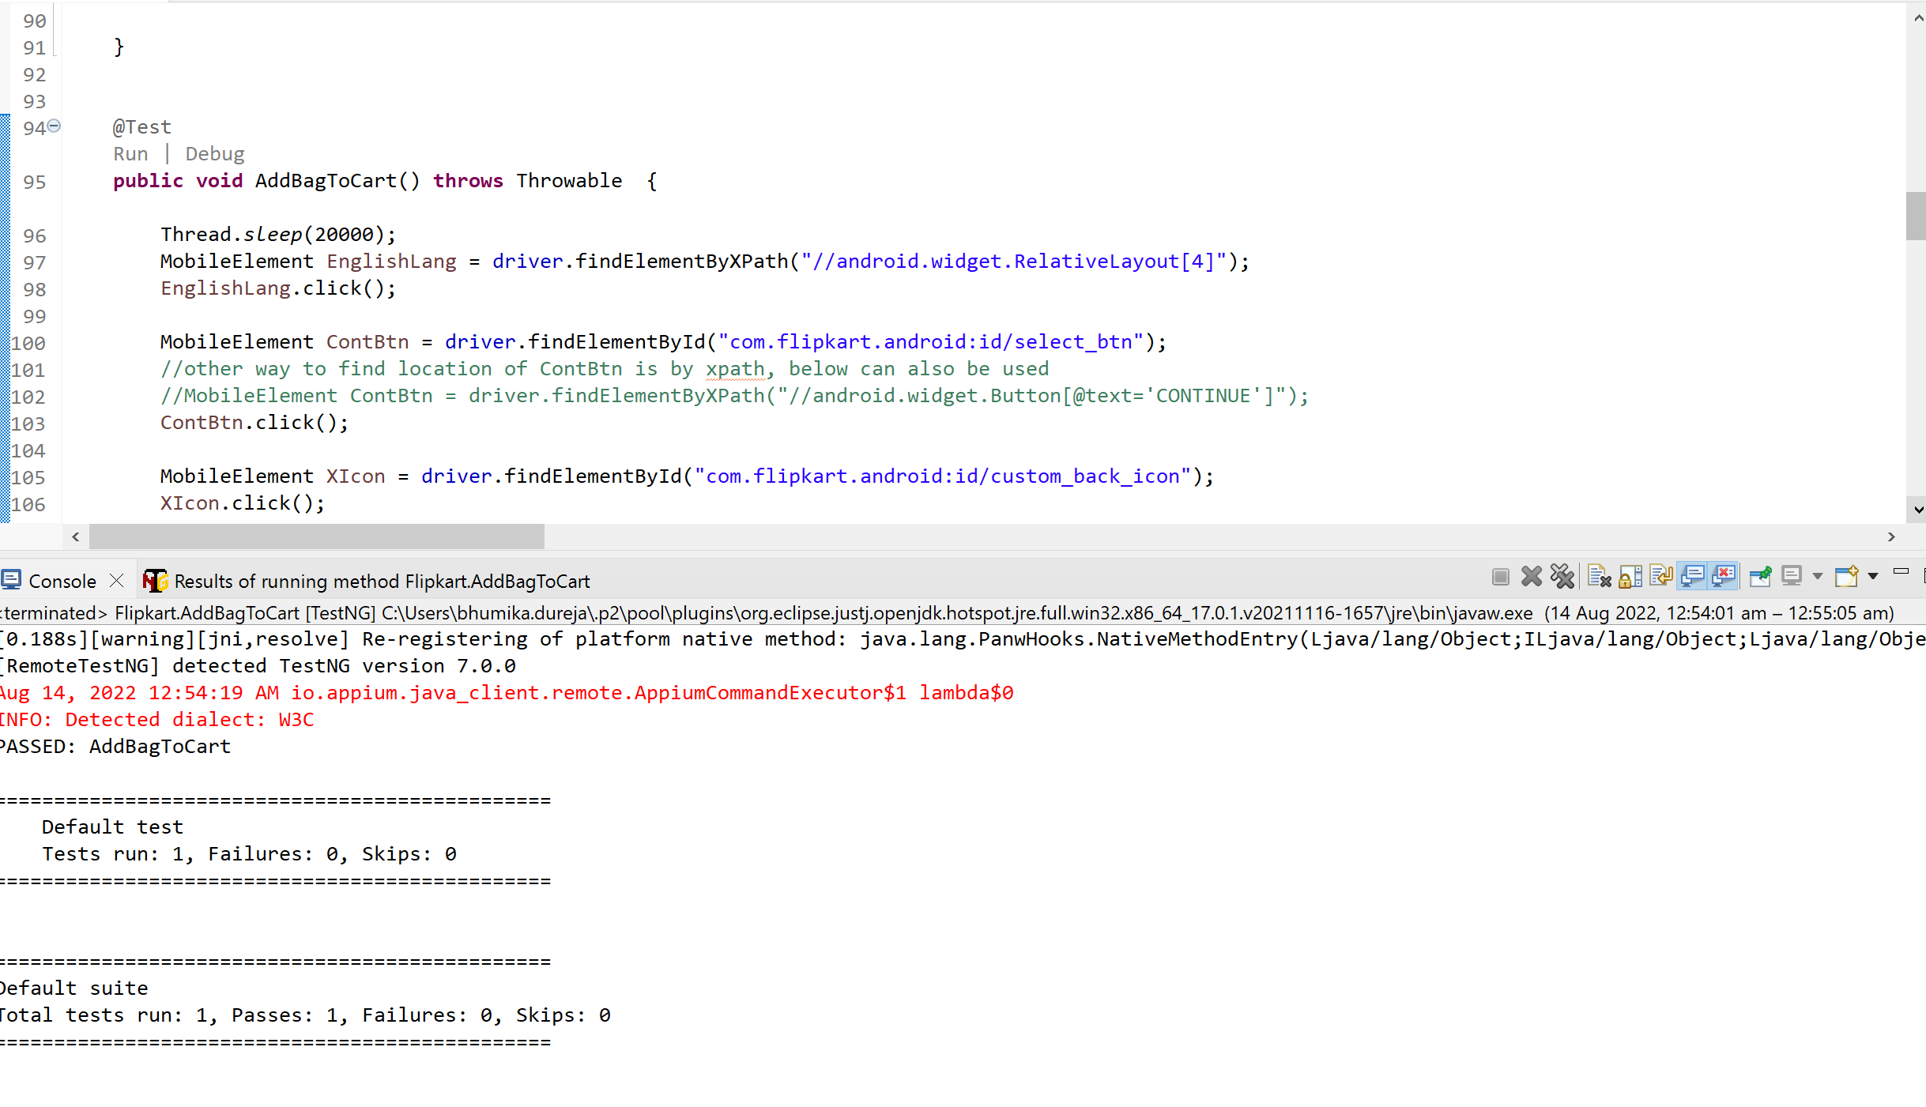

Test 3 – View Cart

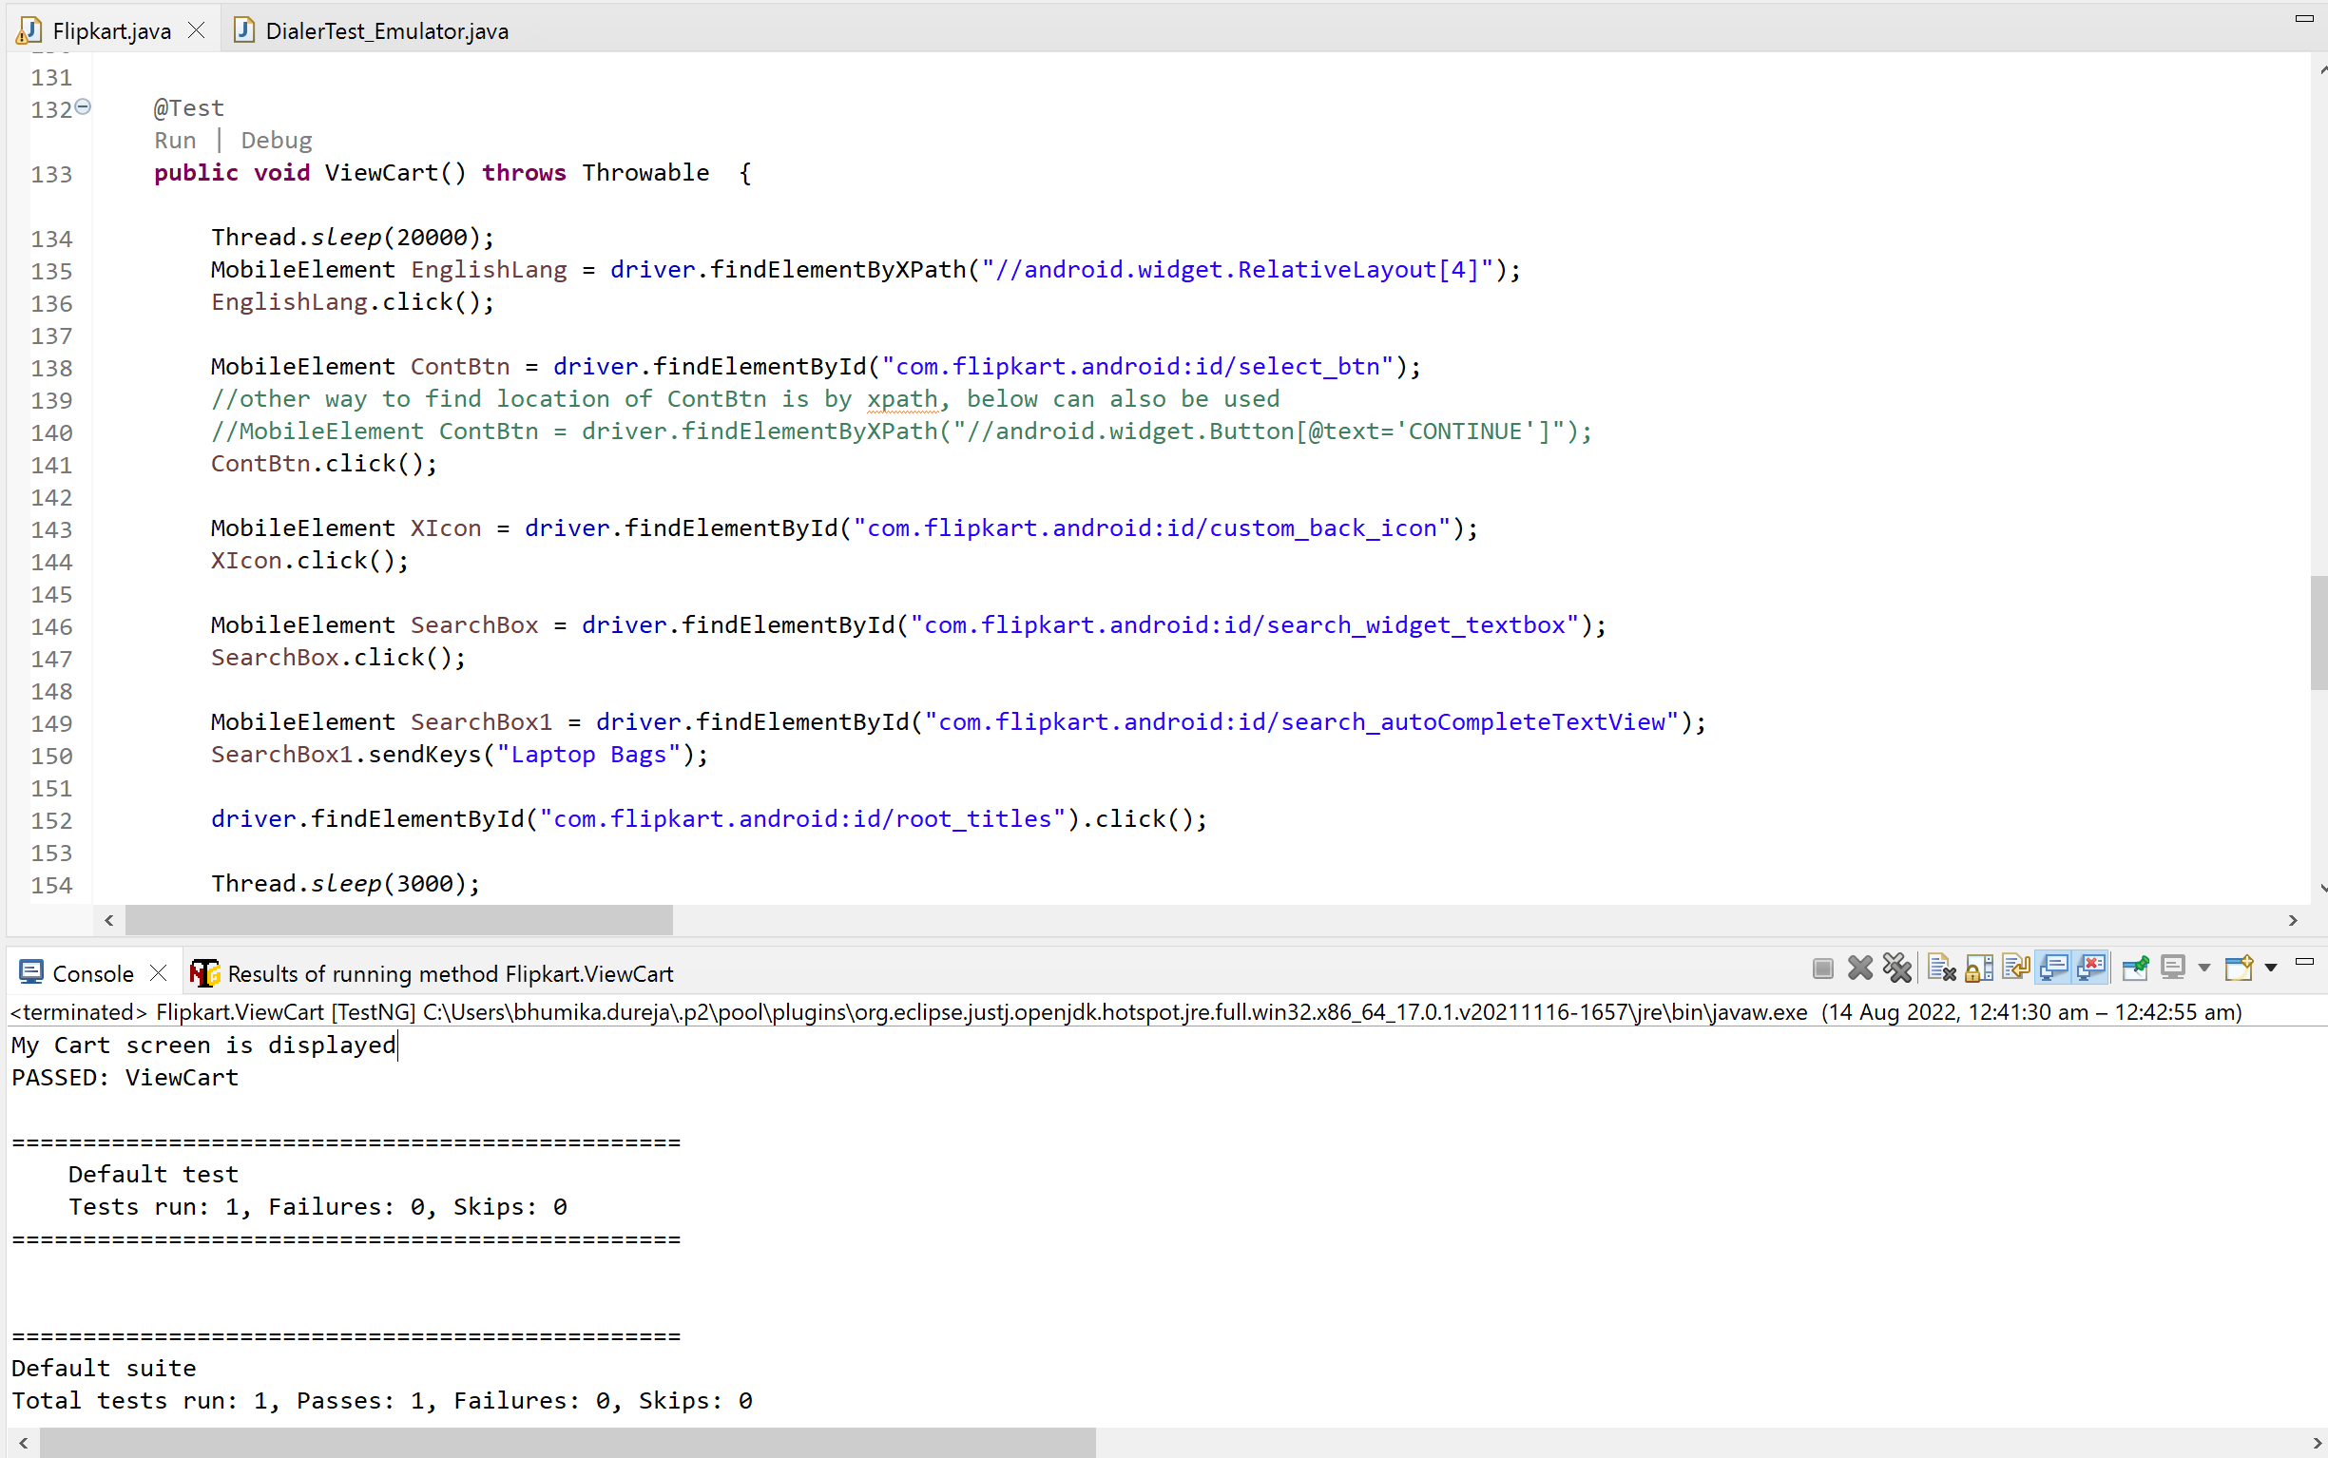

**Installing Jenkins on local machine (via docker)**

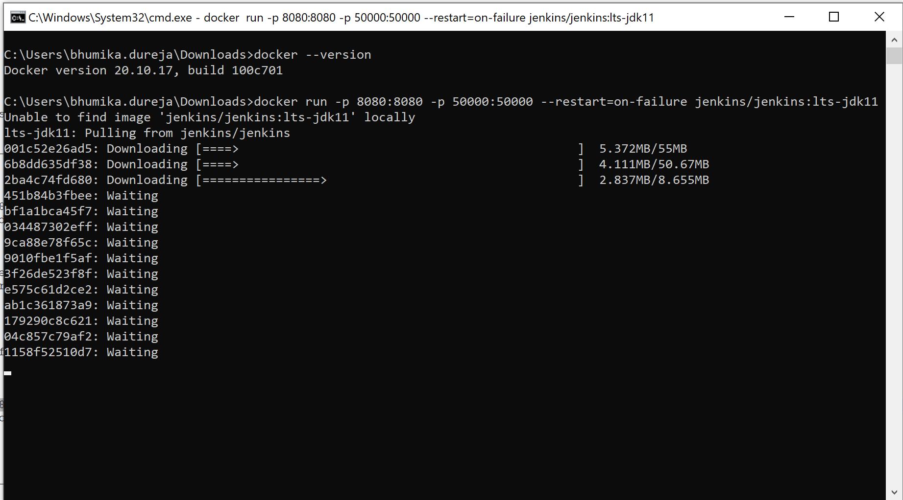

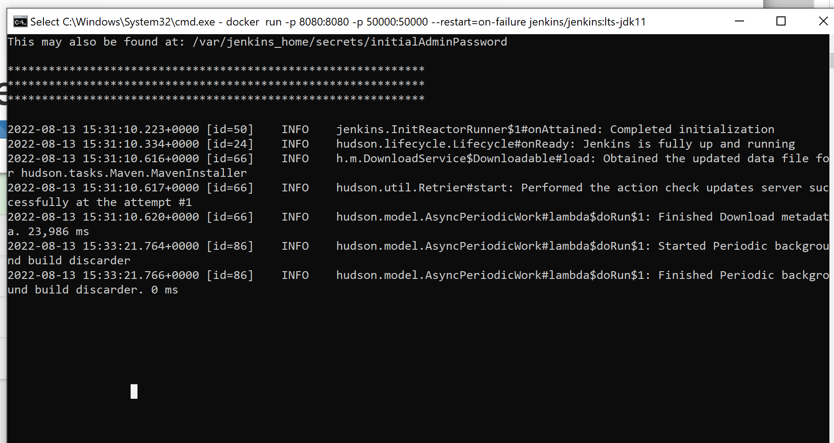

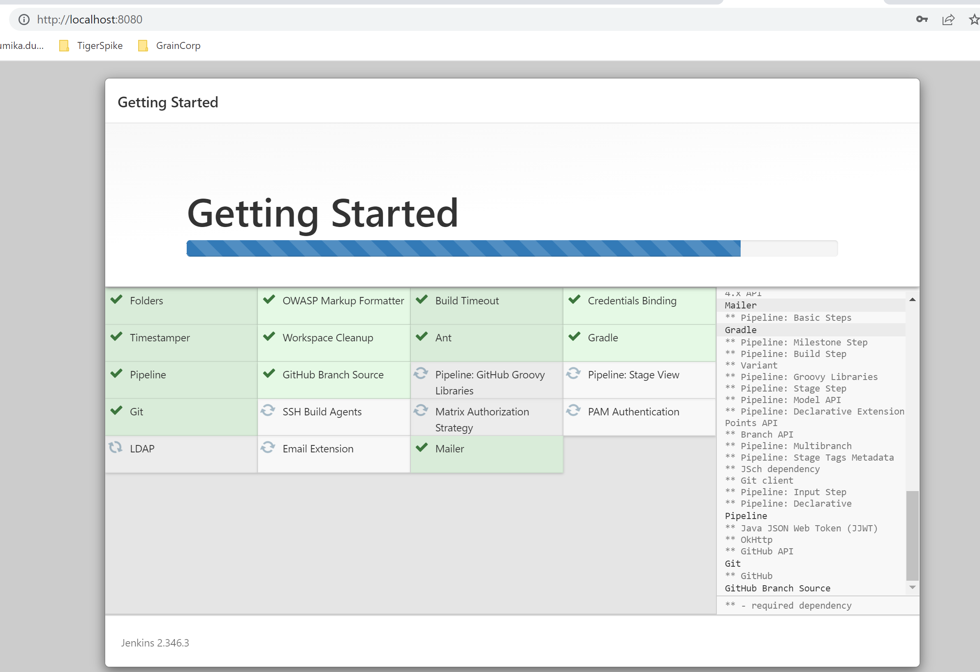

**Running job on jenkins**

**SOURCE CODE**

package com.simplilearn.Phase4Project;

import io.appium.java_client.MobileElement;

import io.appium.java_client.TouchAction;

import io.appium.java_client.android.AndroidDriver;

import io.appium.java_client.TouchAction;

import io.appium.java_client.touch.offset.PointOption;

import java.awt.Frame;

import java.net.MalformedURLException;

import java.net.URL;

import java.util.List;

import java.util.concurrent.TimeUnit;

import org.openqa.selenium.Alert;

import org.openqa.selenium.By;

import org.openqa.selenium.Keys;

import org.openqa.selenium.Point;

import org.openqa.selenium.WebDriver;

import org.openqa.selenium.interactions.Actions;

import org.openqa.selenium.remote.DesiredCapabilities;

import org.testng.Assert;

import org.testng.annotations.AfterMethod;

import org.testng.annotations.AfterTest;

import org.testng.annotations.BeforeMethod;

import org.testng.annotations.BeforeTest;

import org.testng.annotations.Test;

public class Flipkart {

private AndroidDriver<MobileElement> driver;

TouchAction touchAction;

@BeforeTest

public void setUp() throws MalformedURLException {

DesiredCapabilities desiredCapabilities = new DesiredCapabilities();

desiredCapabilities.setCapability("platformName", "Android");

desiredCapabilities.setCapability("appium:platformVersion", "7.1.1");

desiredCapabilities.setCapability("appium:deviceName", "Android SDK built for x86");

desiredCapabilities.setCapability("appium:app", "C:\\Users\\bhumika.dureja\\Downloads\\Flipkart-7.18(1).apk");

desiredCapabilities.setCapability("appium:ensureWebviewsHavePages", true);

desiredCapabilities.setCapability("appium:nativeWebScreenshot", true);

desiredCapabilities.setCapability("appium:newCommandTimeout", 3600);

desiredCapabilities.setCapability("appium:connectHardwareKeyboard", true);

URL remoteUrl = new URL("http://localhost:4723/wd/hub");

driver = new AndroidDriver<MobileElement>(remoteUrl, desiredCapabilities);

touchAction = new TouchAction(driver);

// System.out.println(driver.getSessionId());

}

@Test

public void searchLaptopBags() throws Throwable {

Thread.sleep(20000);

MobileElement EnglishLang = driver.findElementByXPath("//android.widget.RelativeLayout[4]");

EnglishLang.click();

MobileElement ContBtn = driver.findElementById("com.flipkart.android:id/select_btn");

//other way to find location of ContBtn is by xpath, below can also be used

//MobileElement ContBtn = driver.findElementByXPath("//android.widget.Button[@text='CONTINUE']");

ContBtn.click();

MobileElement XIcon = driver.findElementById("com.flipkart.android:id/custom_back_icon");

XIcon.click();

MobileElement SearchBox = driver.findElementById("com.flipkart.android:id/search_widget_textbox");

SearchBox.click();

MobileElement SearchBox1 = driver.findElementById("com.flipkart.android:id/search_autoCompleteTextView");

SearchBox1.sendKeys("Laptop Bags");

driver.findElementById("com.flipkart.android:id/root_titles").click();

// Actions action=new Actions(driver);

// action.sendKeys(Keys.ENTER).build().perform();

Thread.sleep(3000);

}

@Test

public void AddBagToCart() throws Throwable {

Thread.sleep(20000);

MobileElement EnglishLang = driver.findElementByXPath("//android.widget.RelativeLayout[4]");

EnglishLang.click();

MobileElement ContBtn = driver.findElementById("com.flipkart.android:id/select_btn");

//other way to find location of ContBtn is by xpath, below can also be used

//MobileElement ContBtn = driver.findElementByXPath("//android.widget.Button[@text='CONTINUE']");

ContBtn.click();

MobileElement XIcon = driver.findElementById("com.flipkart.android:id/custom_back_icon");

XIcon.click();

MobileElement SearchBox = driver.findElementById("com.flipkart.android:id/search_widget_textbox");

SearchBox.click();

MobileElement SearchBox1 = driver.findElementById("com.flipkart.android:id/search_autoCompleteTextView");

SearchBox1.sendKeys("Laptop Bags");

driver.findElementById("com.flipkart.android:id/root_titles").click();

Thread.sleep(3000);

// driver.switchTo().frame(0);

driver.findElementById("com.flipkart.android:id/not_now_button").click();

Thread.sleep(3000);

touchAction.tap(PointOption.point(128, 338)).perform();

Thread.sleep(2000);

// String BagName = driver.findElementByXPath("//android.widget.TextView[@text = 'DUTY FREE']").getText();

// System.out.println("BagName : " + BagName);

MobileElement AddToCartBtn = driver.findElementByXPath("//android.widget.TextView[@text='ADD TO CART']");

AddToCartBtn.click();

Thread.sleep(2000);

}

@Test

public void ViewCart() throws Throwable {

Thread.sleep(20000);

MobileElement EnglishLang = driver.findElementByXPath("//android.widget.RelativeLayout[4]");

EnglishLang.click();

MobileElement ContBtn = driver.findElementById("com.flipkart.android:id/select_btn");

//other way to find location of ContBtn is by xpath, below can also be used

//MobileElement ContBtn = driver.findElementByXPath("//android.widget.Button[@text='CONTINUE']");

ContBtn.click();

MobileElement XIcon = driver.findElementById("com.flipkart.android:id/custom_back_icon");

XIcon.click();

MobileElement SearchBox = driver.findElementById("com.flipkart.android:id/search_widget_textbox");

SearchBox.click();

MobileElement SearchBox1 = driver.findElementById("com.flipkart.android:id/search_autoCompleteTextView");

SearchBox1.sendKeys("Laptop Bags");

driver.findElementById("com.flipkart.android:id/root_titles").click();

Thread.sleep(3000);

driver.findElementById("com.flipkart.android:id/not_now_button").click();

Thread.sleep(3000);

touchAction.tap(PointOption.point(128, 338)).perform();

Thread.sleep(2000);

// String BagName = driver.findElementByXPath("//android.widget.TextView[@text = 'DUTY FREE']").getText();

// String BagName = driver.findElementByXPath("/hierarchy/android.widget.FrameLayout/android.widget.LinearLayout/android.widget.FrameLayout/android.widget.LinearLayout/android.widget.FrameLayout/androidx.drawerlayout.widget.DrawerLayout/android.view.ViewGroup/android.widget.FrameLayout/android.widget.FrameLayout/android.widget.FrameLayout[1]/android.view.ViewGroup/android.view.ViewGroup[1]/android.widget.ScrollView/android.view.ViewGroup/android.view.ViewGroup/android.view.ViewGroup[1]/android.view.ViewGroup/android.view.ViewGroup[1]/android.view.ViewGroup[1]/android.widget.TextView[1]").getText();

// System.out.println("BagName : " + BagName);

MobileElement AddToCartBtn = driver.findElementByXPath("//android.widget.TextView[@text='ADD TO CART']");

AddToCartBtn.click();

Thread.sleep(2000);

MobileElement GoToCartBtn = driver.findElementByXPath("//android.widget.TextView[@text='GO TO CART']");

GoToCartBtn.click();

String CartScreen = driver.findElementByXPath("//android.widget.TextView[@text='My Cart']").getText();

Assert.assertEquals("My Cart", CartScreen);

System.out.println("My Cart screen is displayed");

// String BagNameOnMyCart = driver.findElementByXPath("//android.widget.TextView[@text='DUTY FREE 032-Laptop Backpack 40 L Laptop Backpack'").getText();

// String BagNameOnMyCart = driver.findElementByXPath("/hierarchy/android.widget.FrameLayout/android.widget.LinearLayout/android.widget.FrameLayout/android.widget.LinearLayout/android.widget.FrameLayout/androidx.drawerlayout.widget.DrawerLayout/android.view.ViewGroup/android.widget.FrameLayout/android.widget.FrameLayout/android.widget.FrameLayout[2]/android.view.ViewGroup/android.view.ViewGroup[1]/android.widget.ScrollView/android.view.ViewGroup/android.view.ViewGroup/android.view.ViewGroup[2]/android.view.ViewGroup/android.view.ViewGroup[3]/android.widget.TextView[1]").getText();

// System.out.println("BagName on My Cart screen : " + BagNameOnMyCart);

// Assert.assertEquals(BagNameOnMyCart.contains(BagName), true);

}

@AfterTest

public void tearDown() {

driver.quit();

}

}