As part of this project, I have done end-to-end development of QA and test environment for a healthcare website. This project Includes:

Browser-based end user testing using Selenium WebDriver

Unit testing for back-end elements of the website using TestNG

API testing with Postman and generating Newman report

Automating the whole testing process by a Jenkins job

Following unit tests were created as part of TestNg framework:

1) As a user, viewing product category

2) As a user, listing out products based on the selected categories

3) As a User adding Product to cart

4) As a user, performing EndToEnd test for viewing a product, adding to cart and then finally purchasing the product

5) As an admin, adding a product to a category

6) As an admin, editing details of a product

7) Running API - get call to view all products - http://localhost:8082/medicare/json/data/all/products

8) Running API - get call to view category - http://localhost:8082/medicare/json/data/category/1/p

9) Running API - get call for most viewed product -http://localhost:8082/medicare/json/data/mv/products

10) Running API - get call for most purchased product - http://localhost:8082/medicare/json/data/mp/products

**GitHUB Link:** [**https://github.com/BhumikaDureja/Phase5_CapstoneProject.git**](https://github.com/BhumikaDureja/Phase5_CapstoneProject.git)

1. **SourceCode (UI & API) Eclipse IDE Screenshots**

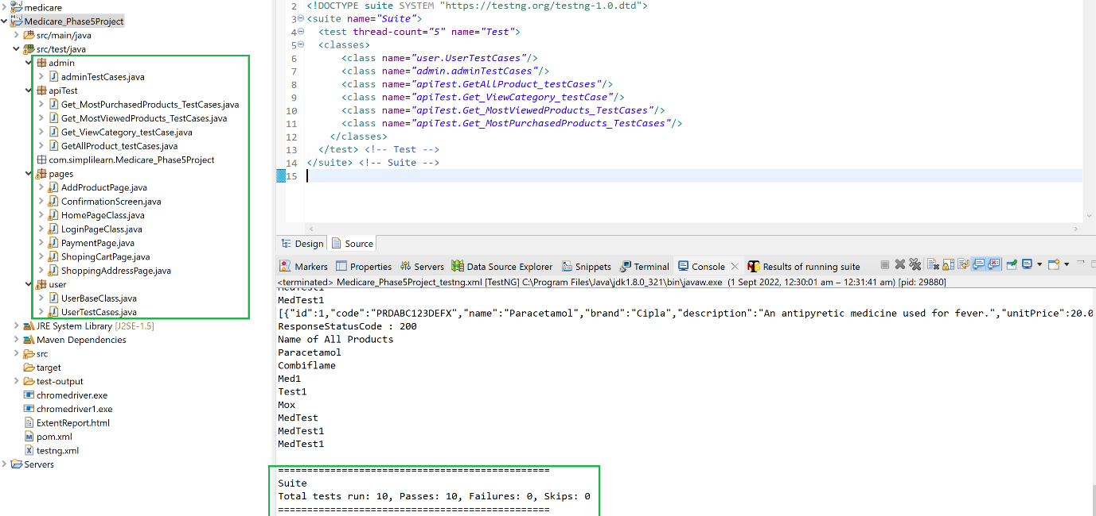

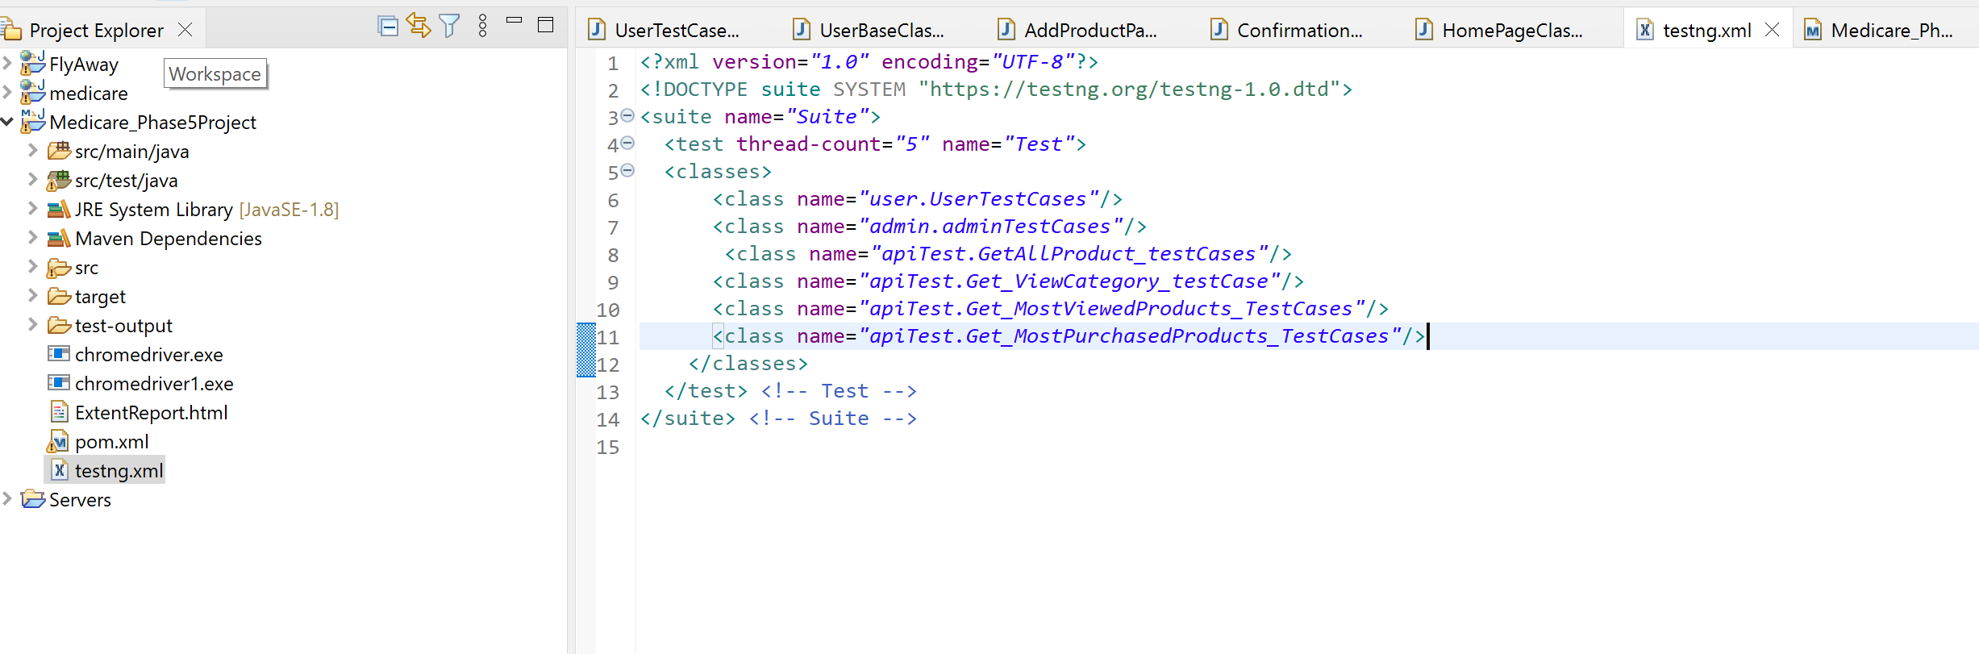

**Running the code through JENKINS**

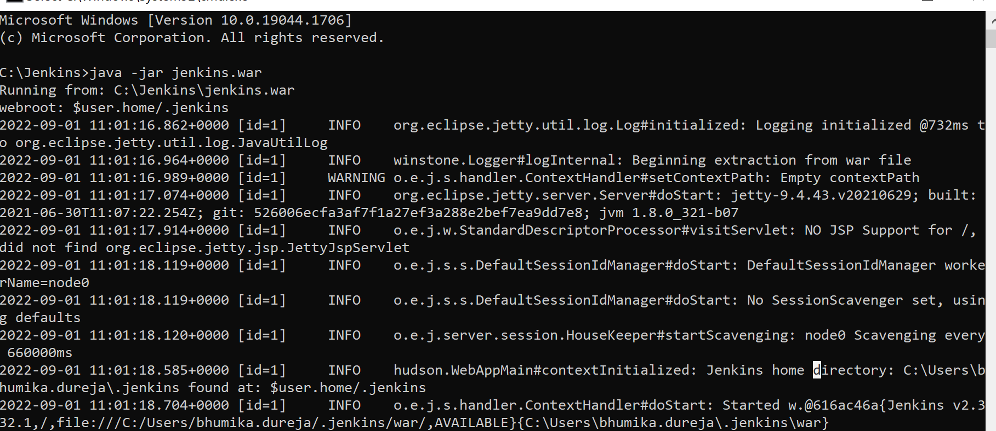

**Running the collection through postman**

**NewMan Test Report**

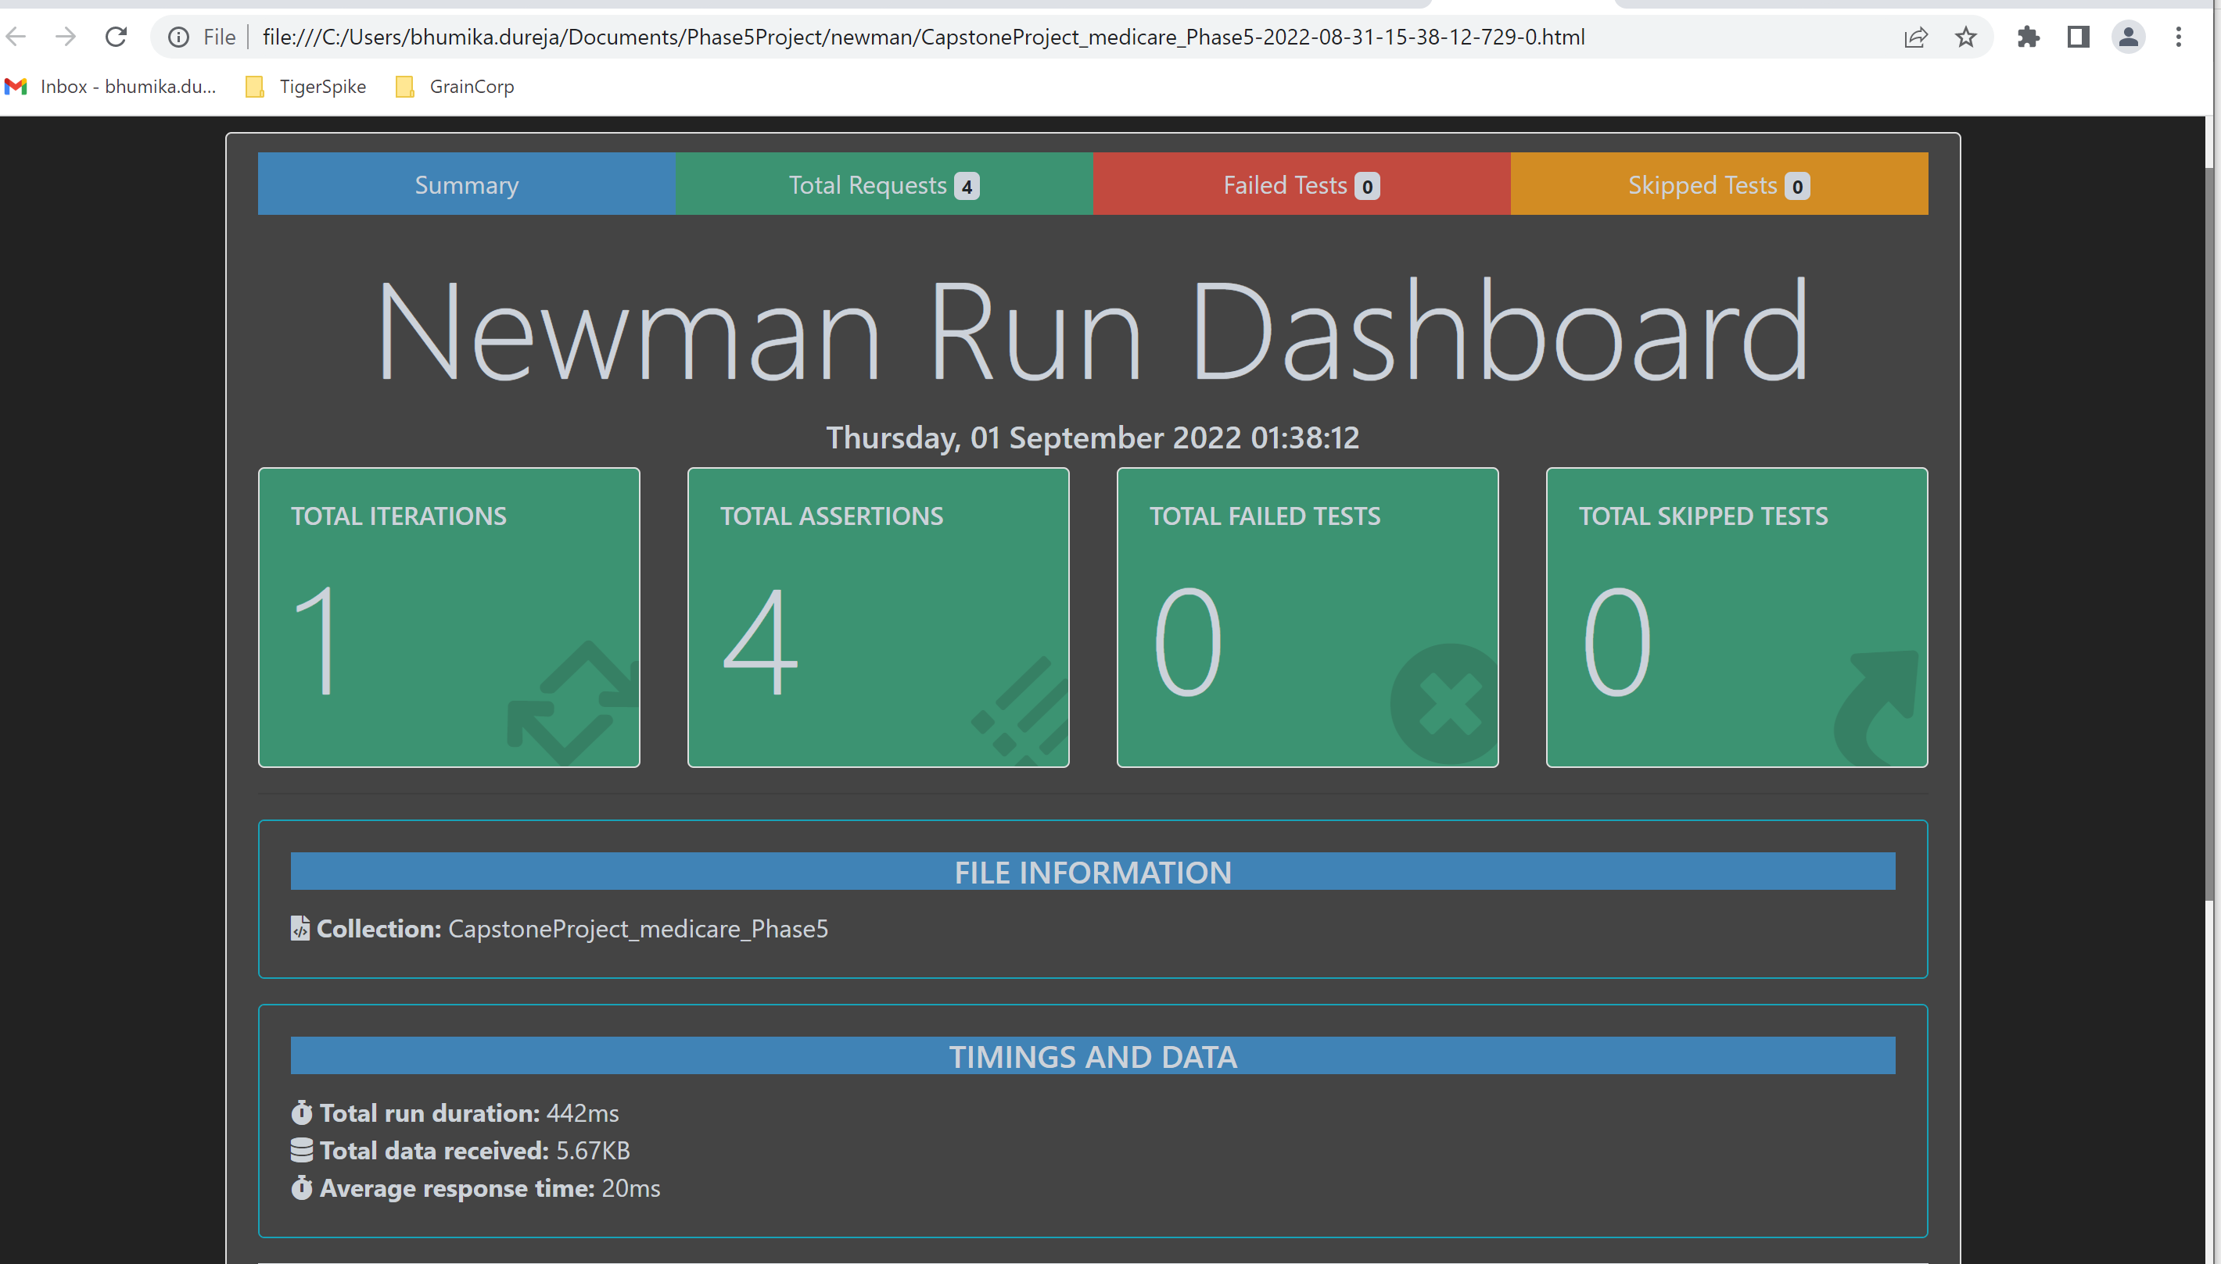

**Jmeter result screenshots**

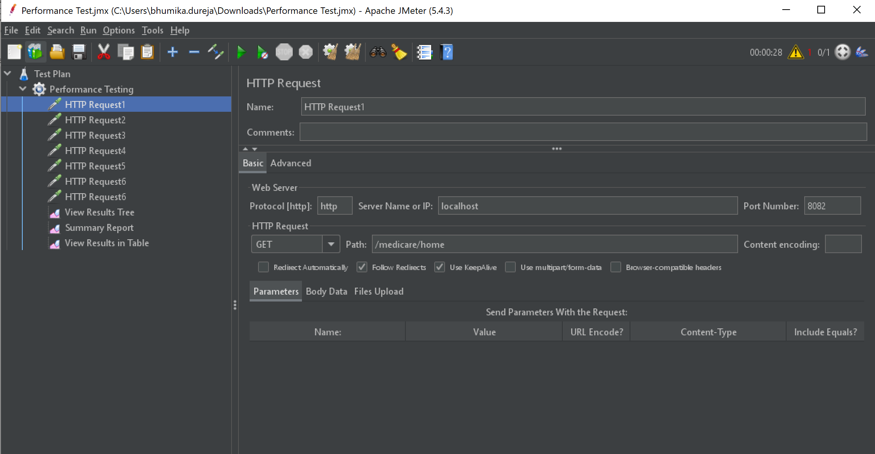

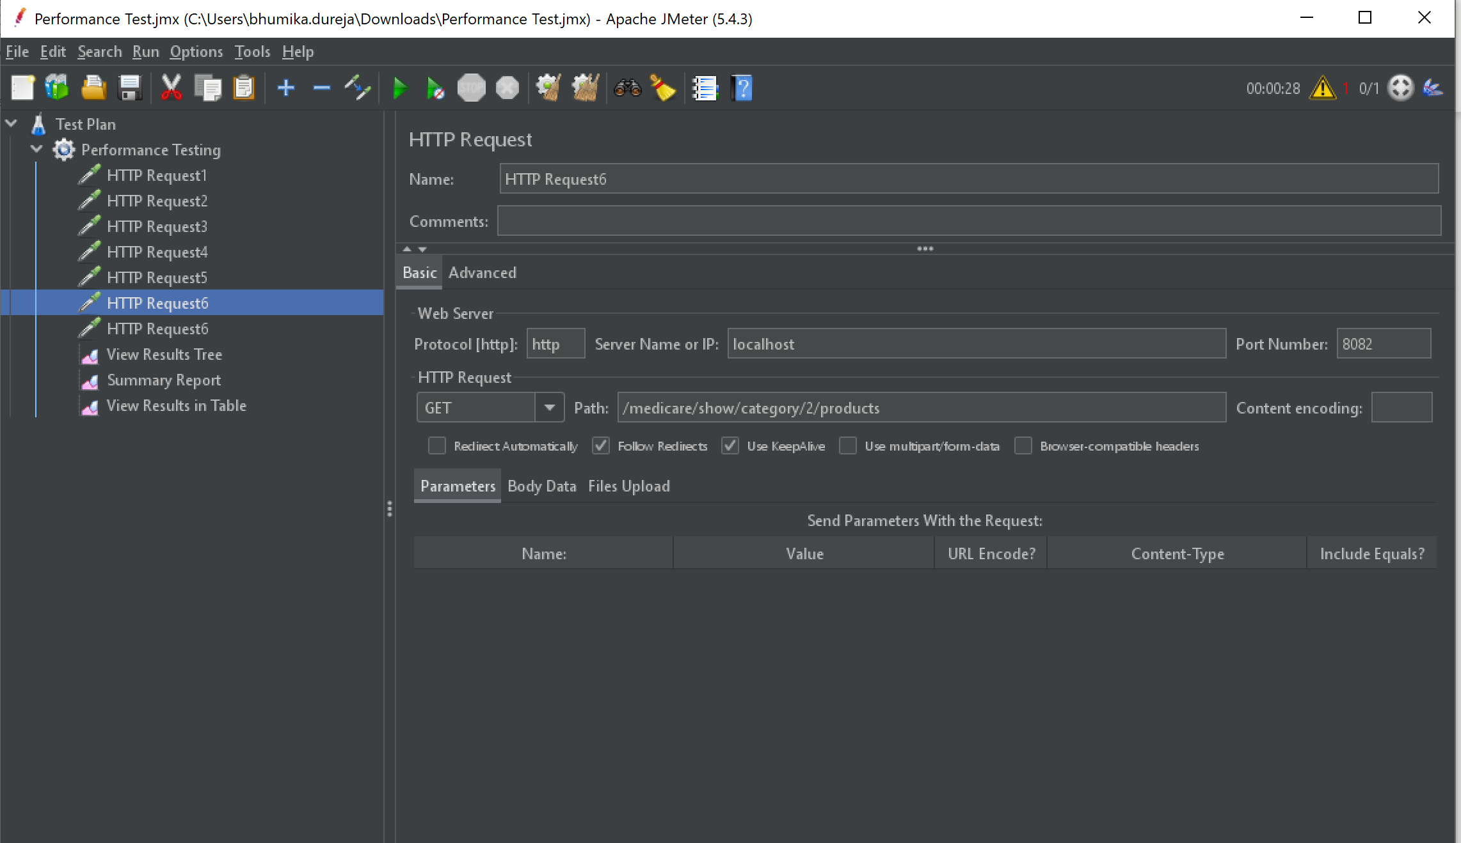

**GitHub screenshot -** [**https://github.com/BhumikaDureja/Phase5_CapstoneProject.git**](https://github.com/BhumikaDureja/Phase5_CapstoneProject.git)

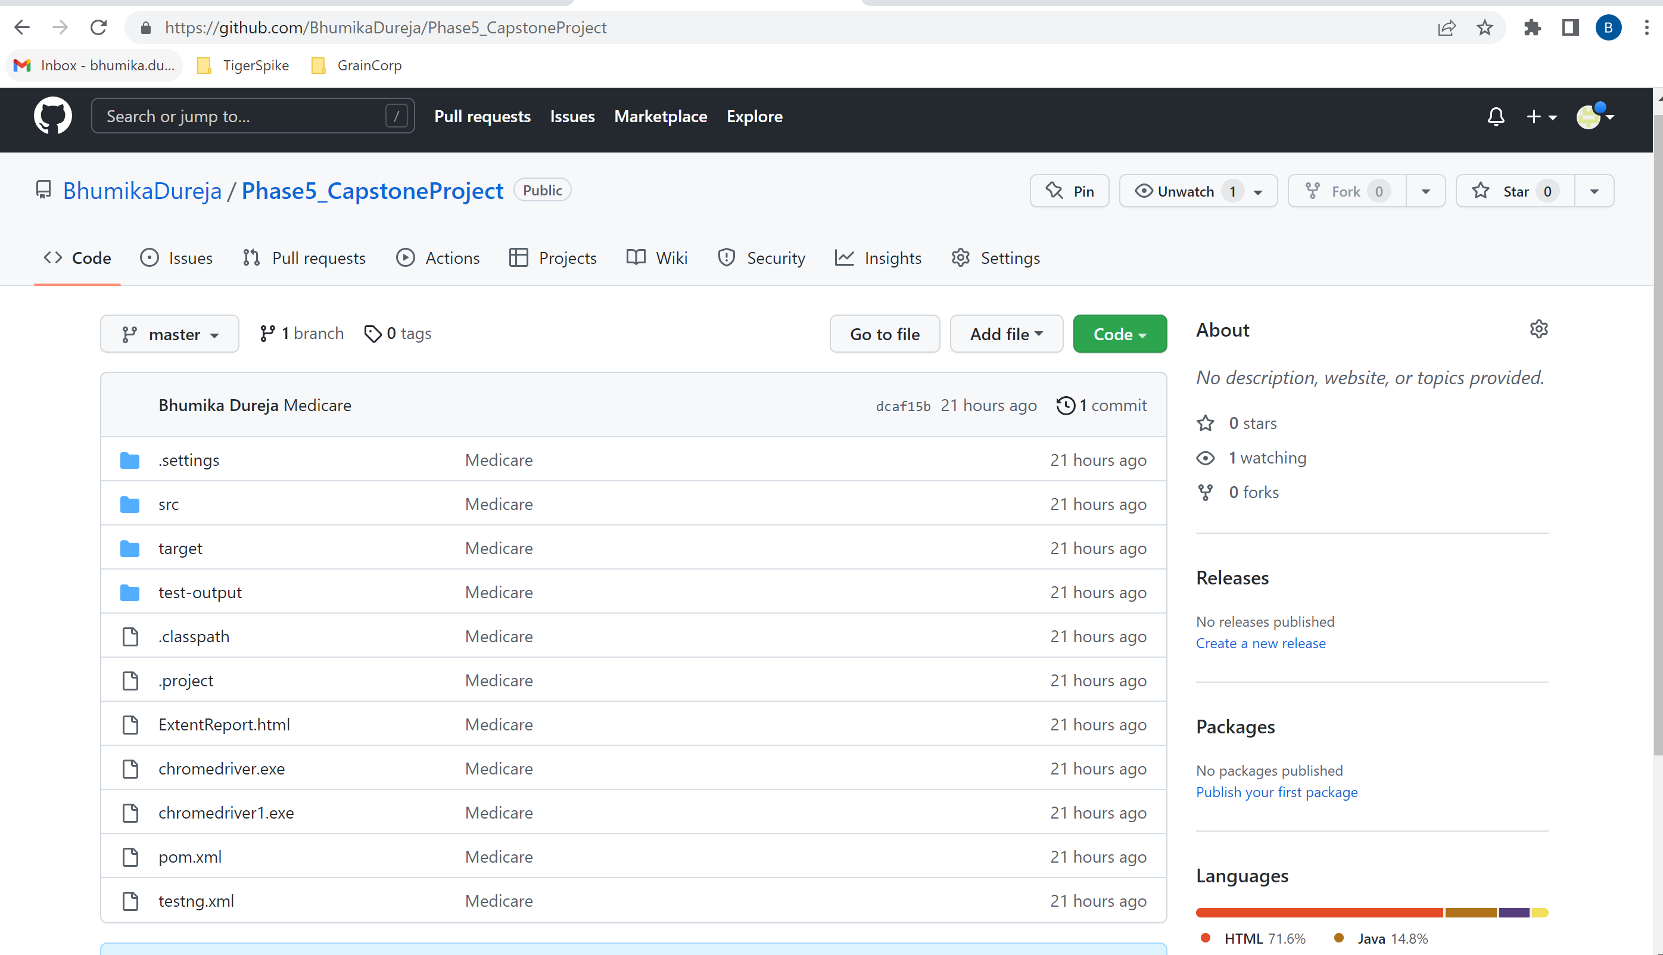

**JMX file, Postman collection & source code present in**

<https://github.com/BhumikaDureja/Phase5_CapstoneProject_DocumentSubmission.git>