Project Report
On
REAL-TIME AUTOMOBILE TRACKER

BACHELOR OF TECHNOLOGY
IN
COMPUTER SCIENCE



SUBMITTED BY

Bhumika Saini (160701220010)
Neerav Pandey (16070122039)
Priyam Maheshwari (16070122045)
Jaanvi Juneja (17070122504)

Under the Guidance of

PROF. SAMADRITA GUHA

SYMBIOSIS INSTITUTE OF TECHNOLOGY
(A CONSTITUTENT OF SYMBIOSIS INTERNATIONAL UNIVERSITY)

PUNE - 412115
2017-18

Software Requirement Specification

Table of Contents:

1.Introduction
1.1 Purpose
1.2 Suggestions
1.3 Input & Output
1.4 Product Scope
1.5 Problem in Existing System
1.6 Entities Involved in Project
1.7 References

2.User Requirements for Passenger
2.1 Login
2.2 GPS Location Enable
2.3 Mobile Data or Wi-Fi Enable
2.4 View Bus Schedule
2.5 Check Running Buses
2.6 Track a Bus
2 .7 Settings
2.7.1 Change the view of the map
2.8 Logout

3.User Requirements for Driver
3.1 Login
3.1.1 Scan QR code
3.2 GPS Location Enable
3.3 Mobile Data or Wi-Fi Enable
3.4 Choose Option
3.4.1 SIT to SB road
3.4.2 SB road to SIT
3.5 View Nearby
3.5.1 Hospitals
3.5.2 Petrol Pumps
3.5.3 Repair Shops
3.6 Settings
3.6.1 Change the view of map
3.7 Logout

4. System Requirements
4.1 GPS Location
4.2 Internet Connectivity
4.3 Android OS
4.4 Firebase
5. Non-Functional System Requirements
5.1 Maintainability
5.2 Reliability
5.3 Security

6. Project Size and Cost Estimation
6.1 Estimation- LOC & COCOMO

7. Project Design
7.1 Use Case Diagram
7.2 Data Flow Diagram
7.3 Class Diagram
7.4 Sequence Diagram
7.5 Gantt Chart
8. Risk Mitigation and Management

1. Introduction

1.1 Purpose
This Software Requirement Specification is for a Real-Time Automobile Tracking System. The proposed system will offer an android application for SIT students to conveniently track buses plying to and from Symbiosis International, Lavale Campus to Symbiosis International, Senapati Bapat Road Campus and vice versa.

1.2 Suggestions
College busses have erratic routes and ever-changing time tables, users in need may miss their bus due to maybe the latest time table change which may not updated elsewhere for the students. We have tried to provide a solution for the same.

1.3 Inputs And Outputs
The main inputs, outputs and major functions of the system are as follows:
INPUTS:
- Users login through emails.
- Admin checks the email if it is an SIT email or not.
- Admin enter his or her user id and password.
- Admin updates the Time-Table of buses as and when changes are made.
- Driver logs in whenever taking a trip, using the specific QR code for the bus.
- Driver selects his destination.
- Driver’s location regularly updated on the database.
OUTPUTS:
- User isn’t allowed to access the application if he doesn’t have an SIT email address.
- User gets details of buses plying currently, and their respective routes and stops the the bus will be halting at.
- User can also access the Time-Table of the buses.
- Driver can see nearby Hospitals, Petrol Pumps or Service Centers in case of emergency.
- The map shows the exact location of the buses and is updated regularly on the database and subsequently on the map.

1.4 Scope
The software provides the following facilities to the users:
- Facilitates easy tracking of buses in real-time.
- Provides updated time-tables.
- Provides information on route of the bus.
- Provides information on the number of and location of stops along the route of the bus.
- Information of the bus (the number plate) helps identifying the bus.

The software will not provide the following facilities to the users:
- It cannot guarantee you a seat in the bus.
- It cannot tell you the approximate time for the bus to arrive to the next stop.
- Can’t make a bus wait for you.

The software provides the following facilities to the drivers:
- Drivers can get immediate relief by finding nearby hospitals, petrol pumps, service centers, etc.
- Drivers can be shown a route, by redirecting you to the Google Maps application.
- Drivers can change their route depending upon traffic conditions.

The software provides the following facilities to the admin:
- Upload newest time-tables whenever necessary
- Database access facilitates admin to check number of buses plying and their current locations.
- Database also tells which buses are currently not running.

The objective of this software is to provide easy assistance to both the users and drivers as well as the admin with proper database and information.

1.5 Problem in Existing System
There is no online feature to track our college buses or to receive immediate updates on
changes in Time-Table or routes of buses, also buses can get late sometimes due to traffic which may lead to user waiting long hours for his bus to arrive which inconvenient and unnecessary and can be avoided. Drivers in case of emergency might need the closest hospitals, petrol pumps etc. All these issues are looked after by our software.

1.6 Entities Involved in the Project
Users- Students, Staff members, Teachers
Bus Drivers
Admin

1.7 References
developer.android.com
www.stackoverflow.com

2. User Requirements

2.1 Login
For a user to access the information of buses he has to login using SIT email address. This is done using a Google Sign-In. The bus driver also has to login using the respective QR code for the bus. This is done so that data is only shown authenticated users, and so that bus plying is a Symbiosis authenticated bus only.

2.2 GPS Location Enable
Users should enable their GPS so that they can view the locations of the buses more precisely relative to their own positions. Enabling GPS would also update the movement of the buses faster and smoothly.

2.3 Mobile Data or Wi-Fi Enable
Internet connection will enable the users to check if buses are running or not, and also to check the time-table and route of stops the buses plying.

2.4 View Bus Schedule
The users should have the access to view the bus schedules whenever required. The bus schedule is taken from the Firebase Storage Cloud and be shown to the user, so whenever the user checks the schedule it’ll be the latest schedule uploaded by the admin.

2.5 Checking Running Buses
Admin makes sure that the buses on map are only shown if the driver is logged in. On clicking on the bus, we get a popup text showing its number and its destination. On clicking on the popup above the bus we can see the route and stops of the bus.

2.6 Track a Bus
Whenever a driver logs in, his location is sent to the database and his location is shown on the map of the passenger’s app and the bus marker is shown. The location is updated at intervals to give real-time tracking of the bus.

2.7 Settings
2.7.1 Change view of Map
The user can change the map type from the Alert Dialog and can switch between a Normal Map Type, Hybrid Map Type and Terrain Map Type so that the user can recognize the locations easily based upon his comfortability.

2.8 Logout
The user (passenger) can logout from his SIT email account linked through Gmail. To avail the facilities of the app he must login again!

3. User Requirements for Driver

3.1 Login
3.1.1 Scan QR Code
For a bus driver to login he has to scan the QR code for the respective bus he would be driving and select to the destination to which he would be travelling. This would make an entry of the bus in the database.

3.2 GPS Location Enable
The bus drivers are required to give access to their location. The destination also selects the route and the respective stops along the route. The bus driver’s location is tracked and uploaded on to the database to show the location of the bus to the user and the admin. It also determines the route of the bus and hence will also decide the bus stops where the users can get onto the bus at.

3.3 Mobile Data or Wi-Fi Enable
The bus driver needs to have an internet connection so that the location can be sent to the server which will store its real-time location in the Firebase database. They will also need it to check for nearby relief locations, like hospitals, petrol pump, service centers.

3.4 Choose Option
3.4.1 SIT to Senapati Bapat Road
Choosing this option will set the location to Senapati Bapat Road. The route will set respectively and stops will also be set along the way which will be shown to the passenger. The respective will give the popup “To SB Road”.

3.4.2 Senapati Bapat Road to SIT
Choosing this option will set the location to SIT. The route will set respectively and stops will also be set along the way which will be shown to the passenger. The respective will give the popup “To SIT”.

3.5 View Nearby
3.5.1 Hospitals
Clicking on Hospitals will show all nearby locations of hospitals.

3.5.2 Petrol Pumps
Clicking on Petrol Pumps will show all nearby locations of petrol pumps.

3.5.3 Repair Shops
Clicking on Repair Shops will show all nearby locations of service centers and repair garages.

3.6 Settings
3.6.1 Change view of Map
The driver can change the map type from the Map Type button and can switch between a Normal Map Type, Hybrid Map Type and Terrain Map Type so that the driver can recognize the route easily based upon his comfortability.

3.7 Logout
The bus driver can log out when he has completed his journey and he doesn’t have a journey right after. When the bus driver logs out the bus is removed from the passenger app and his location is stopped from being fed into the database.

4. System Requirements

4.1 Internet Connection
Internet is the heart and soul of this system. It helps extraction information to the passenger app and helps in uploading data from the driver app to and from Firebase Database.

4.2 GPS Location
It helps in getting and displaying locations more precisely. It also helps in showing routes and stops.

4.3 Android OS
The applications are only compatible with an Android Operating System. So, to use the app we must make sure that we have Android based mobile device.

4.4 Firebase
To store the bus locations, we must use a real-time database, for this we Firebase database. Also, to store the time-table (bus schedule) we should store it on a cloud so that everyone has access to it and update the same file whenever required, this is done using Firebase Cloud Storage.

5. Non-Functional System Requirements

5.1 Maintainability
The software is easy to maintain as there are not much lines of code. The code is divided into a number of classes and functions that make it easier to identify section of wrong code and to debug and rectify that section of code.

5.2 Reliability
The software is very reliable with a stable internet connection, and the database updates the locations at regular intervals to make it real time tracking, hence the software is quite reliable and has experienced no crashes as of yet.

5.3 Security
We do not store your passwords and emails, we take use of Google’s API Client to sign in so that we need not store any user details and hence the user’s credentials are very secure. Only the admin can change bus schedule and no one else is authorized to do so. Only users with SIT email addresses are given access to bus information, hence information is given securely.

6. Project Size and Cost Estimation

6.1 Estimation- LOC & COCOMO

LOC Estimation:

Cost & effort estimation using LOC (Decomposition Technique)
Table of significant modules & their LOC Distribution

Sr. No. | Name | Optimistic | Most Likely | Pessimistic
1 | Authentication | 200 | 230 | 300
2 | Route Directions | 100 | 170 | 210
3 | Map plotting | 500 | 900 | 1200
4 | Schedule retrieval | 30 | 50 | 90
5 | Nearby Services | 200 | 260 | 300
6 | GPS Tracker | 100 | 190 | 250
7 | Auxiliary code | 200 | 250 | 310

Expected value (EV) = (Optimistic + 4*Most Likely + Pessimistic) / 6

Sr. No. | Name | Expected Value
1 | Authentication | 237
2 | Route Directions | 165
3 | Map plotting | 883
4 | Schedule retrieval | 320
5 | Nearby Services | 257
6 | GPS Tracker | 185
7 | Auxiliary code | 252

Estimated LOC = 2299 LOC

Average Productivity = 500 LOC/PM

Estimated Effort = Estimated LOC / Average Productivity = 2299 / 500 = 4.598 = 4.6 PM

Cost / LOC = 10 $

Estimated cost = LOC * (Cost / LOC) = 2299 * 10 = $22990
COCOMO II Model:

4 Simple Screens
4 Medium Screens
2 Difficult Screens
5 Simple Components
3 Simple Reports

High productivity

Reuse percentage = 20%

Object Counts:
4 Simple Screens * 1 = 4
4 Medium Screens * 2 = 8
2 Difficult Screens * 3 = 6
5 Simple Components * 10 = 50
3 Simple Reports * 2 = 6

Therefore, OP = 74

Adjusted NOP = 74 * (1 – (20/100)) = 59.2 = 60

Productivity = High = 25 OP/PM

Therefore,
Estimated Effort Person-Month = Adjusted NOP/Productivity = 60 / 25 = 2.4 P-M

7. Project Design

7.1 Use Case Diagram
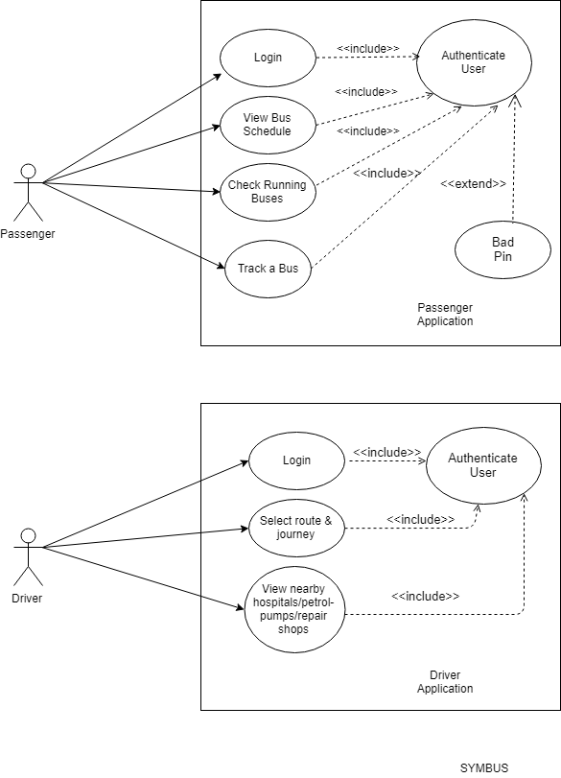

7.2 Data Flow Diagram

Level-0 DFD (Context Diagram)

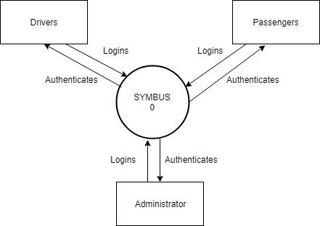

Level-1 DFD

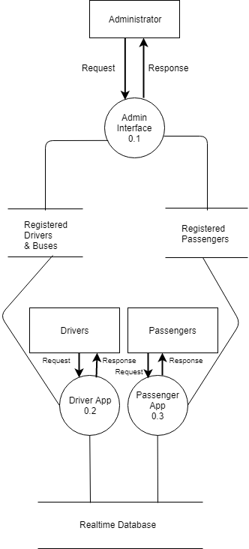

Level-2 DFD Process 0.1

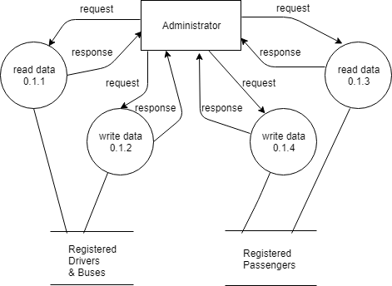

Level-2 DFD Process 0.2

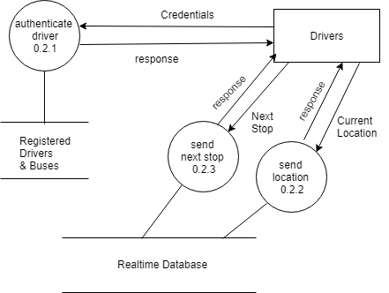

Level-2 DFD Process 0.3

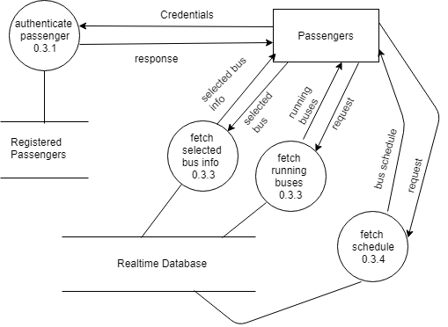

7.3 Class Diagram

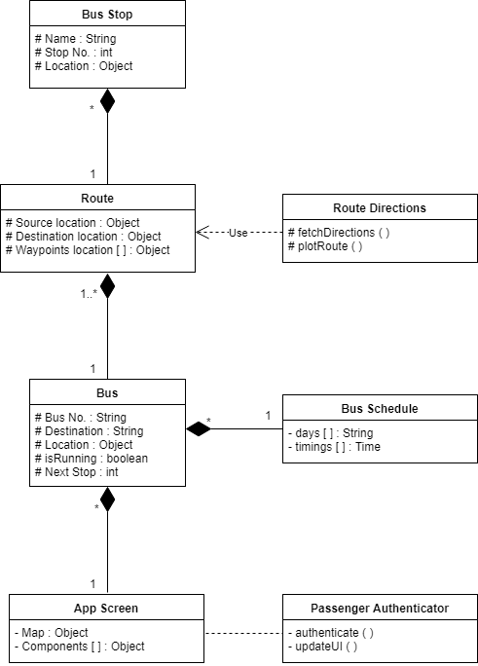

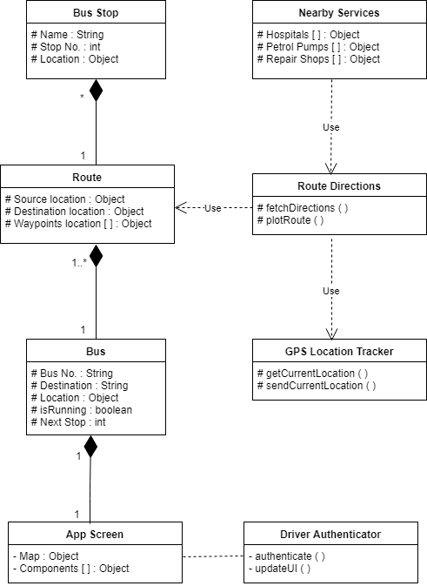

7.4 Sequence Diagram

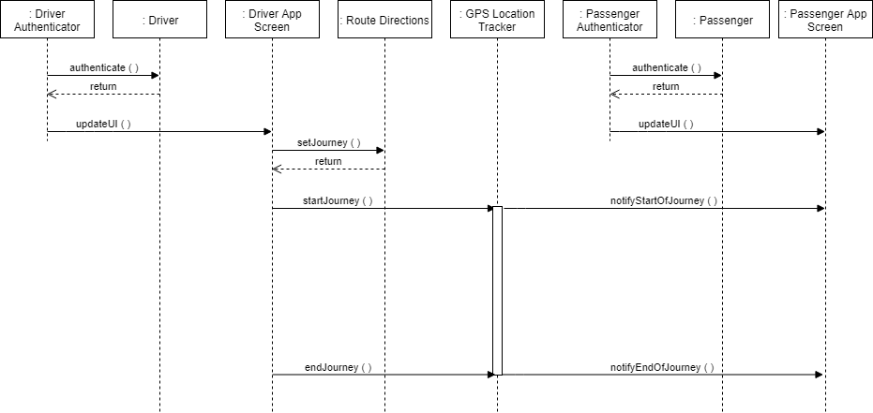

7.5 Gantt Chart

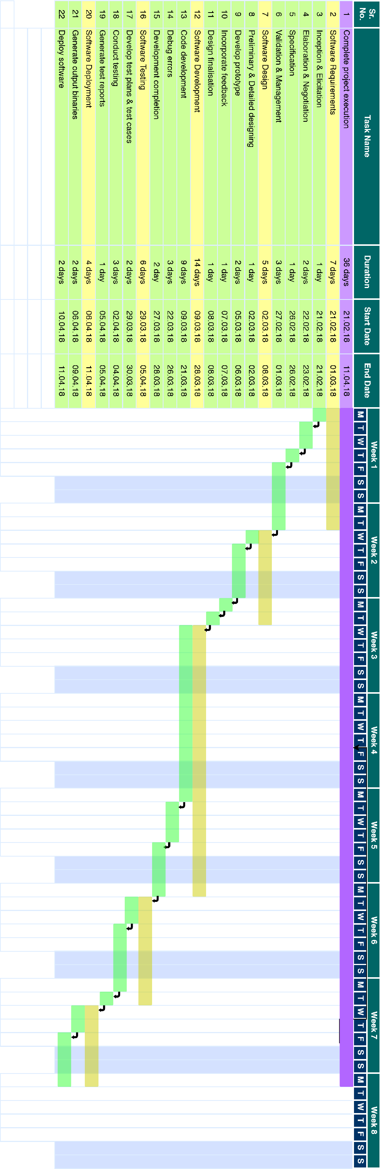

8. Risk Mitigation and Management (RMMM)
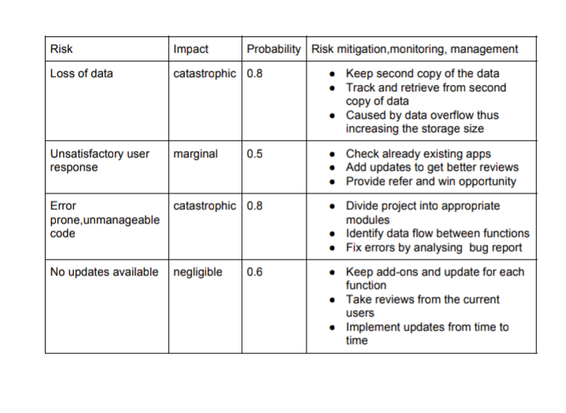

9.

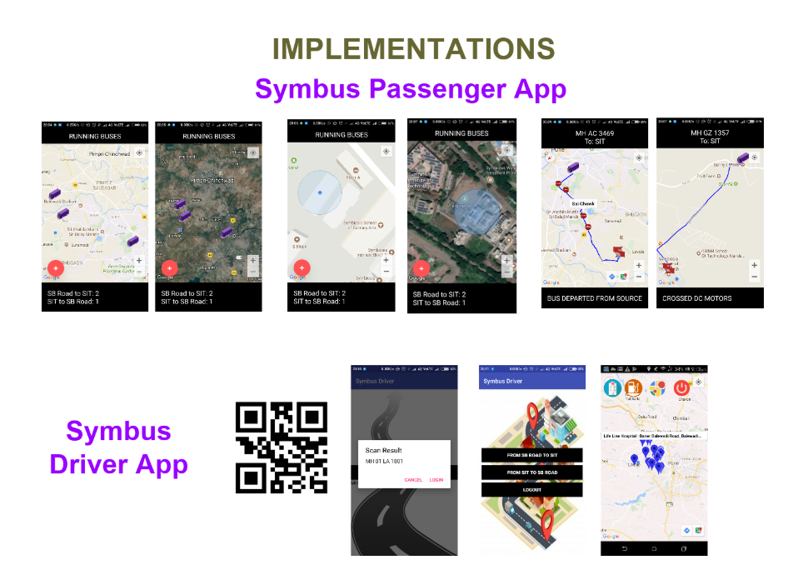

SYMBUS PASSENGER APPLICATION
Test UID | Test Scenario | Test Steps | Test Data | Expected Results | Actaual Results | Pass/Fail
PTC001 | Passenger does not belong to SIT | Sign-in with a non-sitpune email id | bhumi.saini@gmail.com | Should not process sign-in. Notify denial of access. | Does not process sign-in. Notifies denial of access. | Pass
PTC002 | Passenger belongs to SIT | Sign-in with an sitpune email id | bhumika.saini@sitpune.edu.in | Should process sign-in. Enter the app. | Processes sign-in. Enters the app. | Pass
PTC003 | Invalid password with valid email/phone number | Invalid password entered | bhumi.saini@gmail.com thisisasamplepassword | Should fail the sign-in | Sign-in fails | Pass
PTC004 | Invalid email/phone number | Invalid email/phone number entered | thingumbob404@gmail.com | Should notify invalid credentials | Notifies invalid credentials | Pass
PTC005 | Bus on a usual route | Bus driven on a usual route | Locations from a usual route | Relevant status information & bus stops should be provided | Provides relevant status information & plots bus stops | Pass
PTC006 | Bus on an unknown route | Bus driven on a new route | Locations from a new route | Notify about the new route & should not plot any bus stops | Notifies about the new route & does not plot bus stops | Pass
PTC007 | Bus crosses a particular bus stop | Bus driven past a bus stop in the route direction | Locations beyond the bus stop’s location | Should remove the crossed stop & update status | Removes the crossed stop & updates status | Pass
PTC008 | Bus completes a journey | Bus reached destination | Location of destination | Should remove the bus from the map & notify completion of journey | Removes bus from the map & notifies completion of journey | Pass
PTC009 | No internet connection | Disable internet connection | Request for database read | Notify to enable internet | Notifies to enable internet | Pass

SYMBUS DRIVER APPLICATION

Test UID | Test Scenario | Test Steps | Test Data | Expected Results | Actaual Results | Pass/Fail
DTC001 | Unknown driver credentials | Sign-in with an unknown QR Code | AB 12 CD 0000 | Should not process sign-in. Notify denial of access. | Does not process sign-in. Notifies denial of access. | Pass
DTC002 | Valid driver credentials | Sign-in with a valid QR Code | MH 01 LA 1801 | Should process sign-in. Enter the app. | Processes sign-in. Enters the app. | Pass
DTC003 | No nearby services | Bus travelling in a remote location | Location with no nearby services | Notify absence of nearby services | Notifies absence of nearby services | Pass
DTC004 | Driver logged in even after journey is completed | Do not log out on journey completion | Logged in driver | Should not track driver location | Does not track driver location | Pass
DTC005 | No internet connection | Disable internet connection | Request for database transaction | Notify to enable internet | Notifies to enable internet | Pass
DTC006 | No GPS access | Disable GPS | Request to access current location | Notify to enable GPS | Notifies to enable GPS | Pass

