# **Testing**

## **User Authentication**

### **4.1.1 Test Case: User Registration**

**Test Case Title:** User Registration

**Test Case ID:** TC1

**Objective:** To ensure validation and security while user registration

|  |  |  |  |  |  |
| --- | --- | --- | --- | --- | --- |
| S.N | Test Data | Steps | Ecpected Result | Actual Result | Status |
| 1. | Tap Register Button | Pass empty credentials in all fields. | The system should ask user to enter value in all the fields. | It displayed an error saying field cannot be empty. | Pass |
| 2. | Invalid Email | Pass email without the ‘@’ symbol. | The system should ask user for a valid email address. | It displayed “Enter a valid email” error. | Pass |
| 3. | Mismatched Passwords | Type different passwords in password fields. | The system should display password do not match error. | It displayed “Passwords do not match” error. | Pass |
| 4. | Short Password | Type a password shoter than 8 characters. | The system should ask the user to input a valid password. | It displayed an error asking user to input valid password. | Pass |
| 5. | Tap Register Button | Fill out the fields with all the correct credentials. | User should be registered successfully. | User registered successfully. | Pass |

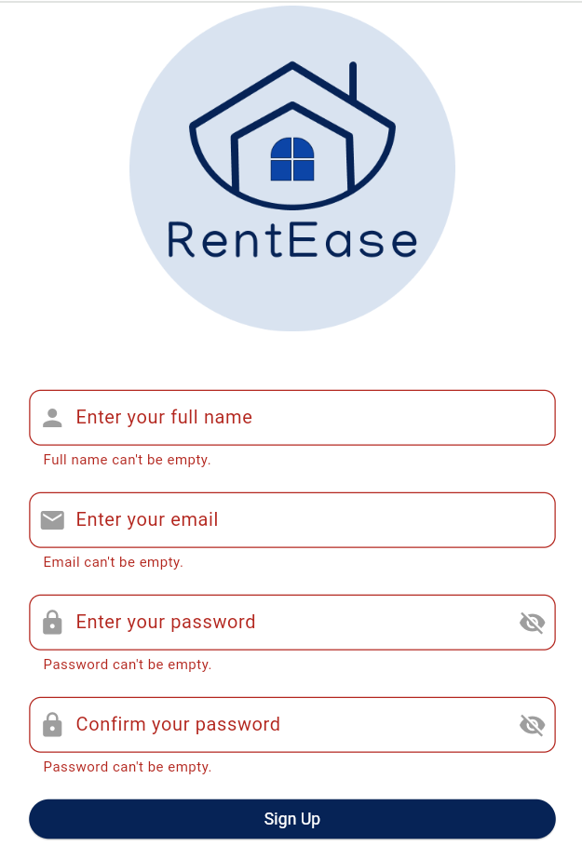 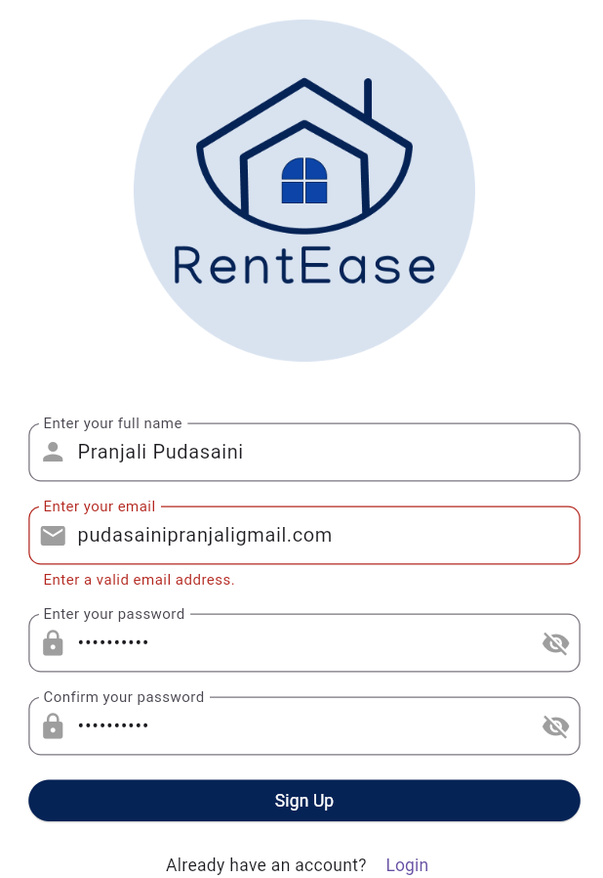

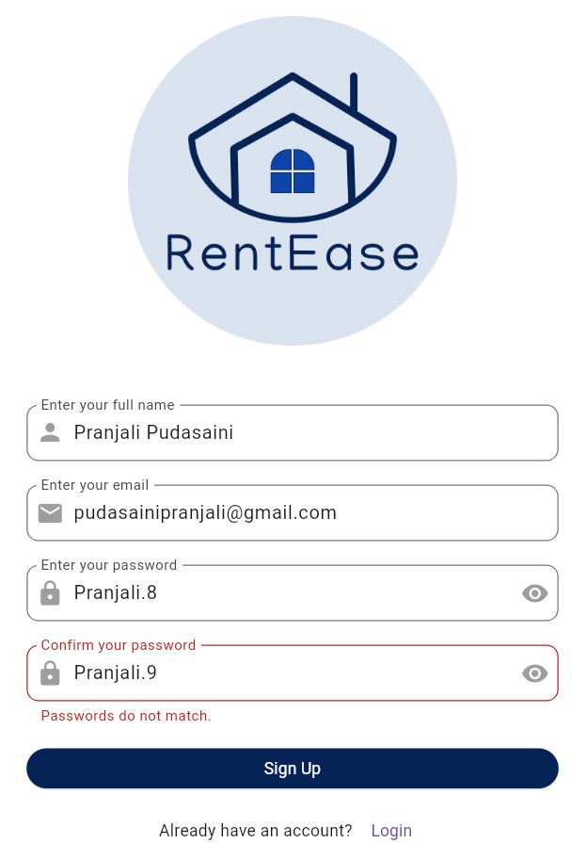 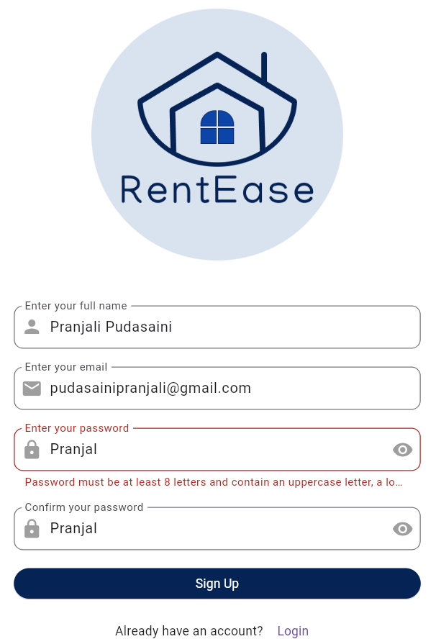

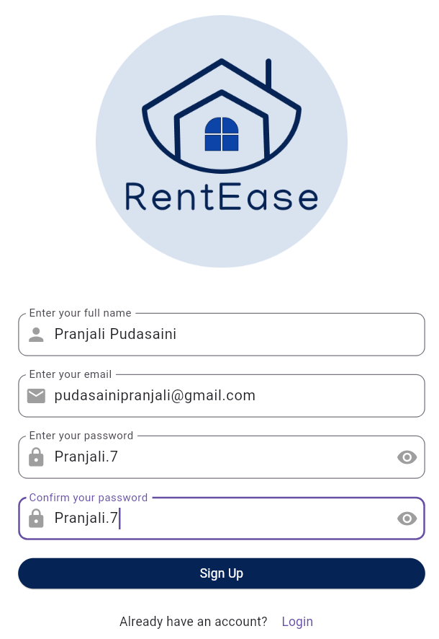 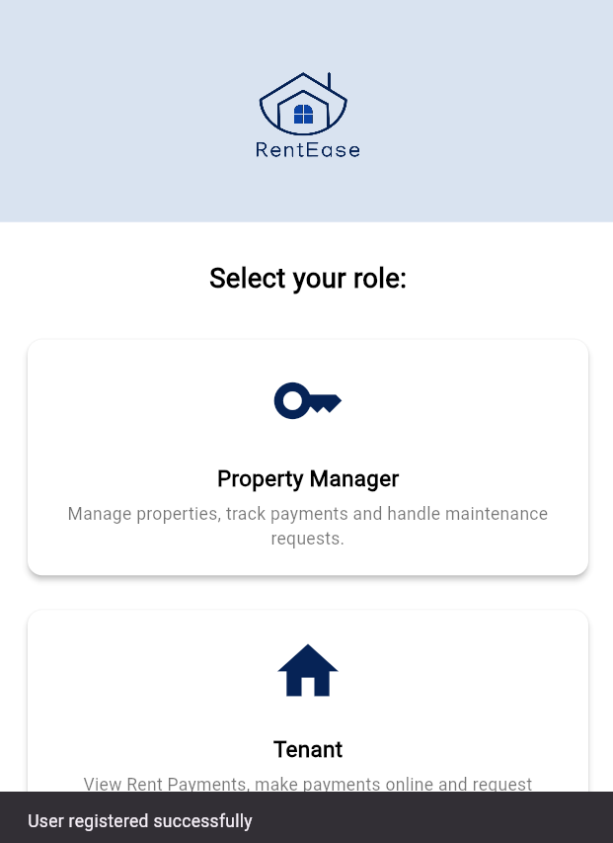

### **4.1.2 Test Case: Role Update**

**Test Case Title:** User Role Update

**Test Case ID:** TC2

**Objective:** To ensure successful role update after signing up

|  |  |  |  |  |  |
| --- | --- | --- | --- | --- | --- |
| S.N | Test Data | Steps | Ecpected Result | Actual Result | Status |
| 1. | Tap Property Manager Option | Tap in the property manager field. | Role should be updated to landlord. | Role was updated successfully to landlord. | Pass |
| 2. | Tap Tenant Option | Tap the tenant field. | Role should be updated to tenant. | Role was updated successfully to tenant. | Pass |

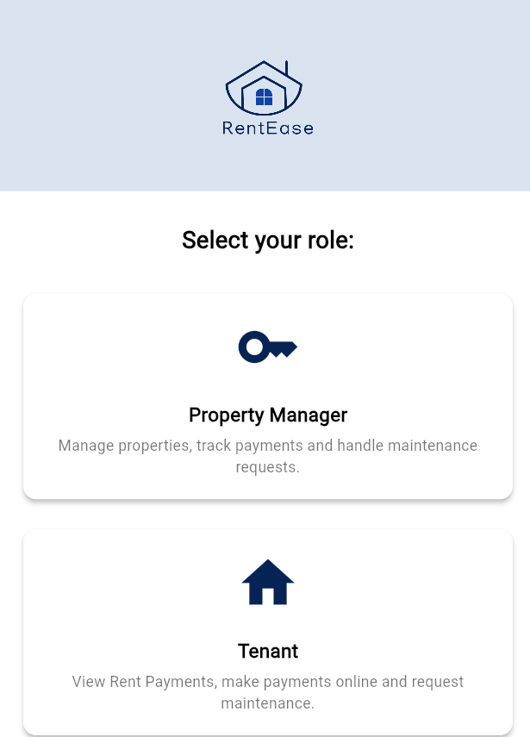

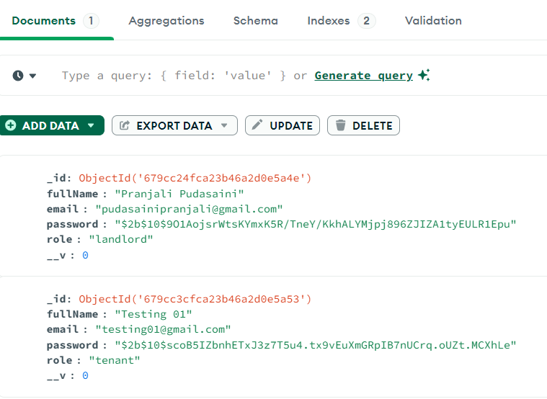

### **4.1.3 Test Case: Log In**

**Test Case Title:** User Log In

**Test Case ID:** TC3

**Objective:** To ensure validation and security while user registration

|  |  |  |  |  |  |
| --- | --- | --- | --- | --- | --- |
| S.N | Test Data | Steps | Ecpected Result | Actual Result | Status |
| 1. | Tap Register Button | Pass empty credentials in all fields. | The system should ask user to enter value in all the fields. | It displayed an error saying field cannot be empty. | Pass |
| 2. | Only Email | Pass only email. | The system should ask user for a password. | It displayed “Password can’t be empty” error. | Pass |
| 3. | Pass Wrong Password | Type wrong password for a registered user. | The system should show a password not matched error. | It displayed “Password not matched” error. | Pass |
| 4. | Tap Log In Button | Fill out the fields with all the correct credentials. | User should be redirected to their own dashboard. | User redirected to their dashboard. | Pass |

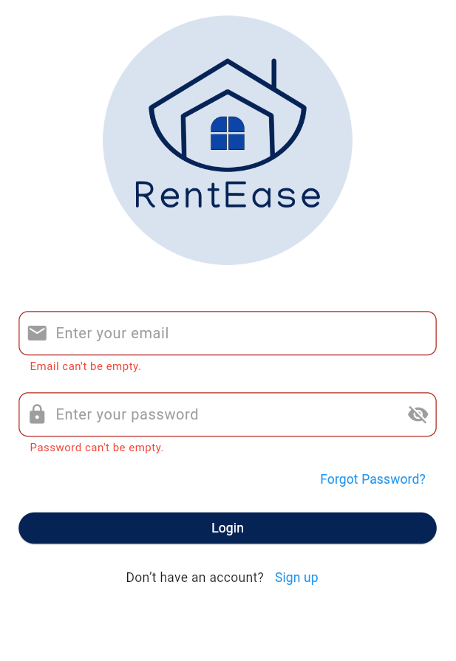 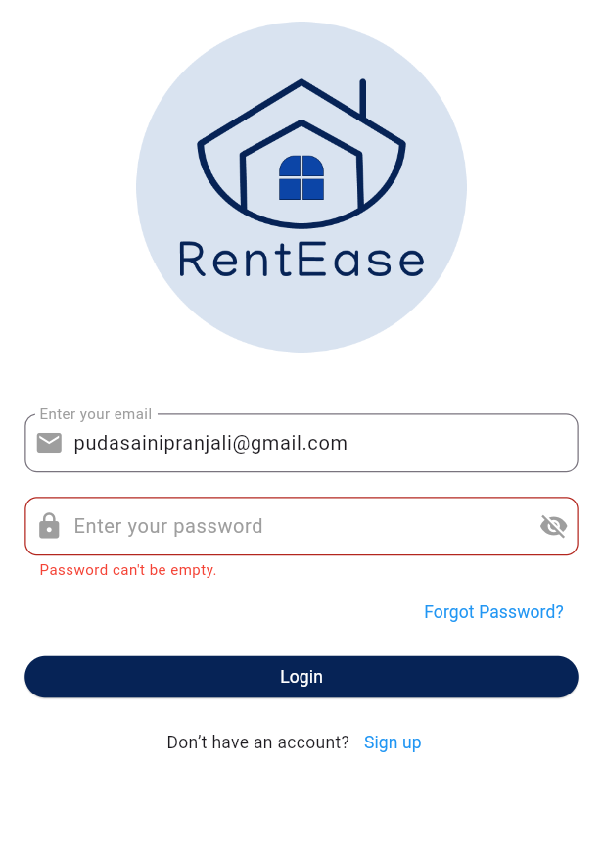

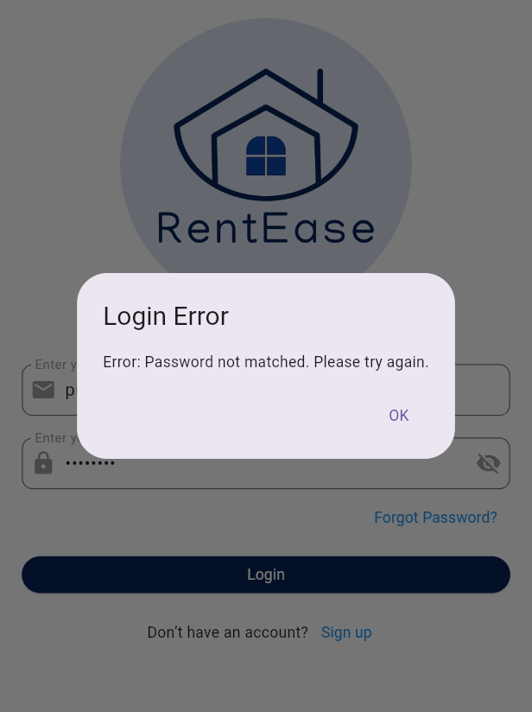 

## **Property Management System**

### **Test Case: Add Property**

**Test Case Title:** Add Property

**Test Case ID:** TC4

**Objective:** To ensure property is added successfully in database

|  |  |  |  |  |  |
| --- | --- | --- | --- | --- | --- |
| S.N | Test Data | Steps | Ecpected Result | Actual Result | Status |
| 1. | Empty fields | Tap the save button while leaving all the fields empty. | The system should ask user to enter all required fields. | It asks user to enter all required fields. | Pass |
| 2. | Valid Name, Empty Address | Fill the property name but leave the address field empty. | The system should prompt the user to enter address field. | It prompted user to add an address. | Pass |
| 3. | All valid fields | Fill all the fields with valid data. | The system should create a property successfully. | It created a property and fetched it for the user to see. | Pass |
| 4. | Property Name already exists. | Fill out the property name field with a property name that already exists. | The system should throw an error saying “Failed to save property”. | It displayed an error saying “Failed to save property”. | Pass |

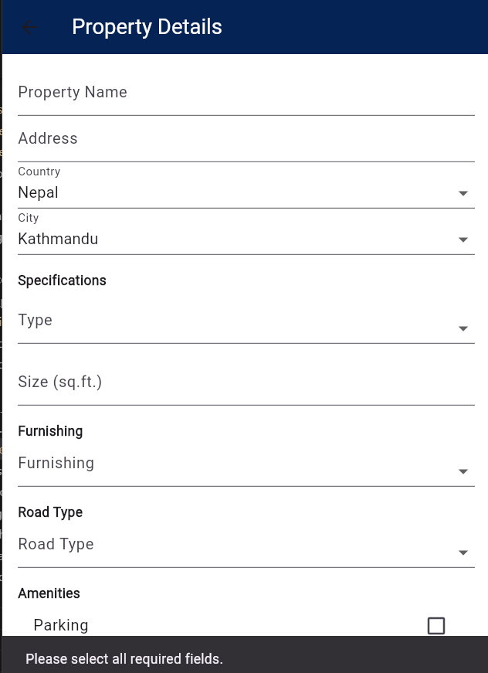 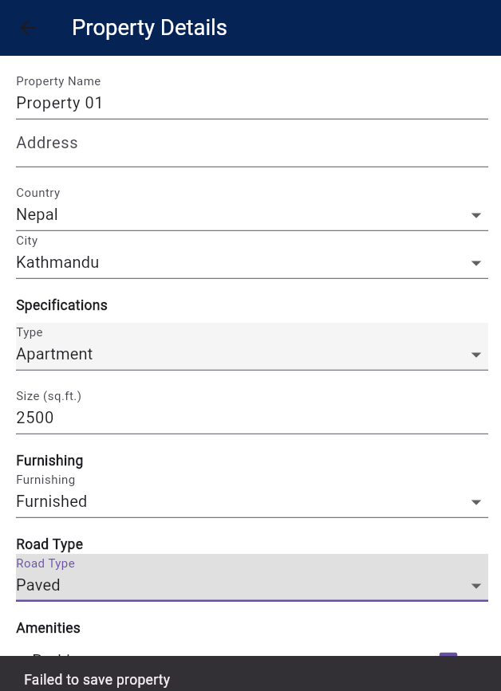

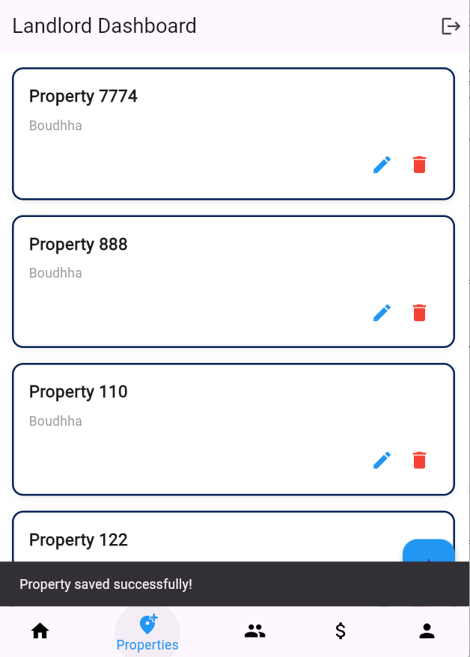 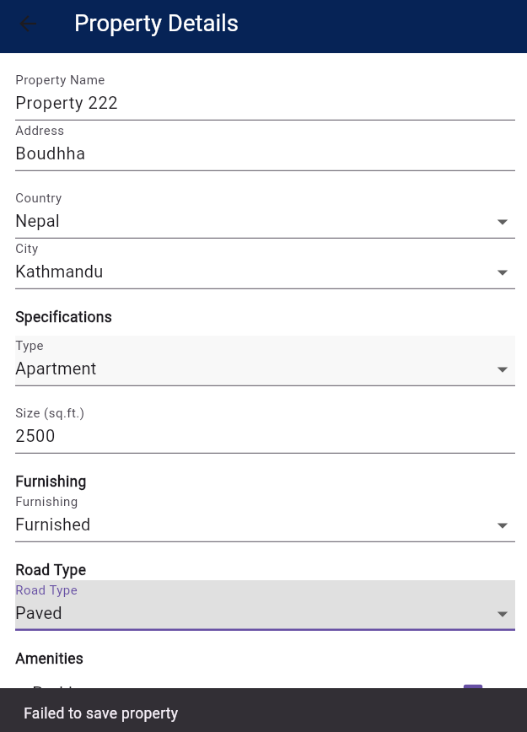

### **Test Case: Edit Property Details**

**Test Case Title:** Edit Property

**Test Case ID:** TC5

**Objective:** To ensure property is edited successfully in database

|  |  |  |  |  |  |
| --- | --- | --- | --- | --- | --- |
| S.N | Test Data | Steps | Ecpected Result | Actual Result | Status |
| 1. | Empty Name, Valid Address | Tap the save button while leaving name field empty. | The system should ask user to enter property name. |  | Pass |
| 2. | Valid Name, Empty Address | Fill the property name but leave the address field empty. | The system should prompt the user to enter address field. |  | Pass |
| 3. | All valid fields | Fill all the fields with valid data. | The system should edit details of a property successfully. |  | Pass |

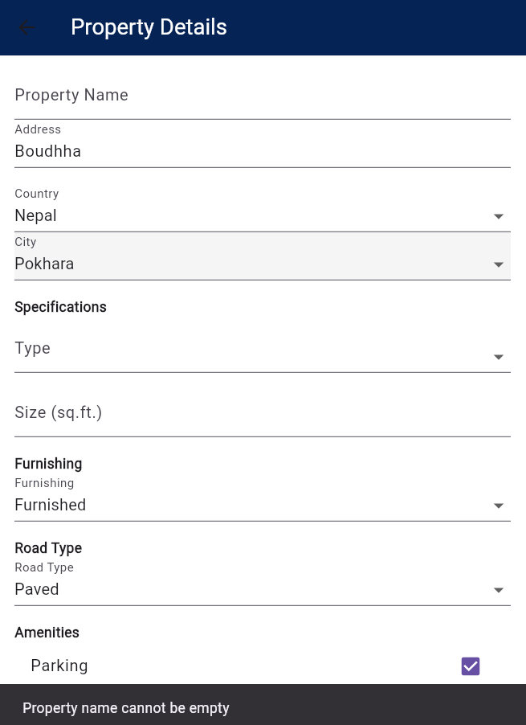 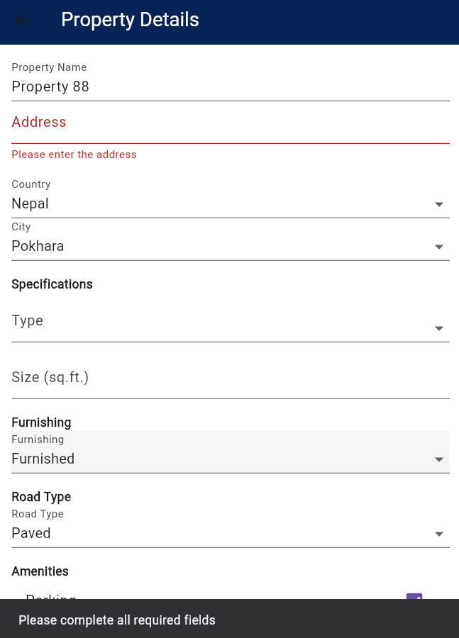

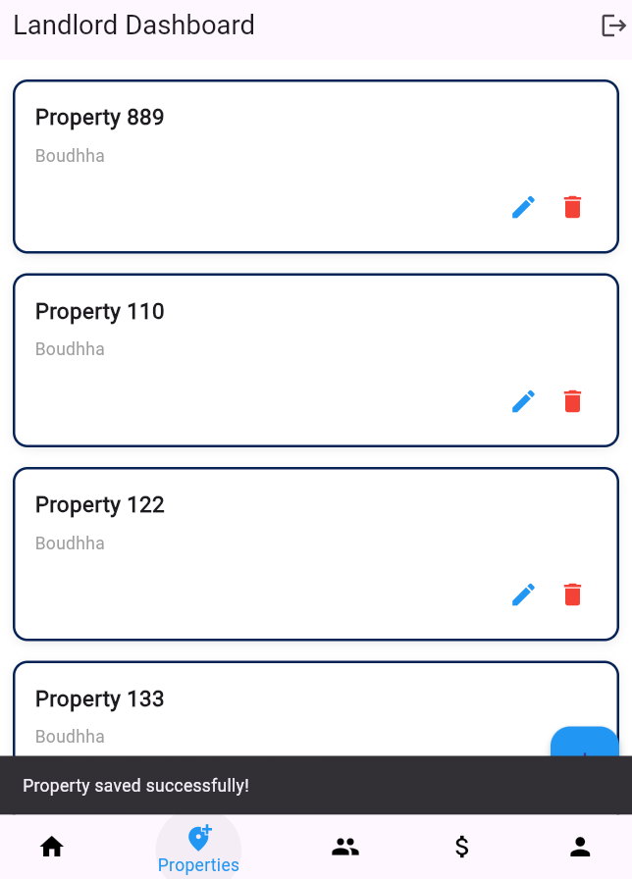

### **4.2.3 Test Case: Delete Property**

**Test Case Title:** Add Property

**Test Case ID:** TC6

**Objective:** To ensure property is deleted successfully from the database

|  |  |  |  |  |  |
| --- | --- | --- | --- | --- | --- |
| S.N | Test Data | Steps | Ecpected Result | Actual Result | Status |
| 1. | Tap Delete on Property List. | Tap the delete icon on a property list and confirm its deletion. | The system should ask for confirmation from the user whether or not to delete the property. | A dialog appears asking user whether to delete or not. | Pass |
| 2. | Cancel Deletion | Tap the delete icon and then tap “Cancel” on the dialog box. | The system should cancel the deletion and the property should still be in the list. | The deletion is cancelled and the property is still seen in the properties page. | Pass |
| 3. | Confirm Deletion | Tap the delete icon and then tap “delete” on the dialog box. | The system should delete the property from the list. | The deletion is confirmed and property disappears from the properties page. | Pass |

