

Bachelor of Computer Applications
Semester – V
Deep Learning
Project 4
Ethical Considerations in Deep Learning

Submitted By:
Name: Bhumika R
Reg. No: 2411021240026
Date: 06/09/2026

Submitted To:
Faculty Name: Nagasri p

Department of Computer Application
Alliance University
Chandapura - Anekal Main Road, Anekal
Bengaluru – 562106

Ethical Considerations in Deep Learning
Exploring Bias, Privacy, Fairness, Transparency, and Responsible AI Use

Introduction
Deep Learning (DL) systems now influence decisions in hiring, lending, healthcare, criminal justice, and everyday consumer technology. As these systems grow more capable and more deeply embedded in society, the ethical implications of how they are designed, trained, and deployed have become just as important as their technical performance. A model that is highly accurate on average can still cause serious harm if it is biased against a particular group, exposes private information, or makes decisions that no one can explain or challenge.
This report examines three major ethical issues in Deep Learning — bias and discrimination, privacy violation, and lack of transparency — analyzes a real-world case in which an AI system caused genuine ethical concern, and proposes practical measures that can reduce these risks.

Task 1: Three Ethical Issues in Deep Learning
Deep Learning systems raise a wide range of ethical concerns. The three most significant and frequently encountered issues are discussed below.

1. Bias and Discrimination
Deep Learning models learn patterns directly from training data. If that data reflects historical prejudices, social inequalities, or under-representation of certain groups, the model will reproduce — and often amplify — those same biases in its predictions. Bias can enter a system through skewed sample selection, biased human-created labels, or proxy variables (such as zip code) that correlate with race, gender, or income even when those attributes are never used directly.
- Example: Facial recognition systems that perform noticeably worse on darker-skinned faces and on women.
- Example: Automated hiring tools that downgrade resumes containing words associated with a particular gender.

2. Privacy Violation
Deep Learning models, especially large ones trained on web-scraped or user-generated data, often require enormous datasets that may contain personal, medical, financial, or biometric information. Trained models themselves can also leak private information: research shows neural networks can sometimes be prompted to reproduce snippets of their training data, and techniques such as membership-inference attacks can reveal whether a specific individual's data was used to train a model at all.
- Example: Facial recognition databases built by scraping billions of photos from social media without consent.
- Example: Large language models unintentionally memorizing and revealing private text from their training corpus.

3. Lack of Transparency (the "Black Box" Problem)
Deep neural networks make decisions through millions or billions of internal parameters that are extremely difficult for humans to interpret. This opacity makes it hard to know why a model produced a particular output, which in turn makes it difficult to detect errors, contest unfair decisions, or assign accountability when something goes wrong. Transparency issues are especially serious in high-stakes domains such as medical diagnosis, criminal sentencing, and loan approval.
- Example: A defendant assigned a high "risk score" by a proprietary algorithm that neither the defense nor the judge can fully inspect.
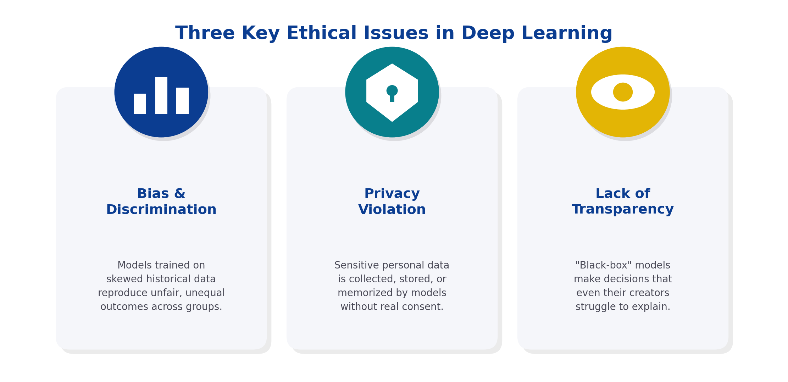
Figure 1: Three key ethical issues commonly associated with Deep Learning systems.

Task 2: Real-World Example — Bias in the COMPAS Recidivism Tool
One of the most widely cited real-world examples of ethical concern in AI is COMPAS (Correctional Offender Management Profiling for Alternative Sanctions), a risk-assessment tool used by several U.S. courts to help predict the likelihood that a criminal defendant would reoffend. Judges used COMPAS risk scores to help inform decisions about bail, sentencing, and parole.
In 2016, an investigation by journalists at ProPublica analyzed COMPAS scores for thousands of defendants in Broward County, Florida, and compared the model's predictions with actual reoffense rates. The analysis found that the tool was substantially more likely to falsely flag Black defendants as high-risk than White defendants, while White defendants who did go on to reoffend were more often incorrectly labeled low-risk. Overall accuracy between racial groups was similar, but the pattern of errors was not — meaning the cost of the model's mistakes fell disproportionately on one group.
This case illustrates how a machine learning system trained on historical criminal justice data can absorb and reproduce structural biases embedded in that data, even without race being used as an explicit input feature. It also illustrates the transparency problem: COMPAS was a proprietary, closed-source algorithm, so defendants and their lawyers could not fully examine how a given score was calculated, making the decision difficult to challenge in court.
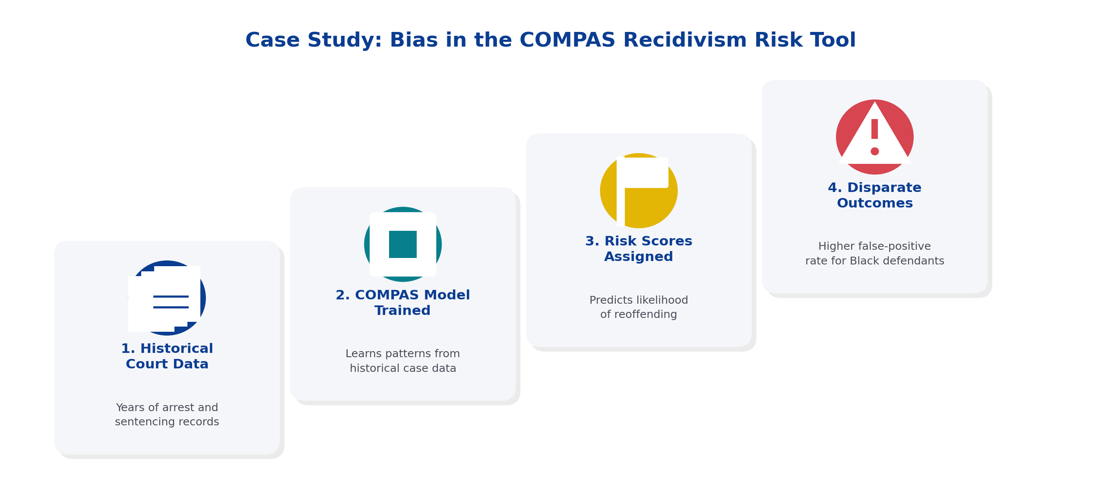
Figure 2: How historical court data flowed through the COMPAS pipeline to produce racially disparate outcomes.

Why This Matters
The COMPAS case is significant because it shows that ethical failures in AI are not hypothetical — they have already influenced real decisions about people's liberty. It also demonstrates that technical accuracy alone is not sufficient evidence that a system is fair; the distribution of errors across groups must also be examined. This case has since become a foundational example in AI fairness research and policy discussions worldwide.

Task 3: Measures to Address These Ethical Issues
Reducing ethical risk in Deep Learning requires action at multiple levels — the data used to train models, the models themselves, and the governance structures around their deployment.

Data-Level Measures
- Bias audits: Audit training datasets for representation gaps and historical bias before model training begins.
- Diverse data collection: Actively collect or augment data to ensure balanced representation across race, gender, age, and other protected attributes.

Model-Level Measures
- Fairness-aware training: Use fairness constraints or re-weighting techniques during training so error rates are balanced across demographic groups.
- Explainability tools: Apply Explainable AI (XAI) methods such as SHAP or LIME so that model decisions can be interpreted by humans.
- Privacy-preserving techniques: Apply techniques like differential privacy and federated learning to limit what a model can reveal about individual training examples.

Governance and Organizational Measures
- Human oversight: Keep a human decision-maker in the loop for high-stakes outcomes rather than fully automating them.
- Ethics review boards: Establish internal AI ethics review boards to evaluate systems before and after deployment.
- Accountability and redress: Give affected individuals the right to know when an automated decision was used, and the right to request a human review.
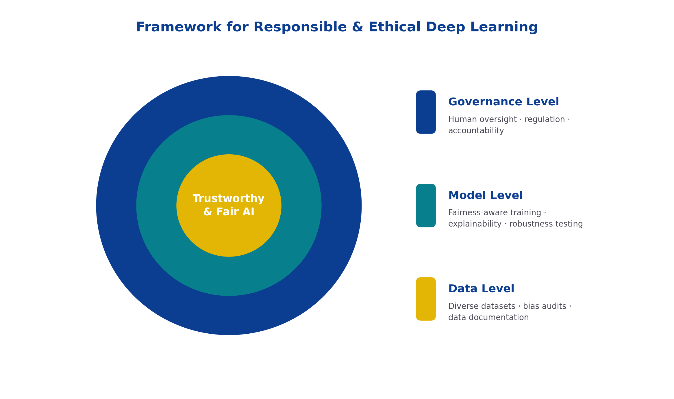
Figure 3: A layered framework — data, model, and governance — for building more trustworthy Deep Learning systems.

Conclusion
Deep Learning has enormous potential to improve decision-making, but as the COMPAS case shows, it can also cause real harm when ethical considerations are not built into the system from the start. Bias, privacy violation, and lack of transparency are interconnected challenges: biased data leads to unfair outcomes, opaque models make those outcomes hard to detect or contest, and inadequate privacy protections put individuals' data at risk. Addressing these issues requires sustained effort at the data, model, and governance levels — combining technical solutions such as fairness-aware training and explainability tools with organizational safeguards such as human oversight, ethics review, and regulation. Responsible AI is not a one-time checklist but an ongoing commitment that must evolve alongside the technology itself.

References
Angwin, J., Larson, J., Mattu, S., & Kirchner, L. (2016). Machine Bias. ProPublica.
Buolamwini, J., & Gebru, T. (2018). Gender Shades: Intersectional Accuracy Disparities in Commercial Gender Classification. Proceedings of Machine Learning Research.
European Commission. (2024). The EU Artificial Intelligence Act.
Jobin, A., Ienca, M., & Vayena, E. (2019). The Global Landscape of AI Ethics Guidelines. Nature Machine Intelligence.

