FitZone Gym Website
Name : Makwana Bhumi Bipinbhai
ID : D26AIML087
Sem : 3
Branch : AIML
Subject: Web Technology
Subject Code: AIUE203

Project Type: Web Development Project
Technologies Used: HTML, CSS, JavaScript, PHP and MySQL
Project Description: A gym website designed to provide information about gym facilities, workout programs, membership plans, and member registration and login.

Project Explanation
Overview
FitZone Gym Website is a web development project designed to provide users with information about a gym and its fitness services. The website has a user-friendly interface that allows visitors to explore gym facilities, workout programs, membership plans, and other fitness-related information.
The website is developed using HTML, CSS, and JavaScript for the front end, while PHP and MySQL are used for server-side processing and database management.
Objectives
- To develop a simple and user-friendly gym website.
- To display gym information and available workout programs.
- To present membership plans and their prices.
- To provide a membership registration form.
- To store member details in a MySQL database.
- To provide login functionality for registered members.
- To practise front-end development and database connectivity.
Functionality
The website contains the following modules:
- Home Module: Displays the FitZone introduction, main banner, gym features, and statistics.
- About Module: Provides information about the gym.
- Workouts Module: Presents workout-related information.
- Membership Module: Displays membership plans.
- BMI Module: Provides a BMI-related feature.
- Gallery Module: Displays gym-related images.
- Contact Module: Provides contact information or a contact form.
- Registration Module: Collects member information and saves it to the database.
- Login Module: Checks the registered user's email and password.
The website combines a front-end interface with PHP and MySQL to demonstrate basic web development and database operations.

Website Output
Home Page
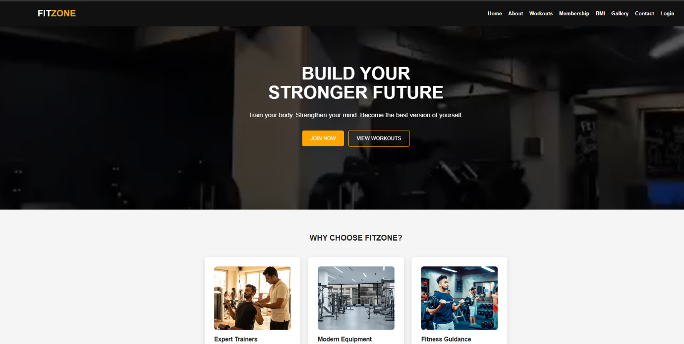
Registration Module
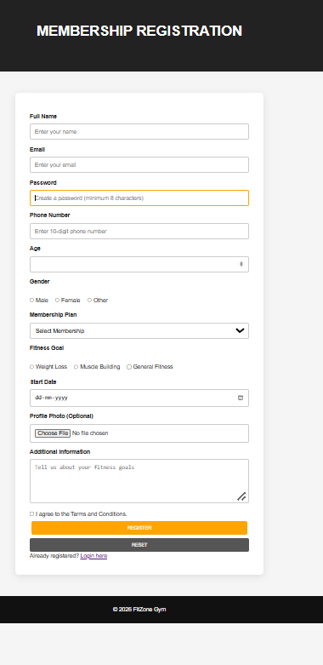
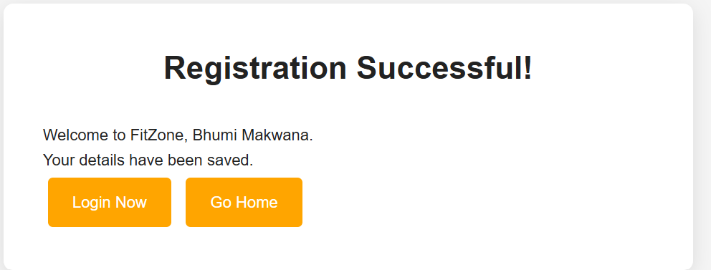
Login Module
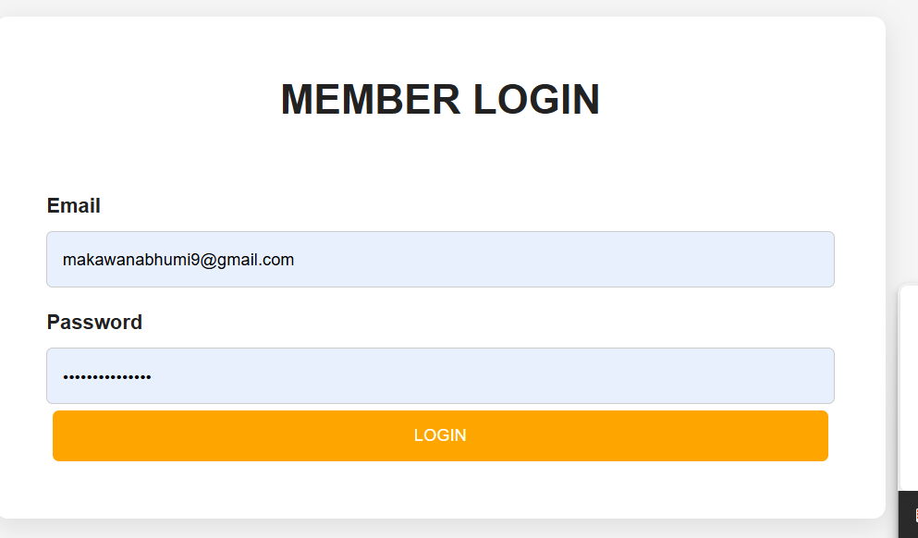
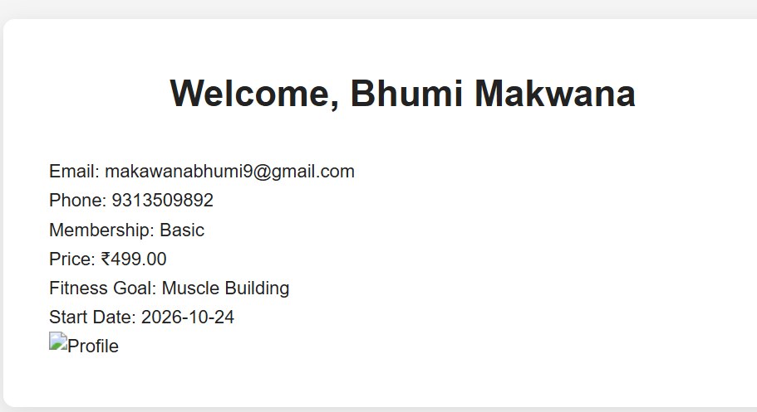

Database
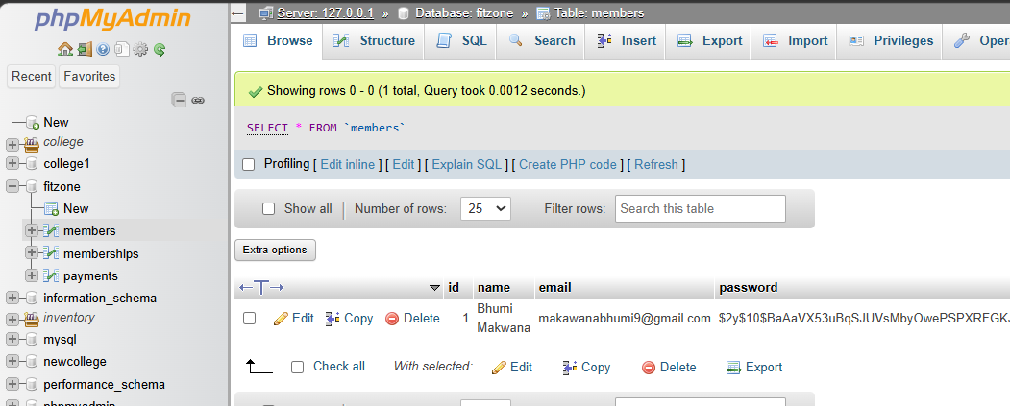

About Module
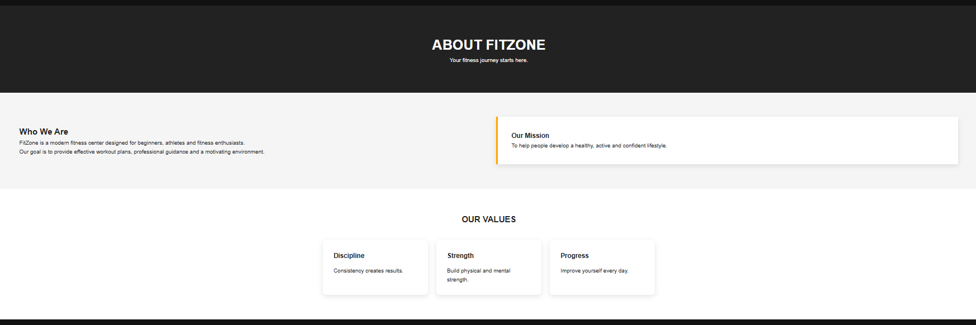
Workouts Module
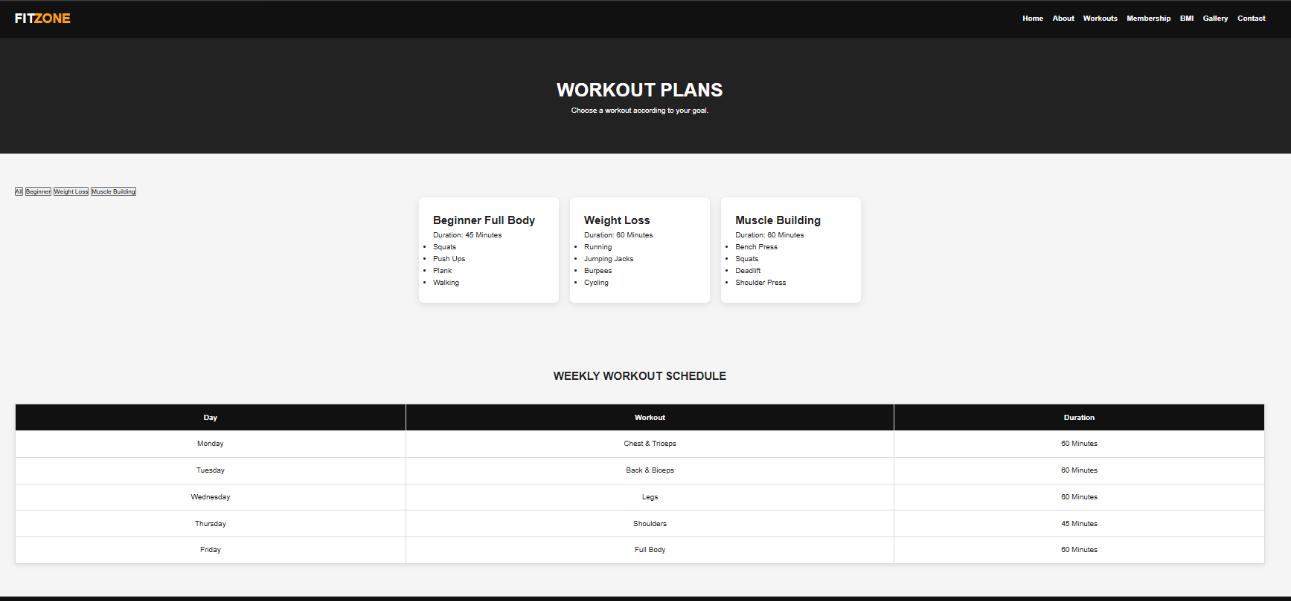
Membership Module
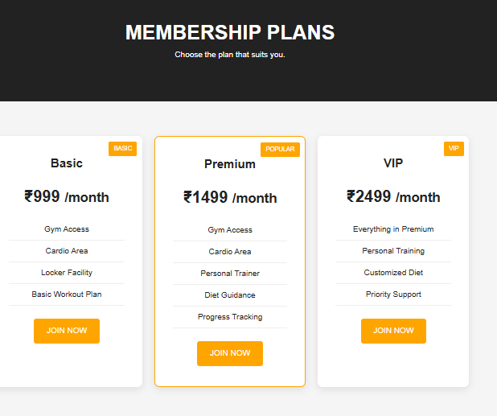
BMI Module
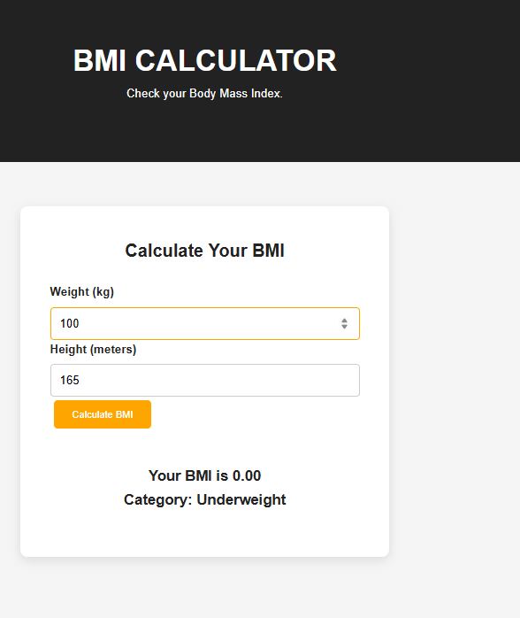

Main Module Logic Code
Database Connection = db.php
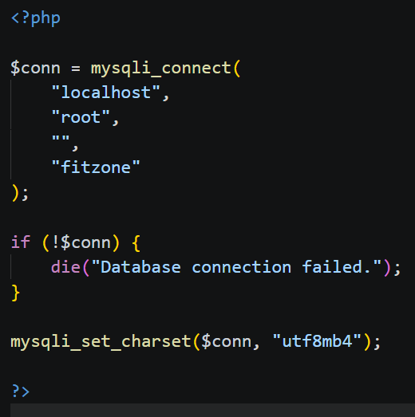
Member Registration — register.php
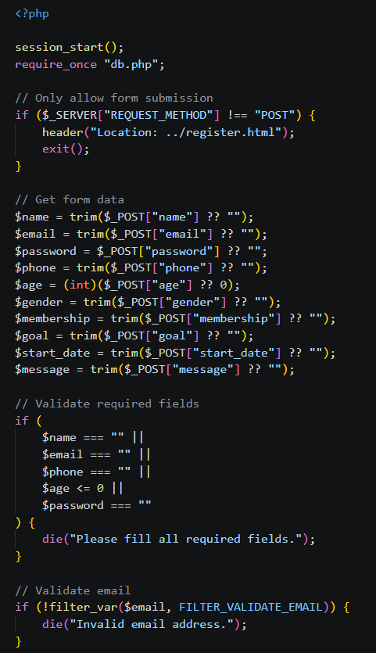
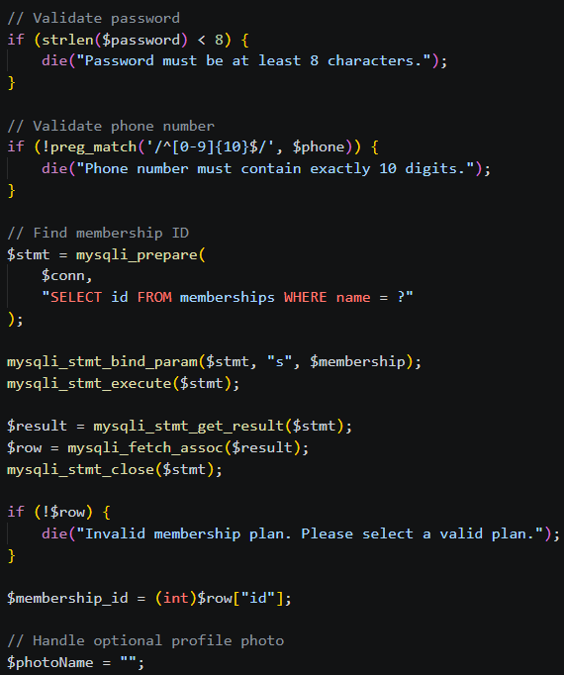
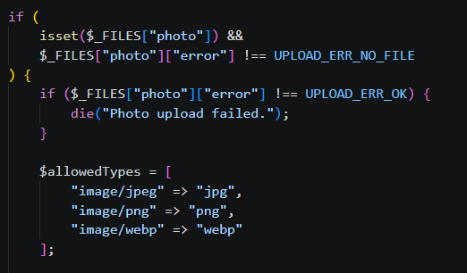

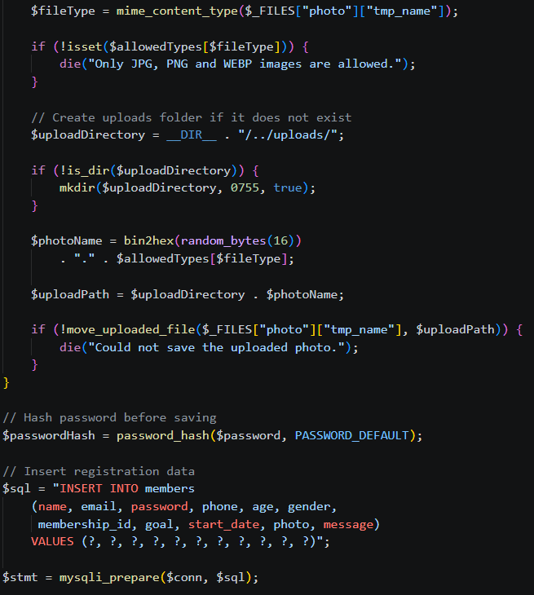
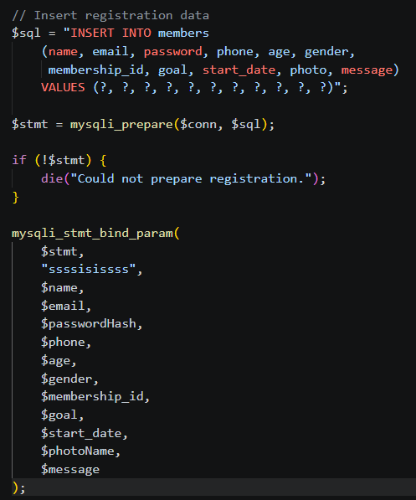
User Login — login.php
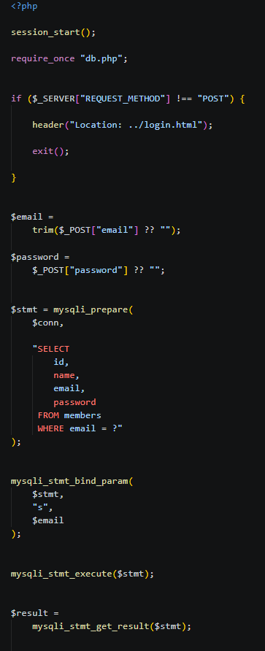
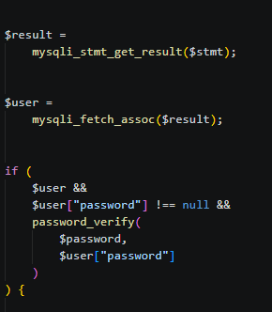
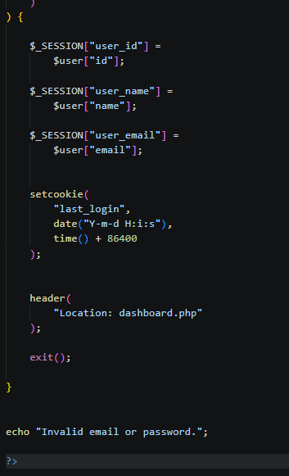
BMI Calculator — bmi.html / js/script.js
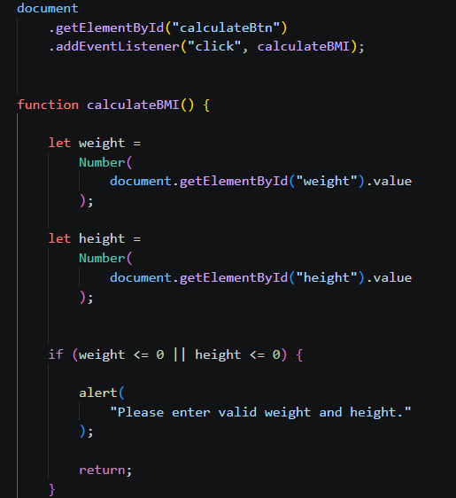
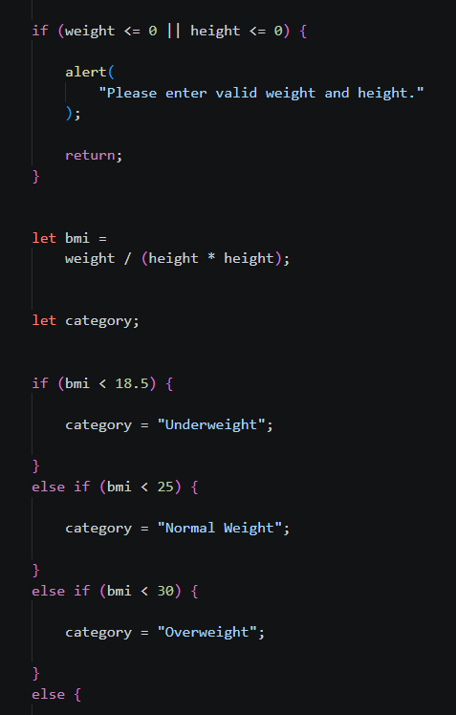
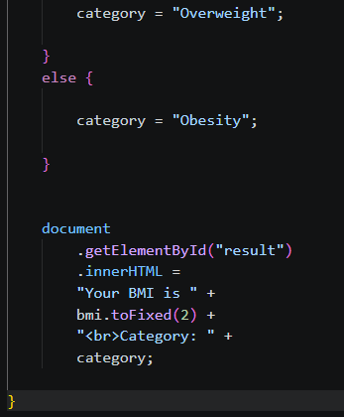
Conclusion
The FitZone Gym Website was developed to provide users with information about gym facilities, workout programs, membership plans, and fitness services. The project uses HTML, CSS, and JavaScript to create an interactive and user-friendly interface, while PHP and MySQL are used for server-side processing and database management.
The website includes different modules such as Home, About, Workouts, Membership, BMI Calculator, Gallery, Contact, Registration, and Login. The registration module allows users to submit their details, which can be stored in the database, while the login module verifies registered users.
Overall, this project provided practical experience in developing a website by combining front-end technologies with back-end programming and database connectivity. It also improved my understanding of website structure, form handling, data validation, and user authentication. The project can be further enhanced by adding more fitness features and deploying it on a live web server.
Learning Outcomes
During the development of the FitZone Gym Website, I gained knowledge and practical experience in the following areas:
- HTML: Learned to create webpages using headings, paragraphs, links, forms, images, videos, and semantic elements.
- CSS: Learned to design webpages, apply colours and layouts, style navigation menus, and improve the overall appearance of the website.
- JavaScript: Gained an understanding of client-side validation, user interaction, and basic website functionality.
- PHP Programming: Learned to process form submissions, validate user inputs, handle registration requests, and implement login functionality.
- MySQL Database: Learned to create and manage database tables and store and retrieve member information.
- Database Connectivity: Understood how to connect PHP with MySQL using MySQLi and execute SQL queries.
- Form Handling and Validation: Learned how to collect user information through HTML forms and validate the submitted data before processing it.
- Password Security: Understood the importance of hashing passwords and verifying them securely during login.
- Website Organisation: Learned to organise project files into separate folders for HTML, CSS, JavaScript, PHP, images, and videos.
- Debugging and Testing: Improved problem-solving skills by identifying errors, correcting code, and testing website functionality.
- Version Control Using GitHub: Gained experience in uploading and managing project source code in a GitHub repository.
- Project Development: Learned how different web technologies work together to develop a functional website.
This project enhanced my web development skills and provided a foundation for building more advanced websites and web applications in the future.

