Practical-5
Aim : 1. Shape areas: an abstract Shape with abstract area(); subclasses Circle, Rectangle, Triangle. Put a mix in a Shape[] and loop once to print each area and the running total, tracking the largest — one loop handling every shape through polymorphism.
Code :
ShapeArea.java
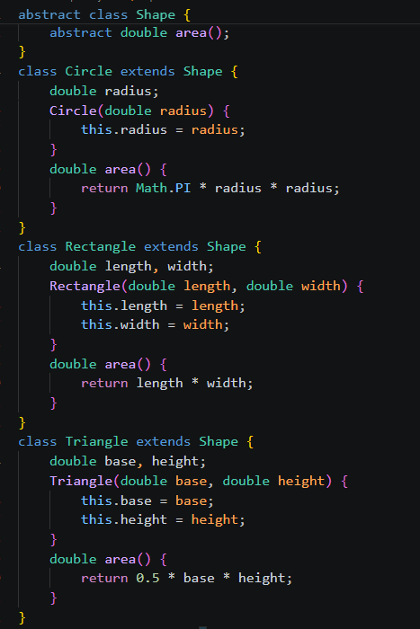

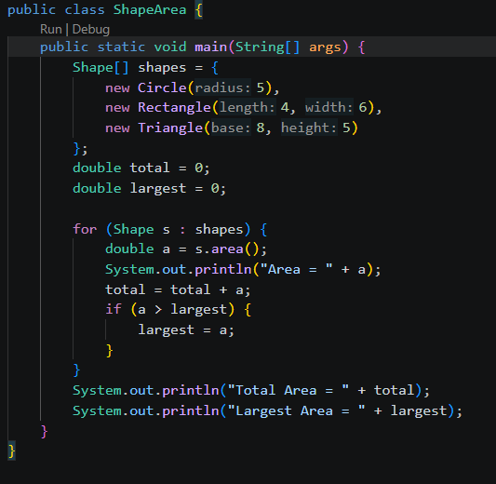
Output:
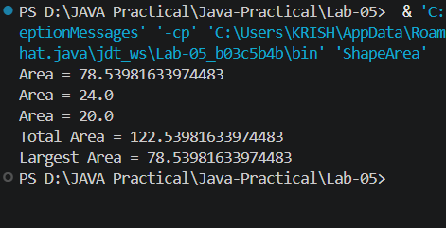
.
Aim : 2. Payroll: an abstract Employee with abstract monthlySalary(); FullTime (fixed), PartTime (hours × rate) and Intern (stipend), each calling super for the shared name/id. Loop a mixed array to print each salary and the total; use instanceof to add a note only for interns.
Code :
Payroll.java
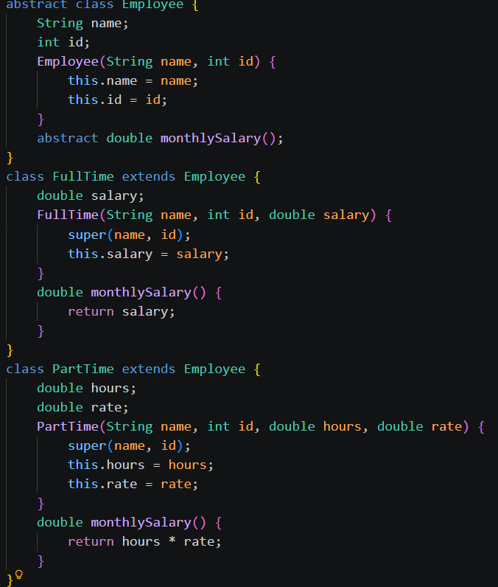

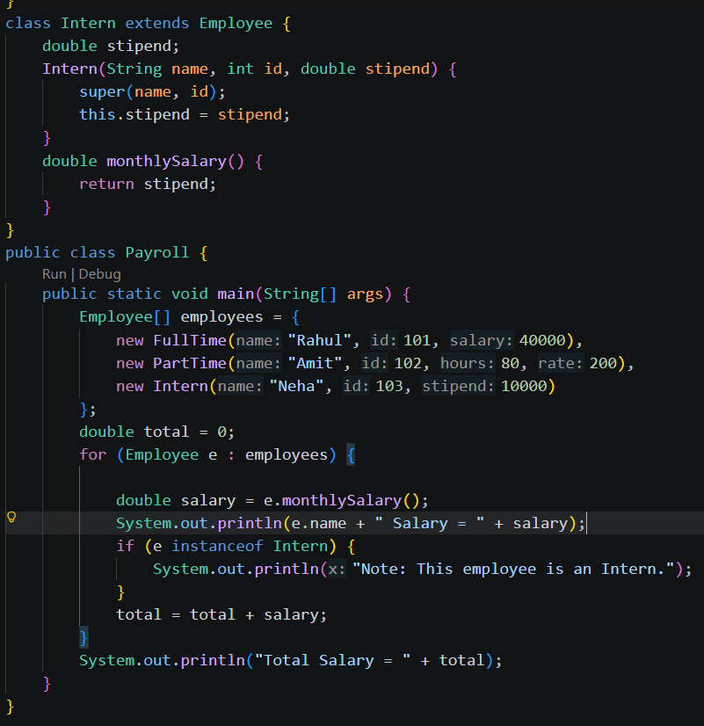
Output:
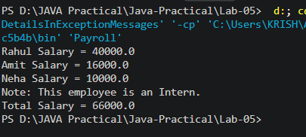

Aim : 3. (For Advanced Learners – home) Model a few media types that each compute a late fee differently and total the fees for a returned batch. Design the hierarchy and rules yourself.
Code :
BookLibrary.java
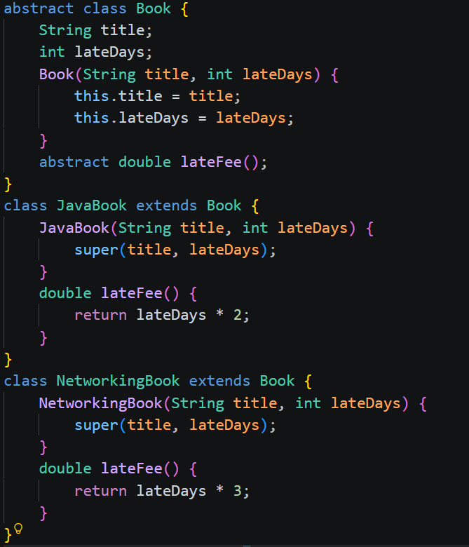
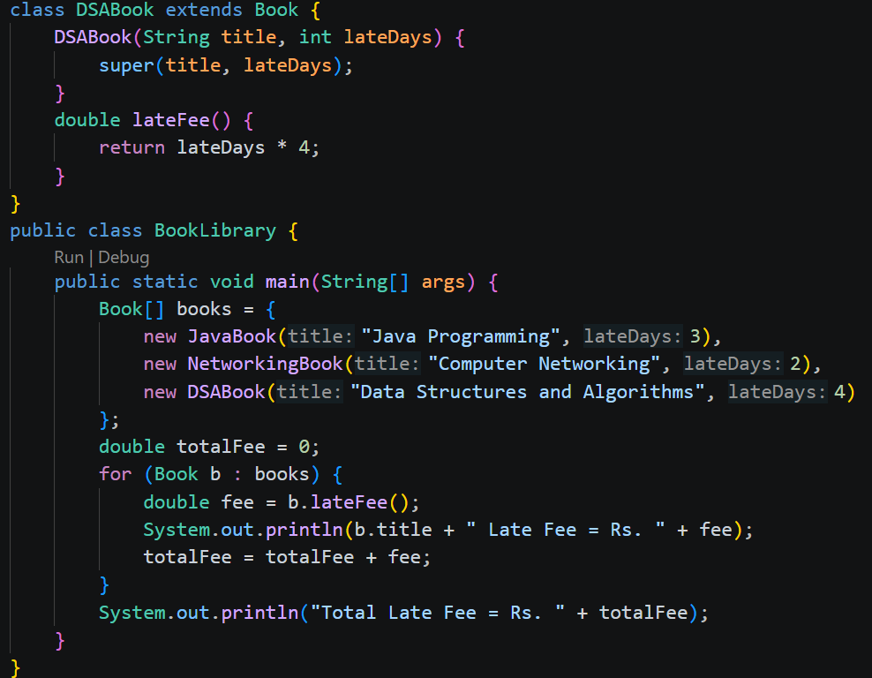Output:
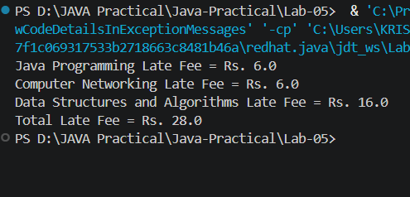
Github link:
https://github.com/Bhumimak2006/Java-Practical/tree/main/Lab-04

