Practical-4
Aim : 1. Password strength (PasswordChecker.java + Driver.java)
(a) In PasswordChecker, check four rules — length ≥ 8, contains an uppercase letter, contains a digit, contains a special character — using regex (e.g. “.*[A-Z].*”) orString methods.(b) Write strength(String pw) that counts how many rules pass and returns “Weak” (0–1), “Medium” (2–3) or “Strong” (4).
(c) In Driver.main: test several passwords; for each, print which rules passed and the final label.
Expected output: “abc” → Weak; “Abcd1234!” → Strong.
Code :
PasswordChecker.java
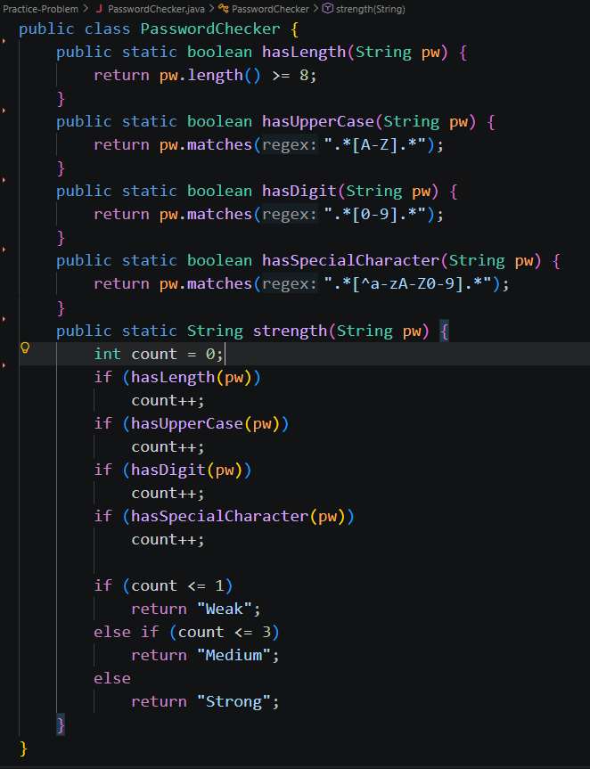

Driver.java
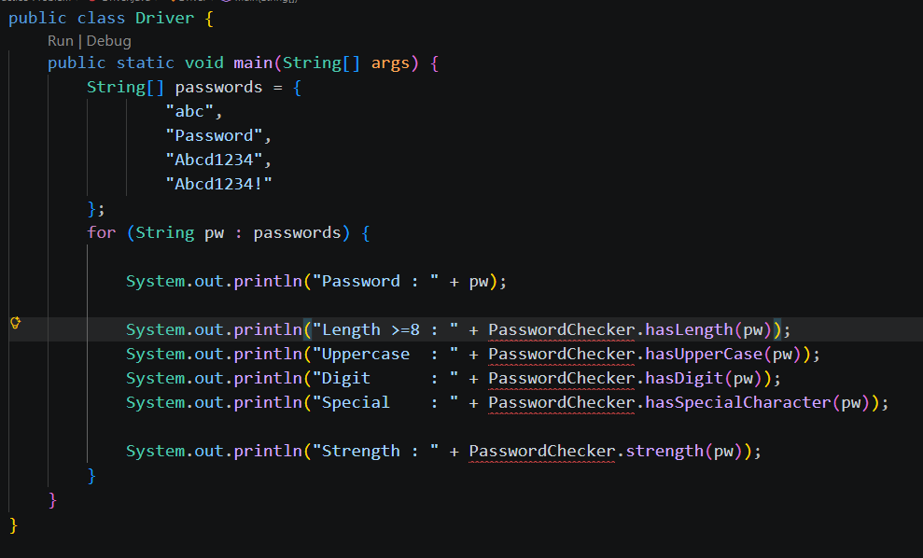
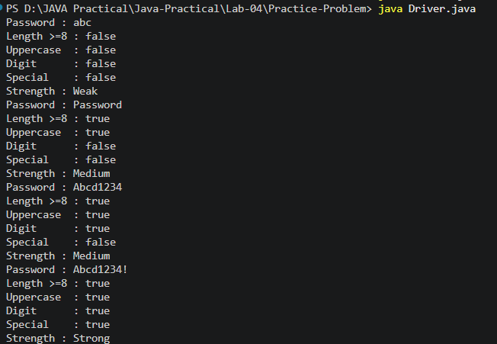
Output:

Learning Outcome:
- Understand how to create and use classes and objects in Java.
- Learn constructor overloading and constructor chaining using this().
- Practice encapsulation using private data members and getter methods.
- Use static variables and methods to maintain shared information.
- Implement boundary checking using if-else conditions.
Aim : 2. Cinema Chat-log filter (ChatFilter.java + Driver.java)
(a) In Driver.main, define a String[] of log lines like “10:05 alice Hello there” (include one malformed line with fewer than 3 parts). (b) Read a keyword from the user. (c) For each line, split into time/user/message with split(“ ”, 3); skip lines that do not have 3 parts.
(d) If the message contains the keyword (case-insensitive), increment a counter and append “time user: message” to a StringBuilder.
(e) Print “Matches: N” and the built report. Expected output: keyword “hello” over 3 lines (1 malformed) → “Matches: 1” and the matching line.
Code :
ChatFilter.java
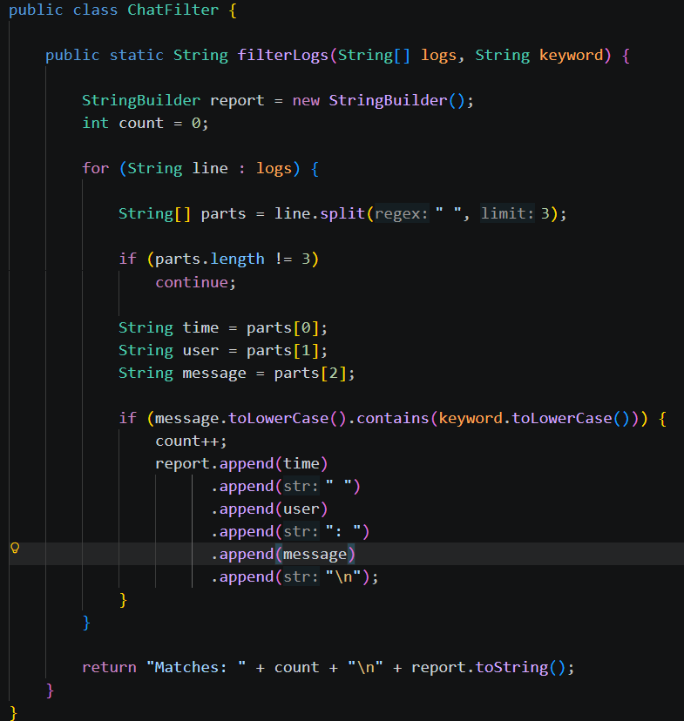

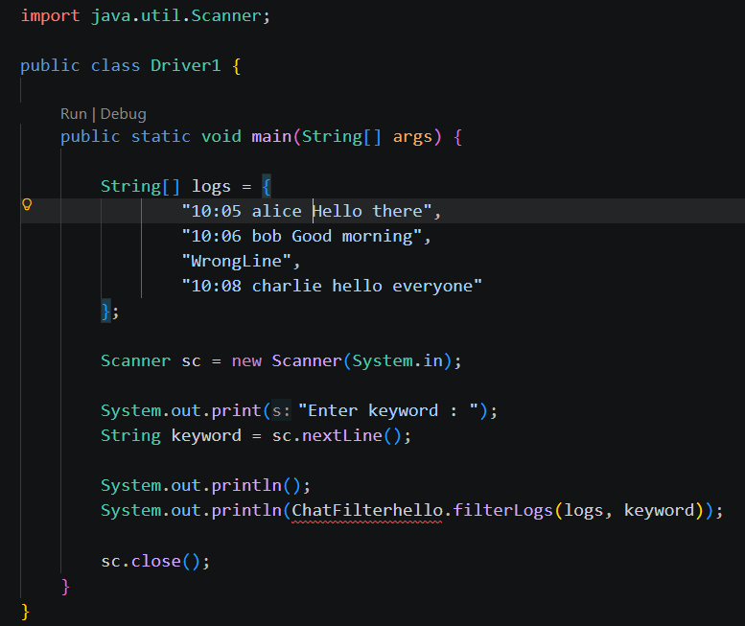
Driver1.java

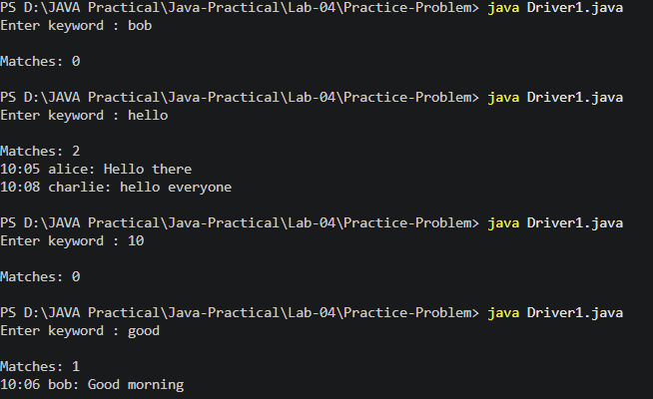
Output:

Learning Outcome:
- Learn to model a real-world cinema booking system using classes.
- Understand the use of final variables for fixed values (capacity).
- Practice constructor overloading and chaining.
- Use boolean methods to indicate success or failure of operations.
- Manage shared data using static variables.
- Apply conditional statements to validate bookings and cancellations.
Aim : 3. (For Advanced Learners – home) Template filler (TemplateFiller.java +
Driver.java) (a) In Driver.main, define a template like “Dear {name}, order {id} ships {date}.” And two parallel arrays: names {“name”, “id”} and values {“Riya”, “A07”} (note {date} is not supplied). (b) Compile a Pattern for \{(\w+)\} and get a Matcher on the template. (c) Walk the matches with a StringBuilder: for each {placeholder}, look up its value inthe names array and replace with the value, or with “[?]” if not found.(d) Print the filled template.
Expected output: the unsupplied {date} becomes [?].
Code :
TemplateFiller.java
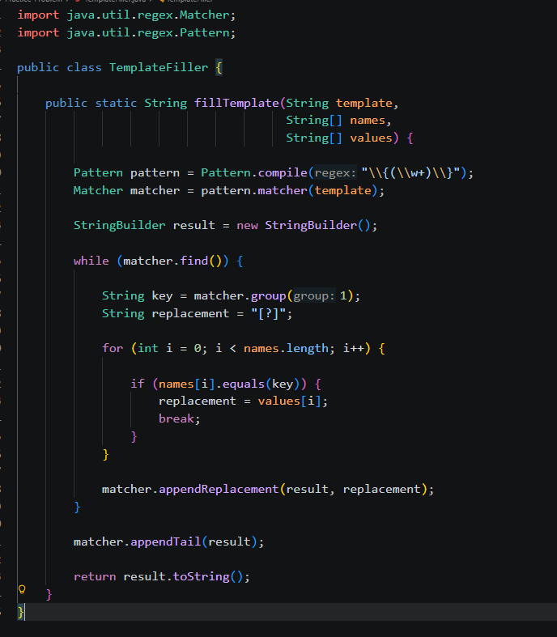
Driver2.java
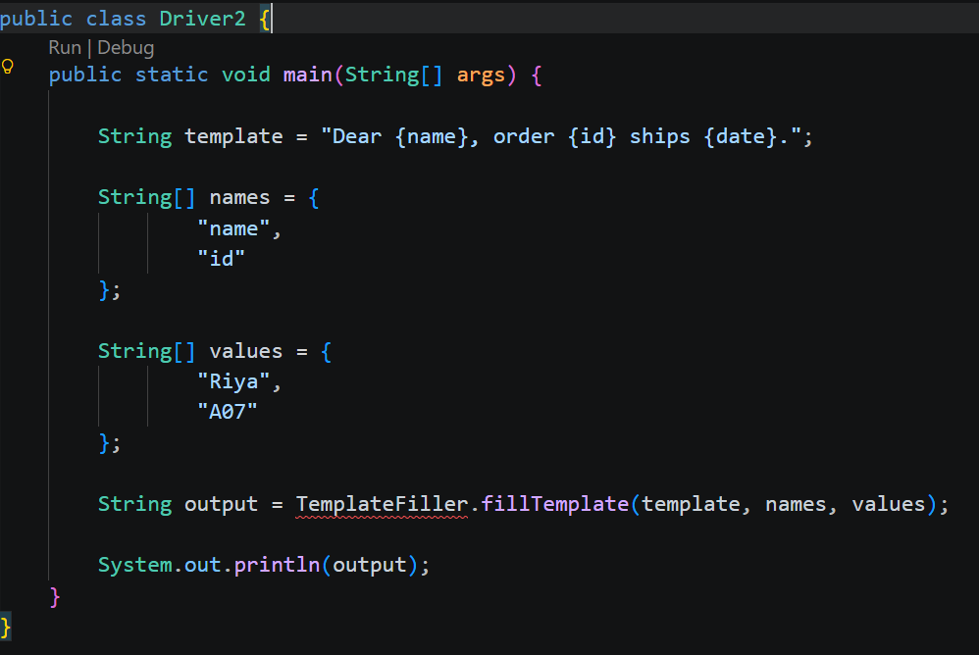
Output:
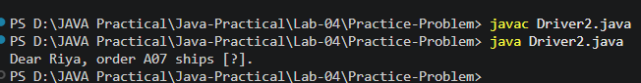

Learning Outcome:
- Develop a parking management system using object-oriented programming.
- Understand the use of instance variables, final, and static members.
- Implement methods to manage parking and vehicle exits.
- Apply conditional logic to prevent parking beyond capacity and negative vehicle counts.
- Calculate and maintain total revenue using static variables.
- Simulate real-world parking operations through method calls.

Github link:

