Practical-7
Aim : 1. Form validator: define @NotBlank and @MaxLength(int) for fields and annotate a SignupForm. Write a checker that uses reflection to read each field’s annotations and returns the list of validation errors for a given object.

FormValidator.java
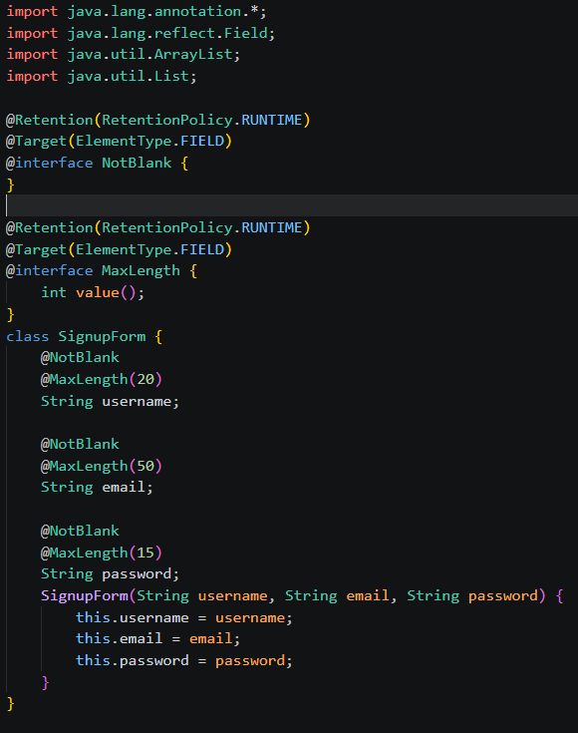

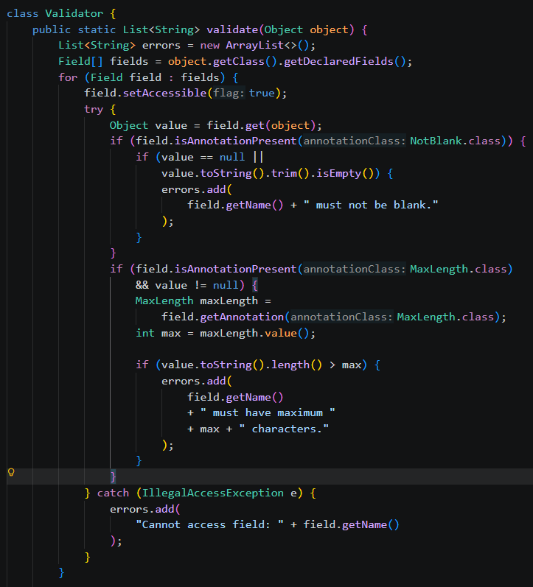


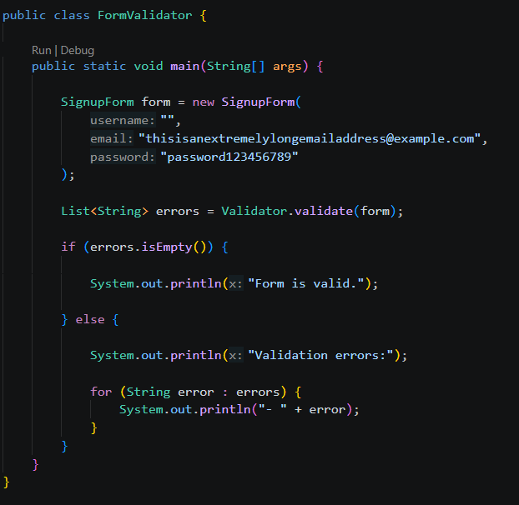
Output:
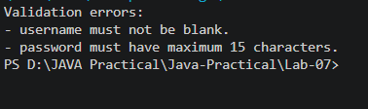

Aim : 2. Mini test runner: define a @Run annotation and mark some no-arg methods of a class with it. Use reflection to find and invoke only the @Run methods and report how many ran — the idea behind how JUnit finds @Test methods.

MiniTestRunner.java
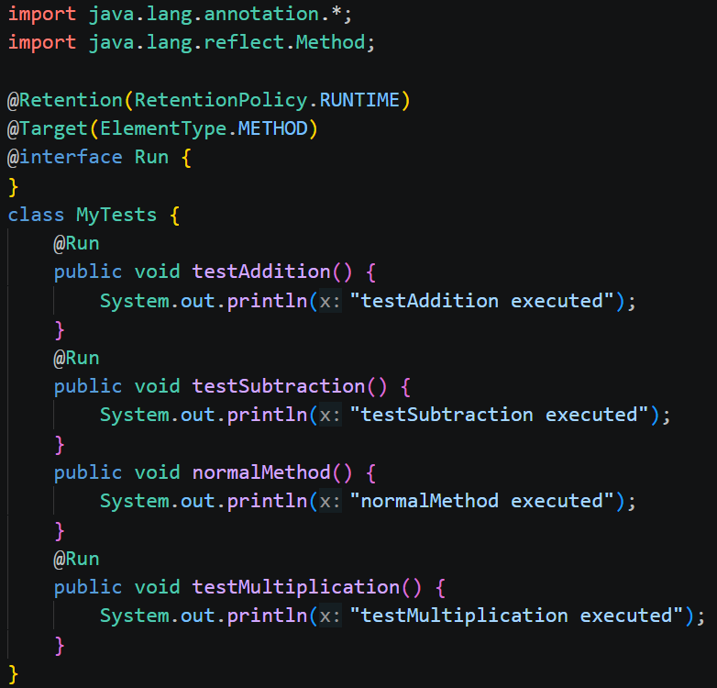

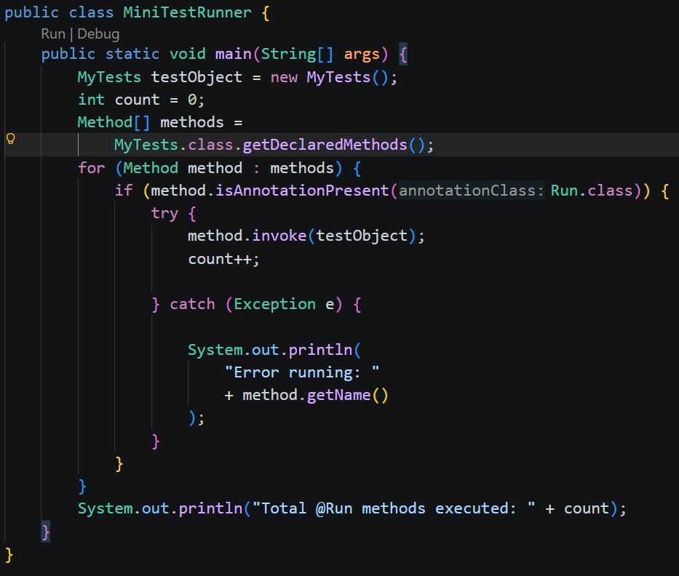

Output:
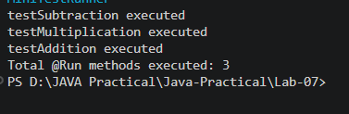

Aim : 3. (For Advanced Learners – home) Define a @Column(name) annotation and, by reflection, populate an object’s fields from a header row and a data row by matching column names; decide how to handle a missing column.

ColumnMapper.java
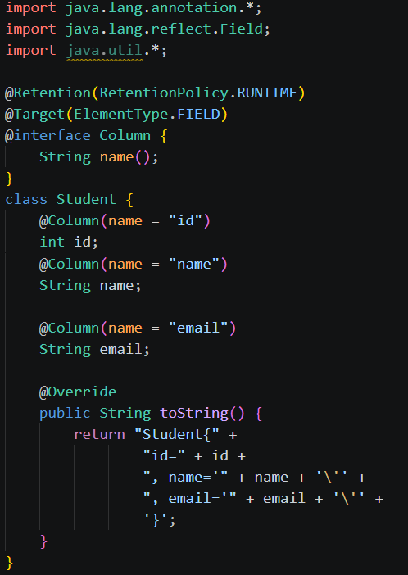
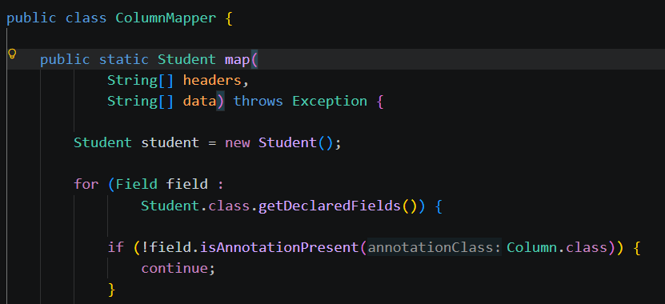
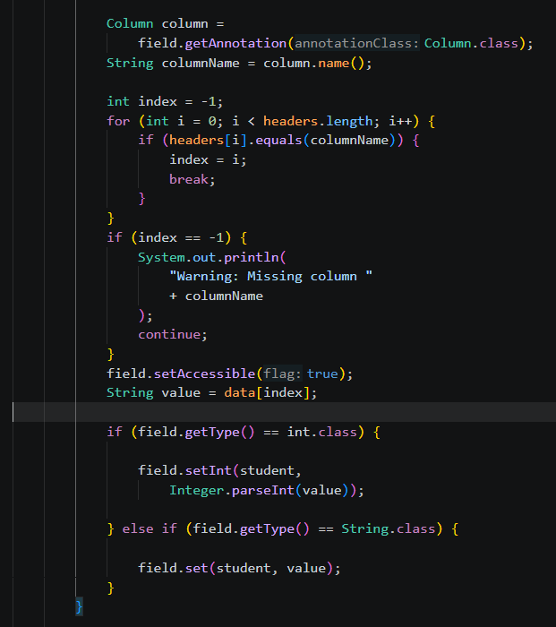
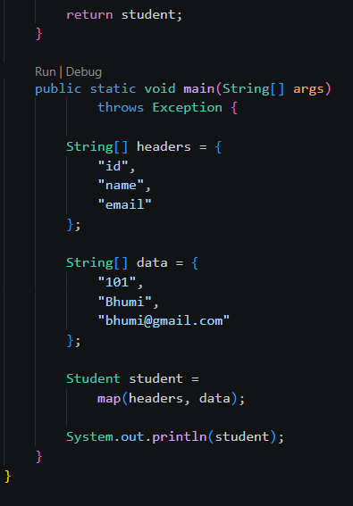
Output:
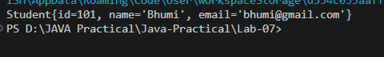

Learning outcome:
- Understand and create custom Java annotations using @Retention and @Target.
- Use Java Reflection API to inspect fields, methods, and annotations at runtime.
- Validate object fields dynamically using annotations such as @NotBlank and @MaxLength.
- Discover and invoke annotated methods using reflection, similar to how testing frameworks find test methods.
- Map data to object fields dynamically using annotations and reflection.

