Practical-1
Aim : 1. Vending machine (VendingMachine.java, main in this file)
(a) Define an enum Coin with constants ONE, TWO, FIVE, TEN.
(b) In main, set a snack price of 15 and a running total of 0; create a Scanner.
(c) Loop: read a coin name, use a switch expression to convert the Coin to its value (ONE→1, TWO→2, FIVE→5, TEN→10), add it to the total, and print the total so far.
(d) Stop the loop once the total reaches 15 or more.
(e) Print the change to return (total − 15). Expected output: TEN then FIVE prints “Paid. Change: 0”; TEN then TEN prints “Paid. Change: 5”
Code :
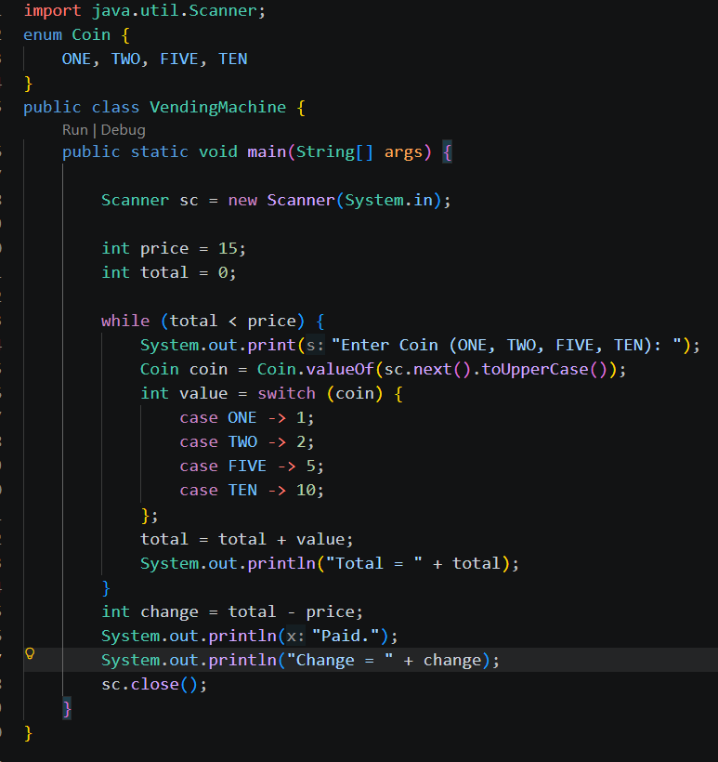

Output:
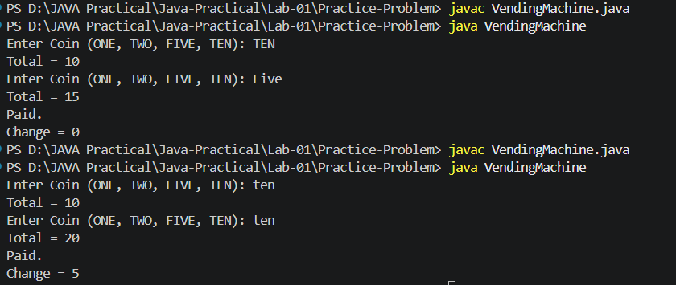

Learning Outcome:
- Understand to how to create enum and how use
- Learn how to take input from user using Scanner class
- Use a while loop to repeat task and also understand how to use switch to convert enum value into number

Aim : 2. Toll booth (TollBooth.java, main in this file)
(a) Define a record Vehicle(String number, String type).
(b) In main, keep a running toll total and three counters (bike, car, truck).
(c) Loop until the user types “done” for the number: build a Vehicle, use a switch expression on its type for the toll (bike→20, car→50, truck→150), add to the total, and increment that type’s counter.
(d) After the loop, print the total toll and the type with the highest count. Expected output: two cars + one bike → “Total toll: 120”, “Most frequent: car”
Code :
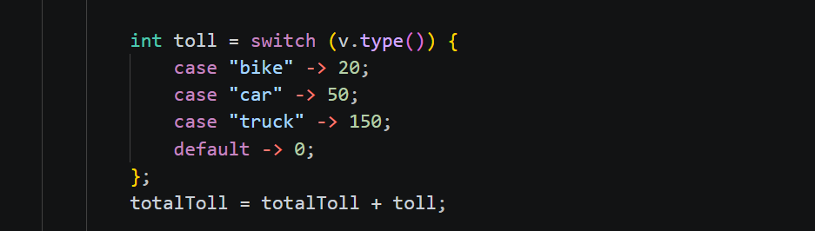
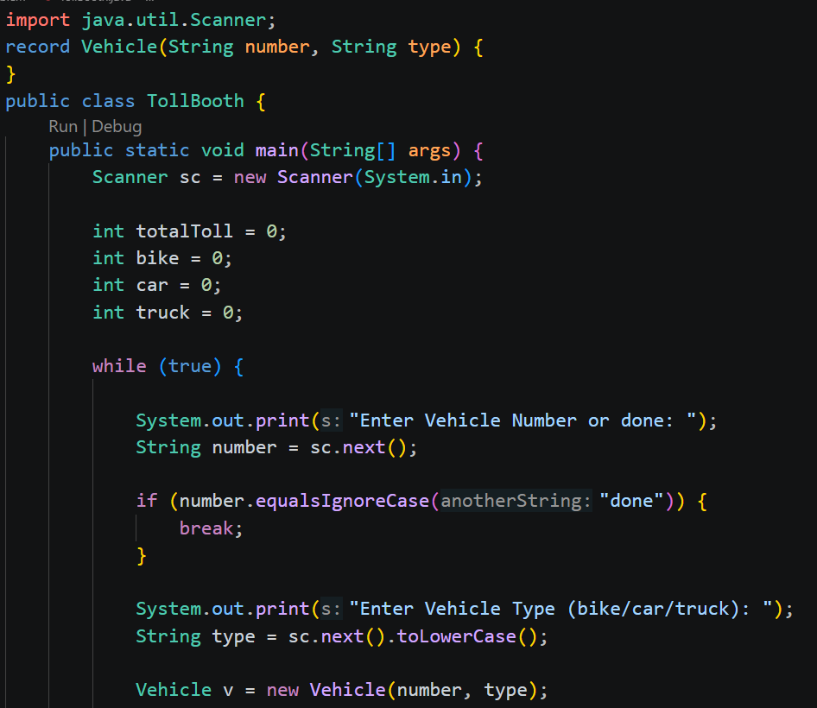

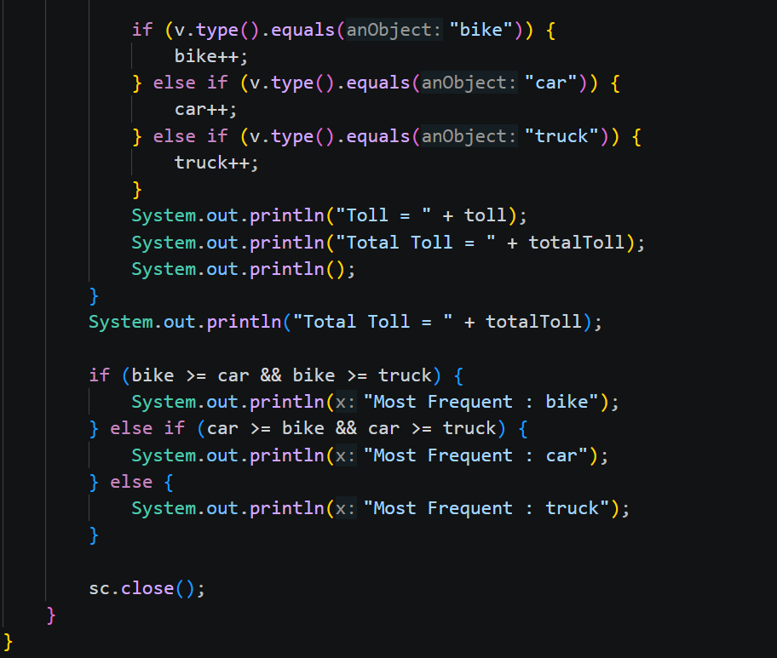Output:
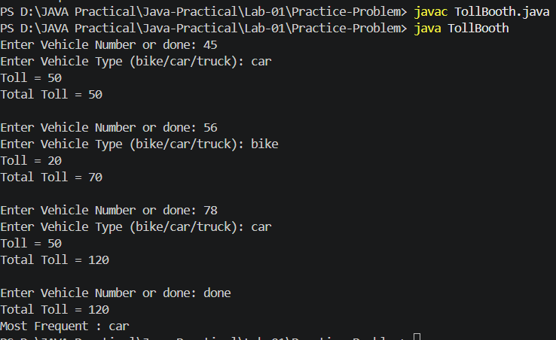
Learning Outcome:
- Understand how to use enum in java and how to compare different value in switch expression
- Using Random class generate random value
- To program logic use winner() method also used loop and if-else statement

Aim : 3. (For Advanced Learners – home) Rock-Paper-Scissors-Lizard-Spock (RPSLS.java)
(a) Define an enum Move with ROCK, PAPER, SCISSORS, LIZARD, SPOCK. (b) Write winner(Move a, Move b) returning 1 if a beats b, -1 if b beats a, 0 for a tie — use a switch expression listing what each move beats (Scissors cut Paper, Paper covers Rock, Rock crushes Lizard, Lizard poisons Spock, Spock smashes Scissors, and the five mirror cases).
(c) In main, play 5 rounds: pick a random computer Move, read the player’s Move, call winner(), print the round result and keep score.
(d) After 5 rounds, print the overall winner. Expected output: each round prints both moves and the round winner; ends with a “You win 3–2” summary.
Code :
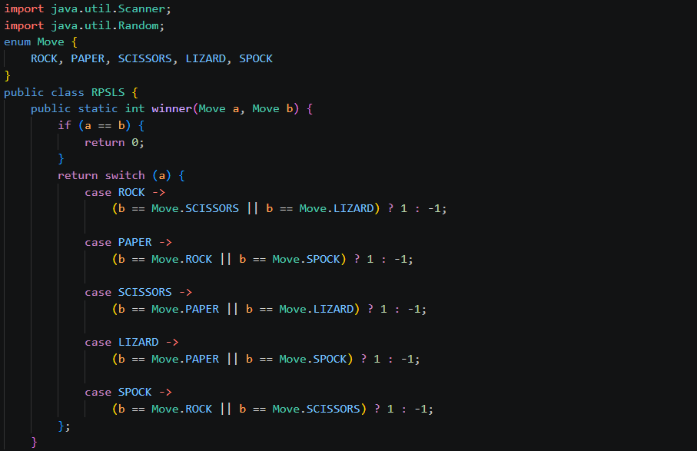
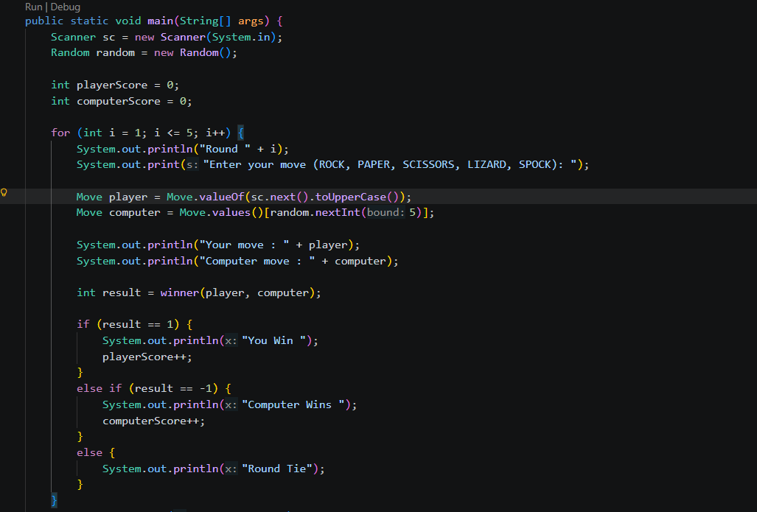
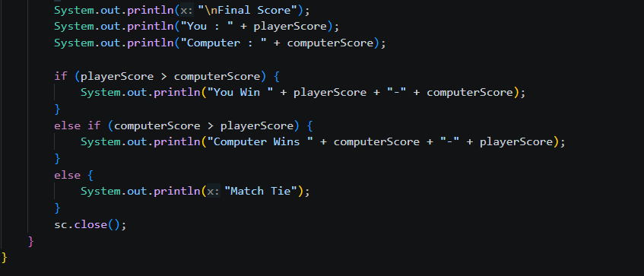
Output:
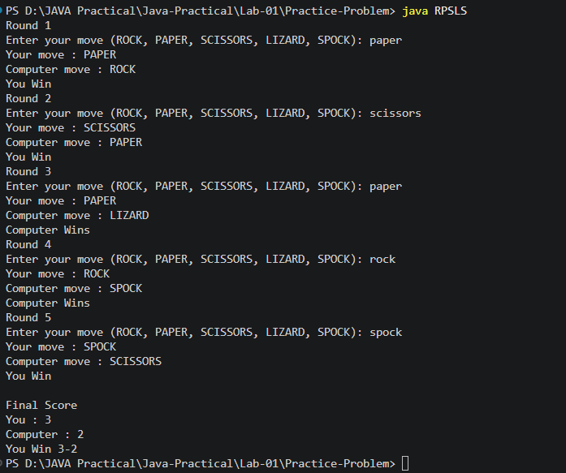

Learning Outcome:
- Understand how to create and store vehicle information in record
- Calculate toll based vehicle type using switch expression
- Use scanner to read user input , loops for process multiple vehicles
- To count vehicle types and most frequent one use if-else statement , calculate and display total toll collected

Github link:
https://github.com/Bhumimak2006/Java-Practical/tree/main/Lab-01

