Practical-3
Aim : (For Advanced Learners – home) Rock-Paper-Scissors-Lizard-Spock (RPSLS.java)
(a) Define an enum Move with ROCK, PAPER, SCISSORS, LIZARD, SPOCK. (b) Write winner(Move a, Move b) returning 1 if a beats b, -1 if b beats a, 0 for a tie — use a switch expression listing what each move beats (Scissors cut Paper, Paper covers Rock, Rock crushes Lizard, Lizard poisons Spock, Spock smashes Scissors, and the five mirror cases).
(c) In main, play 5 rounds: pick a random computer Move, read the player’s Move, call winner(), print the round result and keep score.
(d) After 5 rounds, print the overall winner.
Expected output: each round prints both moves and the round winner; ends with a “You win 3–2” summary.

Code Screenshot:
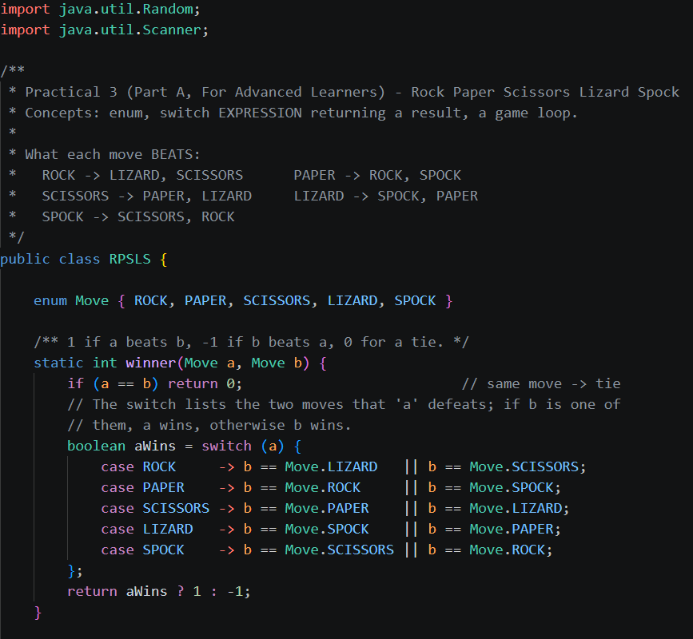
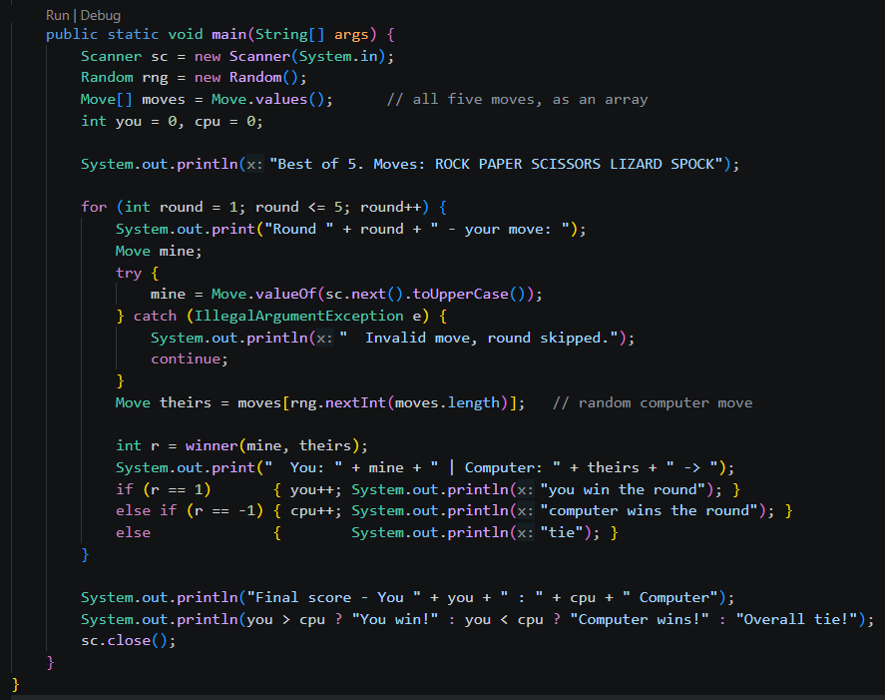

Output Screenshot:
