Practical-6
Aim : 1. Remote control: an interface Switchable with on()/off() and a default toggle(); Fan and Light implement it. Loop over a Switchable[] toggling each. Then add a functional interface that decides, given a device and an hour, whether it may switch on, and supply it once as an anonymous class and once as a lambda.
Code :
RemoteControlDemo.java
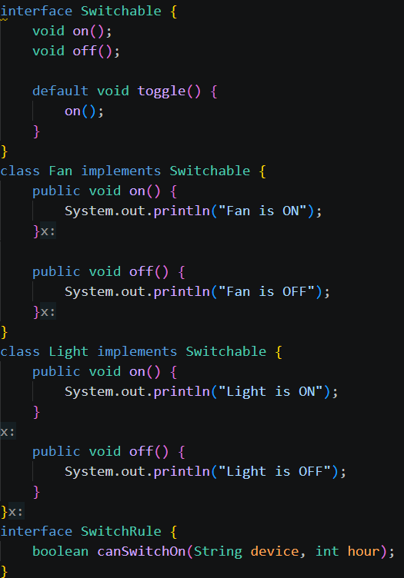

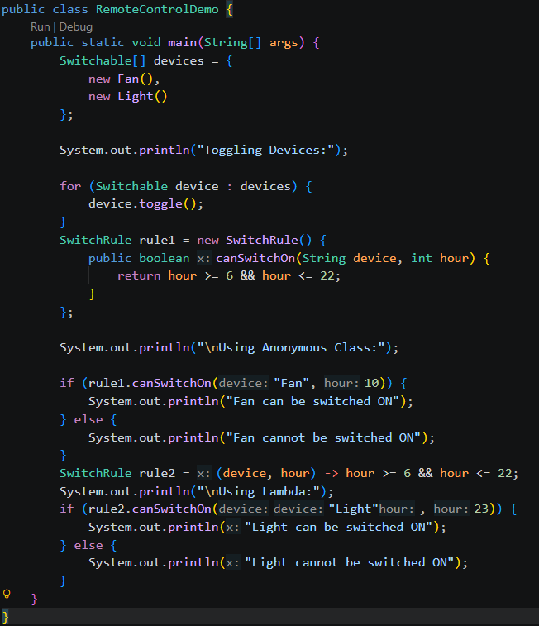

Output:
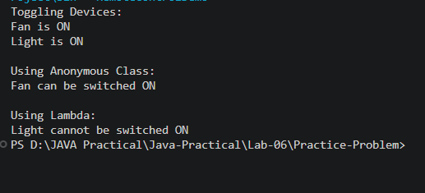

Aim : 2. Notification senders: a functional interface Notifier with send(String); make email and SMS senders as lambdas, hold them in an array, and broadcast one message through all. Add a marker interface Urgent and send twice for senders marked urgent.
NotificationDemo.java
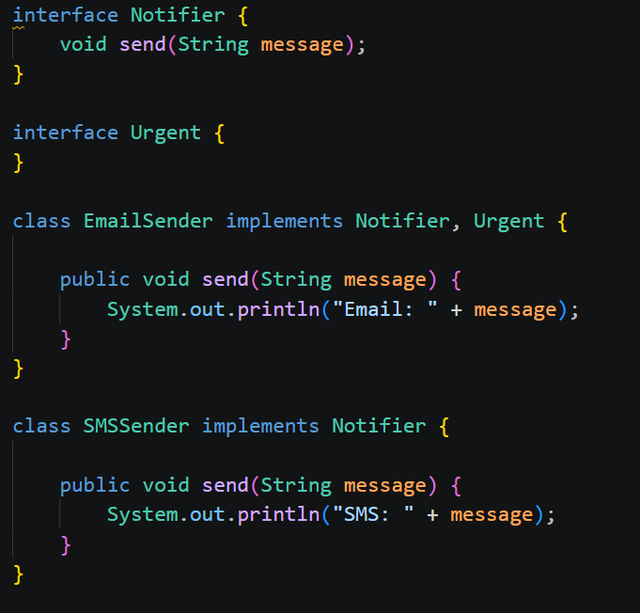

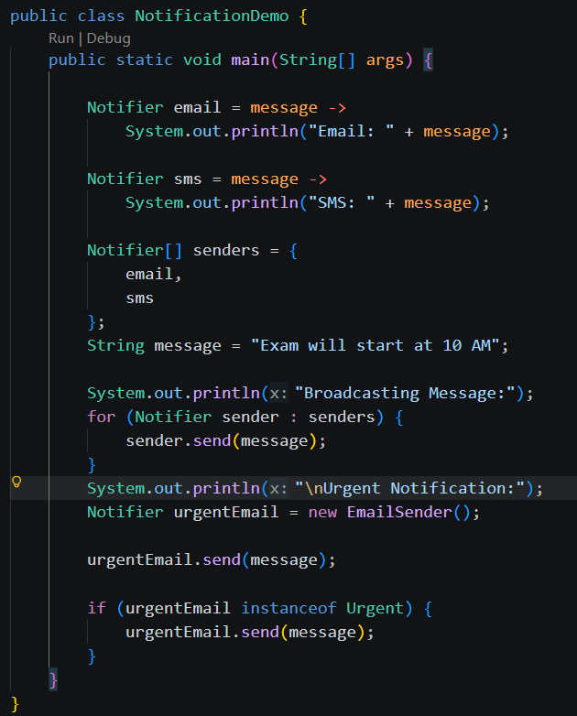
Output :
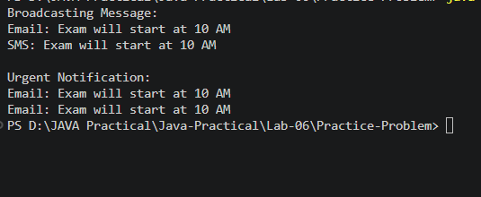

Aim : 3. (For Advanced Learners – home) Build a small discount engine where each rule is a lambda the user picks at runtime and applies to a list of prices; organise it into packages and ship it as a runnable JAR.
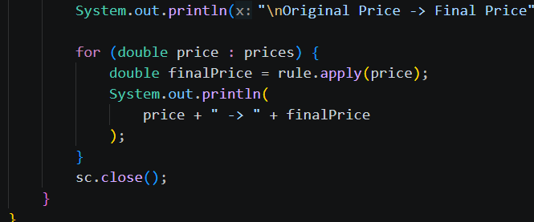
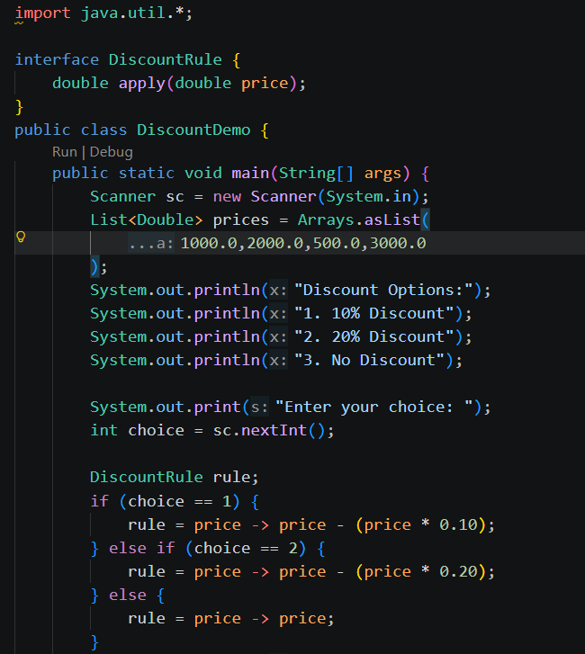
DiscountDemo.java

Output:
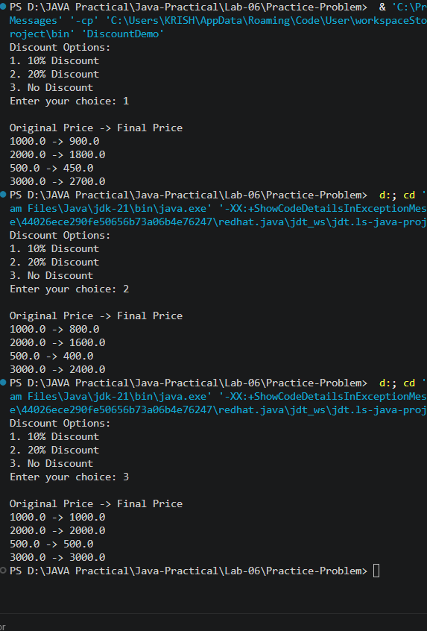

Github link:

