Practical-9
Aim : 1. Counter race: several threads each increment a shared counter many times. Run it without synchronization to watch the total come out too low, then make the increment synchronized and confirm it is exactly right every run.
CounterRace.java
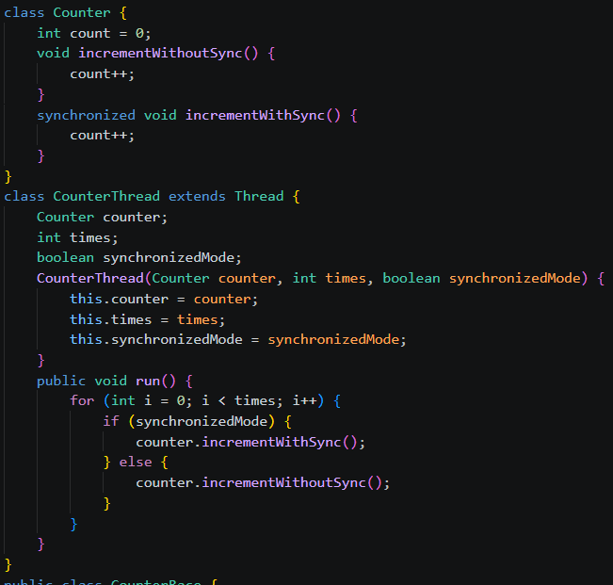
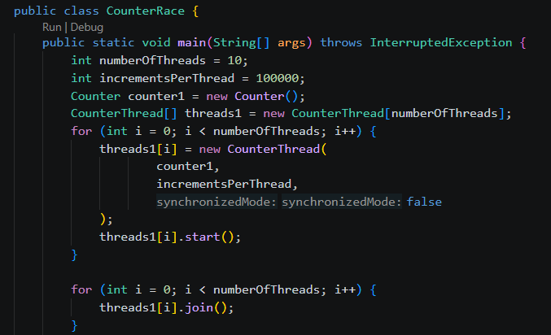

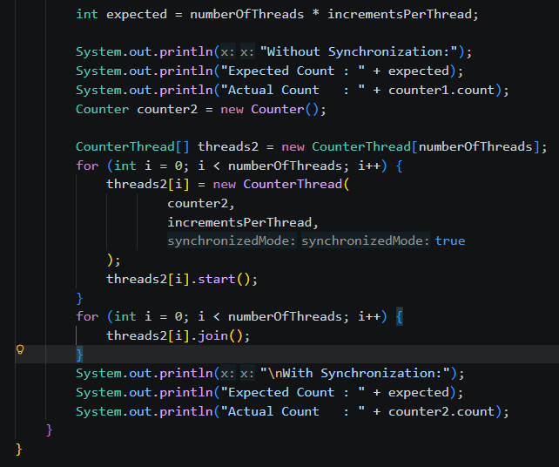

Output:

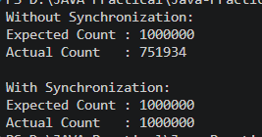

SeatBookingRace.java
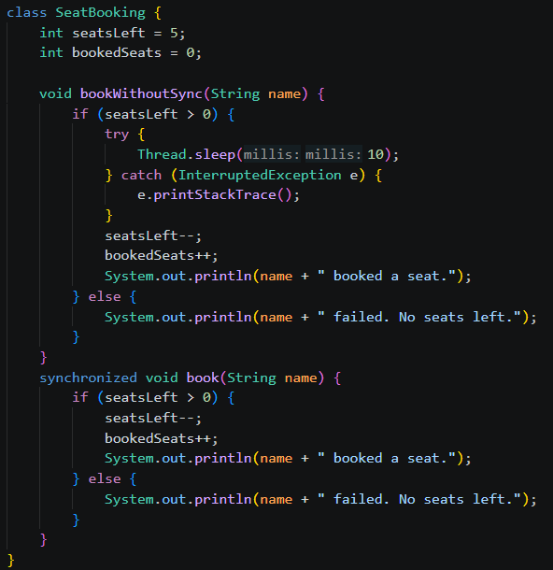
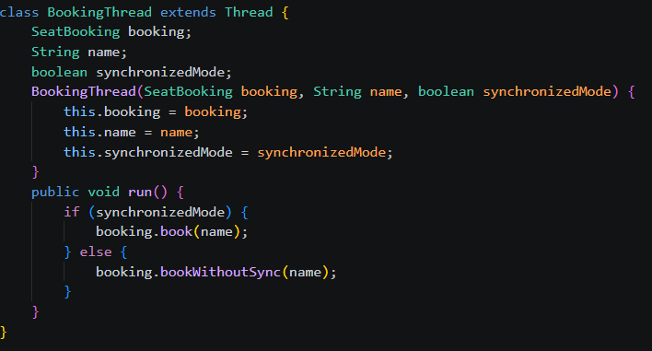

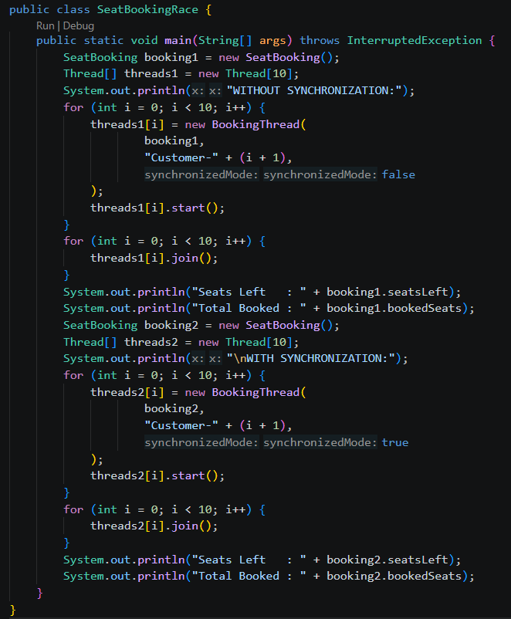
Output:
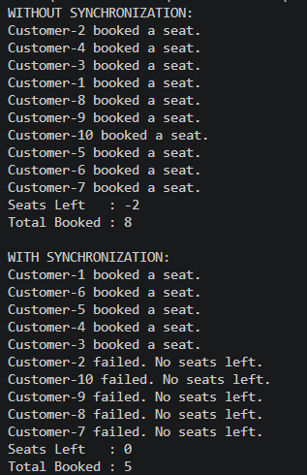
ParallelArraySum.java
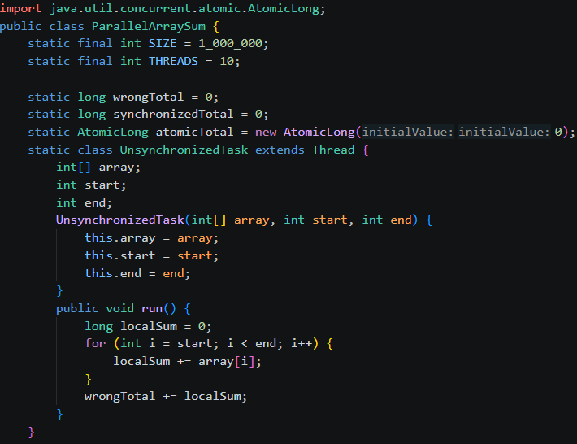
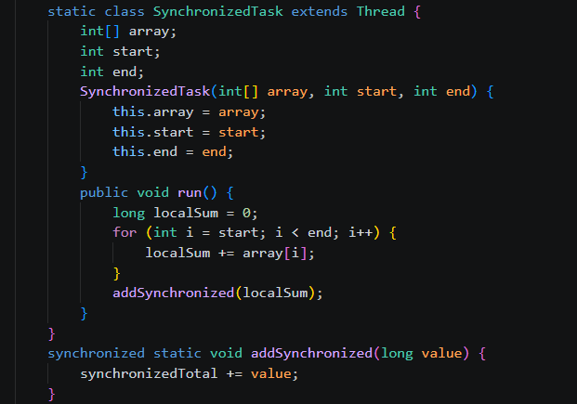
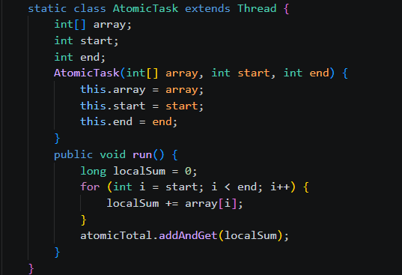
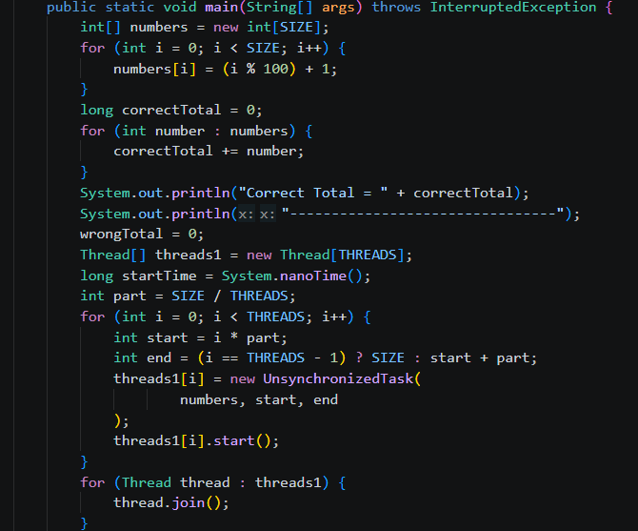
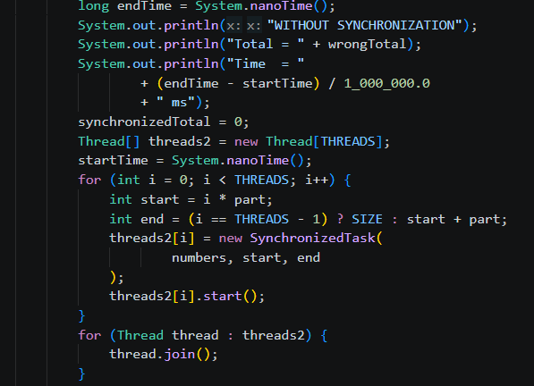
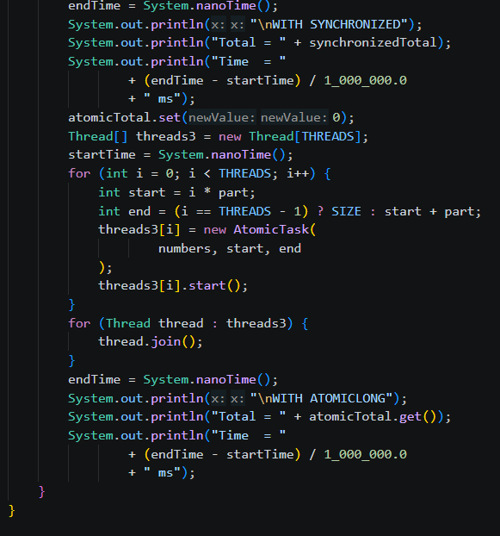
Output:
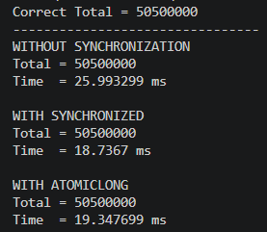
Learning Outcome:
- Understand multithreading by dividing a large array among multiple threads.
- Identify race conditions when multiple threads update a shared variable.
- Understand why unsynchronized shared data can produce incorrect results.
- Use the synchronized keyword to safely update shared data.
- Use AtomicLong for thread-safe atomic operations.
- Compare different synchronization techniques based on correctness and execution time.
- Use System.nanoTime() to measure and compare thread execution performance.
- Understand the importance of thread safety when working with shared resources.

