Practical-10
Aim : 1. Thread-pool runner: with a fixed pool of 3 (ExecutorService), submit about 10 Runnable tasks that print their id and sleep briefly; shut down and await completion, observing the few threads being reused.
ThreadPoolDemo.java
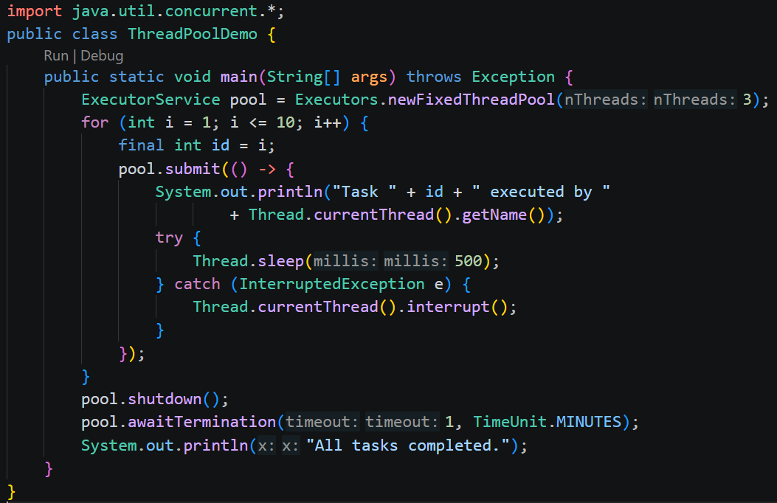
Output:

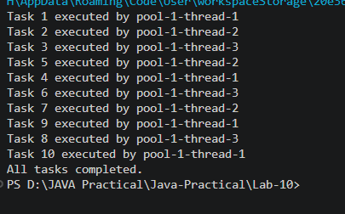

ProducerConsumer.java
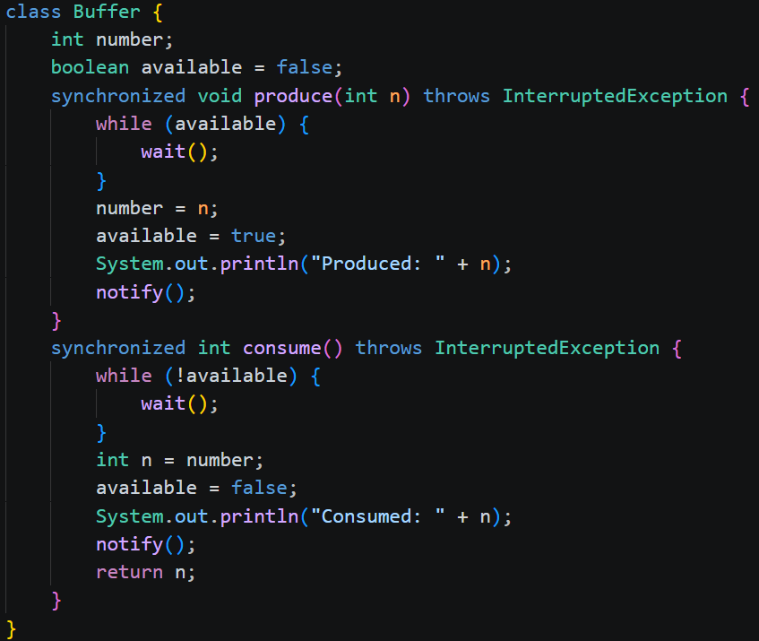
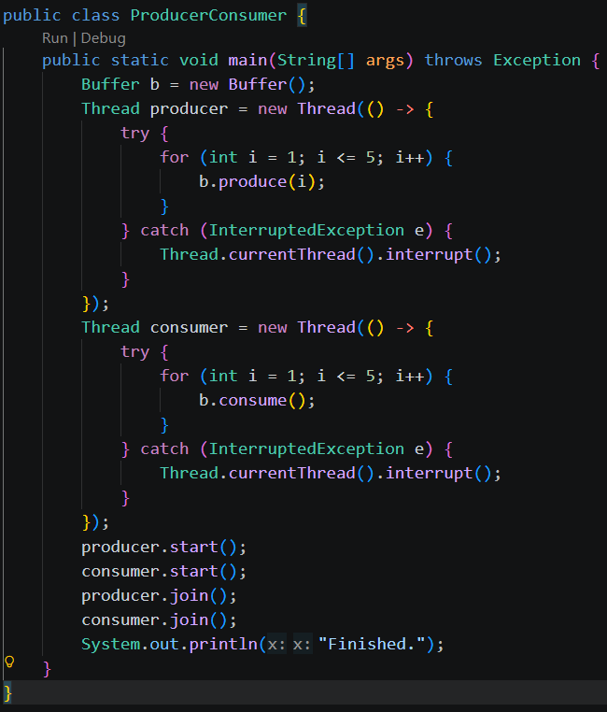

Output:
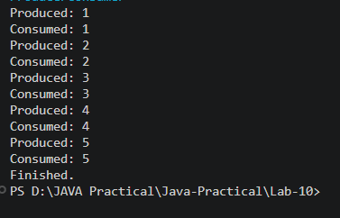
DeadlockDemo.java
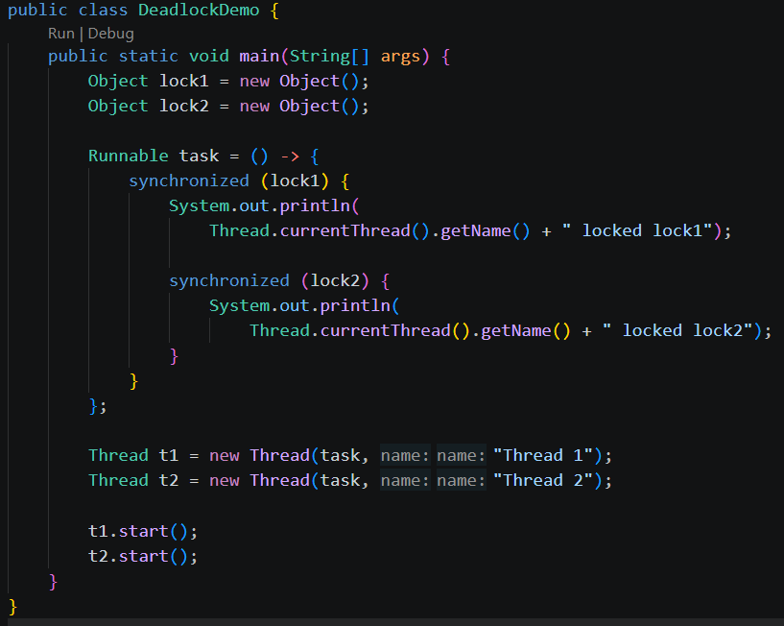
Output:
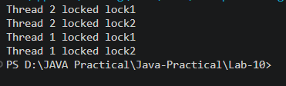
Learning Outcome:
- Understand thread pool execution using ExecutorService and learn how worker threads are reused to execute multiple tasks.
- Implement inter-thread communication using wait() and notify() to coordinate producer and consumer threads.
- Understand the causes of deadlock in multithreading and learn how to prevent it by acquiring locks in a consistent order.

Github link
https://github.com/Bhumimak2006/Java-Practical/tree/main/Lab-09

