Practical-11
Aim : 1. Save/load: make a small class Serializable, save an array of its objects to a file with ObjectOutputStream, then read it back into fresh objects and confirm the values survived. Mark one field transient and show it is not saved.
SerializationDemo.java
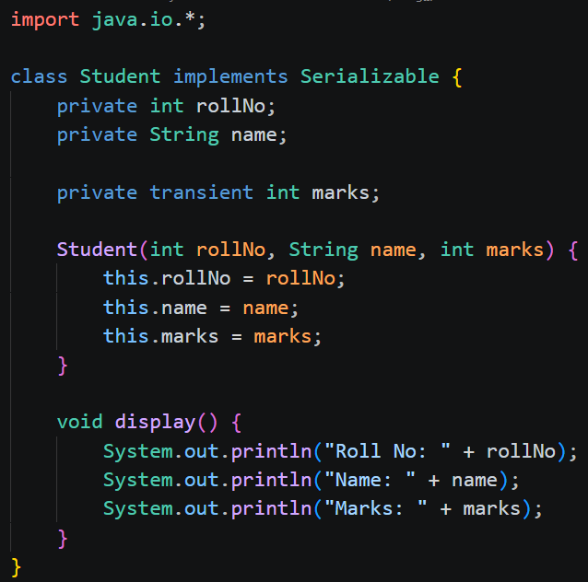
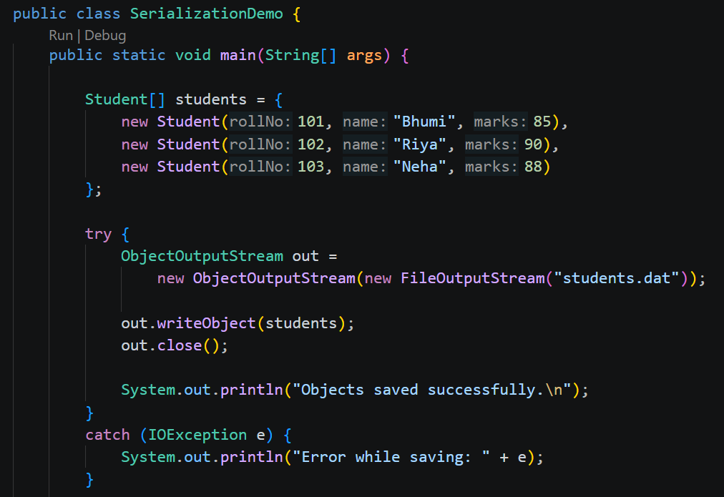
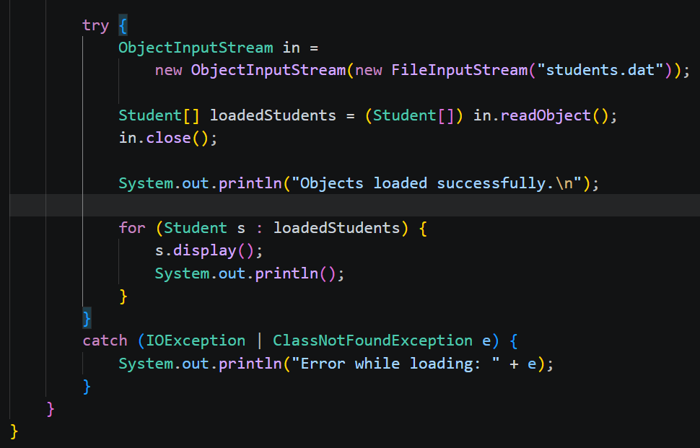
Output:
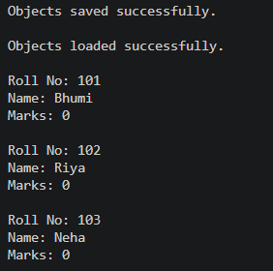

2. Log analyzer: create a few text files, then use Path/Files to read each line by line and count the total lines and how many contain a keyword across all files; also print each file’s size from its attributes.
LogAnalyzer.java
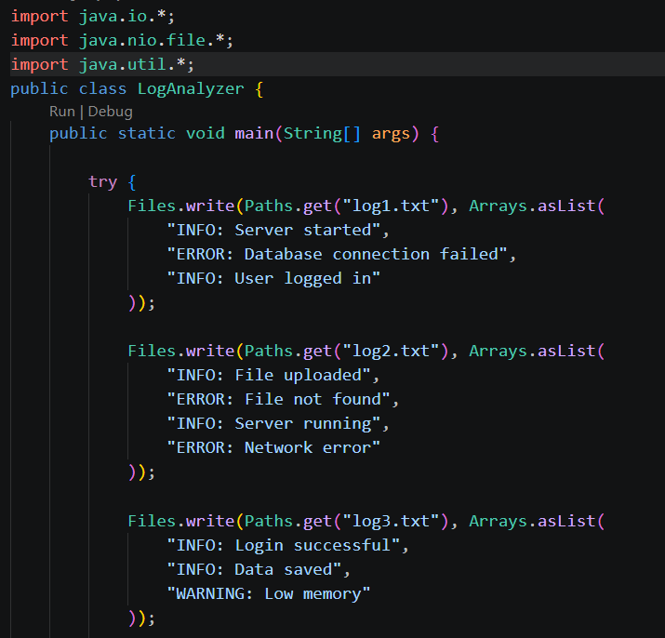
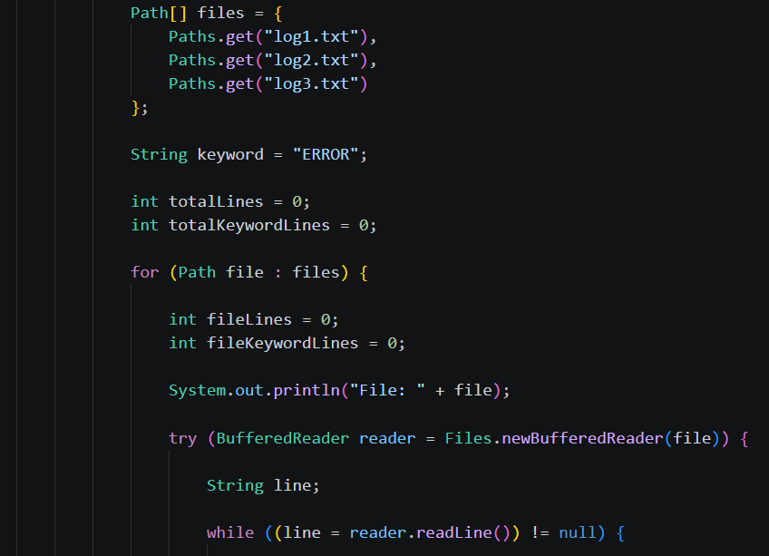
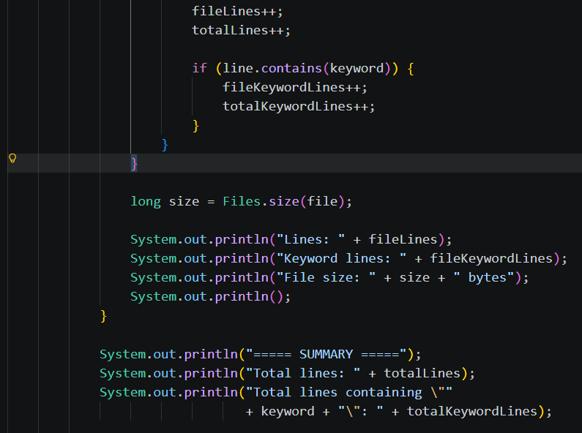
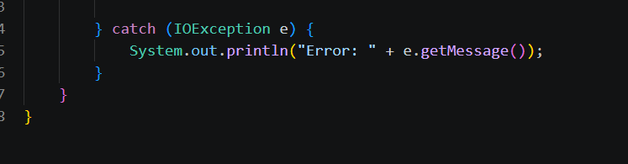
Output:
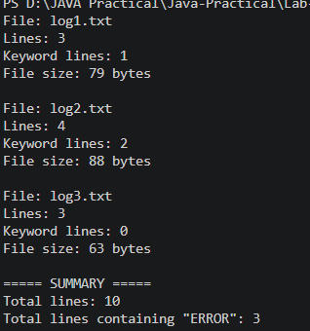

3. (For Advanced Learners – home) Walk a folder tree with NIO and produce a report of the files it contains (name, size, modified time), writing the summary to a file; decide what to include.
FolderReport.java
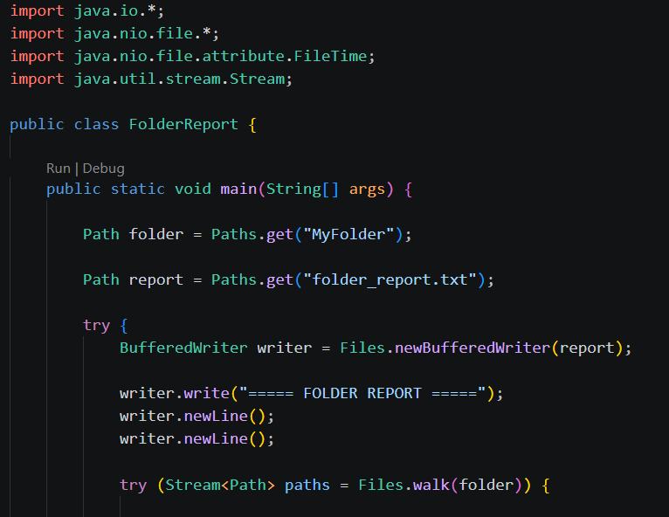
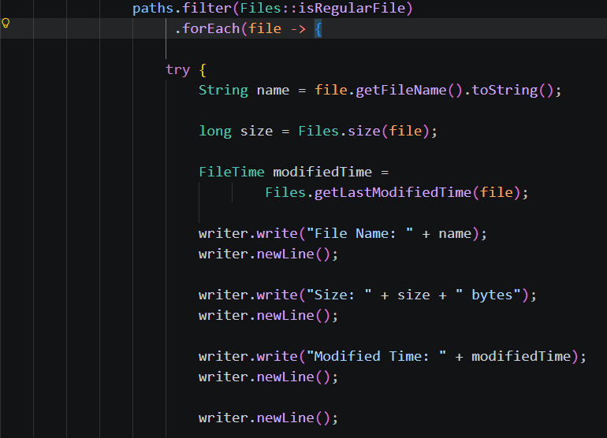
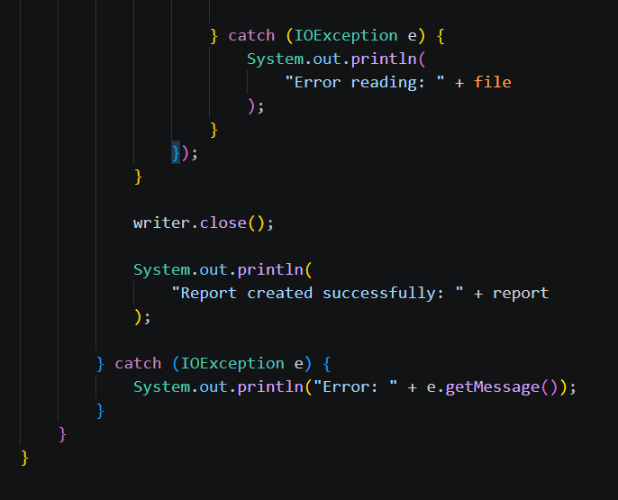
Output:
