Practical-12
1. Word frequency: split a paragraph into words, count each in a HashMap, and print the words sorted by frequency (highest first) using a Comparator.
WordFrequency.java
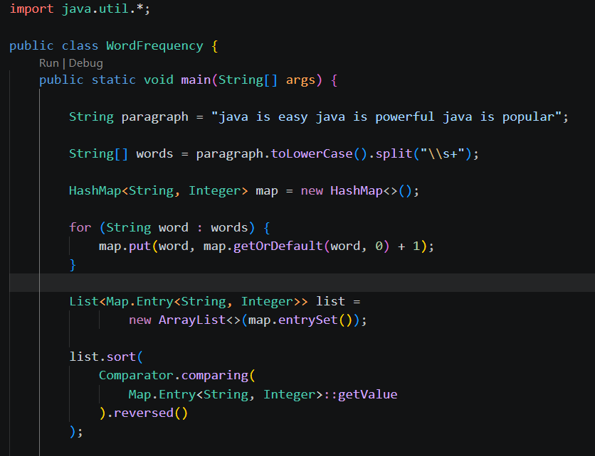
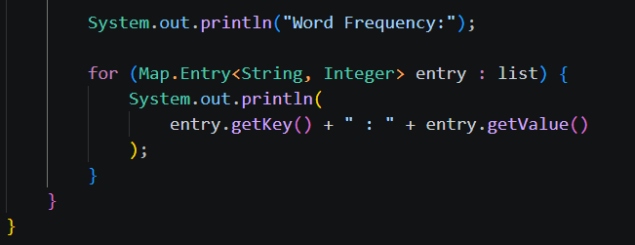
Output:
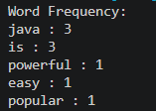
2. Unique visitors: from a list of login names with repeats, use a HashSet to count unique users and a LinkedHashSet to keep first-seen order; print the unique count and the first three distinct names.
UniqueVisitors.java
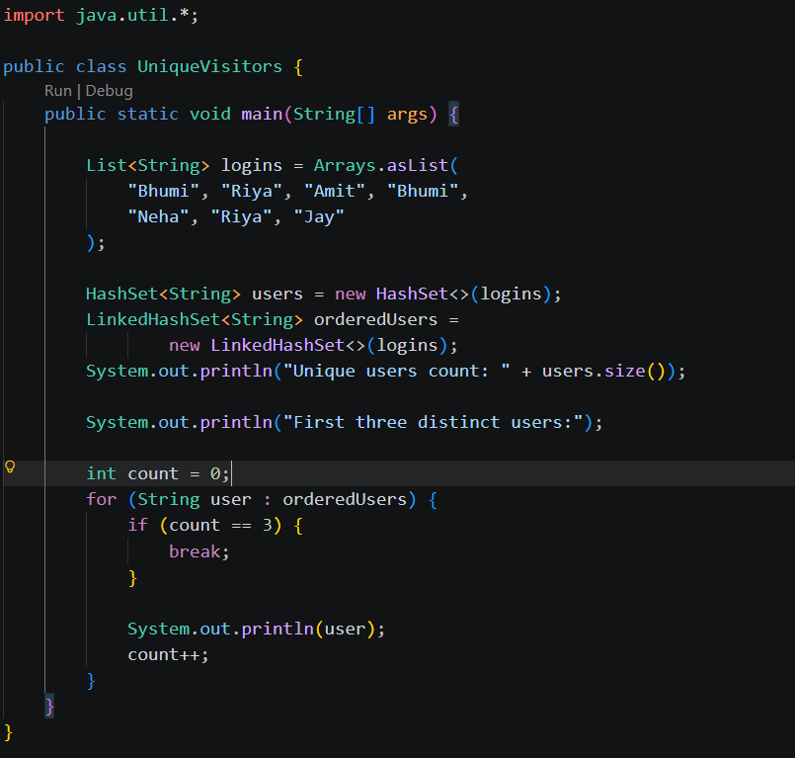
Output:
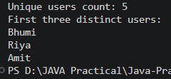

3. (For Advanced Learners – home) Build a leaderboard from player scores held in a Map and print the top-N sorted by score (ties broken by name); choose the data and sorting details.
Leaderboard.java
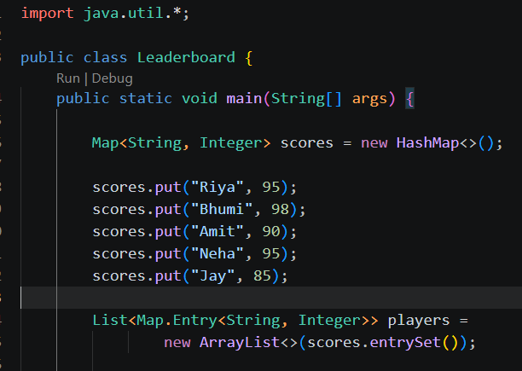
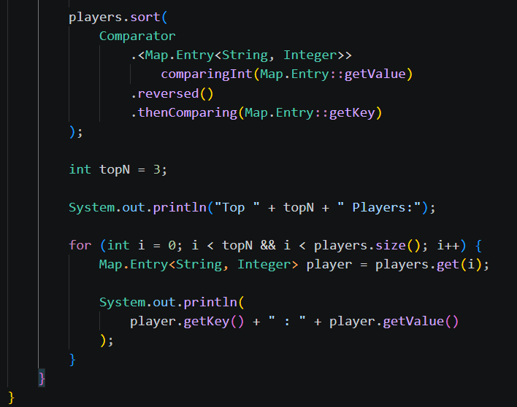
Output:
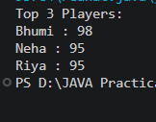
Learning Output:
- Learned to use HashMap and Comparator to count word frequencies and sort words.
- Learned to use HashSet and LinkedHashSet to identify unique users and maintain insertion order.
- Learned to use Map and Comparator to create a leaderboard with score-based sorting and alphabetical tie-breaking.

