Practical-13
1. Generic containers: a generic Box<T> with get/set and a Pair<A,B>; use them with different types to show type safety without casts, and write a generic method that returns the first element of any array.
GenericContainer.java
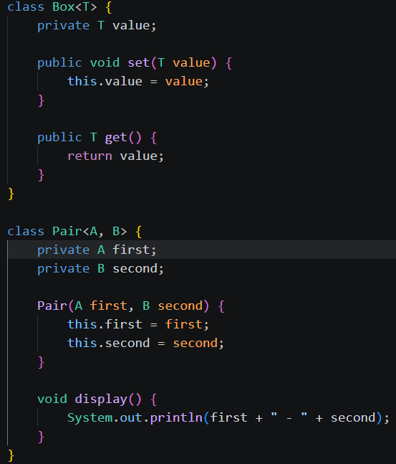
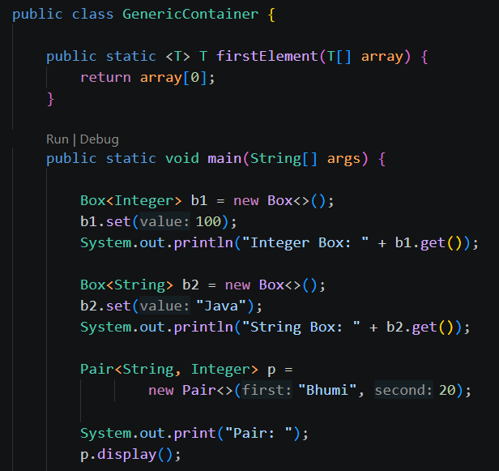
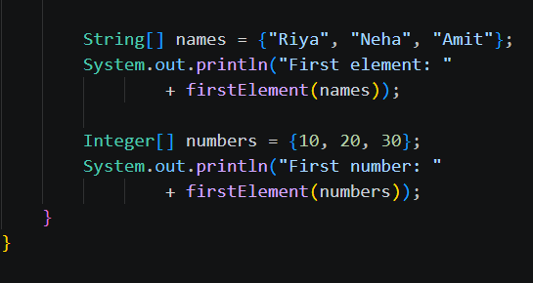
Output:
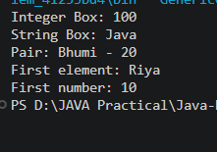

2. Bounded stats: a generic method <N extends Number> double average(N[] values) that works for Integer[], Double[] and Long[]; note why it refuses non-Number types.
BoundedStats.java
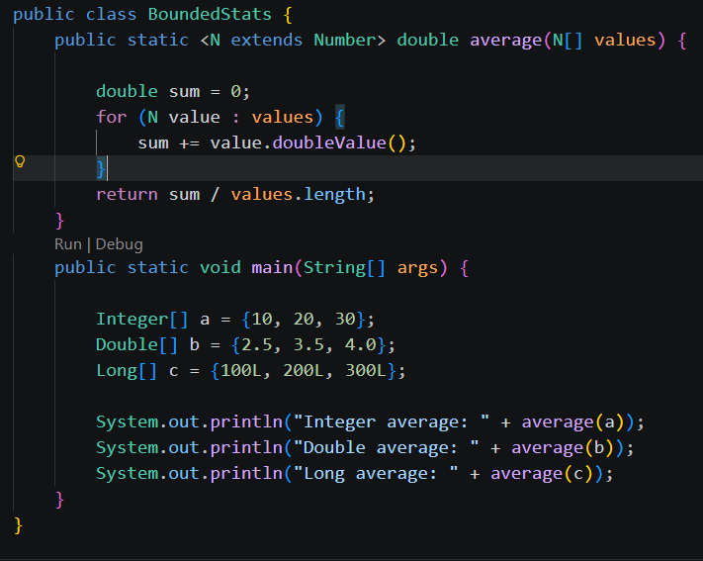
Output:
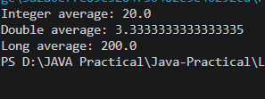

3. (For Advanced Learners – home) Implement a small generic container of your choice (e.g. a stack) backed by an array, reuse it for two different types, and handle the empty case sensibly.
GenericStack.java
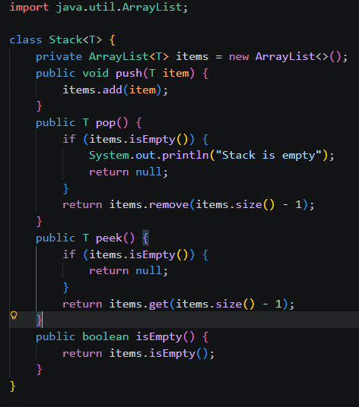
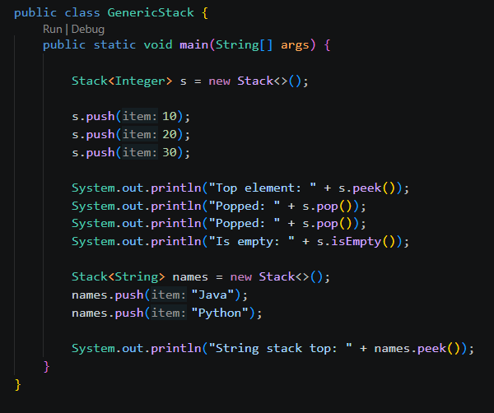
Output:
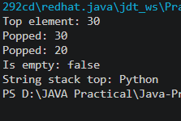
Learning Outcome:
- Learned to create generic classes, Box<T>, Pair<A,B>, and generic methods for type-safe data handling.
- Learned to use bounded generics with Number to calculate averages of different numeric types.
- Learned to implement a generic stack using ArrayList and perform push, pop, peek, and empty-check operations.

