Practical-14
1. Assemble and test: build a tiny layered app (a model, a service using an ArrayList, and a menu main), then write two or three JUnit @Test methods checking that adding increases the count and an invalid action throws — practice before testing MiniBank.
Item.java
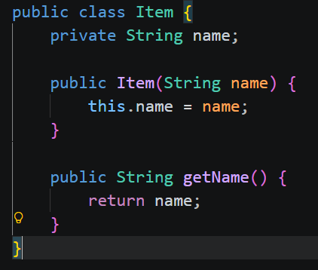
ItemService.java
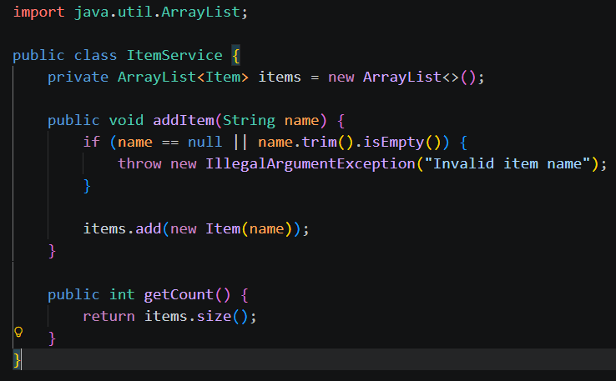

ItemServiceTest.java
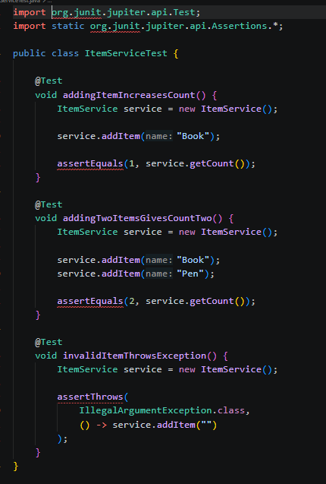
Main.java
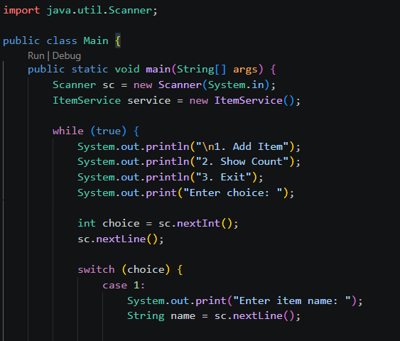
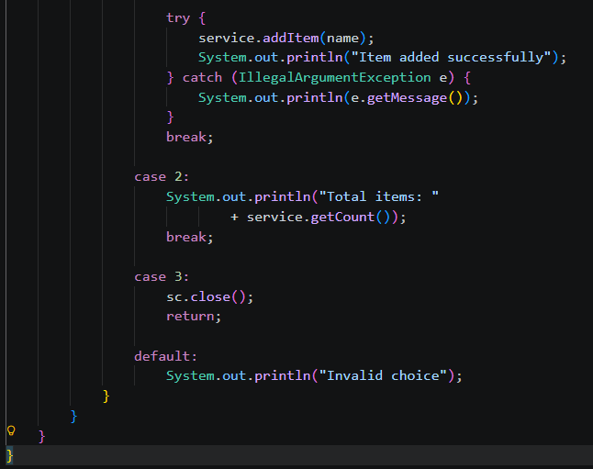
Output:
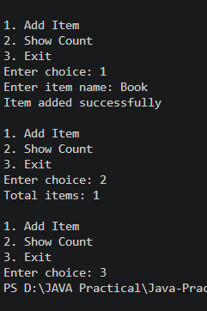
Learning outcomes
- Learned to develop a layered Java application using a model, service, and menu.
- Learned to store objects using ArrayList and validate input.
- Learned to write JUnit tests using @Test, assertEquals(), and assertThrows() to verify application behavior.
2. (For Advanced Learners – home) Organise that app into packages, build a runnable JAR, and add a test that saves and reloads its data unchanged.
AdvancedApp/
├── src/
│ └── app/
│ ├── model/
│ │ └── Item.java
│ ├── service/
│ │ └── ItemService.java
│ └── Main.java
├── test/
│ └── app/
│ └── service/
│ └── ItemServiceTest.java
├── manifest.txt
└── data/
Item.java
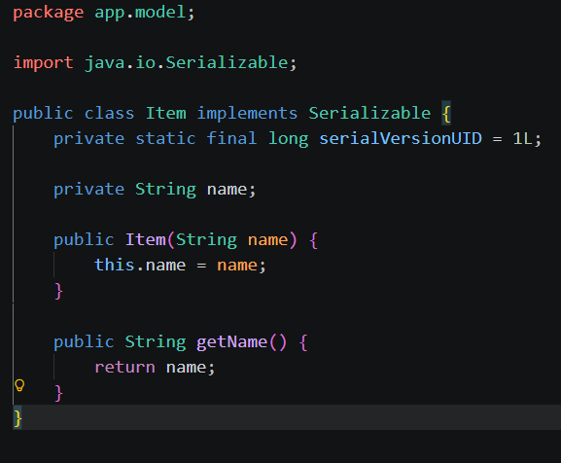
ItemService.java
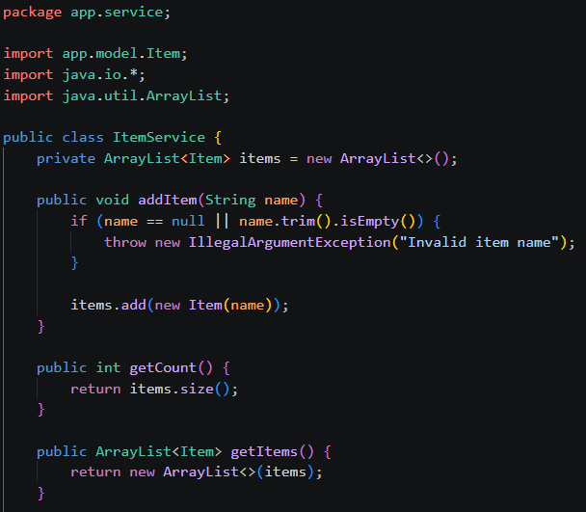
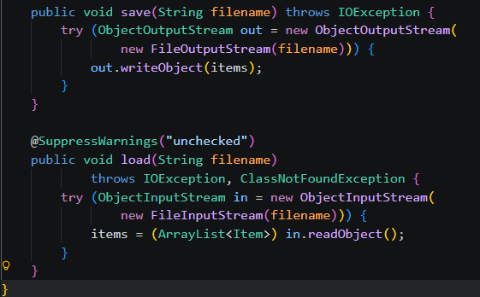

ItemServiceTest.java
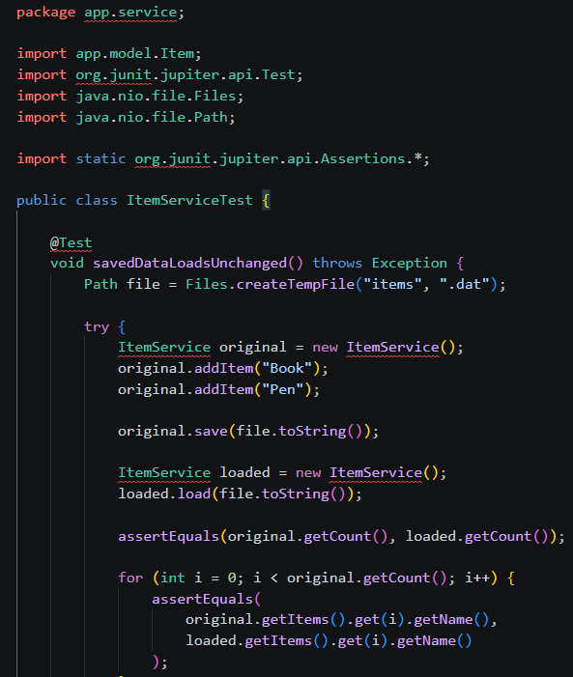
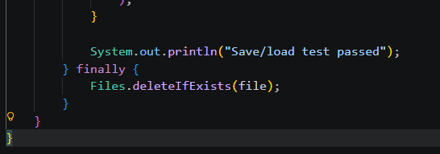

Main.java
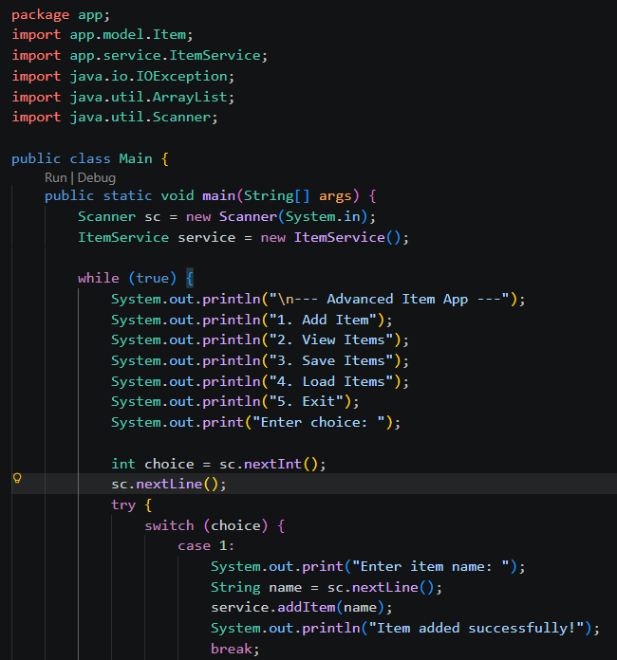
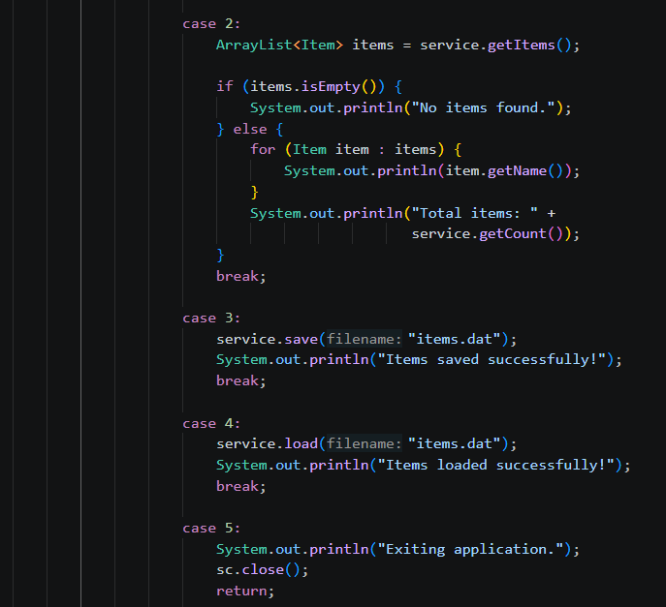
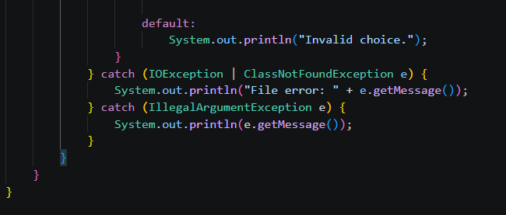
Output:
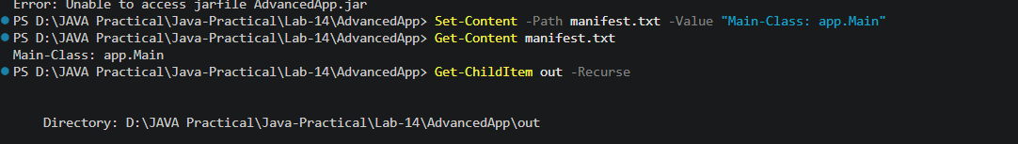
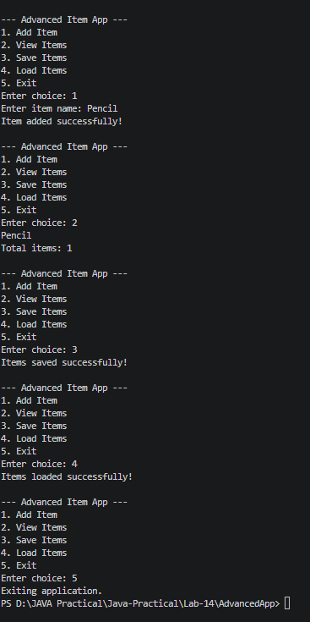
Learning Outcome:
- Learned to organize a Java project using packages such as app, app.model, and app.service.
- Understood object-oriented programming by creating classes and objects.
- Learned to manage items using ArrayList and separate business logic using a service class.
- Implemented object serialization and deserialization to save and load items from a file.
- Learned to compile Java programs using javac and execute them using the Java command.
- Understood how to create and run an executable JAR file using JDK tools.

