**Ex No: JDBC**

**Date:**

**Aim:**

To implement JDBC Programs between Java applications and relational databases.

**Algorithm**

**STEP 1: Establish connection with the database**

* Import the necessary JDBC libraries.
* Load the Oracle JDBC driver using Class.for name().
* Establish a connection to the Oracle database using DriverManager.getConnection().
* Check if the connection was successful.

**STEP 2: Execute SQL Query and Display Results:**

* Create a Statement object from the connection to execute SQL queries.
* Execute an SQL SELECT statement to retrieve all records from the "employee" table using st.executeQuery("SELECT * FROM employee").
* Iterate over the ResultSet to fetch and display each record.
* Inside the loop:
* Retrieve values using rs.getString and rs.getInt.
* Print the values.

**STEP 3: Execute SQL Insert Statement:**

* Create a Statement object from the connection to execute SQL queries.
* Execute an SQL INSERT statement to insert a new record into the "employee" table using st.executeUpdate.
* The SQL statement is: insert into employee values('Mams', 2021503522).

**SETP 4: Display Inserted Record:**

* Create another Statement object to execute an SQL SELECT statement to fetch records from the "employee" table.
* Execute an SQL SELECT statement to retrieve all records from the "employee" table using sta.executeQuery("SELECT * FROM employee").
* Iterate over the ResultSet to fetch and display each record.
* Inside the loop:
* Retrieve values using rs.getString and rs.getInt.
* Print the values.

**STEP 5: Input Student Details:**

1. Create variables to store student details such as regNo, name, gen (gender), m1, m2, and m3.
2. Use a Scanner to take user input for these details.

**Calculate GPA:**

1. Calculate GPA using the provided formula: gpa = ((m1 * 4) + (m2 * 6) + (m3 * 5)) / 15.

**Execute SQL Insert Statement:**

1. Create a Statement object from the connection to execute SQL queries.
2. Execute an SQL INSERT statement to insert a new record into the "GPA" table.
3. The SQL statement is: insert into GPA values(regNo, 'name', 'gen', m1, m2, m3, gpa).

**Display Insertion Result:**

1. Print the number of rows inserted into the "GPA" table.
2. **ESTABLISH CONNECTION**

import java.sql.Connection;  
import java.sql.DriverManager;  
import java.sql.ResultSet;  
import java.sql.Statement;  
public class connection {  
 public static void main(String args[]) {  
 Connection con;  
 try {  
 con = DriverManager.getConnection("jdbc:oracle:thin:@192.168.109.28:1521:orcl", "ct2021503052", "ct2021503052");  
 if (con == null)  
 System.out.println("Database not Connected");  
 else  
 System.out.println("Database Connected");  
 }   
 catch (Exception e) {  
 System.out.println(e);  
 }  
 }  
}

**OUTPUT**  
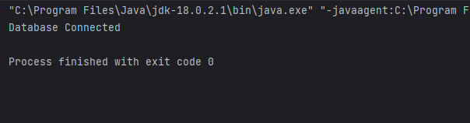

1. **Display The Table**

**CODE**

import java.sql.DriverManager;

import java.sql.Connection;

import java.sql.SQLException;

import java.sql.Statement;

import java.sql.ResultSet;

public class display {

public static void main(String[] argv) {

System.out.println("Oracle JDBC Connection Testing ");

//load oracle driver

try {

Class.forName("oracle.jdbc.driver.OracleDriver");

} catch (ClassNotFoundException e) {

System.out.println("Oracle JDBC Driver?"); e.printStackTrace(); return; }

System.out.println("Oracle JDBC Driver Registered!");

//establish connection hostname:localhost port no :1521, username :system, pwd: 123456

Connection connection = null;

try {

connection = DriverManager.getConnection("jdbc:oracle:thin:@192.168.109.28:1521:orcl", "ct2021503704", "ct2021503704");

} catch (SQLException e) {

System.out.println("Connection Failed! "); e.printStackTrace(); return; }

if (connection != null)

System.out.println("connect to your database now!"); else System.out.println("Failed to make connection!");

try{

Statement st=connection.createStatement(); // Execute SQL select statement to fetch records from table.

ResultSet rs=st.executeQuery("select * from employee");

while (rs.next()){

String Ename=rs.getString(1);

int EId = rs.getInt(2);

System.out.println("--------------------");

System.out.println("Ename:"+Ename);

System.out.println("EId:"+EId);

} }

catch(SQLException e) { System.out.println(e);}

}

}

**OUTPUT**

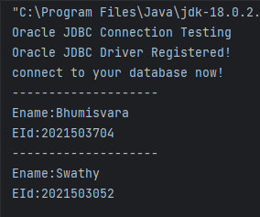

1. **Insert in the Table**

**CODE**

import java.sql.DriverManager;

import java.sql.Connection;

import java.sql.SQLException;

import java.sql.Statement;

import java.sql.ResultSet;

public class insert {

public static <SQLExceptione> void main(String[] argv) {

System.out.println("Oracle JDBC Connection Testing ");

//load oracle driver

try {

Class.forName("oracle.jdbc.driver.OracleDriver");

} catch (ClassNotFoundException e) {

System.out.println("Oracle JDBC Driver?"); e.printStackTrace(); return; }

System.out.println("Oracle JDBC Driver Registered!");

//establish connection hostname:localhost port no :1521, username :system, pwd: 123456

Connection connection = null;

try {

connection = DriverManager.getConnection("jdbc:oracle:thin:@192.168.109.28:1521:orcl", "ct2021503704", "ct2021503704");

} catch (SQLException e) {

System.out.println("Connection Failed! "); e.printStackTrace(); return; }

if (connection != null)

System.out.println("connect to your database nnow!"); else System.out.println("Failed to make connection!");

try{

Statement st=connection.createStatement();

int count=st.executeUpdate("insert into employee values('Mams',2021503522)");

System.out.println("rows inserted: " + count);

Statement sta=connection.createStatement(); // Execute SQL select statement to fetch records from table.

ResultSet rs=sta.executeQuery("select * from employee");

while (rs.next())

{

String Ename=rs.getString(1);

int EId = rs.getInt(2);

System.out.println("--------------------");

System.out.println("Ename:"+Ename);

System.out.println("EId:"+EId);

}

}

catch(SQLException e)

{

System.out.println();

}

}

}

**OUTPUT**

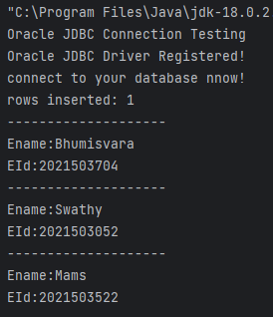

1. **Write a java Jdbc code for storing student details such as name, regno, gender, current semester course mark and GPA( using Calculate GPA method)**

**CODE**

import java.sql.DriverManager;

import java.sql.Connection;

import java.sql.SQLException;

import java.sql.Statement;

import java.util.*;

public class cgpa {

public static void main(String[] argv) {

System.out.println("Oracle JDBC Connection Testing ");

Scanner in=new Scanner(System.in);

try {

Class.forName("oracle.jdbc.driver.OracleDriver");

} catch (ClassNotFoundException e) {

System.out.println("Oracle JDBC Driver?"); e.printStackTrace(); return; }

System.out.println("Oracle JDBC Driver Registered!");

Connection connection = null;

try {

connection = DriverManager.getConnection("jdbc:oracle:thin:@192.168.109.28:1521:orcl", "ct2021503704", "ct2021503704");

} catch (SQLException e) {

System.out.println("Connection Failed! "); e.printStackTrace(); return; }

if (connection != null)

System.out.println("connect to your database now!"); else System.out.println("Failed to make connection!");

int m1=0,m2=0,m3=0,regNo;

String name;

char gen;

int gpa;

System.out.println("Enter your register number:");

regNo=in.nextInt();

in.nextLine();

System.out.println("Enter your name:");

name=in.nextLine();

System.out.println(name);

System.out.println("Enter gender:");

gen=in.next().charAt(0);

System.out.println("Enter grade points\n 10 -> 90<=Mark<=100\n 9 -> 80<=Mark<90\n 8 -> 70<=Mark<80\n 7 -> 60<=Mark<=50\n 6 -> Mark<50\n");

System.out.println("Enter grade point for Subject 1: ");

m1= in.nextInt();

System.out.println("Enter grade point for Subject 2: ");

m2= in.nextInt();

System.out.println("Enter grade point for Subject 3: ");

m3= in.nextInt();

gpa=((m1*4)+(m2*6)+(m3*5))/15;

try{

Statement sta=connection.createStatement();

int count=sta.executeUpdate("insert into GPA values(" + regNo + ",'" + name + "','" + gen + "'," + m1 + "," + m2 + "," + m3 + "," + gpa + ")");

System.out.println("rows inserted: " + count);

System.out.println("Details entered in table successfully");

}

catch(SQLException e) { System.out.println(e);

}

}

}

**OUTPUT**

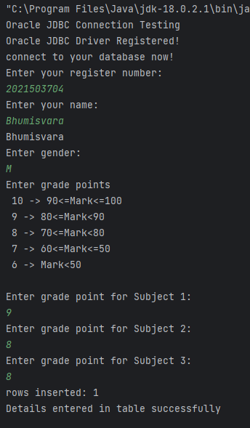

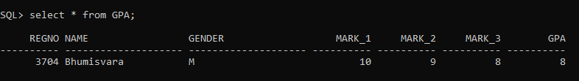

**RESULT**

Thus, The JDBC program has been successfully implemented.