**EX NO: 1 BASICS OF JAVA PROGRAMMING**

**DATE: 01-08-2023**

**AIM:**

To explore the basic classes, methods and data types of Java Programming.

**ALGORITHM:**

**STEP 1:** Printing Hello World In Java

1. **public static void main(String args[])** - The main method is the entry point of the program, where execution begins.
2. **System.out.print()** - Used to print the data in output console

**STEP 2:** Display Name and Register Number

1. **input.nextLine()** - Reads the entire line of text as input, capturing the user's name.
2. **input.nextLong()** - Reads a long integer input from the user, capturing the user's register number.

**STEP 3**: Add two numbers

1. **Scanner in = new Scanner(System.in)** - Creates a Scanner object for reading user input from the console.
2. **System.out.println(String s)** - Prints the specified string to the standard output.
3. **in.nextInt()** -: Reads an integer input from the user, capturing the first number.

**STEP 4:** Converation between two Friends

1. **main():** Entry point of the program.Prints information about the user.Sets up a conversation loop using a while loop.
2. **System.out.println():** Prints messages to the console.
3. **Scanner class():** Takes user input using in.nextLine().
4. **Objects.equals():** Compares user input for equality.
5. **break statement**: Exits the conversation loop when a user inputs "Bye."

**STEP 5**: Create Simple Profile

1. **in.close()** - Closes the Scanner object to release system resources.
2. **in.nextLine()** - Reads the entire line of text as input, which is used for capturing the user's name and address.
3. **in.nextInt()** - Reads an integer input, which is used for capturing the user's register number.
4. **in.next()** - Reads a single word or token of input, which is used for capturing the user's phone number

**STEP 6**: Compile and run a java program

1. **javac Filename.java** - To compile the java program
2. **java Classname** - To run the java program

**STEP 7**: Print current date and time

1. **java.time.LocalDate.now()** - To get current System Date
2. **java.time.LocalTime.now()** - To get current System Time

**STEP 8**: Identify the most error-prone one-line output and provide a brief description.

1. **System.out.print()** - Used to print the data in output console
2. **System.out.print(args[0])** - Used to print the cmdline input in output console

**STEP 9**: Identify the most error-prone statement and rectify them.

1. **new Scanner(System.in)** - Initialize the Scanner object
2. **in.nextInt()** - Get the integer input from the user in command line during execution

**STEP 10**: Data types in Java

1. **int**: -2,147,483,648 to 2,147,483,647

2. **float**: Approximately 1.4e-45 to 3.4e38 3. **byte**: -128 to 127

4. **long**: -9,223,372,036,854,775,808 to 9,223,372,036,854,775,807

5. **boolean**: Accepts only true and false

**STEP 11**: Fahrenheit to Celsius and vice versa

1. **new DecimalFormat("0.00")** - Creates a DecimalFormat object for formatting floating- point numbers with two decimal places.
2. **decimalFormat.format(double d)** - Formats a double value as a string with the specified formatting.
3. **decimalFormat.setRoundingMode(RoundingMode.DOWN)** - Sets the rounding mode for the DecimalFormat to round down (toward zero)
4. **(f - 32) * 5 / 9 and (9 * c / 5) + 32 -** Convert temperatures between Fahrenheit and Celsius.

**STEP 12**: Velocity and Acceleration

1. **in.nextDouble()** - Reads a double value input from the user.
2. **v = u + a*t** - Finding velocity of the program
3. **in.close()** - Closes the Scanner object to release system resources
4. **Printing Hello World In Java.**

**Source Code:**

public class Bhumi3704 {

public static void main(String[] args){ System.out.println("NAME : Bhumisvara"); System.out.println("REG NO: 2021503704"); System.out.println("Hello World!");

}

}

**OUTPUT**

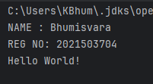

1. **Display Name and Register Number**

**Source Code:**

import java.util.*;

public class Bhumi3704 {

public static void main(String[] args) { System.out.println("NAME : Bhumisvara"); System.out.println("REG NO: 2021503704"); Scanner in = new Scanner(System.in); System.out.printf("Enter your name: "); String name = in.nextLine(); System.out.printf("\nEnter your reg num: ");

int regnum = in.nextInt();

System.out.printf("\nI am %s. My register number is %d\n", name, regnum); in.close();

}

}

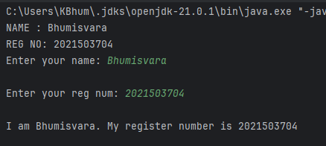**OUTPUT**

1. **Add two numbers**

**Source Code**

import java.util.*;

public class Bhumi3704{

public static void main(String[] args) { System.out.println("NAME : Bhumisvara"); System.out.println("REG NO: 2021503704"); Scanner scan = new Scanner(System.in); System.out.println("Enter a :");

int a = scan.nextInt(); System.out.println("Enter b :"); int b = scan.nextInt();

System.out.println("The sum of two numbers = " + (a+b));

}

}

**OUTPUT**

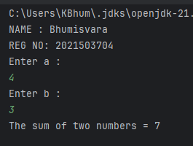

1. **Conversation between two friends Source Code:**

import java.util.*;

public class Bhumi3704 {

public static void main(String[] args) { Scanner in = new Scanner(System.in); String s1 = "",s2=”

System.out.println("Start your conversation!"); while (!s1.equals("Bye") && !s2.equals("Bye")) {

System.out.printf("User 1: "); s1 = in.nextLine(); if(Objects.equals(s1, "Bye"))

break; System.out.printf("User 2: "); s2 = in.nextLine();

}

System.out.println("Conversation Ended!"); in.close();

}

}

**OUTPUT**

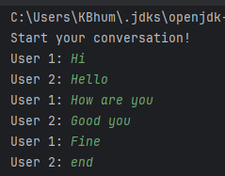

1. **Display User Profile**

**Source Code:**

import java.util.*;

public class Bhumi3704{

public static void main(String[] args) { System.out.println("NAME : Bhumisvara"); System.out.println("REG NO: 2021503704"); Scanner in = new Scanner(System.in); System.out.printf("Enter your name: "); String name = in.nextLine(); System.out.printf("Enter your reg no: ");

long regnum = in.nextLong();

String dummy = in.nextLine(); // to clear the buffer System.out.printf("Enter your address: ");

String addr = in.nextLine(); System.out.printf("Enter your phone number: "); long ph_no = in.nextLong();

System.out.printf("\nI am %s. My register number is %d\nI am from %s. Contact me @ +91

%d", name, regnum, addr, ph_no); in.close();

}

}

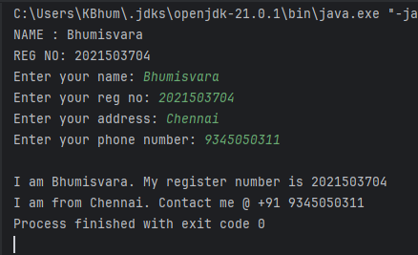**OUTPUT**

1. **Write the program and compile the code @ command line to execute.**

**With Error**

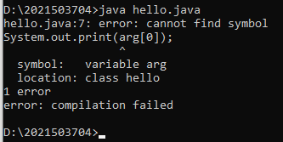

**Without Error**



1. **Write the program to print current date and time.**

**CODE**

import java.time.LocalDate;

import java.util.Date;

import java.time.LocalTime;

public class time {

public static void maint(stringt[] args){

LocalTime MyTime = LocalTime.now();

LocatDate MyDate = LocatOate.now();

System.out.println("Time: "+MyTime);

System.out.println("Date: "+MyDate);

}

}

**OUTPUT :**

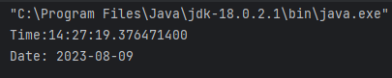

1. **Find the maximum Compile time and Runtime error messages of simple one line output message.**
   1. **Delete any of the semicolons.**



* 1. **Misspell the word public, static, void, main.**

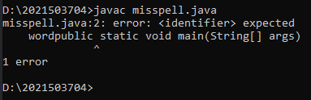

* 1. **omit the word public, static, void, main, arg,**

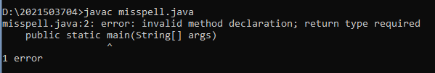

* 1. **Remove the quotation marks around string**



* 1. **change the main method argument data type, omit the argument, change the argument variable name.**

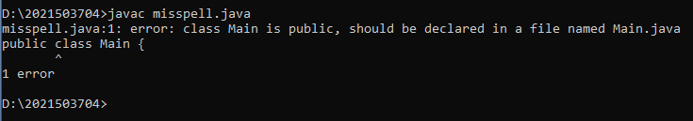

* 1. **Remove the curly braces**



1. **Copy the program and compile it. Find the error messages that the compiler finds out. Correct it out and repeat the process until the code runs.**

**CODE**

Class Bug{

public static int main (int param) {

string name Scanner in=new Scanner(System.in);

System.out.println("Hello. Please type your name:);

name = in.readline(); system.out.println("Hello"+name);

System.out.println (“Have a, nice day!)

}

}

**ERROR**

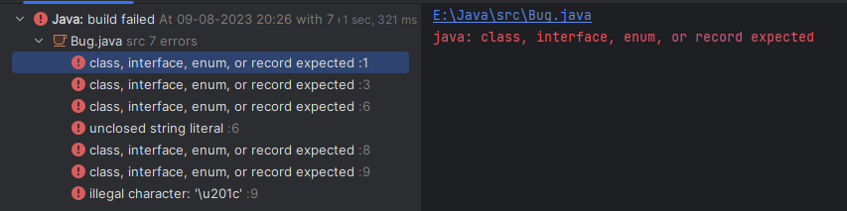

**OUTPUT:**

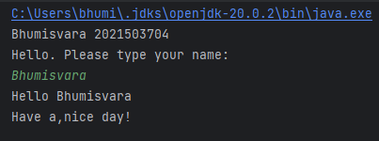

1. **Write a program to learn the different Java data types and their correct /incorrect values. Example.**

**CODE**

import java.util.*;

class datatypes3704 {

public static void main(String args[]) {

byte byteValue = 127;

byte b = 128;

long longValue = 9223372036854775807;

long l = 9223372036854775807L;

long longValue = 9223372036854775807;

float floatValue = 3.14f;

boolean booleanValue = true;

System.out.println("\n\tByteValue: "+byteValue); System.out.println("\tIntValue: "+intValue);

System.out.println("\tLongValue: "+longValue);

System.out.println("\tFloatValue: "+floatValue);

System.out.println("\tDoubleValue: "+doubleValue);

System.out.println("\tBooleanValue: "+booleanValue);

}

}

**OUTPUT**

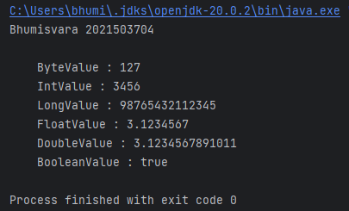

1. **Write a program that takes as input Fahrenheit temperature. It converts the input temperature to Celsius and prints out the converted temperature as shown in the example. The formula for conversion between the two is: C=5/9(F−32), Where C is the temperature in Celsius and F is the temperature in Fahrenheit.**

**CODE.**

import java.util.*;

import java.text.DecimalFormat;

public class Conversion {

public static void main(String[] args){

Scanner s=new Scanner(System.in);

System.out.println("Bhumisvara 2021503704");

System.out.print("Enter Fahrenheit value :");

float f=s.nextFloat();

float c=((float)5/9)*(f-32);

DecimalFormat decimalFormat = new DecimalFormat( pattern: "#.##");

System.out.print ("Cellcius :"+decimalFormat.format(c));

}

}

**OUTPUT**

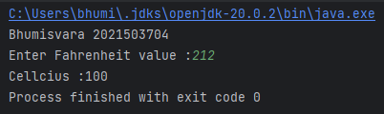

1. **Writea program that accepts the three numbers u, a, and t as input. Here, u denotes the starting speed, a the acceleration, and t the amount of time. The programoutputsthe displacement covered (d) in time (t).The program prints the final velocity (v).v=u+at.**

**CODE:**

import java.util.Scanner;

import java.text.DecimalFormat;

public class Velocity {

public static void main(String[] agrs){

System.out.println("Bhumisvara 2021503704");

Scanner obj=new Scanner(System.in);

float u=obj.nextFloat();

float a=obj.nextFloat();

float t=obj.nextFloat();

float result=u+(at);

DecimalFormat decimalFormat = new DecimalFormat(patter: "#.##");

System.out.print("The Final Velocity is: "decimalFormat.format(result));

}

**}**

**OUTPUT**

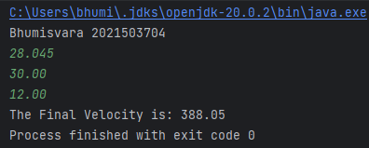

**RESULT:**

Thus the Java programming has been explored and implemented successfully.