School of Engineering & Technology
BCA (AI&DS) | DAA Lab 2 | ENCA351
Lab 2 Final Benchmarking Report
Student Name: __________________________ Roll No.: __________________________

1. Introduction
This project implements a reusable Algorithm Performance Measurement and Benchmarking Tool. It evaluates search algorithms and common program patterns by measuring execution time, peak memory and operation counts, and by comparing theoretical complexity with observed growth.

2. Algorithms / Programs
Linear Search, Binary Search, Single Loop Traversal, Nested Loop Traversal, Recursive Factorial and Iterative Factorial.

3. Complexity Comparison
Algorithm / Pattern | Best Case | Average Case | Worst Case | Space
Linear Search | O(1) | O(n) | O(n) | O(1)
Binary Search | O(1) | O(log n) | O(log n) | O(1)
Single Loop | O(n) | O(n) | O(n) | O(1)
Nested Loop | O(n²) | O(n²) | O(n²) | O(1)
Factorial (Recursive) | O(n) | O(n) | O(n) | O(n)
Factorial (Iterative) | O(n) | O(n) | O(n) | O(1)

4. Experimental Results
The benchmark engine was run for multiple input sizes. The exact measured values are stored in benchmark_results.csv. Because execution time is hardware- and runtime-dependent, the CSV values should be treated as experimental observations rather than universal constants.
algorithm | input_size | time_sec | memory_kb | operations
Single Loop | 100 | 0.00002916 | 0.102 | 100
Nested Loop | 100 | 0.00382934 | 0.156 | 10000
Linear Search | 100 | 0.00000692 | 0.164 | 100
Binary Search | 100 | 0.00000387 | 0.023 | 7
Single Loop | 500 | 0.00019076 | 0.133 | 500
Nested Loop | 500 | 0.12273744 | 0.250 | 250000
Linear Search | 500 | 0.00015088 | 0.207 | 500
Binary Search | 500 | 0.00000635 | 0.062 | 9
Single Loop | 1000 | 0.00045375 | 0.133 | 1000
Nested Loop | 1000 | 0.53963982 | 0.281 | 1000000
Linear Search | 1000 | 0.00050996 | 0.207 | 1000
Binary Search | 1000 | 0.00000712 | 0.094 | 10
Single Loop | 2000 | 0.00104319 | 0.133 | 2000
Nested Loop | 2000 | 2.27440200 | 1.117 | 4000000
Linear Search | 2000 | 0.00159108 | 0.207 | 2000
Binary Search | 2000 | 0.00000906 | 0.125 | 11
Factorial (Recursive) | 100 | 0.00023243 | 0.195 | 100
Factorial (Recursive) | 500 | 0.00136868 | 8.090 | 500

5. Visualizations
Search Comparison
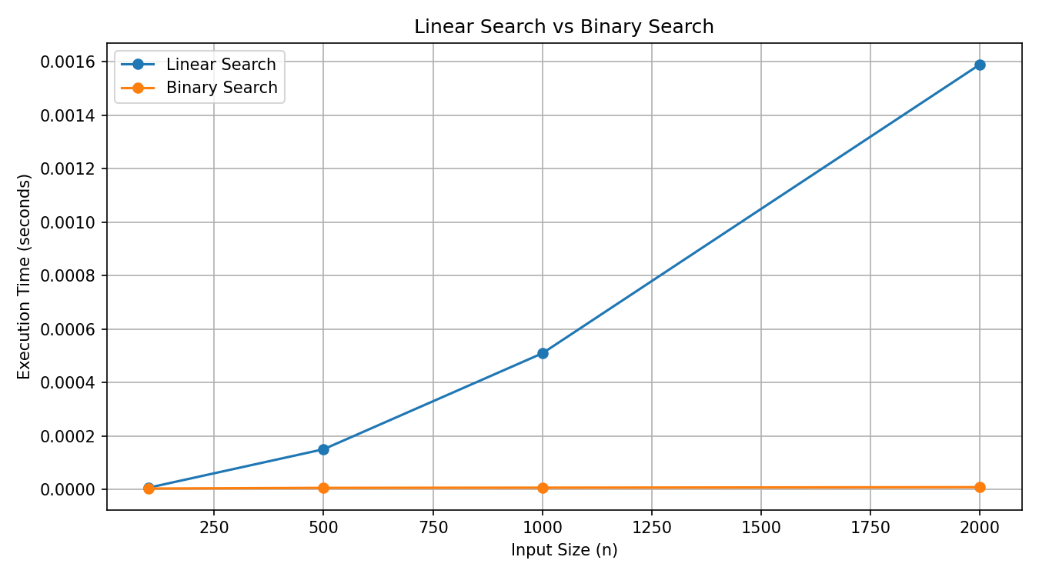
Factorial Comparison
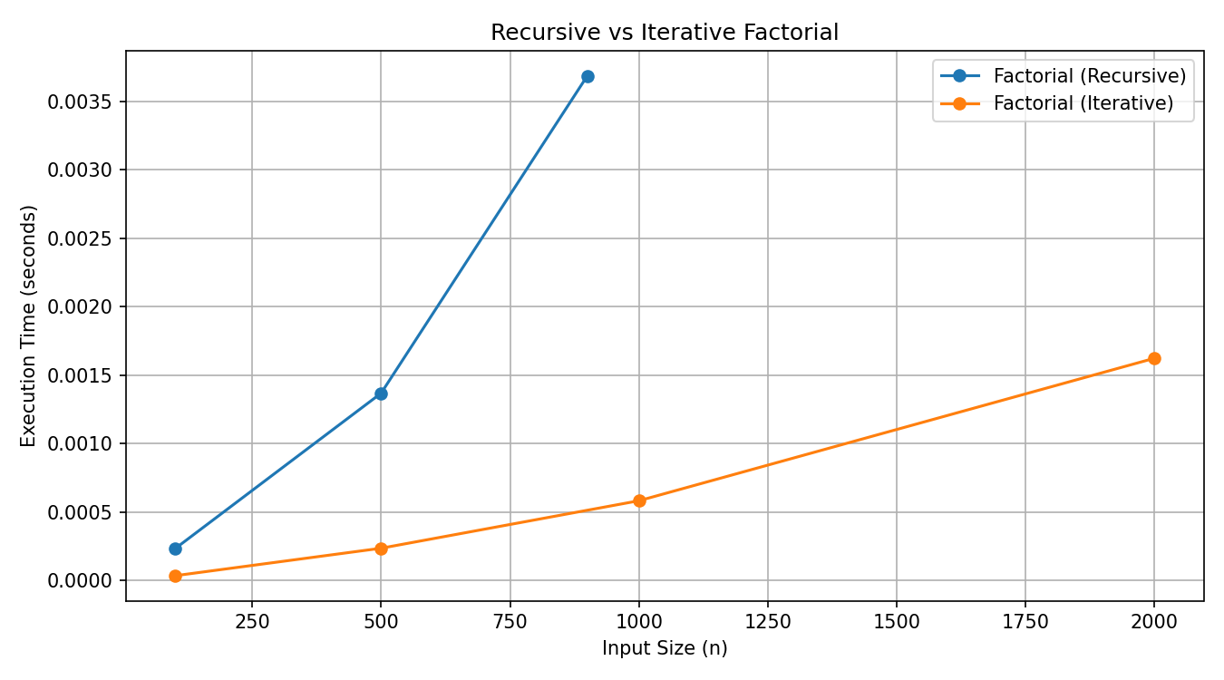
Loop Comparison
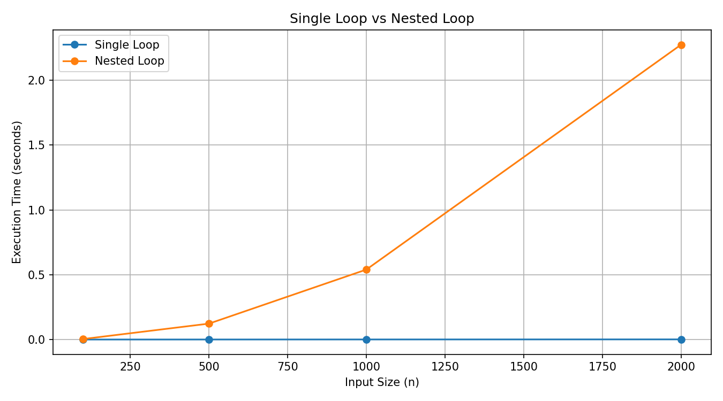

6. Analysis and Observations
Linear Search performs a sequential scan and therefore grows linearly in the worst case. Binary Search repeatedly halves the search interval and therefore grows logarithmically, but it requires sorted data.
Nested loops perform approximately n² inner operations, so their execution time increases much faster than a single O(n) loop as n grows.
Recursive and iterative factorial implementations both require O(n) time. Recursive factorial additionally requires O(n) call-stack space, whereas the iterative version requires O(1) auxiliary space.

7. Time-Space Trade-off
The recursive factorial implementation uses additional stack memory in exchange for a direct recursive formulation. The iterative implementation avoids recursion and has lower auxiliary-space complexity.

8. Conclusion
The experiments demonstrate that asymptotic complexity is a useful predictor of scalability. Binary search is preferable for repeated searches on sorted data; single-loop structures scale better than nested loops; and iterative factorial is preferable when minimizing auxiliary space is important.

9. Future Enhancements
Possible enhancements include additional algorithms, repeated trials with statistical summaries, CSV export from the Streamlit interface, user-defined code snippets in a safe sandbox, and richer interactive charts.

Additional Detailed Discussion
The project demonstrates an important distinction between asymptotic complexity and wall-clock execution time. Big-O notation describes how resource requirements grow with input size while ignoring machine-specific constants. Experimental benchmarking measures the actual implementation on a particular system. Both views are useful: theoretical analysis explains scalability, while measurement validates the behaviour of the implementation.

Reproducibility Procedure
- Create and activate the project virtual environment.
- Install the dependencies from requirements.txt.
- Run the benchmark engine using the same input-size configuration.
- Save the generated benchmark_results.csv.
- Regenerate the graphs from the same CSV.
- Record the Python version and system details if a formal experimental study is required.
- Attach screenshots of the Streamlit interface and generated outputs to the final submission.

Recommended Screenshot Set
- Streamlit interface showing the algorithm selector and input-size field.
- A completed Linear Search benchmark with result and comparison count.
- A completed Binary Search benchmark.
- Benchmark DataFrame containing multiple algorithms and input sizes.
- Search comparison graph.
- Factorial comparison graph.
- Loop comparison graph.
- Jupyter notebook output showing benchmark data and a chart.

Viva / Explanation Points
- Linear Search is O(n) in the average and worst case because it may inspect many elements.
- Binary Search is O(log n) because the search interval is halved after each comparison.
- Nested Loop is O(n²) when both loops execute n times.
- Recursive Factorial is O(n) time and O(n) auxiliary space due to recursive calls.
- Iterative Factorial is O(n) time and O(1) auxiliary space.
- time.perf_counter() is used for elapsed-time measurement.
- tracemalloc records peak Python memory allocations during the measured execution.
- Observed timing can differ between computers even when the algorithm is unchanged.

Final Evaluation Summary
Overall, the implementation satisfies the central requirements of the benchmarking assignment: multiple algorithms are implemented, a reusable engine measures performance, theoretical complexity is documented, experimental results are stored, and comparative charts are generated. The project can be extended later with more algorithms, repeated trials, statistical summaries and additional interactive visualizations.

