Department Of Computer Science & Application



Open Elective

MATLAB

Submitted To:-

Ms. Rupali (R.Scholar)

Submitted By:-

Bhumit

21212

(M.Sc. 2nd Year)

1. Create a random matrix of size [4x4]

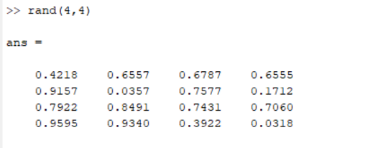

1. Create following matrix of any order:
   1. Unit Matrix

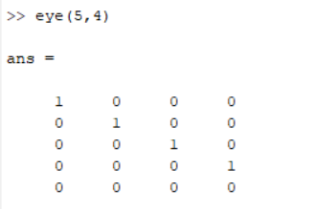

* 1. Magic Matrix

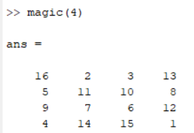

* 1. Matrix with all zeros

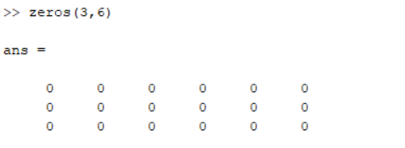

1. Write a MATLAB expression to build a matrix involving reshaping, accessing, and deleting some rows and columns, and show their respective results.

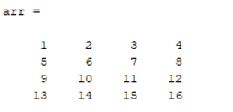

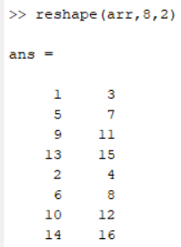

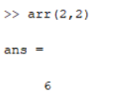

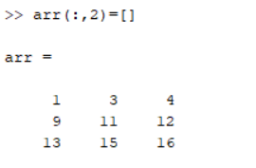

1. Give a MATLAB expression that multiplies two vectors to obtain

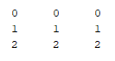

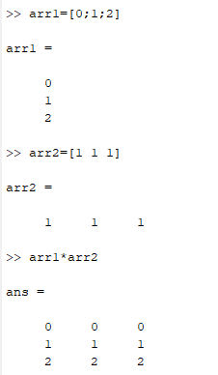

1. Write a script to form a calculator with arithmetic operations.

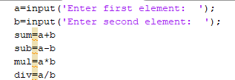

Result:-

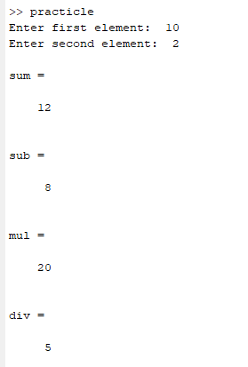

1. Crete two matrices, and find the addition, subtraction and multiplications of these two matrices.

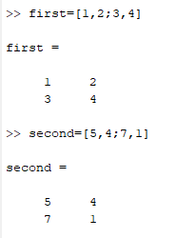

Addition: -

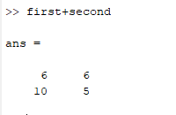

Subtraction: -

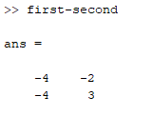

Multiplication: -

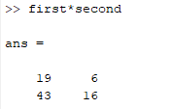

1. Create a matrix, and find the inverse of that matrix.

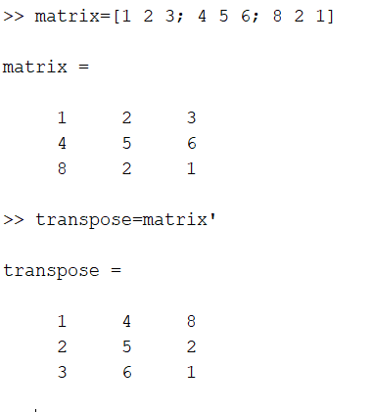

1. Create a matrix, and find the inverse of that matrix.

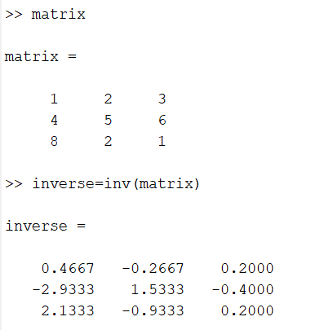

1. Write a script to show the use of
   1. If-else-end statement

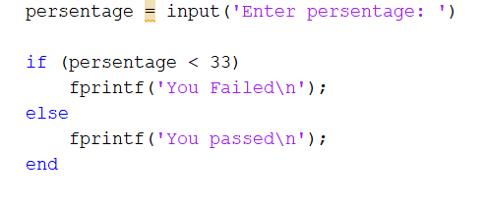

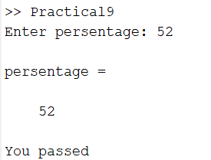

* 1. If-elseif-else end statement

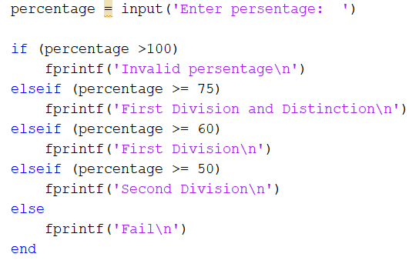

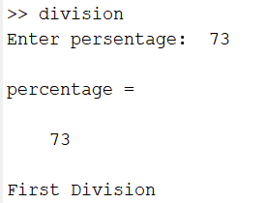

1. Write a script to show the use of
   1. For loop

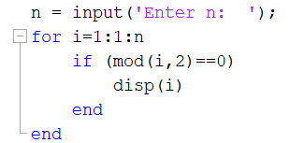

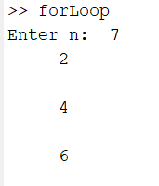

* 1. While loop

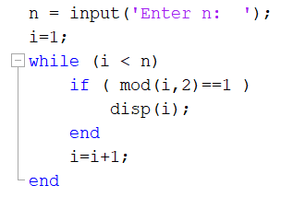

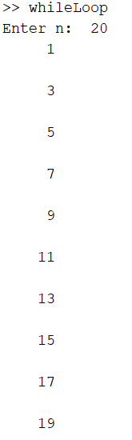

1. Find the roots of the equation

6x5-41x4+97x3-97x2+41x-6.

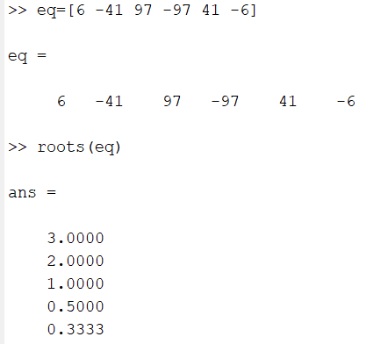

1. Write a script file for creating a user-defined function.

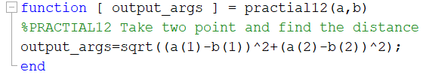

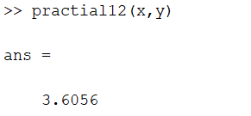

1. Plot Sinc function, where Sinc(x)=sin(x)/x, and -2*pie <= x <= 2*pie



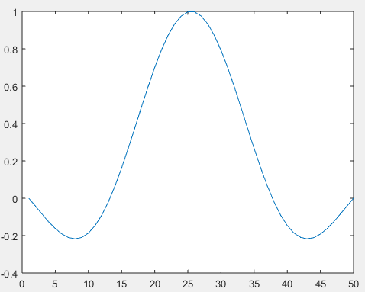

1. Plot sin(x) and cos(x) on the same figure, then on the same axis using different colours.

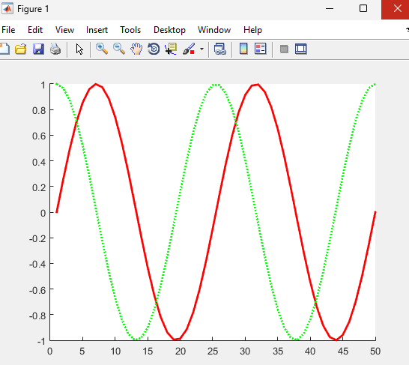

1. Exchange the real and imaginary parts of the following matrix



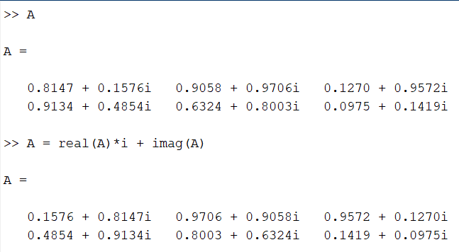

1. If x= $\left[ \begin{aligned}1 5 9 \\ 2 7 4 \end{aligned}\right]$,then
   1. Display the last two elements using disp command.
   2. Display the sum of each row as shown below

The sum of1st row=

The sum of 2nd =

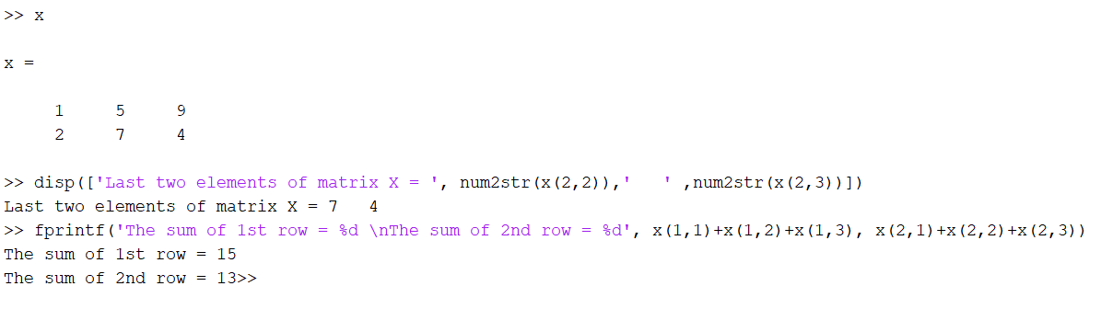

1. Find the eigen values and eigen vectors of the matrix

$$\left\lfloor \begin{aligned} 3 1 1 \\ 1 0 2 \\ 1 2 0 \end{aligned}\right\rfloor$$

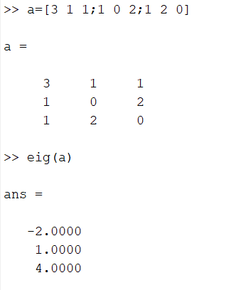

1. Use the colon operator to create a vector of x values ranging from 0 to 2*pi, compute the sin of these values, and plot the result.



