Ls:- list content of the directory

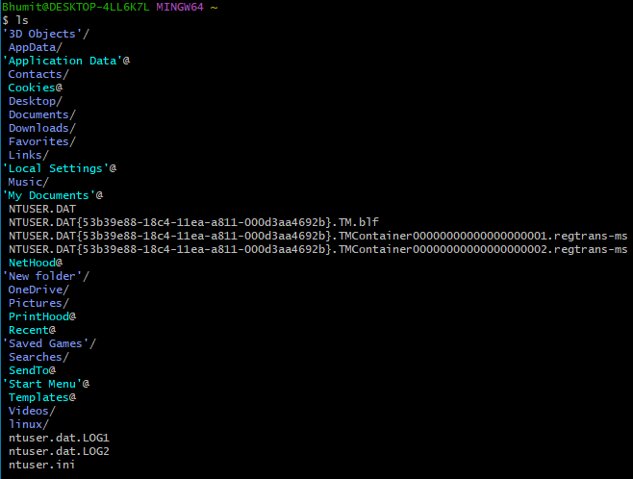

**Ls –a :- also show file starting with . (hidden file)**

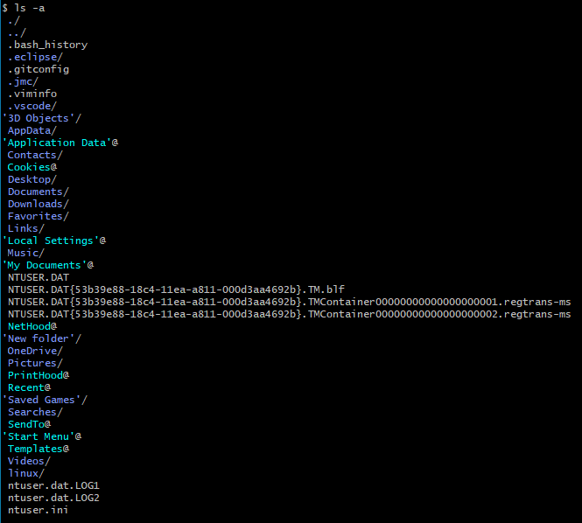

**Ls –al :- use long list format**

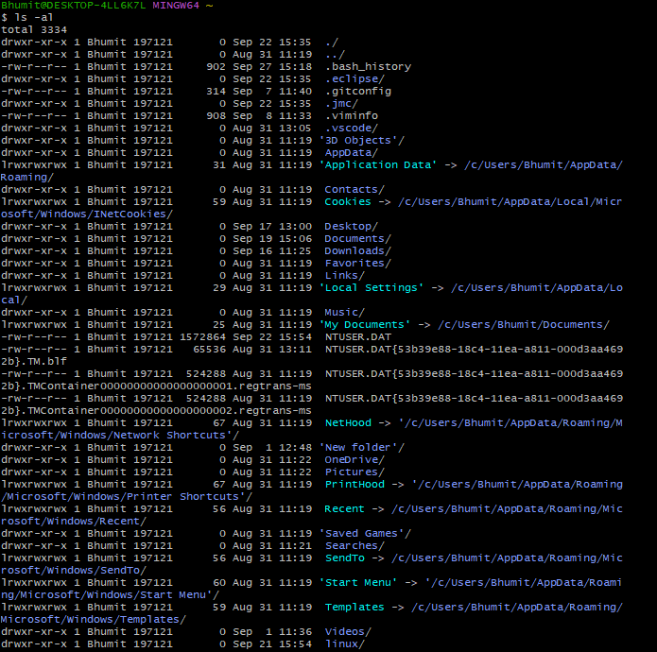

**Ls –r :- reverse order while sorting**

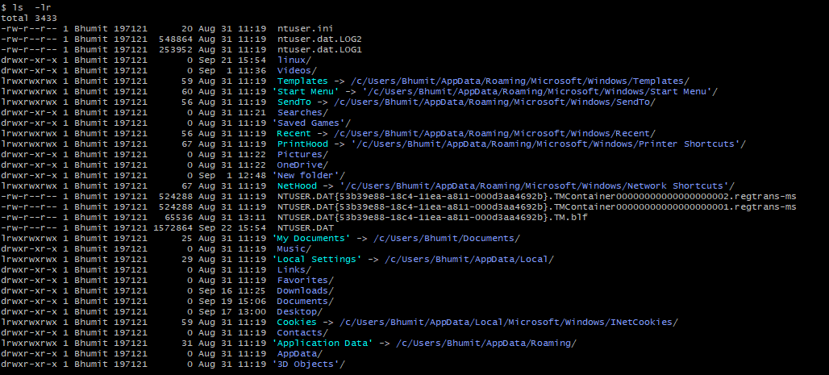

**Ls –s :-** print the allocated size of each file, in blocks

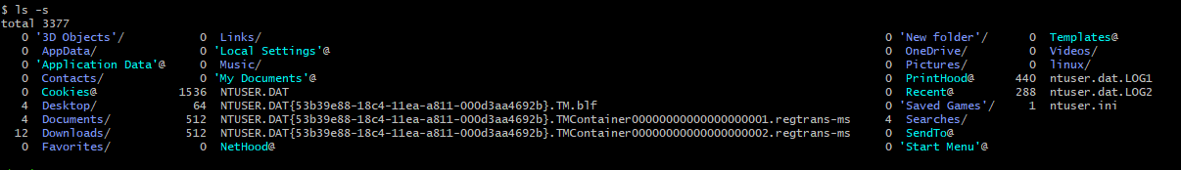

**Ls –f**

