Homepage :
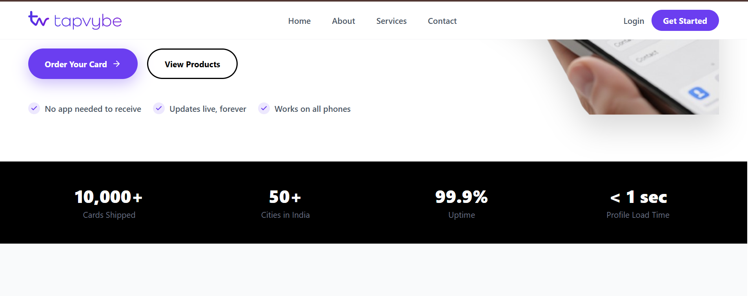
Change karvnu che otherwise kaik buju set kari deje


Remove line:” no subscription”

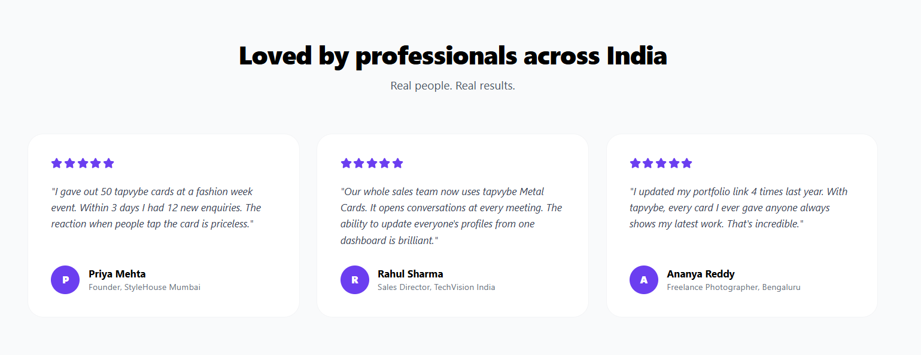
name1.bhargav dodiya (real estate)
"The NFC Digital Card has been a great addition to my real estate business. It helps me share my contact information instantly and creates a professional impression. Highly recommended!"

name2.dhruv sompura(architech)
I recently started using this NFC Digital Business Card, and I’m really impressed with it. As an architect, it has made networking so much easier. I can instantly share my contact details, portfolio, and social media with just a tap, I’m genuinely happy with the experience and would definitely recommend it to anyone looking for a professional way to connect.
name3. girirajstduio (photography)
Great experience with the Digital NFC Card! As a photographer, it helps me instantly share my contact details, portfolio, and social media with clients. It's professional, easy to use, and perfect for networking. Highly recommended!

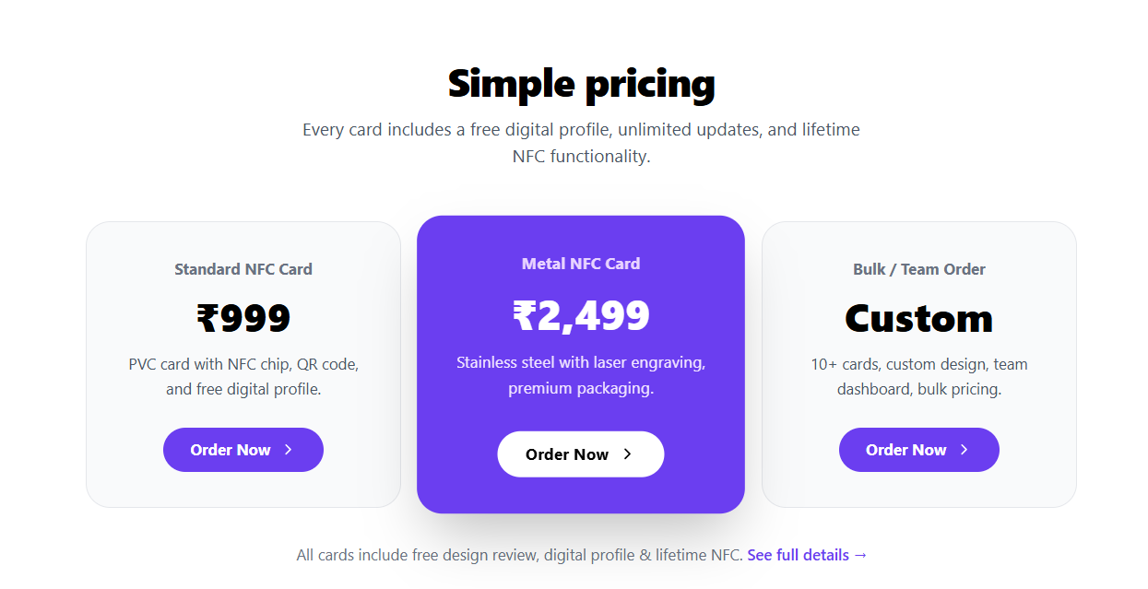
999 to replace 699
2499 to 1111
badhi jagya aa price set karvni che

About page:
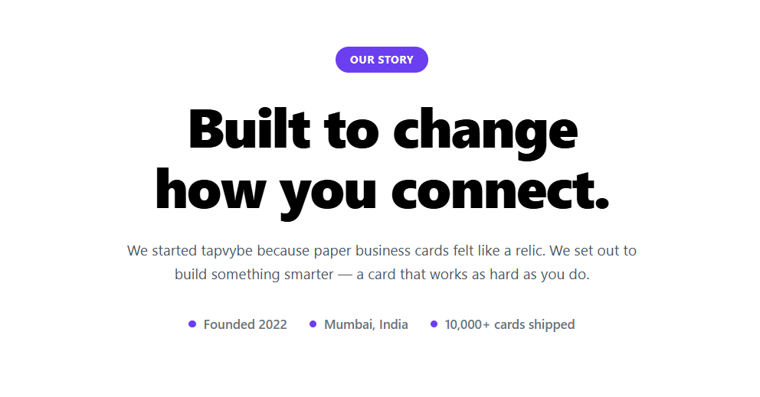
Remove other wise change tara rite

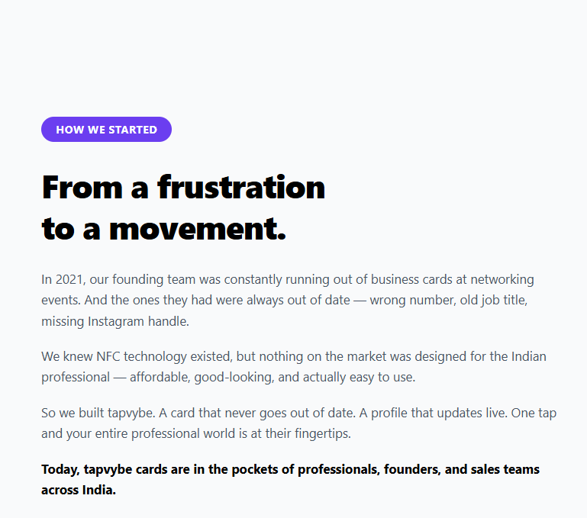

TAPVYBE was born from a personal experience.
During a business meeting, I exchanged a traditional paper business card like everyone else. But as someone working in the IT and Digital Marketing industry, I couldn't ignore one simple thought:
"If I'm asking businesses to embrace digital transformation, why am I still introducing myself with paper?"
That question became the beginning of TAPVYBE.
We realized that networking deserved an upgrade—one that reflects today's digital-first world.

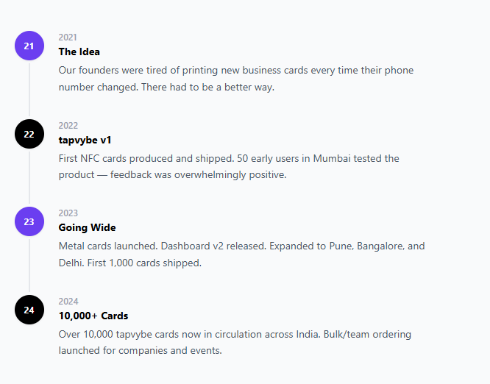

Replace kari deje content our values kari ne
Our Values
Innovation First
We embrace technology that simplifies business communication.
Professional by Design
Every interaction should leave a lasting impression.
Affordable for Everyone
Digital transformation shouldn't be limited to large companies.
Customer Success
Your growth is our greatest achievement.

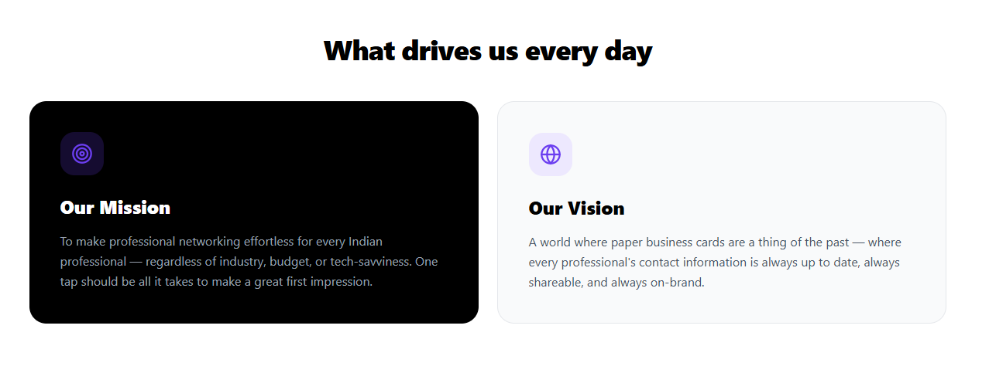
Our mission
To make professional digital identity accessible, affordable, and effortless for every business.
Whether you're a freelancer, entrepreneur, startup, salesperson, consultant, or established company, we believe your identity should be available instantly—with just one tap.
Our Vision
At TAPVYBE, we believe technology should create a smarter and greener future.
By replacing disposable paper business cards with reusable NFC cards, we aim to reduce paper waste, encourage recycling, and inspire people to plant more trees.
Less Paper. More Trees. Smarter Connections.

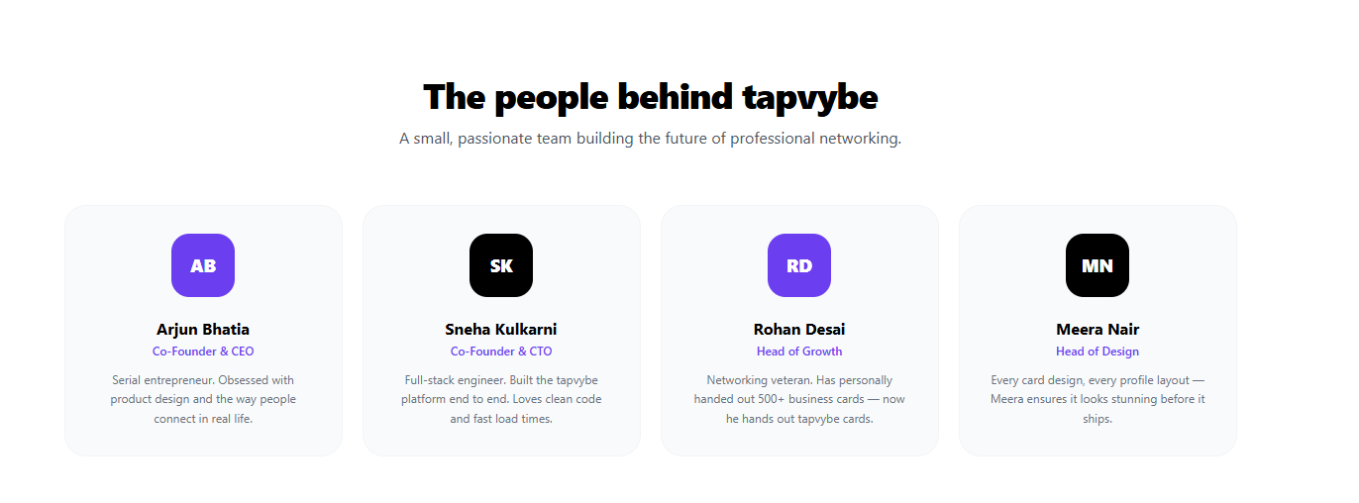
A part atyre hide kari deje pachi use karvno che

Join the Digital Revolution
The future of networking isn't paper.
It's instant.
It's interactive.
It's memorable.
Whether you're meeting a client, attending an event, closing a deal, or growing your brand, TAPVYBE helps you make every connection count.

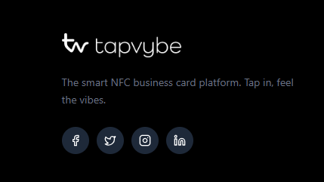

"One Smart Card. Hundreds of Trees Saved. Countless Connections Created."

Add business mail: info@tapvybe.in all places
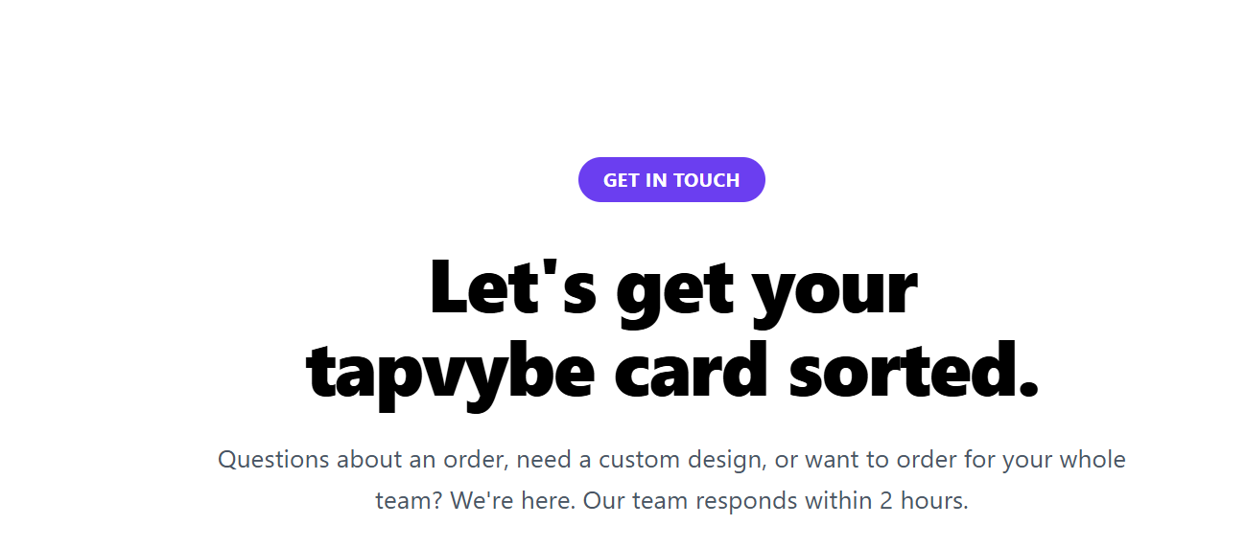

Let's get your
tapvybe card sorted.
Replace:
"Go Digital. Reduce Paper. Recycle Responsibly. Plant More Trees."

