

PROJECT BASED LEARNING REPORT

ONLINE FOOD ORDERING SYSTEM USING QUEUE

Submitted by:

Bhumi (1/24/SET/BCS/582) Bhavuk (1/24/SET/BCS/583)

Under the Guidance of:

Faculty Name: Ms. Rashi Sahay

Department of Computer Science and Engineering

Manav Rachna International Institute of Research and Studies

Academic Year: 2025–2026

ABSTRACT

The Online Food Ordering System is a Data Structures and Algorithms (DSA) mini-project designed to simulate real-world food ordering using the Queue data structure (FIFO). The system allows customers to place orders, restaurants to serve them in sequence, and display pending orders. It demonstrates core DSA concepts such as queue operations (enqueue, dequeue), overflow/underflow handling, and struct-based data organization. This project helps students practically understand how queues operate in real applications like food delivery, ticket booking, and service counters.

INTRODUCTION

Data Structures and Algorithms (DSA) play a crucial role in developing efficient, real-world applications. A Queue is one of the most commonly used linear data structures that follows the First-In First-Out (FIFO) principle.
In an online food ordering scenario, multiple customers place orders, and the restaurant processes them in the order they arrive. This makes a queue the perfect structure to model such a system.
This project aims to design and implement an Online Food Ordering System using a queue, where each order contains customer details, placed in sequence and served accordingly.

OBJECTIVES
- To understand and implement queue operations using arrays.
- To simulate a real-world food ordering system using DSA concepts.
- To apply enqueue (insert), dequeue (delete), and display operations.
- To demonstrate handling of queue overflow and underflow conditions.
- To learn the practical use of structures for storing composite data.
- To design a simple, interactive, menu-driven application in C.

SYSTEM ANALYSIS

The proposed system is a menu-driven console application created using C programming and array-based queue implementation.

Key Features:
- Customers can place food orders.
- Orders are stored in sequence using a queue.
- Orders are served one-by-one following FIFO.
- The system displays pending orders at any time. Why Queue?
In real-life service systems (restaurants, customer service, ticket counters), requests are handled in arrival order, making FIFO the natural choice.
Data Structure Used:
  - Queue (Linear, Array-Based)
  - Structures (to store customer name, item, price)

ER DIAGRAM AND SCHEMA DESIGN

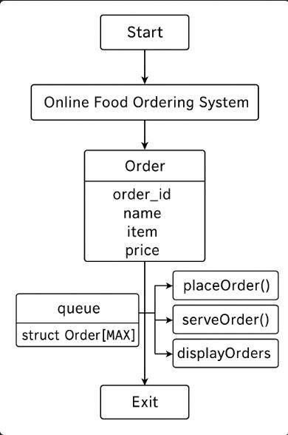

IMPLEMENTATION

The system is implemented using C programming and Queue data structure. Code:
#include <stdio.h> #include <string.h>

#define MAX 100 // Maximum number of orders

// Structure for order struct Order {
int order_id; char name[50]; char item[50]; float price;
};

// Queue variables
struct Order queue[MAX]; int front = -1, rear = -1;

// Function to check if queue is full int isFull() {
return rear == MAX - 1;
}

// Function to check if queue is empty int isEmpty() {
return front == -1 || front > rear;
}

// Add order (enqueue) void placeOrder() {
if (isFull()) {
printf("\nQueue is full! Cannot place more orders.\n"); return;
}
struct Order o; //temp. structure to store new coming order printf("\nEnter customer name: ");
scanf(" %[^\n]", o.name); printf("Enter food item: "); scanf(" %[^\n]", o.item); printf("Enter total price: "); scanf("%f", &o.price);
o.order_id = rear + 2; // this will generate order IDs starting from 1

if (front == -1) front = 0;
rear++; queue[rear] = o;

printf(" Order %d placed successfully!\n", o.order_id);
}

//here i am using Serve order (dequeue) operation
void serveOrder() { if (isEmpty()) {
printf("\nNo orders to serve!\n"); return;
}
printf("\nServing Order %d for %s (Item: %s, Price: %.2f)\n", queue[front].order_id, queue[front].name, queue[front].item, queue[front].price);
front++;
}

// Display all pending orders void displayOrders() {
if (isEmpty()) {
printf("\nNo pending orders.\n"); return;
}
printf("\n--- Pending Orders ---\n"); for (int i = front; i <= rear; i++) {
printf("Order ID: %d | Name: %s | Item: %s | Price: %.2f\n", queue[i].order_id, queue[i].name,
queue[i].item, queue[i].price);
}
}

int main() { int choice;

while (1) {
printf("\n=== Online Food Ordering System ===\n"); printf("1. Place Order\n");
printf("2. Serve Order\n");
printf("3. Display Pending Orders\n"); printf("4. Exit\n");
printf("Enter your choice: "); scanf("%d", &choice);

switch (choice) {
case 1: placeOrder(); break; case 2: serveOrder(); break; case 3: displayOrders(); break;
case 4: printf("Exiting... Thank you!\n"); return 0; default: printf("Invalid choice! Try again.\n");
}
}
}

OUTPUT:

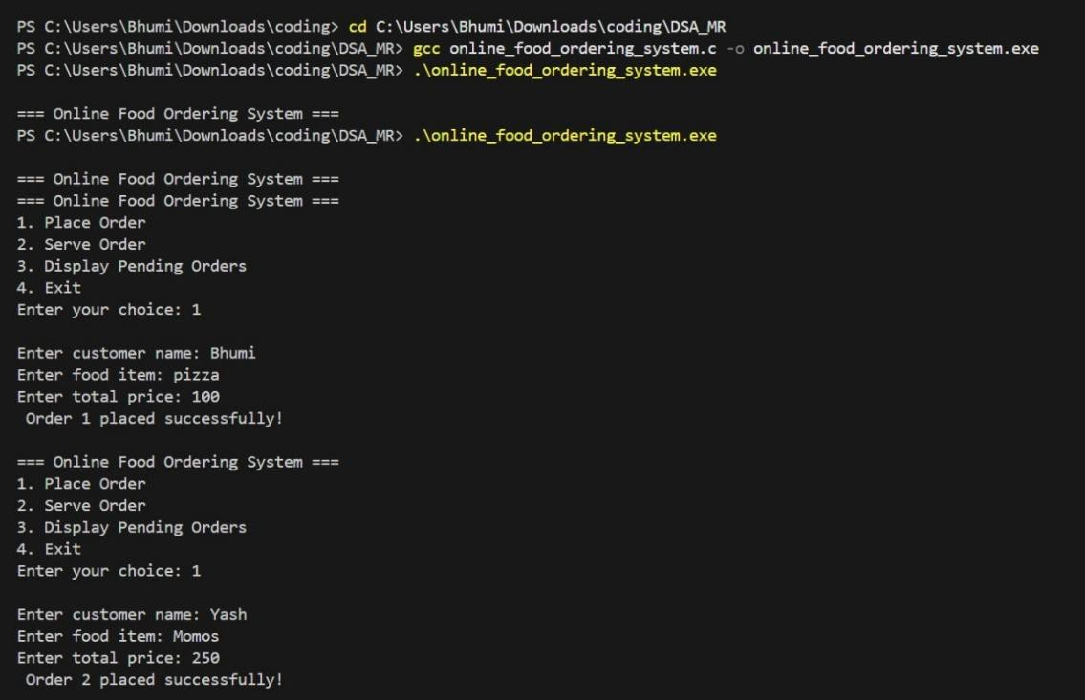
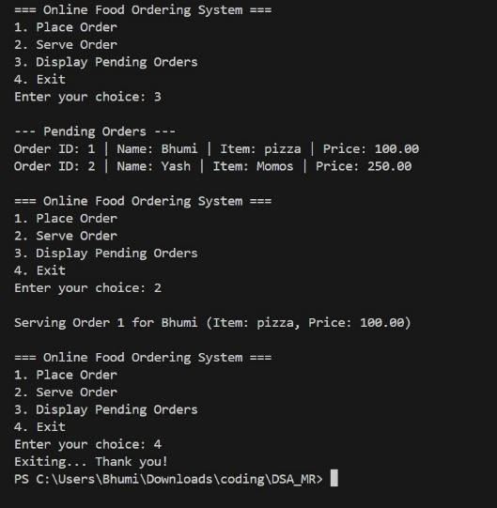

IMPLEMENTATION TABLE:

Table Name | Primary Key | Attributes
Orders | Order_ID | Order_ID, Customer_Name, Food_Item, Price
Queue | Front / Rear | Queue_Array, Front, Rear, MAX_Size
Functions | Function_Name | placeOrder(), serveOrder(), displayOrders(), isFull(), isEmpty()
Structure (struct Order) | order_id | order_id, name, item, price
System Components | Component_Name | Queue Logic, Array Memory, Front/Rear Pointers, Menu System
User Input | Input_ID | Customer_Name, Item_Name, Price, Choice_Selection
Output | Output_ID | Order_Placed_Message, Served_Message, Display_Order_List

RESULTS AND DISCUSSION

The program successfully performs the following:
- Accepts customer name, food item, and price as input
- Stores every order in a queue using FIFO logic.
- Serves orders in the exact sequence they were placed.
- Displays remaining pending orders clearly.
- Handles both underflow (no orders left) and overflow (queue full) conditions.
Practical Applications:
- Zomato / Swiggy order processing
- Bank queues
- Printer job scheduling
- Call center request handling
- This project enhances understanding of array-based queue implementation in real scenarios

CONCLUSION AND FUTURE WORK

The Online Food Ordering System effectively demonstrates the implementation of queue operations in C. It bridges theoretical DSA concepts with practical real-world workflow. The project highlights FIFO processing, structured data storage and menu-driven programming.
- Future Enhancements:
- Use Circular Queue to utilize memory efficiently
- Add multiple food items per order
- Implement priority queue for VIP customers
- Add file handling to store order history
- Create a GUI or integrate it with a web application

REFERENCES

- Ellis Horowitz & Sartaj Sahni — Fundamentals of Data Structure
- Reema Thareja — Data Structures Using C
- GeeksForGeeks — Queue Data Structure
- TutorialsPoint C Programming Documentation

