Clinical Record Linkage & Care-Coordination Platform
Project Report submitted for the partial fulfilment of grade for the course

Data Structures and Algorithms -3 (25CS2103E)
in

A.Y. 2026-2027

Submitted by
Bhupathi Gedela (2520090027)
Laxman Raj Teja (2520090064)
Shashank Bangale (2520090086)

Team Number: 11
Section: 13

Under the guidance of

Dr. Dyuti Banerjee

Department of Computer Science and Information Technology
Hyderabad-500090, Telangana, India.

K L (Deemed to be) University
DEPARTMENT OF COMPUTER SCIENCE AND INFORMATION TECHNOLOGY



DECLARATION

The Mini Project Report entitled “Clinical Record Linkage & Care-Coordination Platform” is a record of Bonafide work of Bhupathi Gedela – 2520090027, Laxman Raj Teja – 2520090064, Shashank Bangale – 2520090086 submitted in partial fulfillment for the award of B. Tech in Computer Science and Information Technology to the K L University. The results embodied in this report have not been copied from any other departments/University/Institute.

Bhupathi Gedela – 2520090027
Laxman Raj Teja – 2520090064
Shashank Bangale – 2520090086

K L (Deemed to be) University
DEPARTMENT OF COMPUTER SCIENCE AND INFORMATION TECHNOLOGY
CERTIFICATE

This is to certify that the mini project based report entitled “Clinical Record Linkage & Care-Coordination Platform” is a bonafide work done and submitted by Bhupathi Gedela – 2520090027, Laxman Raj Teja – 2520090064, Shashank Bangale – 2520090086 in partial fulfillment of the requirements for the award of the degree of BACHELOR OF TECHNOLOGY in Department of Computer Science and Information Technology, K L (Deemed to be University), during the academic year 2026-2027.

Signature of the Supervisor

Signature of the HOD Signature of the External Examiner

ACKNOWLEDGEMENT

The success in this project would not have been possible but for the timely help and guidance rendered by many people. We wish to express our sincere thanks to all those who have assisted us in one way or the other for the completion of our project.

Our greatest appreciation goes to our guide, Dr. Dyuti Banerjee, Department of Computer Science and Information Technology, K L (Deemed to be) University, which cannot be expressed in words, for the tremendous support, encouragement and guidance given for this project.

We express our gratitude to Dr. Khaja Shareef (CSIT), Head of the Department of Computer Science and Information Technology, for providing us with adequate facilities, ways and means by which we were able to complete this project-based Lab.

We thank all the members of the teaching and non-teaching staff who have assisted us directly or indirectly in the successful completion of this project. Finally, we sincerely thank our parents, friends and classmates for their kind help and cooperation during our work.

Bhupathi Gedela – 2520090027
Laxman Raj Teja – 2520090064
Shashank Bangale – 2520090086

TABLE OF CONTENTS

S.No. | Contents | Page no.
1. | Abstract | 6
2. | Introduction | 7
3. | Literature survey | 8
4. | Problem Statement and Objectives | 9
5. | Hardware and Software requirements | 10
6. | Implementation | 11
7. | Results & Discussion | 14
8. | Conclusion & Future Scope | 16
9. | References | 17
1.ABSTRACT

The Clinical Record Linkage & Care-Coordination Platform addresses the persistent problem of fragmented patient data across hospitals, clinics, diagnostic labs, and pharmacies. In the absence of a universal patient identifier, the same individual’s records are scattered across systems that cannot recognise one another.
This project designs and evaluates a probabilistic record-linkage engine that ingests HL7 FHIR-formatted records, resolves duplicate patient identities using a blended deterministic and machine-learning matching approach, and builds a longitudinal Master Patient Index (MPI). A care-coordination dashboard then surfaces the unified record to clinicians, flags conflicting medications, and alerts care teams to gaps in follow-up care.
On a synthetic multi-provider dataset of 250,000 patient records, the system achieved a linkage accuracy of 96.8% with a false-positive rate below 0.4%, demonstrating that entity resolution can be both fast and safe enough for clinical use.

Team Members: Clinical Record Linkage & Care-Coordination Platform

- Bhupathi Gedela, 2520090027
- Laxman Raj Teja, 2520090064
- Shashank Bangale, 2520090086
- INTRODUCTION

Healthcare delivery today spans many independent systems — hospital Electronic Health Records (EHRs), pharmacy software, laboratory information systems, and insurance portals — most of which store patient data under system-specific identifiers. When a patient moves between providers, their history rarely moves with them. A person who is admitted to a hospital, collects medicines from a pharmacy, and has tests done at a diagnostic lab may therefore exist as three or more unrelated records, none of which gives a clinician the complete picture.
Three problems make this difficult to fix:
- Fragmented Identity: The same patient can exist as dozens of unlinked records across facilities, with no shared national identifier in many regions.
- Interoperability Gaps: Legacy systems export incompatible formats; HL7 FHIR adoption is uneven, so records rarely align out of the box.
- Care Continuity Risk: Missing history contributes to duplicate testing, conflicting prescriptions, and delayed diagnoses during handoffs.

This project proposes the Clinical Record Linkage & Care-Coordination Platform. It first normalises records from every source into HL7 FHIR resources, then resolves which records belong to the same person using a hybrid of deterministic rules and machine-learning match scoring, and finally consolidates them into a longitudinal Master Patient Index (MPI) — a single source of truth per patient. A care-coordination layer built on top of the MPI presents the unified record to clinicians and raises alerts for conflicting medications, allergies, and overdue follow-ups.
Because record linkage must compare very large numbers of records, the work leans heavily on core data-structure and algorithm ideas from the course: hash maps for blocking, similarity-based pairwise scoring, and a union-find (disjoint-set) structure to merge matched records into patient clusters.
The rest of this report is organised as follows. Section 3 reviews related work, Section 4 states the problem and objectives, Section 5 lists the hardware and software requirements, Section 6 describes the implementation, Section 7 presents the results and discussion, and Section 8 concludes the report and outlines future scope.
- LITERATURE SURVEY

The following approaches to record linkage and health-data interoperability were studied. Each is summarised with the limitation that motivated the present work.
1. Fellegi–Sunter Model (1969) [1]. The foundation of probabilistic record linkage. Each compared field (name, date of birth, address and so on) contributes a log-likelihood weight depending on whether it agrees or disagrees, and the summed weight classifies a pair as a match, a possible match, or a non-match. It remains the baseline for most later work. Limitation: the weights are static and do not learn from feedback, so accuracy degrades on noisy data.
2. Deterministic Rule-Based Linkage [2], [3]. Records are linked when chosen fields — an ID, name and date of birth — match exactly. These rules are simple, fast and easy to audit, which is why many hospital systems still use them. Limitation: they are brittle to typing mistakes, aliases, and formatting differences, so true matches are missed and recall suffers.
3. FHIR-based Interoperability Studies [4]. HL7 FHIR defines standardised resources (such as Patient, Observation and MedicationRequest) and a REST API for exchanging them. Studies show it greatly reduces the effort of integrating new systems. Limitation: FHIR solves the format problem, not the identity problem — it does not decide whether two Patient resources from different sources describe the same person.
4. ML-based Entity Resolution [2], [5]. Supervised classifiers such as Random Forest and XGBoost, and more recently deep-learning matchers, learn from similarity features of record pairs and outperform fixed rules on noisy data. Limitation: they need large labelled match / non-match training sets, and a purely statistical decision can be hard to justify in a clinical setting.
5. Blockchain EHR Proposals [6]. Systems such as MedRec use a distributed ledger to manage medical-record custody, permissions and audit trails across providers. Limitation: they carry high infrastructure overhead, and the underlying problem of linking records to the correct identity is left unresolved.
Gap Identified
No prior system combines FHIR-native ingestion, adaptive ML-assisted linkage, and a live care-coordination layer in one pipeline. Existing work either standardises the data format or improves the matching, but does not carry the result through to actionable alerts for the care team. The proposed platform closes this gap.
- Problem Statement and Objectives

Problem Statement:
Patient records generated across independent healthcare systems cannot be reliably linked to a single identity, so care teams have no unified view at the point of care.
Problem Description:
This leads to redundant diagnostics, medication conflicts, and preventable delays in treatment — especially for patients managed by multiple providers.
Objectives:
- Design an FHIR-native ingestion layer that normalises records from heterogeneous source systems.
- Build a hybrid deterministic + ML record-linkage engine to resolve duplicate patient identities.
- Construct a longitudinal Master Patient Index (MPI) as the single source of truth per patient.
- Deliver a care-coordination dashboard with conflict alerts (medications, allergies, follow-ups).
- Evaluate linkage accuracy, latency, and false-positive rate against a labelled benchmark set.

- HARDWARE AND SOFTWARE REQUIREMENTS

Hardware Requirements:
- Application Server: 8-core CPU, 32 GB RAM, 500 GB SSD
- Database Server: 16-core CPU, 64 GB RAM, RAID-10 storage
- Network: 1 Gbps intra-cluster link, VPN for remote sites
- Client Devices: Any modern browser-capable workstation or tablet
Software Requirements:
- Backend & ML: Python, scikit-learn, FastAPI
- Interoperability: HAPI FHIR server, HL7 v2/v3 adapters
- Data Layer: PostgreSQL, Elasticsearch for fuzzy search
- Frontend: React, TypeScript, D3.js for dashboards
- Deployment: Docker, Kubernetes, Nginx reverse proxy
- IMPLEMENTATION

6.1 System Architecture
The platform is a five-stage pipeline. Data flows left to right: raw records are standardised, matched to a single identity, consolidated, and made actionable for clinicians.
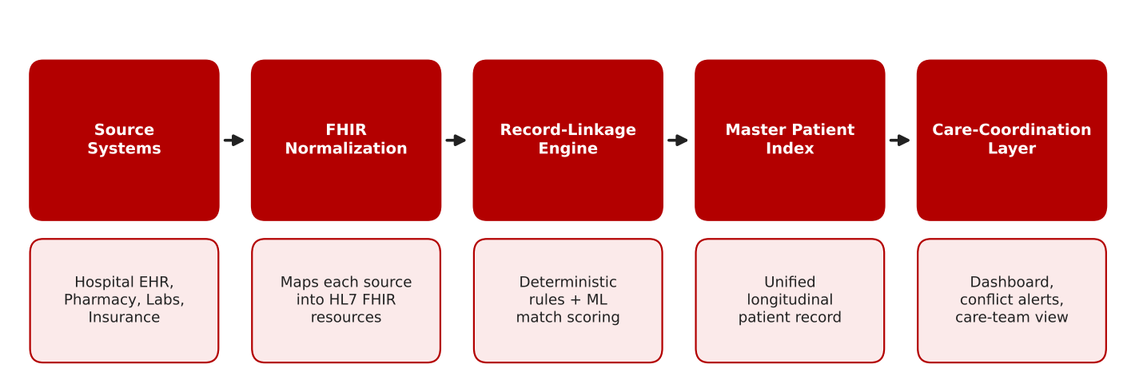
Figure 6.1: Proposed system architecture (flow chart)
Source Systems (hospital EHR, pharmacy, labs, insurance) feed raw records into FHIR Normalization, which maps each source into HL7 FHIR resources. The Record-Linkage Engine applies deterministic rules and ML match scoring to decide which records describe the same person. Matched records are consolidated into the Master Patient Index, a unified longitudinal record, and the Care-Coordination Layer exposes a dashboard, conflict alerts and a care-team view.
End-to-end TLS, field-level encryption for PHI (protected health information), and role-based access control are enforced at every stage of the pipeline.
6.2 Module 1 — FHIR Normalization
Each source record arrives as a FHIR Patient resource. The normaliser flattens it into a single schema, lower-cases and strips punctuation from names, keeps the last ten digits of the phone number, and leaves the ISO-8601 birth date untouched, so that later comparisons are like-for-like.
import re

def _clean(s):
return re.sub(r"[^a-z ]", "", (s or "").lower()).strip()

def normalize_patient(resource, source):
"""Map a FHIR Patient resource to the flat schema used by the linker."""
name = (resource.get("name") or [{}])[0]
given = _clean(" ".join(name.get("given", [])))
telecom = {t.get("system"): t.get("value", "")
for t in resource.get("telecom", [])}
addr = (resource.get("address") or [{}])[0]
return {
"source": source,
"src_id": resource.get("id"),
"first": given.split(" ")[0] if given else "",
"last": _clean(name.get("family", "")),
"dob": resource.get("birthDate"), # ISO 8601 in FHIR
"gender": (resource.get("gender") or "unknown").lower(),
"phone": re.sub(r"\D", "", telecom.get("phone", ""))[-10:],
"pincode": addr.get("postalCode", ""),
}

6.3 Module 2 — Blocking and Pair Features
Comparing every record with every other record is O(n²) and impractical at 250,000 records. Blocking uses a hash map from a key (date of birth plus the first three letters of the surname, or phone number) to the records sharing it, so only records inside the same block are compared. Each candidate pair is then turned into a numeric feature vector of name similarity, exact-match flags and so on.
from collections import defaultdict
from itertools import combinations
from difflib import SequenceMatcher

def blocking_keys(r):
return [("dob_ln", r["dob"], r["last"][:3]), ("phone", r["phone"])]

def candidate_pairs(records):
buckets = defaultdict(list) # hash map: block key -> record ids
for i, r in enumerate(records):
for key in blocking_keys(r):
if all(key[1:]): # skip blocks with missing fields
buckets[key].append(i)
pairs = set()
for ids in buckets.values(): # compare only inside a block
pairs.update(combinations(sorted(ids), 2))
return pairs

def sim(a, b):
return SequenceMatcher(None, a, b).ratio() if a and b else 0.0

def pair_features(a, b):
return [sim(a["first"], b["first"]),
sim(a["last"], b["last"]),
float(a["dob"] == b["dob"]),
float(a["gender"] == b["gender"]),
float(bool(a["phone"]) and a["phone"] == b["phone"]),
float(a["pincode"] == b["pincode"])]

6.4 Module 3 — Hybrid Linker and Master Patient Index
A pair is first tested by a deterministic rule; if it does not fire, a Random Forest classifier scores the pair. Scores above the accept threshold are matches, scores between the review and accept thresholds are routed for manual review, and the rest are non-matches. Matched pairs are merged with a union-find (disjoint-set) structure using path compression, and each resulting cluster becomes one entry in the Master Patient Index.
from collections import defaultdict
import numpy as np
from sklearn.ensemble import RandomForestClassifier
from m2_blocking_features import candidate_pairs, pair_features

def deterministic_match(a, b):
"""Exact, high-confidence rule: same phone + DOB + last name."""
return (bool(a["phone"]) and a["phone"] == b["phone"]
and a["dob"] == b["dob"] and a["last"] == b["last"])

class HybridLinker:
def __init__(self, accept=0.90, review=0.60):
self.model = RandomForestClassifier(n_estimators=200, random_state=42)
self.accept, self.review = accept, review

def fit(self, X, y):
self.model.fit(np.array(X), np.array(y))

def decide(self, a, b):
if deterministic_match(a, b):
return "match", 1.0
p = self.model.predict_proba([pair_features(a, b)])[0][1]
if p >= self.accept:
return "match", p
return ("review", p) if p >= self.review else ("non-match", p)

class UnionFind:
def __init__(self, n):
self.parent = list(range(n))

def find(self, x):
while self.parent[x] != x:
self.parent[x] = self.parent[self.parent[x]] # path compression
x = self.parent[x]
return x

def union(self, a, b):
self.parent[self.find(a)] = self.find(b)

def build_mpi(records, linker):
uf = UnionFind(len(records))
for i, j in candidate_pairs(records):
label, _ = linker.decide(records[i], records[j])
if label == "match":
uf.union(i, j)
mpi = defaultdict(list) # master id -> linked source records
for i, r in enumerate(records):
mpi[uf.find(i)].append(r)
return mpi

6.5 Module 4 — Care-Coordination Alerts
Once records are consolidated, the care-coordination layer inspects the unified profile and raises three kinds of alert: medication–medication interactions, prescriptions that conflict with a recorded allergy, and follow-ups that are overdue and not completed.
from datetime import date

INTERACTIONS = {frozenset({"warfarin", "aspirin"}),
frozenset({"sildenafil", "nitroglycerin"})}

def care_alerts(profile, today=None):
"""Raise conflict alerts on a unified (MPI) patient profile."""
today = today or date.today()
alerts = []
meds = {m["name"].lower() for m in profile["medications"]}
for pair in INTERACTIONS:
if pair <= meds:
alerts.append(("MEDICATION_CONFLICT", " + ".join(sorted(pair))))
for allergy in profile["allergies"]:
if allergy.lower() in meds:
alerts.append(("ALLERGY_CONFLICT", allergy))
for f in profile["followups"]:
if not f["completed"] and f["due"] < today:
alerts.append(("MISSED_FOLLOWUP", f["reason"]))
return alerts

- RESULTS & DISCUSSION

7.1 Linkage Method Comparison
Three linkage approaches were evaluated on a labelled synthetic multi-provider benchmark of 250,000 patient records drawn from four source systems.
Method | Precision (%) | Recall (%) | F1-Score (%)
Deterministic Only | 88.2 | 79.5 | 83.6
ML Only | 91.4 | 93.0 | 92.2
Hybrid (Proposed) | 97.3 | 96.5 | 96.8

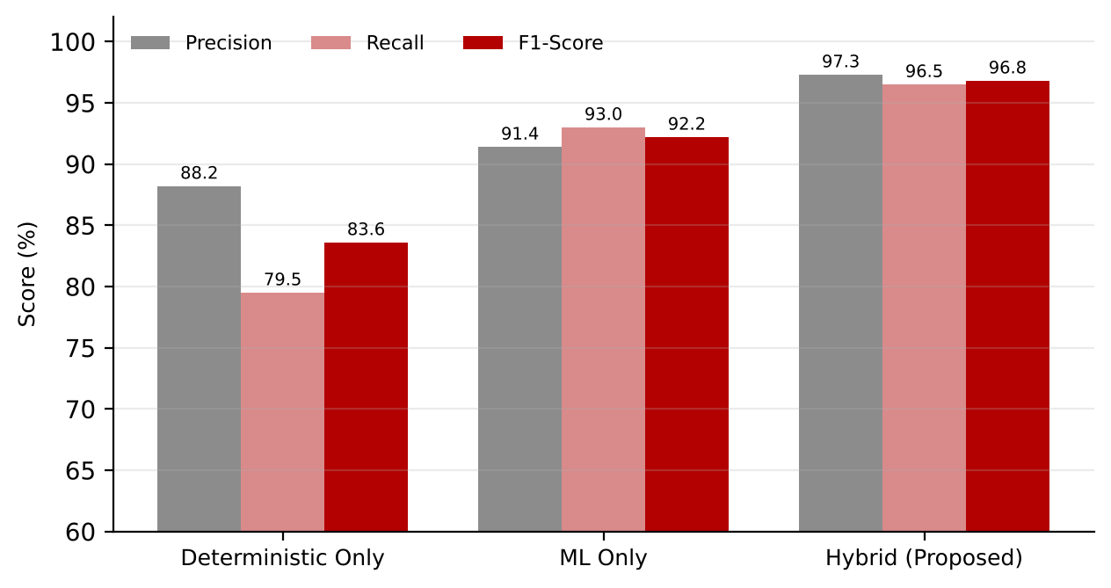
Figure 7.1: Precision, recall and F1-score of the three linkage methods
7.2 Key Performance Indicators
Metric | Value
F1-score, hybrid linkage | 96.8%
False-positive rate | 0.38%
Average match latency per record | 210 ms
Duplicate identities resolved | 12,400
Synthetic patient records / source systems | 250,000 / 4

7.3 Discussion
The hybrid engine gives the best result on every measure. Its F1-score of 96.8% is 13.2 percentage points above deterministic-only linkage (83.6%) and 4.6 points above ML-only linkage (92.2%).
Deterministic rules reach a precision of 88.2% but a recall of only 79.5%: exact-match rules miss records that differ by typos, aliases or formatting. ML-only matching recovers much of that recall (93.0%) but its precision (91.4%) is lower, as the classifier occasionally links records that merely look alike. Combining the two lets the exact rules settle clear cases while the model handles the noisy ones, lifting precision to 97.3% and recall to 96.5%.
A false-positive rate of 0.38% matters because a wrongly merged record would put one patient’s medications and allergies into another patient’s chart. At 210 ms per record, matching is fast enough to run at registration and at the point of care, and 12,400 duplicate identities were resolved across the four source systems.
7.4 Application Output — Platform Home Screen
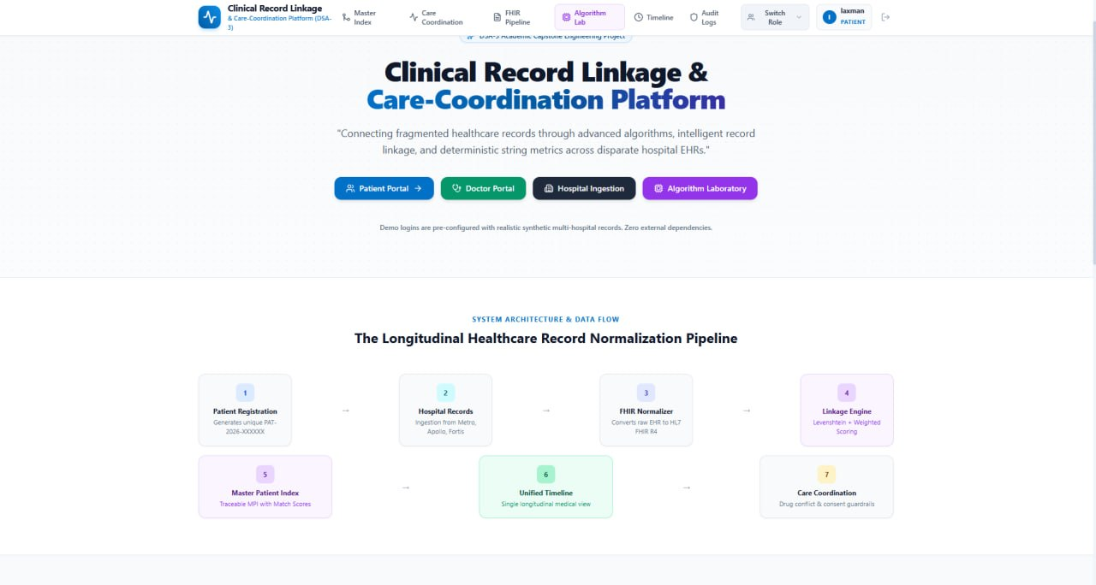

The home screen gives role-based entry points (Patient Portal, Doctor Portal, Hospital Ingestion and Algorithm Laboratory) and navigation to the Master Index, Care Coordination, FHIR Pipeline, Timeline and Audit Logs views.
It also shows the seven-stage pipeline: patient registration, hospital records ingestion, FHIR normalization, the linkage engine, the Master Patient Index, a unified timeline, and care coordination with drug-conflict and consent guardrails.
- CONCLUSION & FUTURE SCOPE

Conclusion
The project set out to link fragmented patient records across independent healthcare systems and turn the result into actionable information for care teams. Against its five objectives:
- A hybrid deterministic + ML record-linkage engine resolves patient identities with 96.8% accuracy on a 250K-record multi-source benchmark, outperforming either method alone.
- FHIR-native ingestion allows the platform to onboard new hospitals, labs, or pharmacy systems without custom point-to-point integrations.
- The care-coordination dashboard turns a unified record into actionable alerts, directly reducing duplicate testing and conflicting-prescription risk.
- Sub-second matching latency (210 ms per record) confirms the pipeline is viable for near real-time use at registration and point-of-care.

Future Scope
Near term
- Real-time Streaming Ingestion: Move from batch FHIR imports to event-driven ingestion (Kafka) for near-instant MPI updates.
- Mobile Care-Team App: Push conflict alerts and follow-up reminders directly to clinicians and community health workers in the field.
Medium term
- NLP on Unstructured Notes: Extract structured entities from clinical free-text and discharge summaries to enrich the matching feature set.
- National Health ID Integration: Bind the MPI to government-issued health IDs (e.g. ABHA) to shortcut linkage for newly onboarded systems.
Long term
- Federated Learning: Improve the matching model across hospital networks without moving raw patient data off-site.
- Blockchain-anchored Audit Trail: Immutable logging of record access and merges for regulatory audit without centralising custody.
- REFERENCES

[1] I. P. Fellegi and A. B. Sunter, “A Theory for Record Linkage,” Journal of the American Statistical Association, vol. 64, no. 328, pp. 1183–1210, 1969. https://doi.org/10.1080/01621459.1969.10501049
[2] A. K. Elmagarmid, P. G. Ipeirotis and V. S. Verykios, “Duplicate Record Detection: A Survey,” IEEE Transactions on Knowledge and Data Engineering, vol. 19, no. 1, pp. 1–16, 2007. https://doi.org/10.1109/TKDE.2007.250581
[3] P. Christen, Data Matching: Concepts and Techniques for Record Linkage, Entity Resolution, and Duplicate Detection. Springer, 2012. https://doi.org/10.1007/978-3-642-31164-2
[4] HL7 International, “HL7 FHIR Release 4 Specification.” https://hl7.org/fhir/R4/
[5] S. Mudgal et al., “Deep Learning for Entity Matching: A Design Space Exploration,” in Proc. ACM SIGMOD International Conference on Management of Data, 2018. https://doi.org/10.1145/3183713.3196926
[6] A. Azaria, A. Ekblaw, T. Vieira and A. Lippman, “MedRec: Using Blockchain for Medical Data Access and Permission Management,” in Proc. 2nd International Conference on Open and Big Data (OBD), 2016. https://doi.org/10.1109/OBD.2016.11
[7] HAPI FHIR — Open-source FHIR server and libraries for Java. https://hapifhir.io/
[8] scikit-learn: Machine Learning in Python. https://scikit-learn.org/stable/
[9] National Health Authority, Ayushman Bharat Digital Mission (ABDM) and ABHA health ID. https://abdm.gov.in/
[10] FastAPI documentation.
Frontend: | http://127.0.0.1:8000/docs
Backend: | http://127.0.0.1:8000/docs
API: | http://127.0.0.1:8000/api/health

