CICD Implementation with Selenium+Java Automation Script

* Trigger the script from POM.xml
* Add SureFire Pluginto POM.xml

<plugin>

<groupId>org.apache.maven.plugins</groupId>

<artifactId>maven-surefire-plugin</artifactId>

<version>2.22.2</version>

<configuration>

<testFailureIgnore>true</testFailureIgnore>

<suiteXmlFiles>

<!-- <suiteXmlFile>./XMLS\\temp.xml</suiteXmlFile> -->

<suiteXmlFile>./testNG.xml</suiteXmlFile>

</suiteXmlFiles>

</configuration>

</plugin>

To Run from local machine without GitLab

//To Run directly from Local Machine without GitLab

System.*setProperty*("webdriver.chrome.driver", "D:\\Sepsamplecicd\\Drivers\\chromedriver85v.exe");

driver = **new** ChromeDriver();

Run through Command Prompt

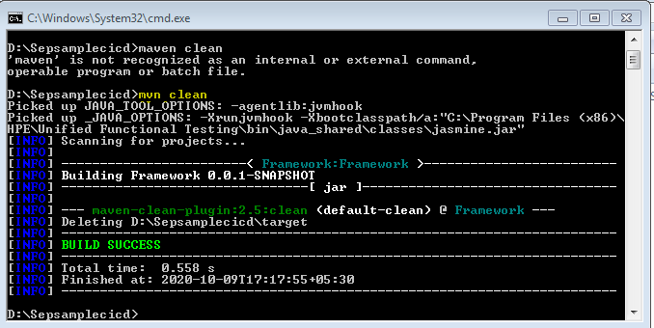

mvn Test:

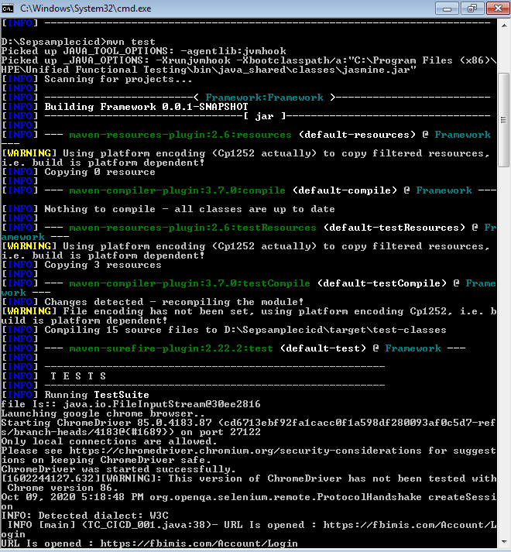

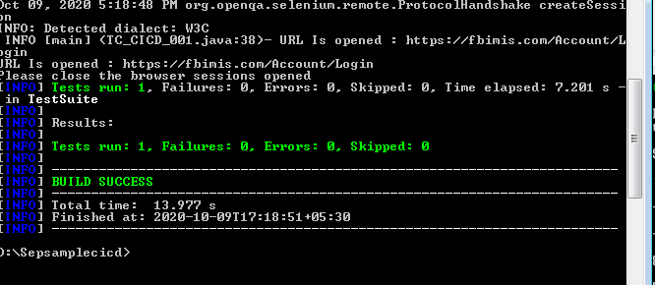

**To Run from remote driver:**

* Pom.xml - > maven clean, maven test
* Change settings in Chrome Browser driver

//To Run through GitLab

System.*setProperty*("webdriver.chrome.driver", "Drivers/chromedriver85v.exe");

ChromeOptions options = **new** ChromeOptions();

DesiredCapabilities capabilities = **new** DesiredCapabilities();

capabilities.setCapability(ChromeOptions.***CAPABILITY***, options);

driver = **new** RemoteWebDriver(**new** URL("http://10.16.225.82:4444/wd/hub"),capabilities);

Register the node in Selenium Grid:

Ref Link : <https://www.browserstack.com/guide/selenium-grid-tutorial>

Run the below commands:

java -jar selenium-server-standalone-3.141.59.jar -role hub

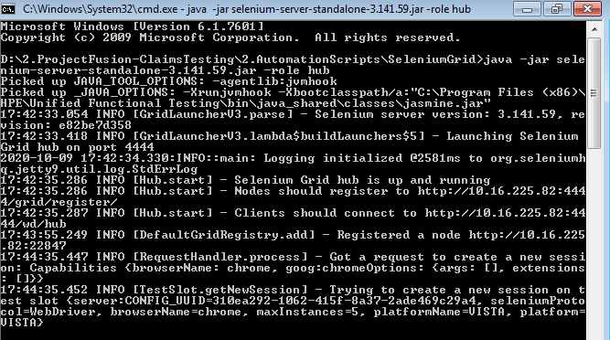

Copy the ip address on which node is registered and paste in the script while launching browser:

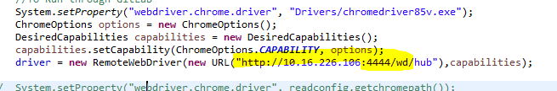

java -jar selenium-server-standalone-3.141.59.jar -role node -hub [http://10.16.225.35:4444/grid/register/](http://10.16.226.106:4444/grid/register/)

or

java -jar selenium-server-standalone-3.141.59.jar -role node -hub <http://10.16.226.106:5555/grid/register/>

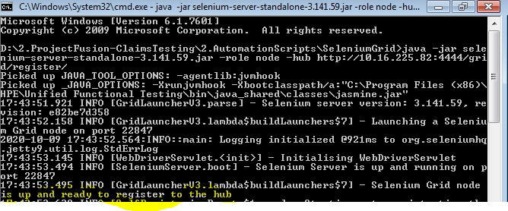

Now, trigger the test as Maven Test from POM.xml

Now push the script to Gitlab, the pipeline should be triggered automatically and run the script.