Quality Gates Pipeline setup

Contents

1. ConnectALL Configuration 2

Note: ConnectALL Access – See Appendix for details 2

2. Python script (API) configuration 14

3. Git lab setup 17

Appendix 19

One-Time request for access to ConnectALL: 19

|  |  |  |  |
| --- | --- | --- | --- |
| Author(s) | Version | Published Date | Modified |
| Venkateshwarlu Bhupathi | 1.0 | 03/26/2024 | Initial version |

# ConnectALL Configuration

Step1: log-into ConnectALL.

## Note: ConnectALL Access – See Appendix for details

By using below URL login to ConnectALL

<https://connectall.broadcom.com/ConnectAll/login.jsp>

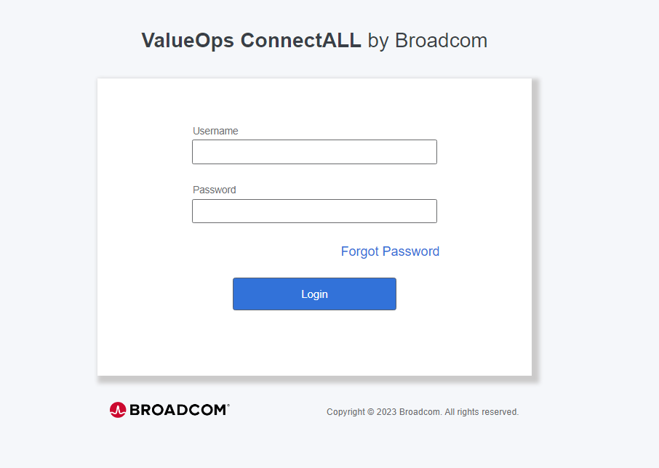

Step2: Generate API Key

Click on profile icon and select “User Management.”

Select API Key & generate API Key

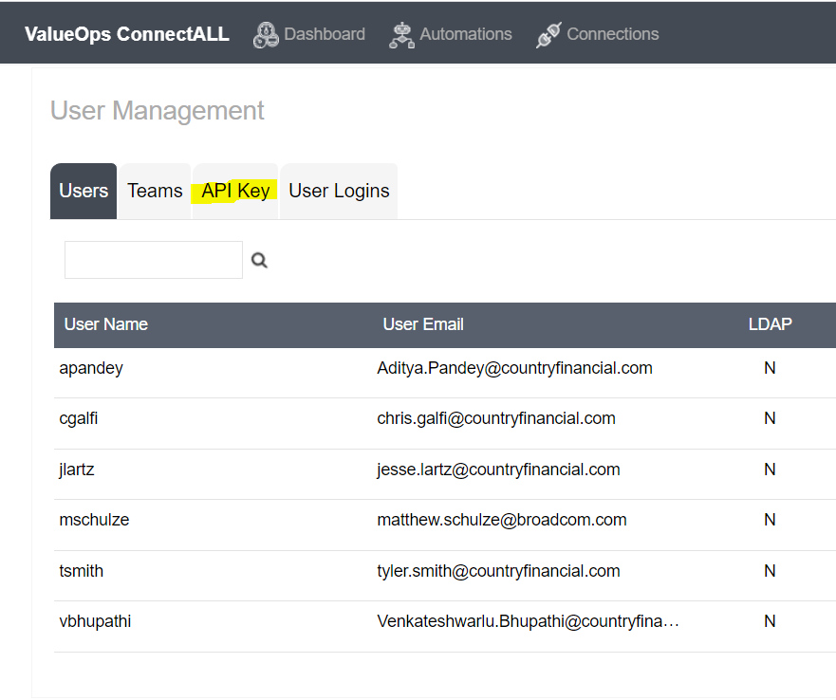

Step3: Click on Connections

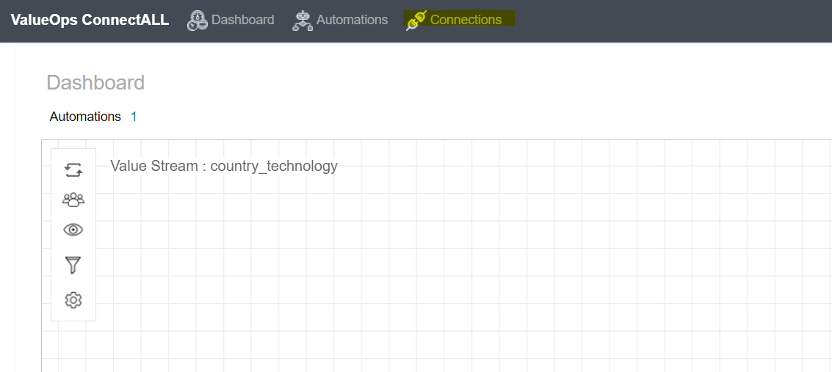

Click on Add connection.

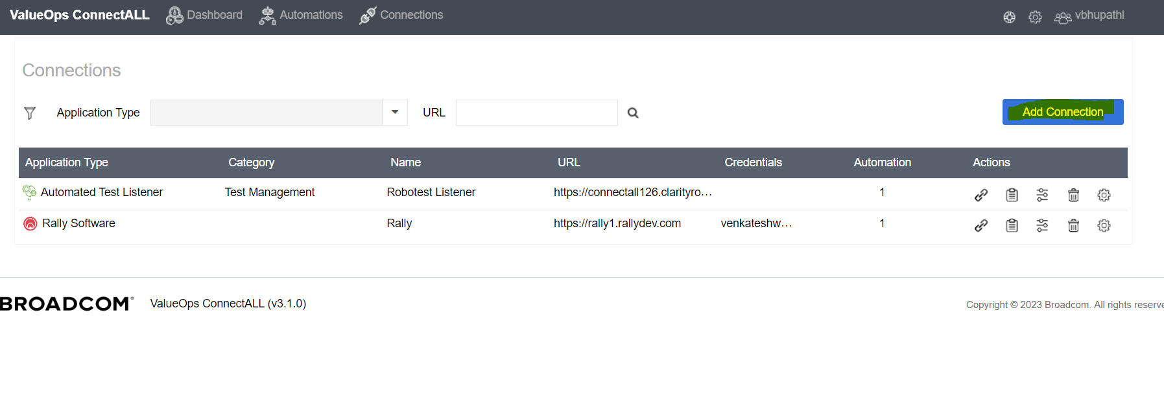

Select “Automated test Listener.”

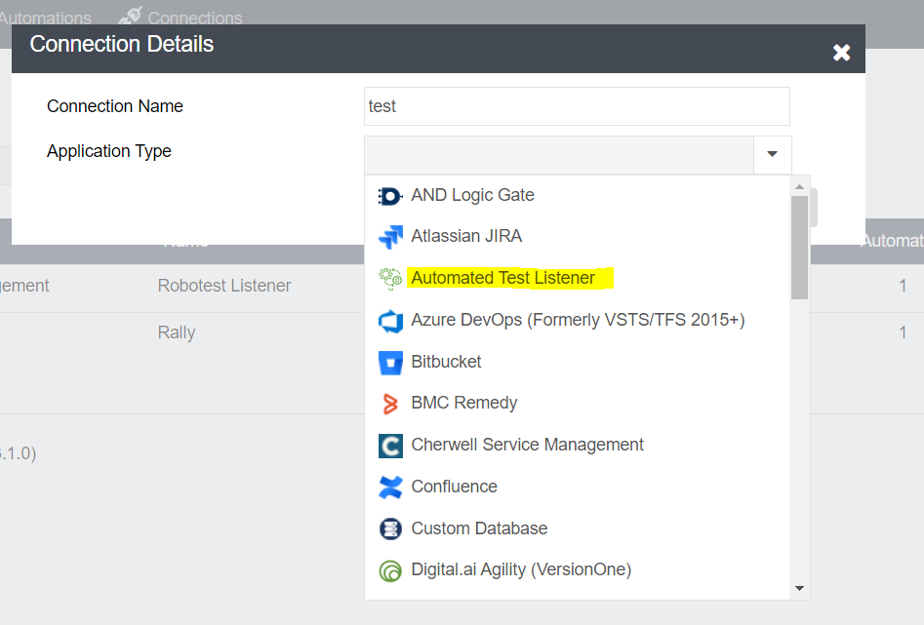

Provide the details.

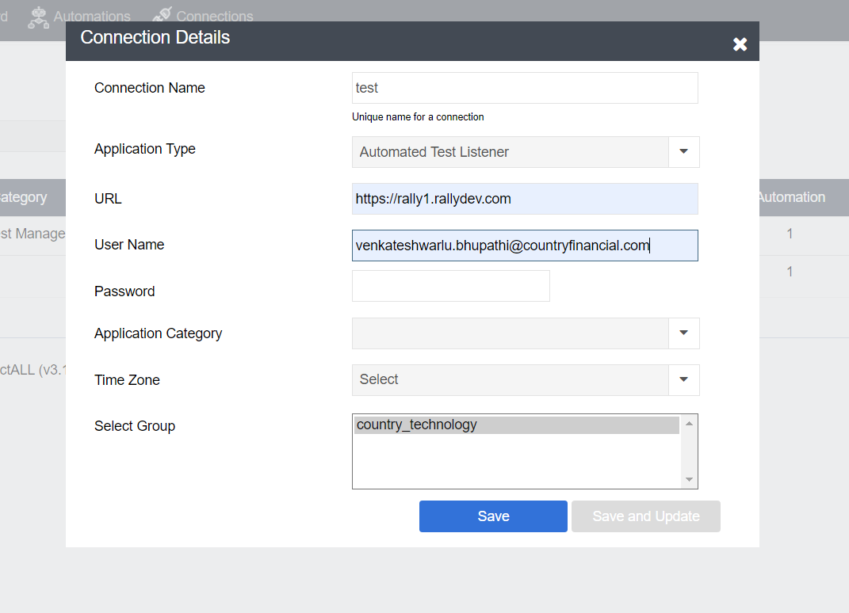

Click on Save

Step4: Click on Add connection.

Select “Rally software”

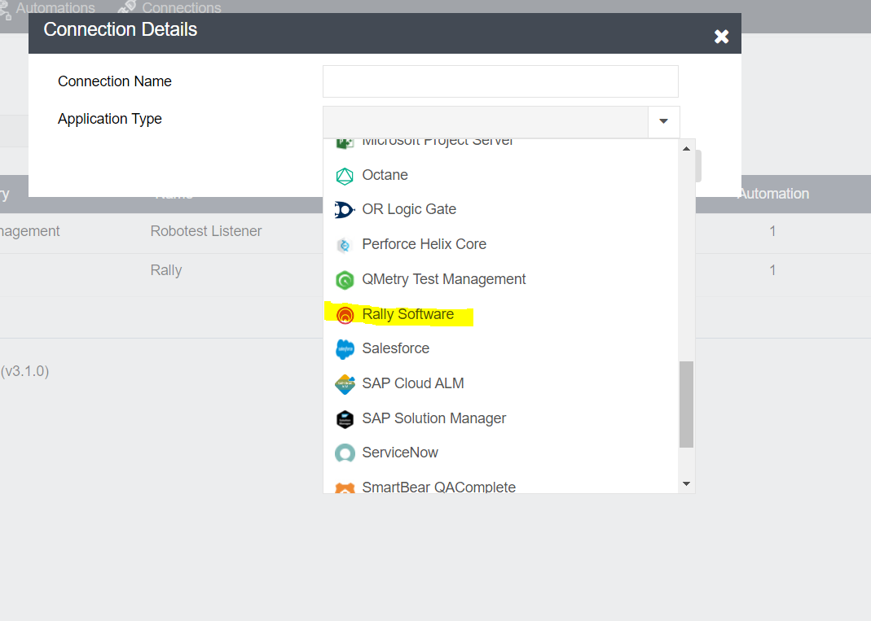

Update the details and save.

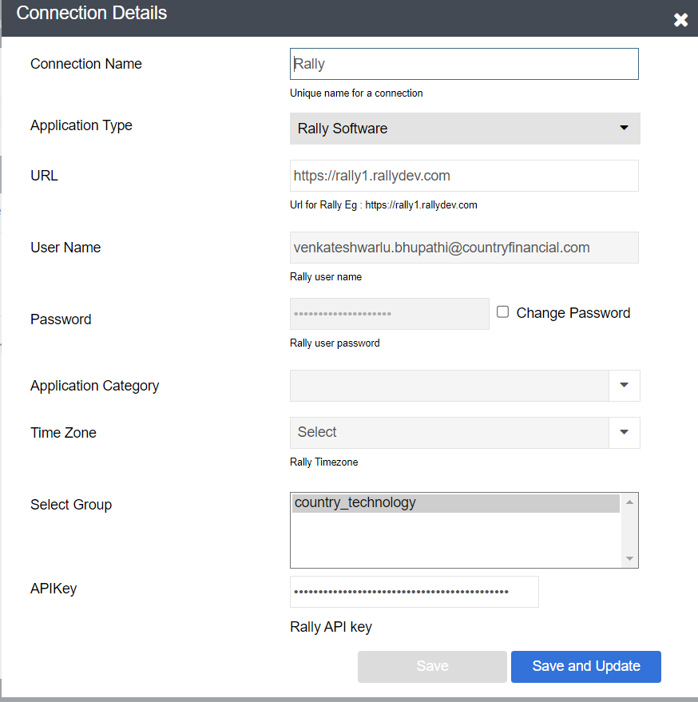

Step5: Click on Automation

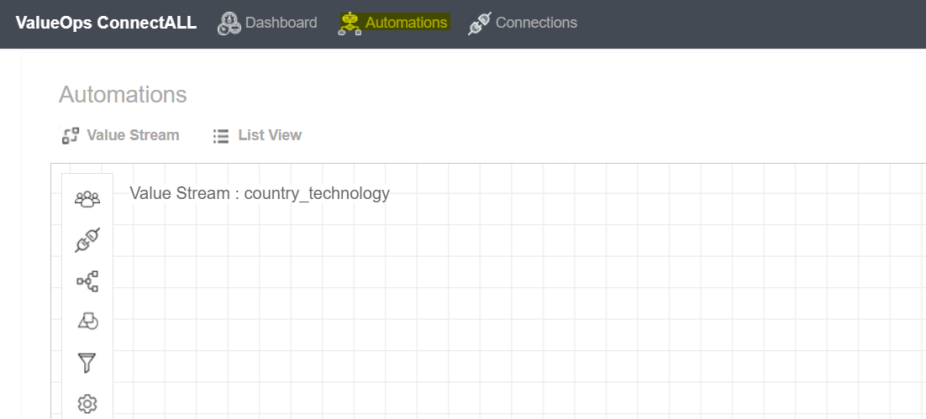

Select Applications icon.

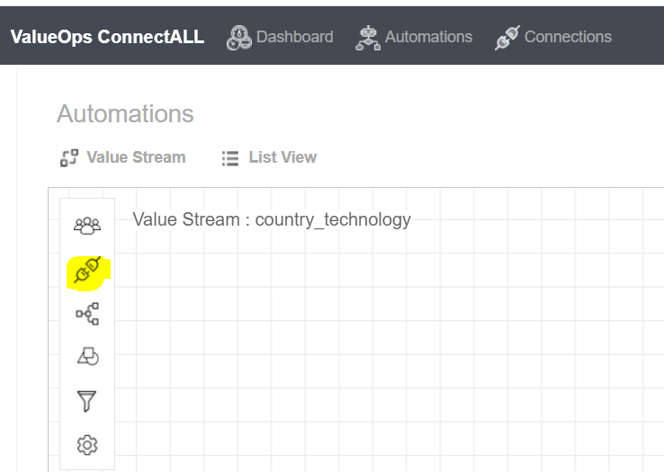

Select “Test Listener and Rally software Icons from the list and drag and drop.”

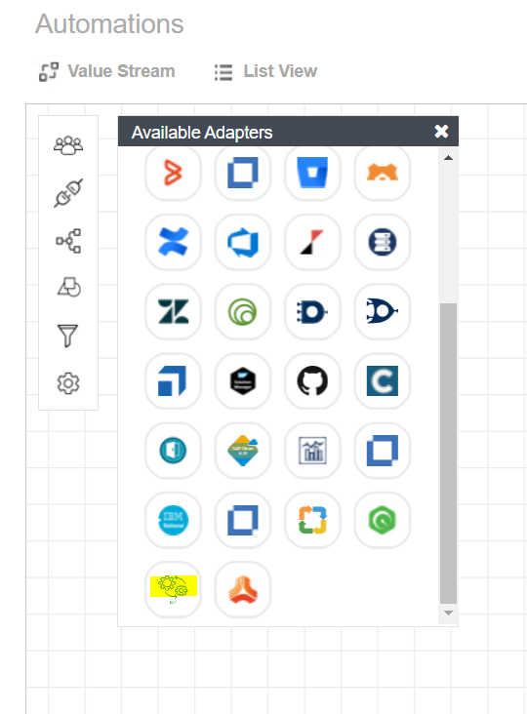

Connect these two icons and name it to “TestResults.”

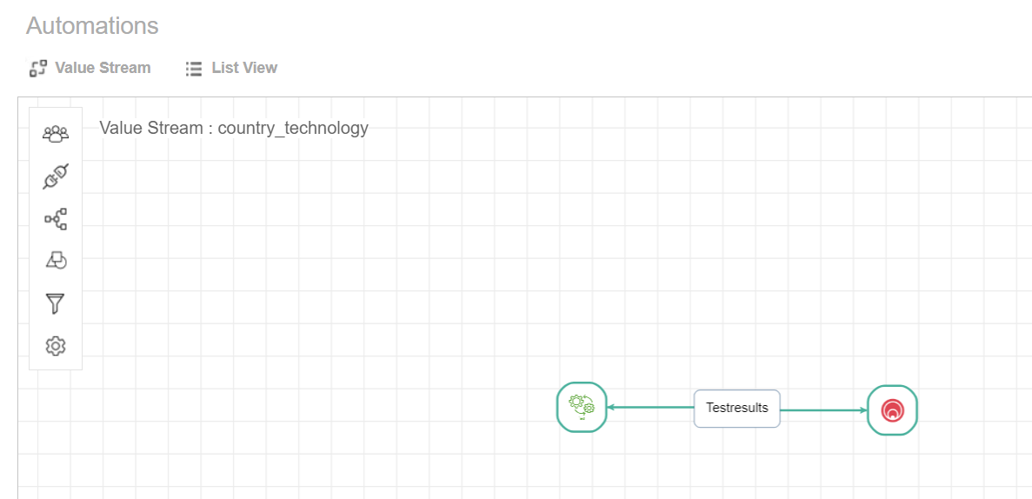

Click on Testresults --🡪 click on hamburger symbol.

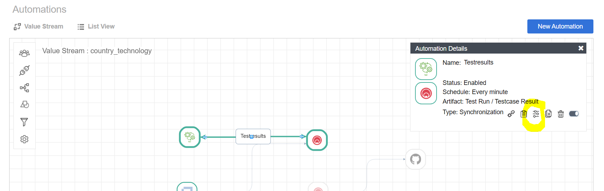

Select Entity Mapping

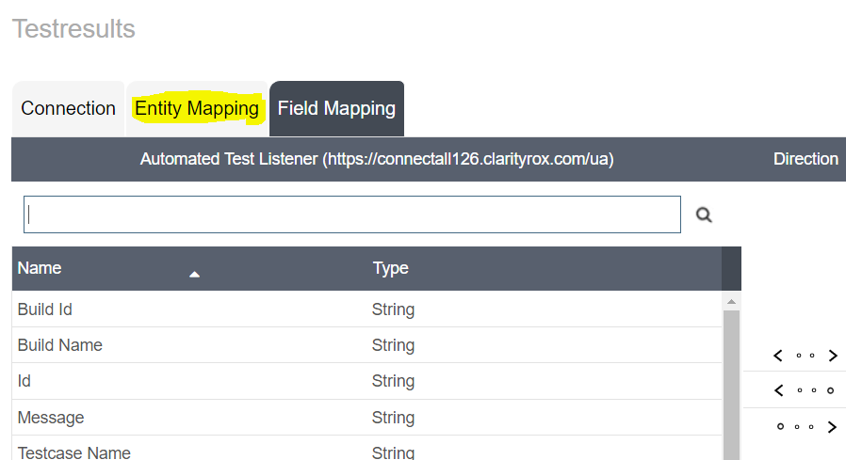

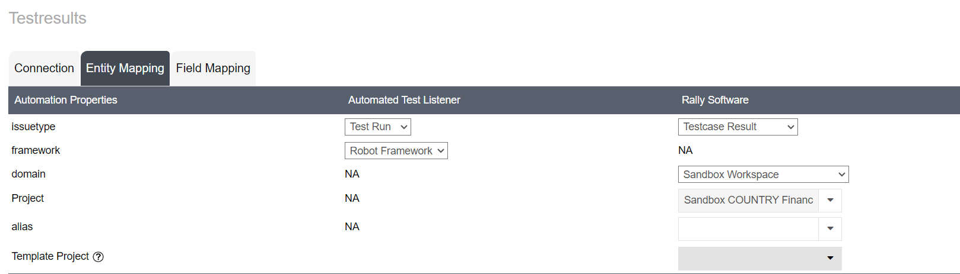

Test Listener:

Issue Type- Test Run

Framework- Robot Framework

Rally:

Issue Type- Testcase Result

Domain- Sandbox Workspace (Select workspace and project where it should update the results)

**Select sync type - Push.**

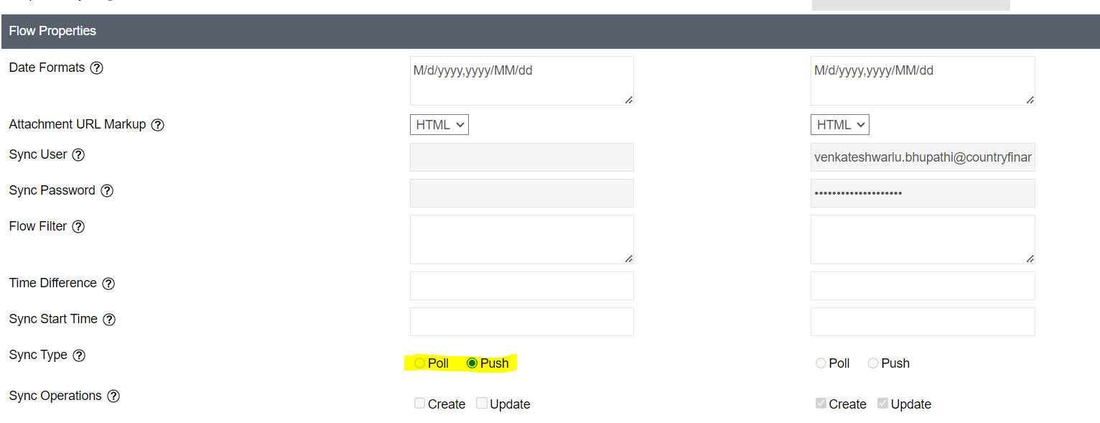

**Select Field mapping.**

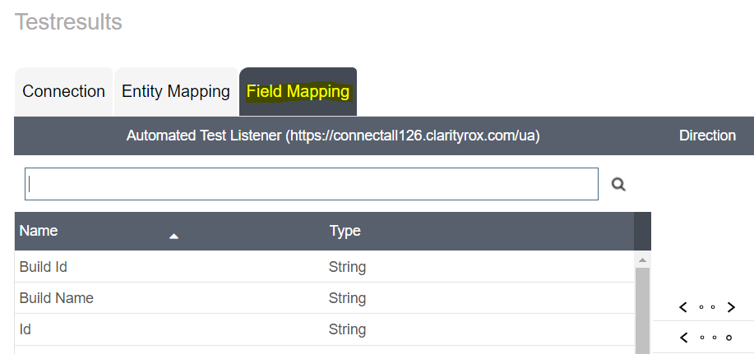

Map the fields (Automated Test Listener to Rally) like below screenshot.

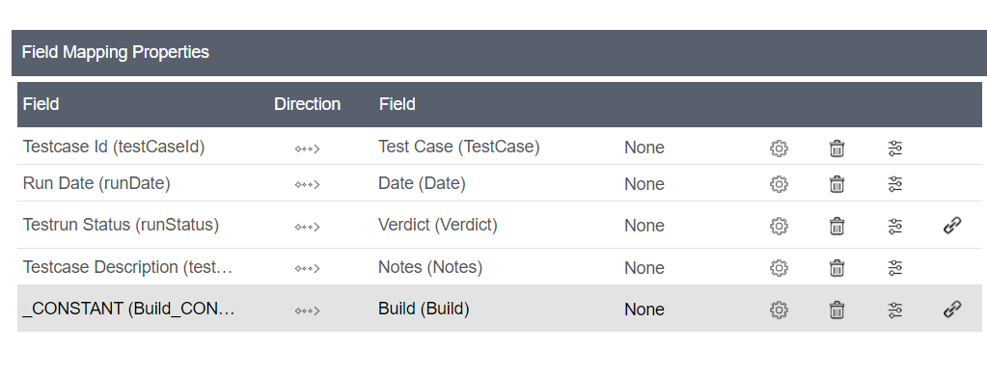

Select Test run Status (edit)

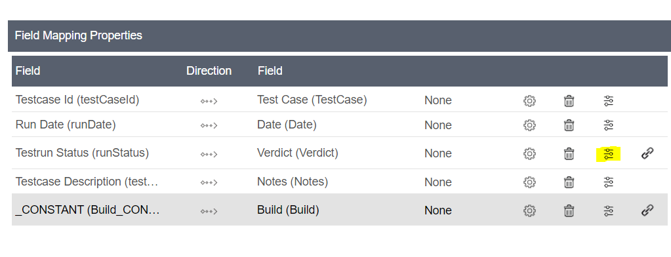

Map fields.

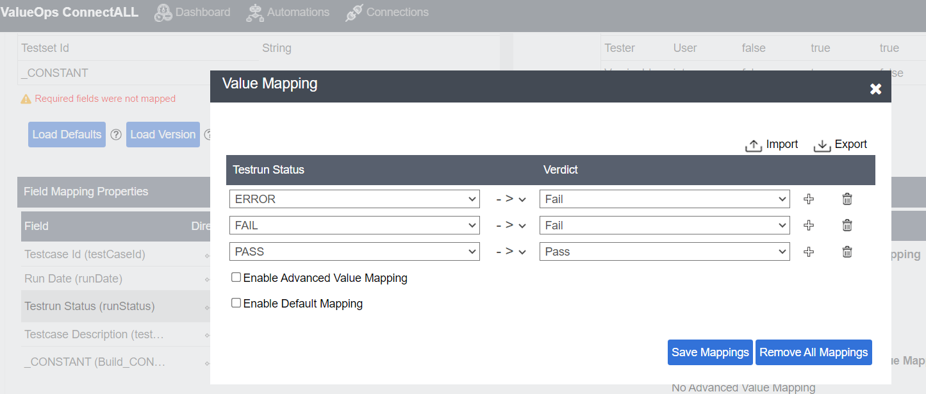

Click on Save mappings.

Click on Save

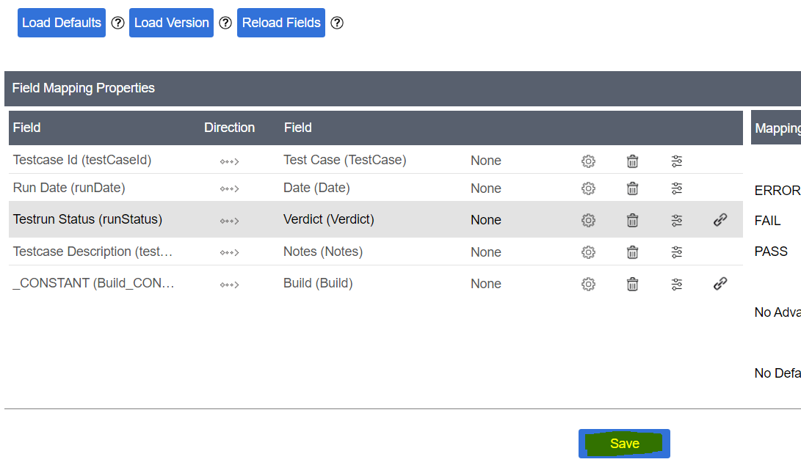

Enter version description and Save Mapping

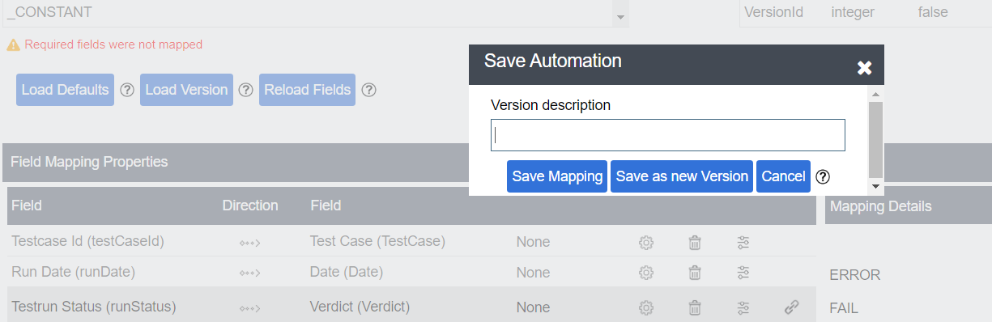

# Python script (API) configuration

1. Write Python script to retrieve Test case results from Rally

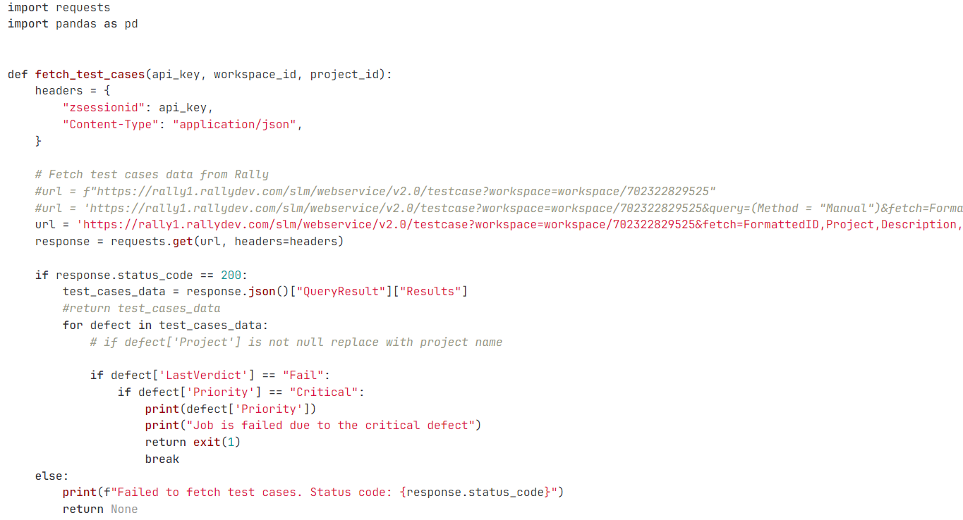

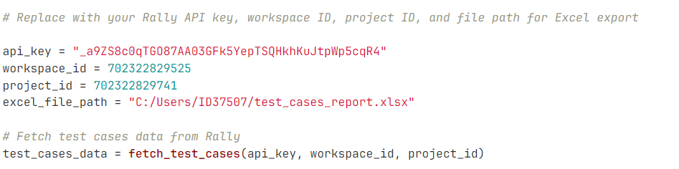

Provide below rally details through Python script.

1. Api Key
2. Workspace ID
3. Project ID

2.Create .toml file for configure ConnectALL.

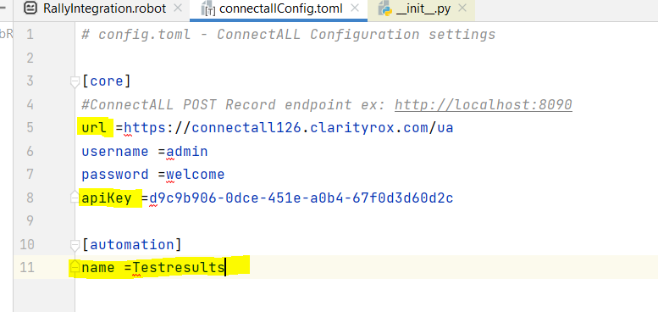

URL: Connect all URL.

Api Key: from Connect all.

Name: from Connect all.

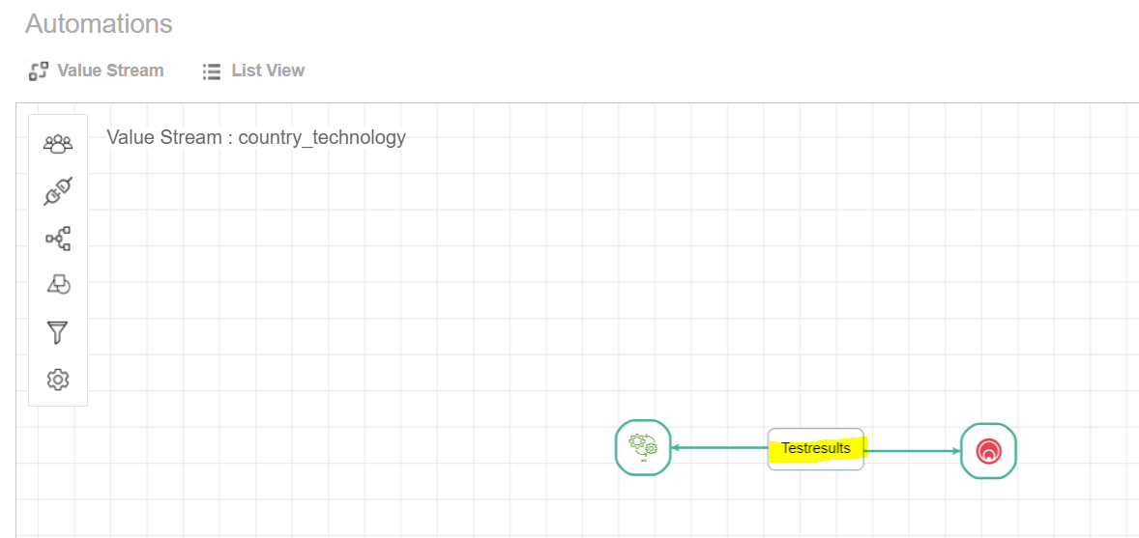

# Git lab setup

<https://gitlab.com/cc-services/ca82-008/15565/automation-team/rallyconnectall/-/tree/QualityGatesIntegration?ref_type=heads>

Push the code in to Git Lab.

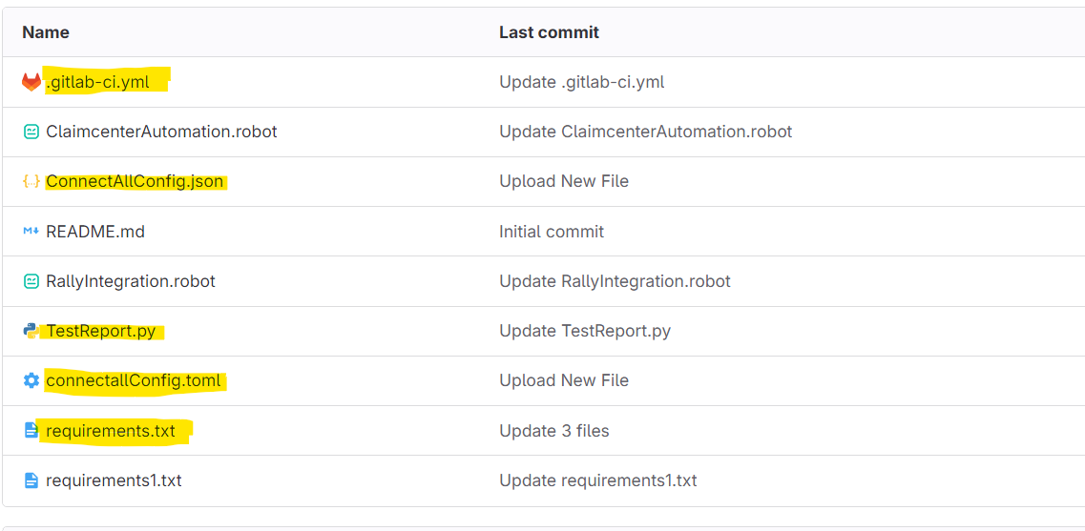

Open .yml file 🡪 update with below commands

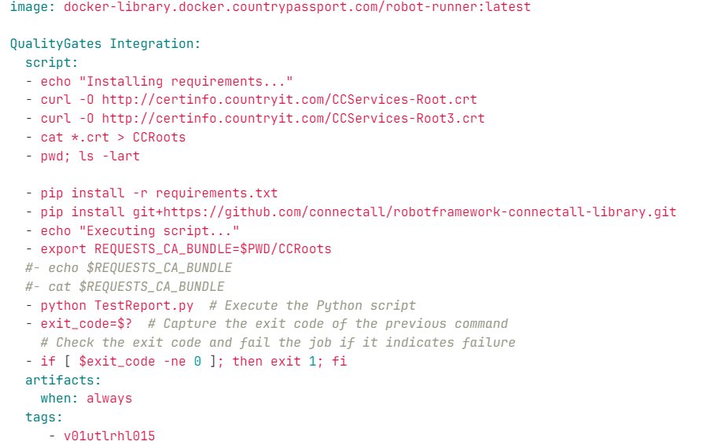

Execution flow:

1. Install required software.
2. Download and execute SSL certificate.
3. Install Listener (from config. toml) -🡪 this will establish connection between Git lab and ConnectALL`
4. Execute the Python script and get exit code.
5. Based on Exit code Pipeline jobs will Pass or Fail
6. Goto pipeline schedule and run.

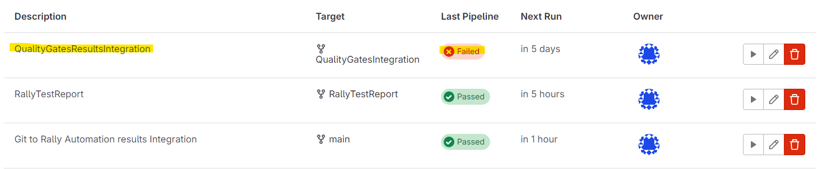

1. Verify status in Jobs sections.

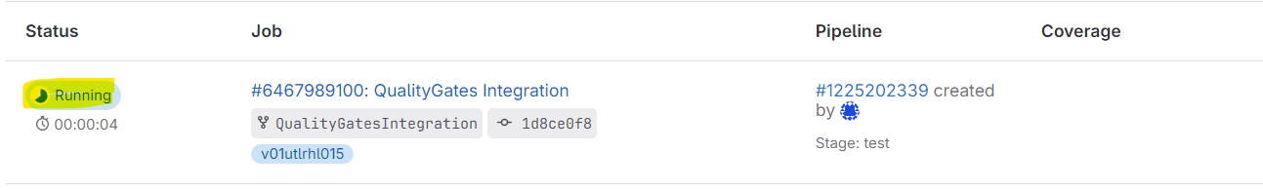

# Appendix

# One-Time request for access to ConnectALL:

Contact Rally team to get the credentials for ConnectALL.

Contact details:

Mickey - micky. holmes@broadcom

Sharath - [sharath.bhaskara@broadcom.com](mailto:sharath.bhaskara@broadcom.com)