PERSONAL FINANCE TRACKER

A web-based application for personal income, expense, budget,
and group expense management
21CSP302L - PROJECT
Submitted by
RISHAV KUMAR SINGH [RA2311003010590]
BHUPEN PRADHAN [RA2311003010606]
ARIN THOLIA [RA2311003010613]
Under the Guidance of
(GUIDE NAME)
(Designation, Department of Computational Intelligence)
in partial fulfillment of the requirements for the degree of
BACHELOR OF TECHNOLOGY
in
COMPUTER SCIENCE ENGINEERING
with specialization in (SPECIALIZATION NAME)
DEPARTMENT OF COMPUTATIONAL INTELLIGENCE
COLLEGE OF ENGINEERING AND TECHNOLOGY
SRM INSTITUTE OF SCIENCE AND TECHNOLOGY
KATTANKULATHUR – 603 203
MAY 2026

Department of Computational Intelligence
SRM Institute of Science & Technology
Own Work Declaration Form
This sheet must be filled in (each box ticked to show that the condition has been met). It must be signed and dated along with your student registration number and included with all assignments you submit – work will not be marked unless this is done.
[To be completed by the student for all assessments]
Degree / Course : Bachelor of Technology in Computer Science Engineering
Student Names : Rishav Kumar Singh, Bhupen Pradhan, Arin Tholia
Registration Numbers : RA2311003010590, RA2311003010606, RA2311003010613
Title of Work : Personal Finance Tracker
I / We hereby certify that this assessment compiles with the University's Rules and Regulations relating to Academic misconduct and plagiarism, as listed in the University Website, Regulations, and the Education Committee guidelines.
I / We confirm that all the work contained in this assessment is my / our own except where indicated, and that I / We have met the following conditions:
- Clearly referenced / listed all sources as appropriate
- Referenced and put in inverted commas all quoted text (from books, web, etc.)
- Given the sources of all pictures, data etc. that are not my own
- Not made any use of the report(s) or essay(s) of any other student(s) either past or present
- Acknowledged in appropriate places any help that I have received from others (e.g. fellow students, technicians, statisticians, external sources)
- Compiled with any other plagiarism criteria specified in the Course handbook / University website
I understand that any false claim for this work will be penalized in accordance with the University policies and regulations.
DECLARATION:
I am aware of and understand the University's policy on Academic misconduct and plagiarism and I certify that this assessment is my / our own work, except where indicated by referring, and that I have followed the good academic practices noted above.
<<Rishav Kumar Singh & Sign>> <<Bhupen Pradhan & Sign>> <<Arin Tholia & Sign>>
If you are working in a group, please write your registration numbers and sign with the date for every student in your group.

SRM INSTITUTE OF SCIENCE AND TECHNOLOGY
KATTANKULATHUR – 603 203
BONAFIDE CERTIFICATE
Certified that 21CSP302L – Project report titled "PERSONAL FINANCE TRACKER" is the bonafide work of "RISHAV KUMAR SINGH [RA2311003010590], BHUPEN PRADHAN [RA2311003010606], ARIN THOLIA [RA2311003010613]" who carried out the project work under my supervision. Certified further, that to the best of my knowledge the work reported herein does not form any other project report or dissertation on the basis of which a degree or award was conferred on an earlier occasion on this or any other candidate.
<<Signature>> <<Signature>>
SIGNATURE  Dr. ABCD  SUPERVISOR  Professor  DEPARTMENT OF COMPUTATIONAL INTELLIGENCE | SIGNATURE  DR. R. ANNIE UTHRA  PROFESSOR & HEAD  DEPARTMENT OF COMPUTATIONAL INTELLIGENCE

Examiner 1 Examiner 2
Name & Signature Name & Signature

ACKNOWLEDGEMENTS
We express our humble gratitude to Dr. C. Muthamizhchelvan, Vice-Chancellor, SRM Institute of Science and Technology, for the facilities extended for the project work and his continued support.
We extend our sincere thanks to Dr. Leenus Jesu Martin M, Dean-CET, SRM Institute of Science and Technology, for his invaluable support.
We wish to thank Dr. Revathi Venkataraman, Professor and Chairperson, School of Computing, SRM Institute of Science and Technology, for her support throughout the project work.
We encompass our sincere thanks to Dr. M. Pushpalatha, Professor and Associate Chairperson – CS, School of Computing, and Dr. C. Lakshmi, Professor and Associate Chairperson – AI, School of Computing, SRM Institute of Science and Technology, for their invaluable support.
We are incredibly grateful to our Head of the Department, <<Name, Designation & Department>>, SRM Institute of Science and Technology, for her suggestions and encouragement at all the stages of the project work.
We want to convey our thanks to our Project Coordinators, Panel Head, and Panel Members, Department of Computational Intelligence, SRM Institute of Science and Technology, for their inputs during the project reviews and support.
We register our immeasurable thanks to our Faculty Advisor, ………………., Department of <<Dept. Name>>, SRM Institute of Science and Technology, for leading and helping us to complete our course.
Our inexpressible respect and thanks to our guide, ……………………, Department of <<Dept. Name>>, SRM Institute of Science and Technology, for providing us with an opportunity to pursue our project under his / her mentorship. He / She provided us with the freedom and support to explore the research topics of our interest. His / Her passion for solving problems and making a difference in the world has always been inspiring.
We sincerely thank all the staff members of <<Dept. Name>>, School of Computing, S.R.M Institute of Science and Technology, for their help during our project. Finally, we would like to thank our parents, family members, and friends for their unconditional love, constant support and encouragement.
Authors

ABSTRACT
The Personal Finance Tracker is a full-stack web application designed to help individuals and groups manage their finances in a structured, transparent, and collaborative way. In an era where most people juggle multiple income sources, recurring expenses, and shared bills with friends or family, traditional spreadsheets and standalone budgeting apps fall short. They either lack support for shared expenses or focus only on individual tracking without offering meaningful analytics. This project addresses that gap by integrating personal expense tracking, budget monitoring, group expense management, and intelligent settlement suggestions into a single application.
The application is built using a modern technology stack consisting of React 18 with Vite for the frontend, Tailwind CSS for responsive styling, Recharts for data visualisation, Node.js with Express.js for the backend REST API, and MongoDB with Mongoose for persistent storage. Authentication is handled using JSON Web Tokens (JWT), with passwords hashed using bcrypt. The system is organised into clean, decoupled layers — pages, services, controllers, models, and middleware — making it maintainable and easy to extend.
Personal finance features include user registration and authentication, transaction management with category and date filters, a financial dashboard displaying monthly income, expense, and balance summaries with line and pie charts, and category-wise budget tracking with overspend alerts. Group features include group creation, member management, shared expenses with four split types (equal, unequal, percentage, and shares), automatic balance calculation, optimised settle-up suggestions, settlement payment tracking, recurring expense rules, expense templates, and activity notifications.
The project followed an Agile development approach with two sprints managed through MS Planner. Sprint 1 delivered the core personal finance functionality, while Sprint 2 introduced collaborative group expense management. All committed user stories were completed and validated against acceptance criteria using manual functional test cases. The final product offers a clean, responsive user experience and demonstrates how AI-era engineering practices and Agile project management can come together to produce a usable, community-oriented financial application.

TABLE OF CONTENTS
ABSTRACT iv
TABLE OF CONTENTS v
LIST OF FIGURES vi
LIST OF TABLES vii
ABBREVIATIONS viii

CHAPTER NO. TITLE PAGE NO.

1 INTRODUCTION 1
1.1 Introduction to Project 2
1.2 Motivation 3
1.3 Problem Statement and Description 4
1.4 Sustainable Development Goal of the Project 5
1.5 Product Vision Statement 6
1.6 Product Goal 7
1.7 Product Backlog (Key User Stories) 8
1.8 Product Release Plan 9
2 SPRINT PLANNING AND EXECUTION 10
2.1 Sprint 1 – Core Personal Finance Module 11
2.1.1 Sprint Goal with User Stories of Sprint 1 12
2.1.2 Functional Document 13
2.1.3 Architecture Document 14
2.1.4 UI Design 15
2.1.5 Functional Test Cases 16
2.1.6 Daily Call Progress 17
2.1.7 Committed vs Completed User Stories 18
2.1.8 Sprint Retrospective 19
2.2 Sprint 2 – Group Expense Management Module 20
2.2.1 Sprint Goal with User Stories of Sprint 2 21
2.2.2 Functional Document 22
2.2.3 Architecture Document 23
2.2.4 UI Design 24
2.2.5 Functional Test Cases 25
2.2.6 Daily Call Progress 26
2.2.7 Committed vs Completed User Stories 27
2.2.8 Sprint Retrospective 28
3 RESULTS AND DISCUSSIONS 29
3.1 Project Outcomes 30
3.2 Committed vs Completed User Stories 31
4 CONCLUSIONS & FUTURE ENHANCEMENT 32
APPENDIX 33
A. PATENT DISCLOSURE FORM 34
B. SAMPLE CODING 35
C. PLAGIARISM REPORT 36

LIST OF FIGURES
FIGURE NO. TITLE PAGE NO.
Figure 1.1 MS Planner Board of Personal Finance Tracker 8
Figure 1.2 Release Plan of Personal Finance Tracker 9
Figure 2.1 User Story for User Registration 12
Figure 2.2 User Story for Add Transaction 12
Figure 2.3 User Story for Dashboard Analytics 12
Figure 2.4 System Architecture Diagram – Sprint 1 14
Figure 2.5 UI Design for Login Page 15
Figure 2.6 UI Design for Dashboard Page 15
Figure 2.7 Standup Meetings – Sprint 1 17
Figure 2.8 Bar Graph for Committed vs Completed (Sprint 1) 18
Figure 2.9 Sprint Retrospective for Sprint 1 19
Figure 2.10 System Architecture Diagram – Sprint 2 23
Figure 2.11 UI Design for Group Details Page 24
Figure 2.12 UI Design for Settlements Page 24
Figure 2.13 Standup Meetings – Sprint 2 26
Figure 2.14 Bar Graph for Committed vs Completed (Sprint 2) 27
Figure 2.15 Sprint Retrospective for Sprint 2 28
Figure 3.1 Overall Committed vs Completed User Stories 31

LIST OF TABLES
TABLE NO. TITLE PAGE NO.
Table 1.1 Product Backlog of Personal Finance Tracker 7
Table 2.1 Detailed User Stories of Sprint 1 12
Table 2.2 Access Level Authorization Matrix – Sprint 1 13
Table 2.3 Detailed Functional Test Cases – Sprint 1 16
Table 2.4 Committed vs Completed Stories – Sprint 1 18
Table 2.5 Detailed User Stories of Sprint 2 21
Table 2.6 Access Level Authorization Matrix – Sprint 2 22
Table 2.7 Detailed Functional Test Cases – Sprint 2 25
Table 2.8 Committed vs Completed Stories – Sprint 2 27

ABBREVIATIONS
SDLC | Software Development Life Cycle
SPA | Single Page Application
REST | Representational State Transfer
API | Application Programming Interface
JWT | JSON Web Token
JSON | JavaScript Object Notation
UI | User Interface
UX | User Experience
CSV | Comma-Separated Values
CRUD | Create, Read, Update, Delete
CORS | Cross-Origin Resource Sharing
HTTP | Hypertext Transfer Protocol
PO | Product Owner
SM | Scrum Master
SDG | Sustainable Development Goal
UPI | Unified Payments Interface
NoSQL | Not Only SQL
ODM | Object Document Mapper

CHAPTER 1
INTRODUCTION
1.1 Introduction to Personal Finance Tracker
The Personal Finance Tracker is a web-based application that brings together personal expense tracking, budgeting, and group expense management in a single platform. The system is designed to help users record their daily income and expenses, set monthly category budgets, visualise spending patterns, and split shared bills with friends or family in a transparent and structured manner. By combining individual financial control with group-oriented features, the platform addresses a real-world problem that conventional budgeting tools and spreadsheets fail to solve effectively.
The frontend of the application is built using React 18 along with the Vite build tool and Tailwind CSS for utility-first responsive styling. Charts and analytics are powered by the Recharts library. The backend uses Node.js with Express.js to expose a RESTful API, and MongoDB with Mongoose acts as the primary data store. Authentication is implemented using JSON Web Tokens (JWT), and user passwords are securely hashed with bcrypt. All interactions between the client and the server happen over HTTPS-friendly REST endpoints, with request validation performed using express-validator on the server side.
Beyond personal expense tracking, the application introduces a group module that allows users to create groups, add members, and log shared expenses with multiple split modes — equal, unequal, percentage, and shares. The system automatically computes per-member balances and provides optimised settle-up suggestions that minimise the number of payments needed to settle dues. Recurring expense rules, expense templates, and activity notifications further enhance the user experience by reducing repetitive entry and keeping users informed of group activity.
1.2 Motivation
The motivation behind this project stems from a common observation: most students and young professionals find it surprisingly difficult to keep track of their own money. Recurring subscriptions, occasional outings, daily food expenses, and shared bills among roommates often go unrecorded, leading to either savings shortfalls at month-end or awkward conversations about who owes whom. Existing solutions tend to be either too narrow — focusing only on personal tracking like a digital ledger — or too commercial, hiding key features behind paywalls.
At the same time, splitting bills with friends remains a fragmented experience. Some apps focus only on splits, others only on tracking, and very few offer both with a clean and unified user experience. This led us to design a single application that lets users control their personal finances and also collaborate with their group on shared expenses, all while staying free, simple, and transparent. The project is also a meaningful exercise in modern full-stack development and Agile project management, giving the team practical exposure to industry-standard tools and processes.
1.3 Problem Statement and Description
Personal financial mismanagement and unclear settlement of shared expenses are two related problems that affect a wide segment of users today. Even with multiple banking apps and digital wallets, users seldom have a consolidated view of their money: where it comes from, where it goes, and what is left at the end of the month. Furthermore, when expenses are shared with others, ad-hoc methods like screenshots, chat messages, and informal records often lead to confusion or missed payments.
This project aims to develop a Personal Finance Tracker — a unified web application — that solves both problems together by:
- Providing a clean, secure interface for users to log income and expenses with category, date, and notes.
- Offering a real-time financial dashboard showing monthly summaries, line trends, and category-wise distribution of spending.
- Allowing users to set per-category monthly budgets and visualising overspending through progress indicators.
- Supporting group creation and shared expense logging with four split types — equal, unequal, percentage, and shares.
- Computing per-member balances within a group and producing optimised settle-up suggestions.
- Tracking settlement payments (full or partial) and updating balances automatically.
- Maintaining a shared expense history with CSV export, recurring expense rules, expense templates, and notifications.
1.4 Sustainable Development Goal of the Project
The Personal Finance Tracker aligns with United Nations Sustainable Development Goal 8 (Decent Work and Economic Growth) and Goal 10 (Reduced Inequalities). By empowering individuals to understand and manage their own finances, the platform promotes financial literacy and supports better economic decision-making at a personal level. When users have visibility into their income, expenses, and savings, they are better equipped to plan for the future, avoid unnecessary debt, and channel resources towards meaningful goals such as education and health.
In addition, the group expense module promotes fair and transparent settlement of shared costs, reducing financial friction within households and communities. Optimised settle-up suggestions ensure that no member is overburdened or under-credited. By making structured financial tracking accessible without cost, the platform contributes to reducing inequality in access to financial tools — historically reserved for users with access to premium banking products or professional accounting software. The application thus supports both economic empowerment of the individual and equitable financial collaboration within groups, contributing to broader sustainable development objectives.
1.5 Product Vision Statement
1.5.1 Audience
- Primary Audience: College students, young professionals, and roommates who want to track personal finances and split shared expenses with friends or family.
- Secondary Audience: Households and small communities seeking a simple, free tool for managing recurring shared bills like rent, utilities, and groceries.
1.5.2 Needs
- Primary Needs: A unified place to record income and expenses, view monthly summaries, set budgets, and split bills fairly.
- Secondary Needs: Automatic balance calculation, optimised settlement plans, recurring rules for predictable expenses, and notifications about group activity.
1.5.3 Product
- Core Product: A responsive web application combining personal finance tracking with group expense management, secured with JWT-based authentication.
- Additional Features: Category-wise budgets with overspend alerts, shared expense history with CSV export, recurring rules, expense templates, and an in-app notification system.
1.5.4 Values
- Core Values: Transparency in shared expenses, simplicity in personal tracking, accuracy in balance calculation, and accessibility through a free, browser-based interface.
- Differentiators: A single application combining both personal and group finance modules, four flexible split types for shared expenses, and minimum-transaction settle-up suggestions.
1.6 Product Goal
The primary goal of the Personal Finance Tracker is to give every user a clear, real-time picture of their financial health and a simple, fair way to manage shared expenses with their group. The application aims to remove the friction that comes with traditional spreadsheets and ad-hoc record keeping by offering a clean dashboard, structured forms, and automated calculations. Users should be able to log a transaction, see its impact on their monthly summary and budget, and immediately understand what it means for their finances.
Beyond personal use, the goal extends to making group finance painless. The application must allow members to log shared expenses with various split types, automatically compute who owes whom, and recommend the smallest set of payments that clears all dues. This goal recognises that financial transparency strengthens relationships within households and communities. By making the process intuitive and data-driven, the project aspires to encourage healthy financial habits and reduce the everyday stress associated with managing money.
1.7 Product Backlog (Key User Stories with Desired Outcomes)
Table 1.1 Product Backlog of Personal Finance Tracker
S.No | User Stories of Personal Finance Tracker
#US 1 | As a new user, I want to register with my name, email, and password so that I can create a personal account.
#US 2 | As a registered user, I want to log in securely so that I can access my financial data.
#US 3 | As a user who forgot my password, I want to receive a reset link via email so that I can regain access to my account.
#US 4 | As a user, I want to add income or expense transactions with category, amount, date, and notes so that I can track my finances.
#US 5 | As a user, I want to view, search, and filter my transactions so that I can review specific records easily.
#US 6 | As a user, I want to edit or delete an existing transaction so that I can correct mistakes.
#US 7 | As a user, I want a dashboard that shows my monthly income, expenses, and balance so that I understand my financial health.
#US 8 | As a user, I want to set monthly category budgets so that I can monitor and control my spending.
#US 9 | As a user, I want to create expense groups so that I can track shared expenses with friends or family.
#US 10 | As a group admin, I want to add members to my group by name and email so that we can split expenses together.
#US 11 | As a group member, I want to log shared expenses with split options (equal, unequal, percentage, shares) so that costs are divided fairly.
#US 12 | As a group member, I want to see who owes whom so that I understand the financial state of the group.
#US 13 | As a group member, I want optimised settle-up suggestions so that I can clear balances with the least number of payments.
#US 14 | As a member, I want to record settlement payments so that balances are kept up to date.
#US 15 | As a user, I want to view shared expense history and export it as CSV so that I can keep my own records.
#US 16 | As a user, I want to create recurring expense rules so that regular shared bills are auto-generated.
#US 17 | As a user, I want to save expense templates so that I can quickly add similar expenses later.
#US 18 | As a user, I want activity notifications so that I stay informed about group changes.

The product backlog of the Personal Finance Tracker was configured using the MS Planner Agile Board, which is represented in the following Figure 1.1. The backlog contains the complete user stories for both personal and group finance modules. Each user story contains essential parameters such as MoSCoW prioritisation, functional and non-functional requirements, detailed acceptance criteria, and linked sub-tasks.
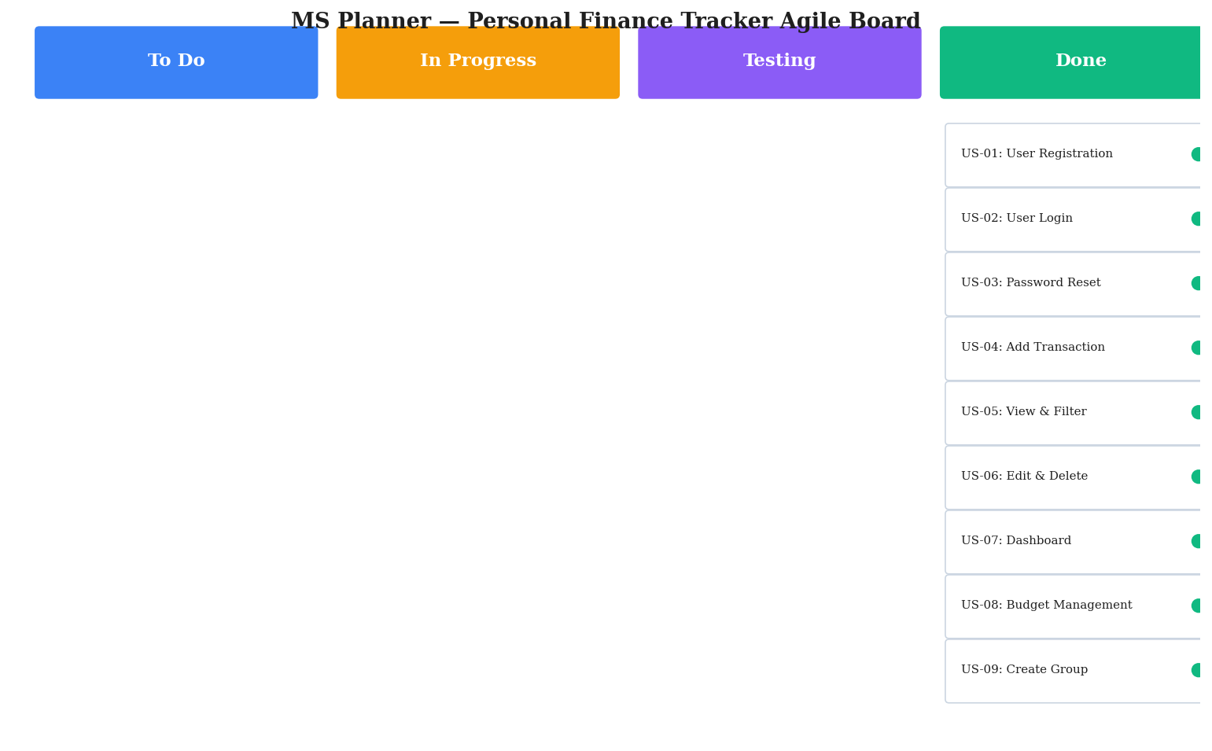
Figure 1.1 MS Planner Board of Personal Finance Tracker
1.8 Product Release Plan
The product release plan organises the user stories into two sprints. Sprint 1 focuses on the foundational personal finance module covering authentication, transactions, dashboard, and budgets. Sprint 2 builds on this foundation by adding group expense management, settlements, recurring rules, templates, and notifications. The following Figure 1.2 depicts the release plan of the project.
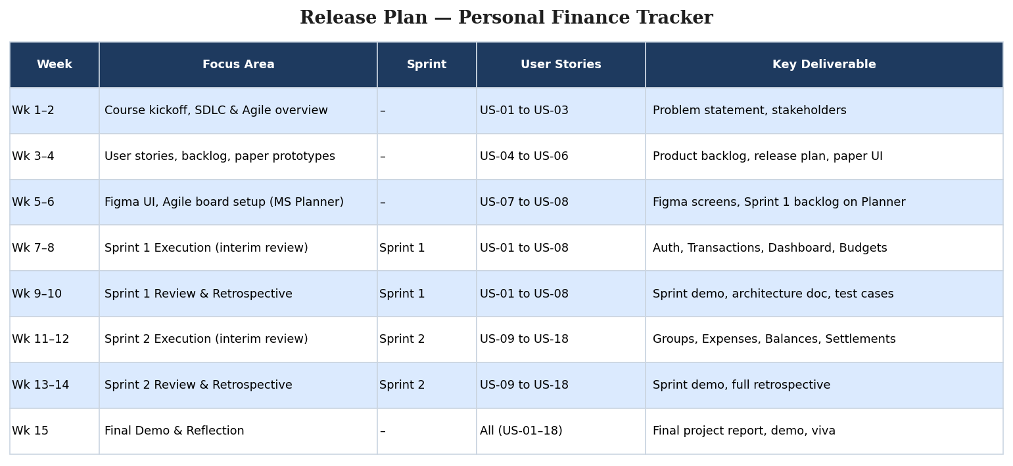
Figure 1.2 Release Plan of Personal Finance Tracker

CHAPTER 2
SPRINT PLANNING AND EXECUTION
2.1 Sprint 1 — Core Personal Finance Module
2.1.1 Sprint Goal with User Stories of Sprint 1
The goal of the first sprint is to deliver a working personal finance application covering user authentication, transaction management, the financial dashboard, and category-wise budget tracking. By the end of Sprint 1, a user should be able to register, log in, record income and expenses, view monthly analytics, and set budgets per category.
The following table 2.1 represents the detailed user stories of Sprint 1.
Table 2.1 Detailed User Stories of Sprint 1
S.No | Detailed User Stories
US #1 | As a new user, I want to register with my name, email, and password so that I can access the application.
US #2 | As a registered user, I want to log in securely so that I can access my financial data.
US #3 | As a user who forgot my password, I want to receive a reset link via email so that I can regain access.
US #4 | As a user, I want to add income or expense transactions with category, amount, date, and notes.
US #5 | As a user, I want to view, search, and filter transactions and export them as CSV.
US #6 | As a user, I want to edit or delete an existing transaction.
US #7 | As a user, I want a dashboard with monthly income, expense, balance, and category-wise charts.
US #8 | As a user, I want to set monthly category budgets and see overspend alerts.

Planner Board representations of selected user stories are shown in Figures 2.1, 2.2, and 2.3.
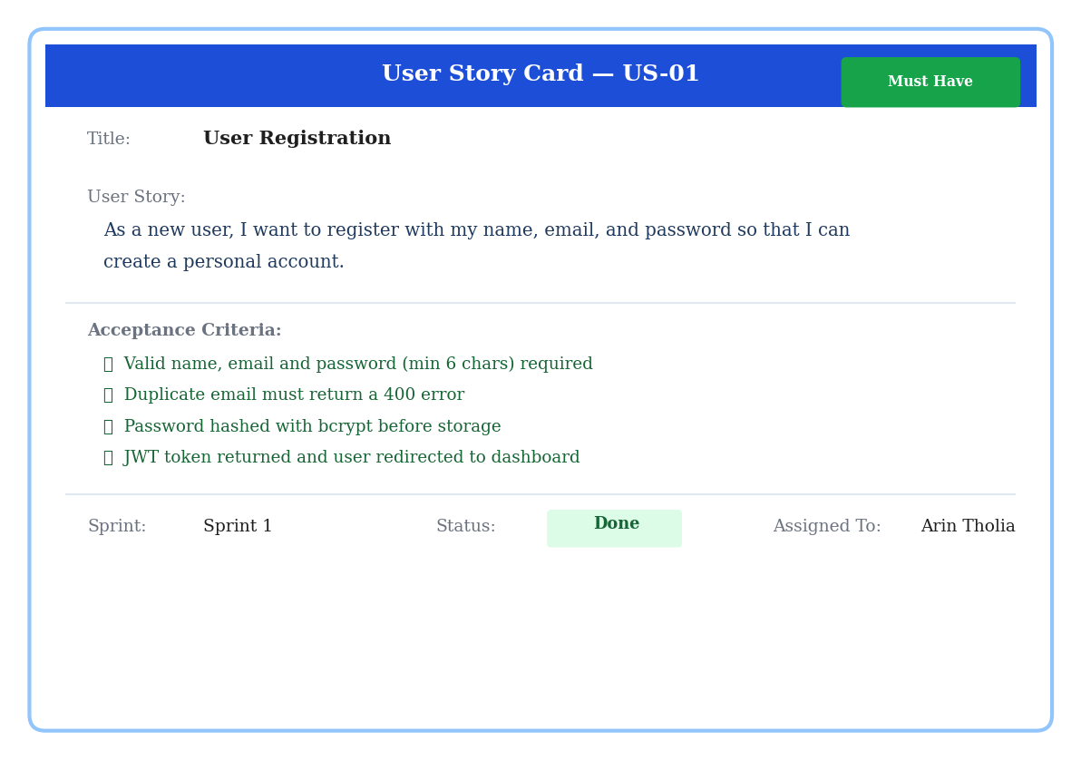
Figure 2.1 User Story for User Registration
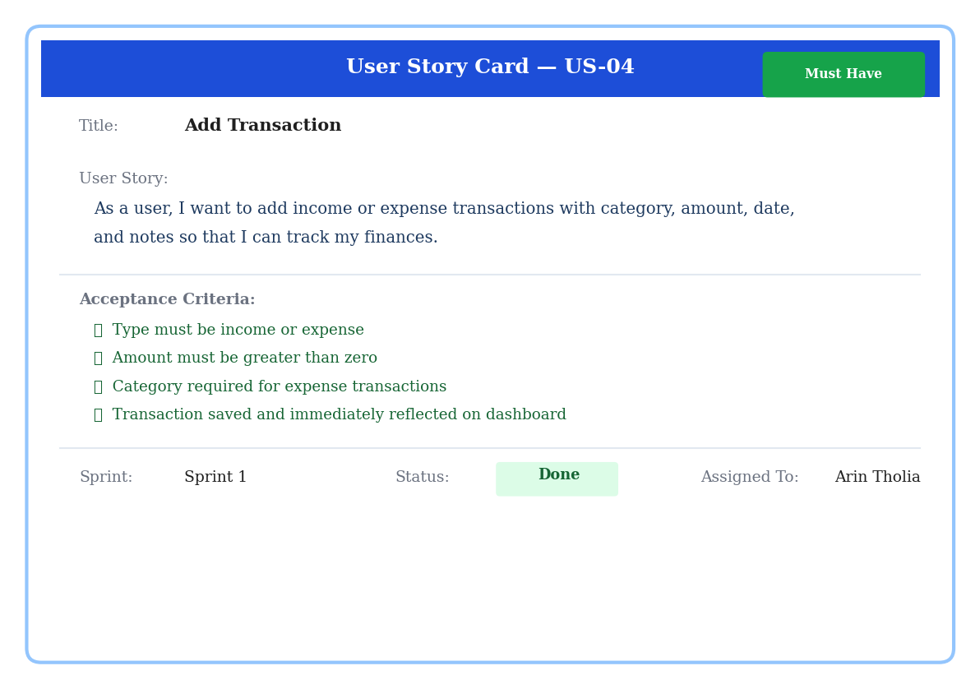
Figure 2.2 User Story for Add Transaction
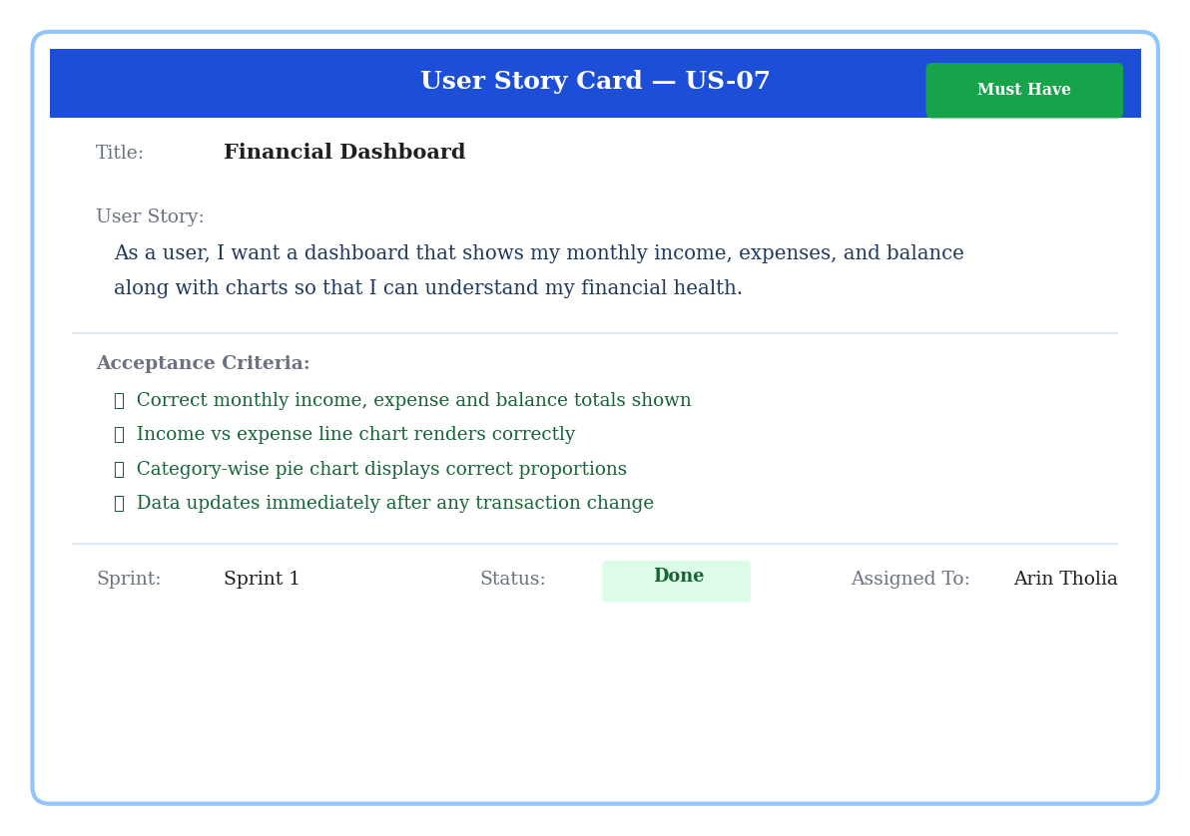
Figure 2.3 User Story for Dashboard Analytics
2.1.2 Functional Document
2.1.2.1 Introduction
The Personal Finance Tracker project is a web-based application that gives users a structured way to manage their money. Sprint 1 focuses on the core personal finance module, delivering authentication, transaction management, an analytics dashboard, and category-wise budgets. The features in this sprint form the backbone of the entire application and act as the foundation on which the group expense module of Sprint 2 is built.
2.1.2.2 Product Goal
The primary goal of Sprint 1 is to provide a secure, intuitive, and reliable platform where users can:
- Create accounts and log in securely using JWT-based authentication.
- Record income and expense transactions with category, amount, date, and notes.
- Filter, search, and export transactions for review.
- Visualise monthly financial summaries and category-wise spending.
- Set per-category monthly budgets with overspend alerts.
2.1.2.3 Demography (Users, Location)
Users:
- Target Users: College students, young professionals, and individuals managing personal finances.
- User Characteristics: Basic web literacy; varying levels of financial discipline; English-speaking primary audience.
Location:
- Target Location: Global, with primary focus on India where INR is the default currency.
2.1.2.4 Business Processes
The key business processes of Sprint 1 include:
User Registration and Authentication:
- Users register with name, email, and password. The system validates input, hashes the password using bcrypt, and creates a record in MongoDB.
- On successful login, a JWT token is issued, which the frontend stores and attaches to subsequent API calls via the Authorization header.
Transaction Management:
- Users can add transactions of type income or expense, attaching a category, amount, date, and optional notes.
- Transactions are listed with pagination, filtering, search, and CSV export.
Dashboard and Budget Tracking:
- The dashboard aggregates current-month transactions to display income, expense, and balance summaries along with line and pie charts.
- Budgets are stored per category per month; the system computes percentage utilisation and indicates overspend visually.
2.1.2.5 Features
This sprint focuses on implementing the following key features.
Feature 1: User Authentication
Description: Secure account creation, login, and password reset flow built using JWT, bcrypt, and email-based reset tokens.
User Story: As a user, I want to register, log in, and reset my password securely so that my financial data remains protected.
Feature 2: Transaction Management
Description: Full CRUD support for income and expense transactions with filtering and pagination.
User Story: As a user, I want to record and manage my transactions so that I can track my finances over time.
Feature 3: Financial Dashboard
Description: Real-time analytics dashboard with summary cards and charts for the current month.
User Story: As a user, I want a dashboard that shows my monthly financial summary so that I can understand my spending at a glance.
Feature 4: Budget Management
Description: Category-wise monthly budgets with progress visualisation and overspend alerts.
User Story: As a user, I want to set spending limits for each category so that I can control my expenses.
2.1.2.6 Authorization Matrix
Table 2.2 Access Level Authorization Matrix – Sprint 1
Role | Access Level
Authenticated User | Full access to own transactions, dashboard, budgets, and account settings.
Guest (Unauthenticated) | Access only to login, registration, and password reset pages.
System / API | Access to validate JWT tokens, run controllers, and persist data via Mongoose.

2.1.2.7 Assumptions
- Users have stable internet access and a modern web browser.
- The MongoDB Atlas cluster is reachable from the deployed backend instance.
- Email delivery for password reset is configured through a transactional email provider.
- Users are responsible for the accuracy of the data they enter.
2.1.3 Architecture Document
2.1.3.1 Application
The application follows a clean layered architecture with a clear separation between presentation, business logic, and persistence:
- Authentication Service: Handles user registration, login, JWT issuance, password reset, and profile retrieval.
- Transaction Service: Provides CRUD operations on transactions, with filtering, pagination, and search.
- Dashboard Service: Aggregates monthly summaries and analytics for the dashboard charts.
- Budget Service: Manages monthly category budgets and computes utilisation against transactions.
2.1.3.2 System Architecture
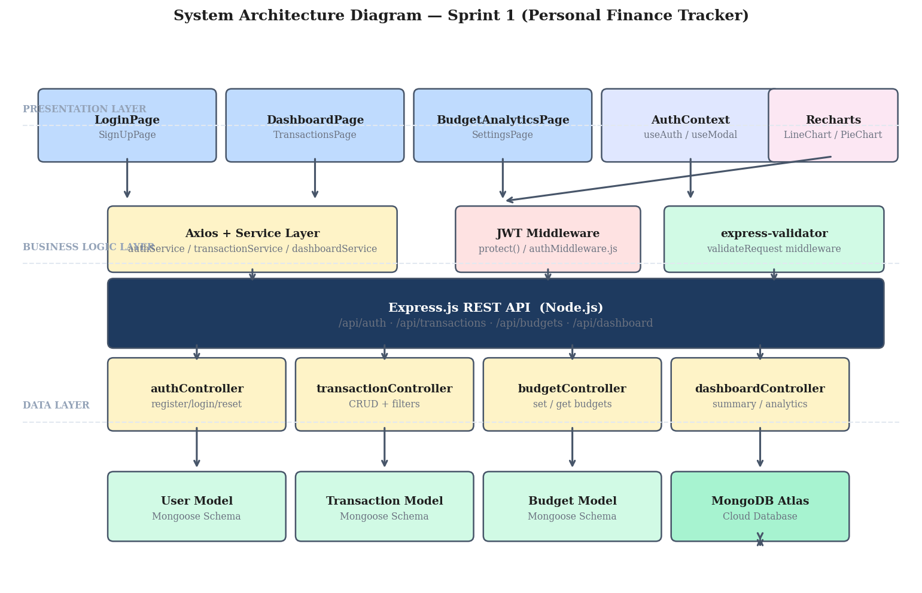
Figure 2.4 System Architecture Diagram – Sprint 1
2.1.3.3 Data Exchange Contract
Frequency of Data Exchanges:
- Real-Time Exchanges: All user-initiated operations (login, transaction CRUD, dashboard load, budget set) are processed synchronously through REST endpoints.
- On-Demand Refresh: The dashboard reloads when the user navigates back to it or after creating a new transaction, ensuring consistency.
Data Sets:
- User Data: name, email, hashed password, preferences (currency, theme, notification settings).
- Transaction Data: type, title, category, amount, date, notes, payment method, userId reference.
- Budget Data: userId, category, monthlyLimit, month, year.
Mode of Exchanges:
- REST API: All client-server interactions use REST endpoints exposed under /api on the Express server.
- JSON: All payloads are serialised as JSON for both requests and responses.
- JWT: Authentication tokens are exchanged via the Authorization HTTP header on protected endpoints.
2.1.4 UI Design
The user interface for Sprint 1 was designed to be clean, responsive, and information-dense without becoming cluttered. The following figures show key UI screens.
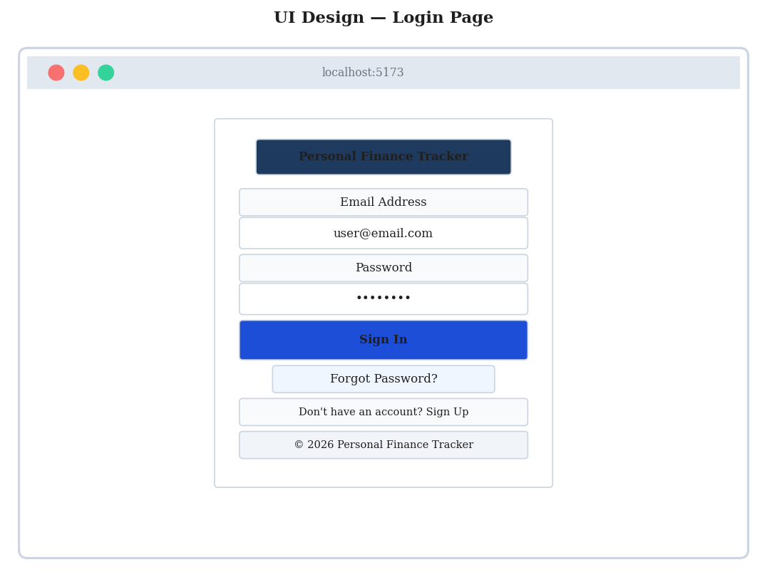
Figure 2.5 UI Design for Login Page
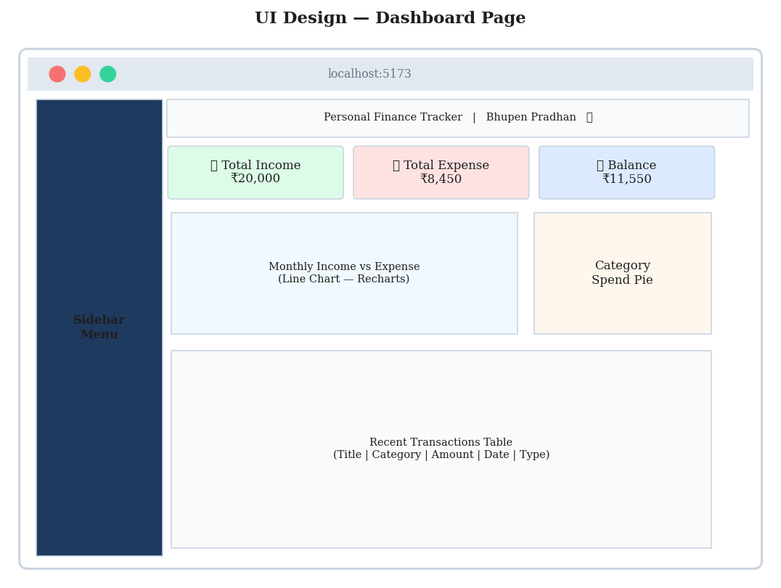
Figure 2.6 UI Design for Dashboard Page
2.1.5 Functional Test Cases
Table 2.3 Detailed Functional Test Cases – Sprint 1
TC# | US | Scenario | Steps / Input | Expected Result | Status
TC-01 | US #1 | Successful registration | Name, valid email, password ≥ 6 chars | Account created; JWT issued | Pass
TC-02 | US #1 | Duplicate email | Register with already-used email | 400 error: Email already exists | Pass
TC-03 | US #2 | Valid login | Correct email and password | JWT issued; redirect to dashboard | Pass
TC-04 | US #2 | Wrong password | Wrong password for valid email | 401 error: Invalid credentials | Pass
TC-05 | US #3 | Forgot password flow | Submit forgot password form | Reset link emailed; success shown | Pass
TC-06 | US #4 | Add expense | Type=Expense, Cat=Food, Amt=250 | Saved; dashboard updates | Pass
TC-07 | US #4 | Zero amount | Submit with amount = 0 | Validation error | Pass
TC-08 | US #5 | Filter by category | Select Travel filter | Only Travel rows shown | Pass
TC-09 | US #5 | Search by title | Type "grocery" in search | Matching rows displayed | Pass
TC-10 | US #5 | CSV export | Click Export CSV | CSV downloaded | Pass
TC-11 | US #6 | Edit transaction | Edit; change amount; save | Updated value reflected | Pass
TC-12 | US #6 | Delete transaction | Delete with confirm | Removed; totals recompute | Pass
TC-13 | US #7 | Dashboard summary | Open dashboard | Income, Expense, Balance correct | Pass
TC-14 | US #7 | Pie chart | Open dashboard with data | Slices match category totals | Pass
TC-15 | US #8 | Set budget | Food budget = 5000 | Saved; bar at 0% initially | Pass
TC-16 | US #8 | Budget overspend | Add Food expense 6000 | Bar turns red; alert shown | Pass

2.1.6 Daily Call Progress
Daily standup meetings were conducted throughout Sprint 1 to discuss progress, blockers, and the plan for the day. Each member shared what they completed yesterday, what they planned for today, and any impediments. Minutes were captured and updated on the MS Planner board.
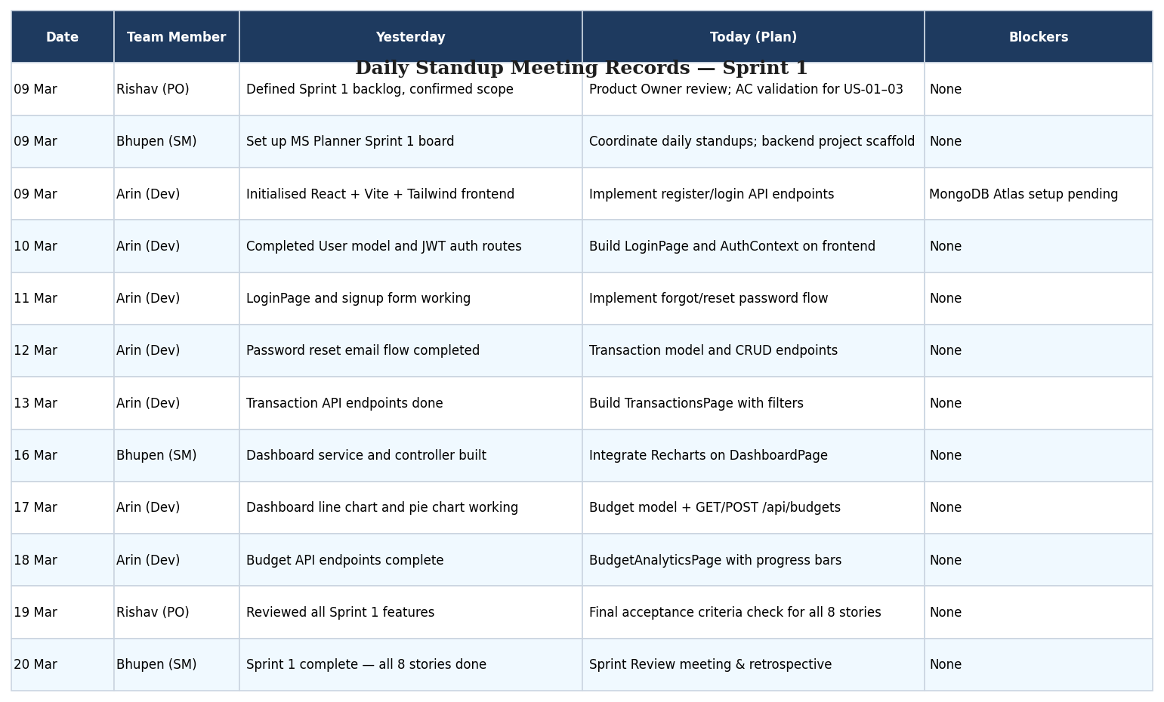
Figure 2.7 Standup Meetings – Sprint 1
2.1.7 Committed vs Completed User Stories
All eight user stories committed for Sprint 1 were completed within the planned timeline. The following table 2.4 summarises the committed and completed stories.
Table 2.4 Committed vs Completed Stories – Sprint 1
Status | Count | Percentage
Total user stories committed | 8 | 100%
Total user stories completed | 8 | 100%
Partially done | 0 | 0%
Not started | 0 | 0%

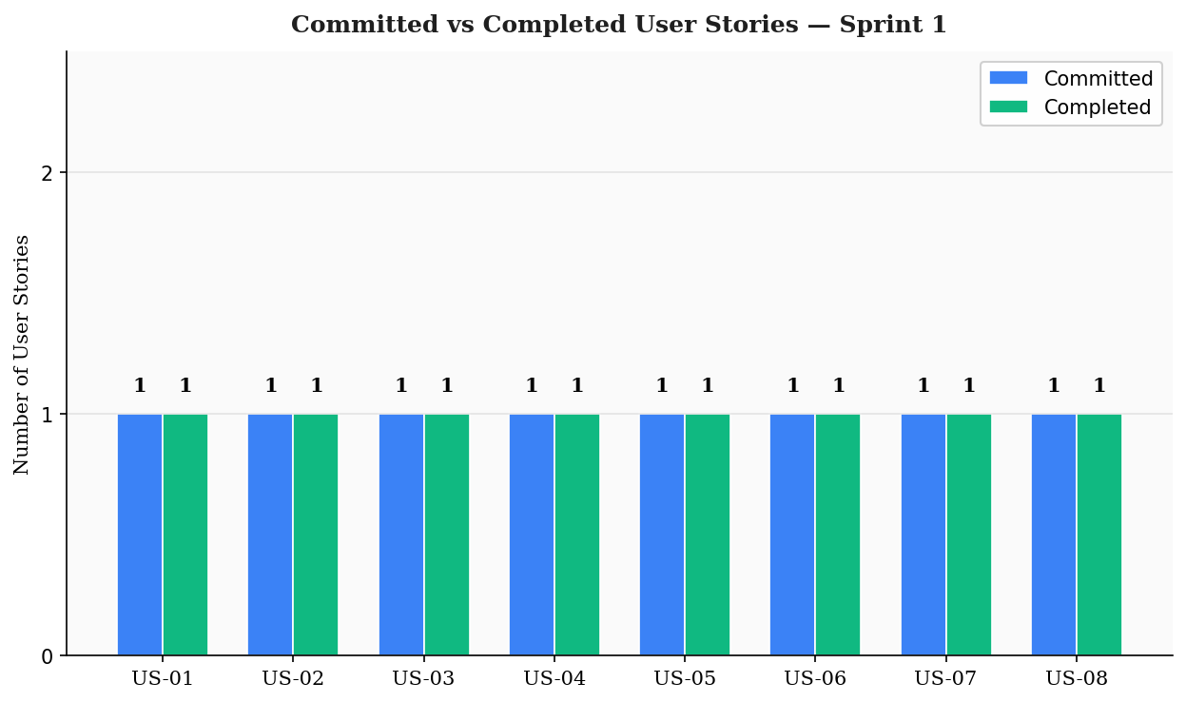
Figure 2.8 Bar Graph for Committed vs Completed – Sprint 1
2.1.8 Sprint Retrospective
At the end of Sprint 1, the team reflected on the sprint. The discussion is summarised below and captured in Figure 2.9.
What went well: All eight stories were completed; JWT authentication worked smoothly; Recharts integration produced clean visuals; Tailwind CSS made responsive design fast; the team communicated effectively over daily standups.
What did not go well: Initial MongoDB Atlas connectivity took time to set up; password reset email integration required additional debugging; some validation edge cases (e.g., zero amount) were caught late.
Action items: Begin Sprint 2 planning early; update the Agile board daily; write functional test cases at the start of each story; review database indexing for transaction queries.
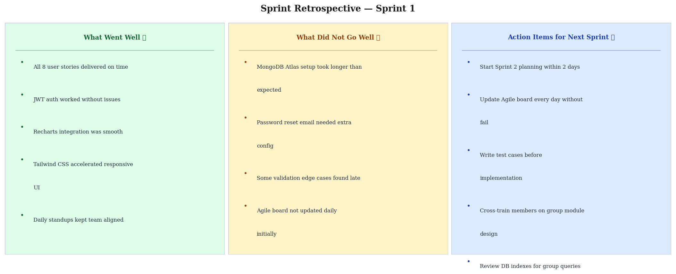
Figure 2.9 Sprint Retrospective – Sprint 1

2.2 Sprint 2 — Group Expense Management Module
2.2.1 Sprint Goal with User Stories of Sprint 2
The goal of Sprint 2 is to extend the application with a complete group expense management module. By the end of Sprint 2, users should be able to create groups, invite members, log shared expenses with multiple split types, view per-member balances, get optimised settle-up suggestions, record settlement payments, manage recurring rules and templates, and receive activity notifications.
The following table 2.5 represents the detailed user stories of Sprint 2.
Table 2.5 Detailed User Stories of Sprint 2
S.No | Detailed User Stories
US #9 | As a user, I want to create an expense group with a name and base currency.
US #10 | As a group admin, I want to add members to my group by name and email.
US #11 | As a member, I want to add shared expenses with split options (equal, unequal, percentage, shares).
US #12 | As a member, I want to see who owes whom and how much.
US #13 | As a member, I want optimised settle-up suggestions to clear balances.
US #14 | As a member, I want to record settlement payments (full or partial).
US #15 | As a user, I want shared expense history with CSV export.
US #16 | As a user, I want recurring expense rules so that regular bills auto-generate.
US #17 | As a user, I want to save expense templates for repeat scenarios.
US #18 | As a user, I want activity notifications about my groups.

2.2.2 Functional Document
2.2.2.1 Introduction
Sprint 2 introduces the group expense management module, building on the authentication and infrastructure delivered in Sprint 1. The module enables users to collaborate on shared expenses with their family, friends, or roommates and reach a fair settlement automatically.
2.2.2.2 Product Goal
The goal of Sprint 2 is to enable transparent and structured tracking of shared expenses. The platform aims to:
- Support group creation, member management, and shared expense logging.
- Compute per-member balances accurately for any combination of split types.
- Suggest the minimum number of settlement transactions required to clear balances.
- Track recurring rules, templates, and notifications to reduce repetitive work.
2.2.2.3 Demography (Users, Location)
Users:
- Target Users: Roommates, family members, project teams, and friend groups who share expenses.
- User Characteristics: Comfortable using web applications; willing to maintain a record of shared spending.
Location:
- Target Location: Global, with INR as the default base currency for groups created in India.
2.2.2.4 Business Processes
Group Creation and Membership:
- A user creates a group; the creator becomes admin.
- Admins add members by name and email; if a registered user matches, the userId is also stored.
Shared Expense Entry:
- Members add shared expenses choosing one of four split types: equal, unequal, percentage, shares.
- The system validates that splits total the expense amount before saving.
Balances and Settlements:
- Per-member balances are calculated using the groupFinance utility module.
- A greedy algorithm produces optimised settle-up suggestions, minimising the number of payments.
- Settlement payments (full or partial) update settlement status and recompute balances.
2.2.2.5 Features
Feature 1: Group Management
Description: Group creation, member management, and group activity tracking.
User Story: As a user, I want to create a group and invite members so that we can split shared expenses.
Feature 2: Shared Expenses with Split Types
Description: Add shared expenses with one of four split modes; backend validates totals.
User Story: As a member, I want to add shared expenses with the right split mode for each scenario.
Feature 3: Balances and Settle-Up Suggestions
Description: Real-time per-member balance calculation and optimised payment suggestions.
User Story: As a member, I want to know who owes whom and how to settle with minimum transactions.
Feature 4: Recurring Rules, Templates, and Notifications
Description: Recurring expense generation, reusable templates, and activity notifications.
User Story: As a user, I want regular bills to auto-generate and to be notified of group activity.
2.2.2.6 Authorization Matrix
Table 2.6 Access Level Authorization Matrix – Sprint 2
Role | Access Level
Group Admin | Can create the group, add members, and access all group features.
Group Member | Can add shared expenses, view balances, suggest settlements, and record payments.
Authenticated User (non-member) | Cannot view or modify group resources.

2.2.2.7 Assumptions
- Group members already have or will create a Personal Finance Tracker account.
- All group members agree on the chosen base currency at the time of group creation.
- Notifications are visible inside the application; email-based notifications are out of scope for Sprint 2.
2.2.3 Architecture Document
2.2.3.1 Application
Sprint 2 retains the layered architecture from Sprint 1 and adds:
- Group Service: Manages groups, members, expenses, balances, settlements, recurring rules, templates, notifications, and offline drafts.
- Finance Utility (groupFinance.js): Computes per-member balances and produces minimum-transaction settle-up suggestions.
- Notification Service: Records and serves user-specific activity notifications with read state.
2.2.3.2 System Architecture
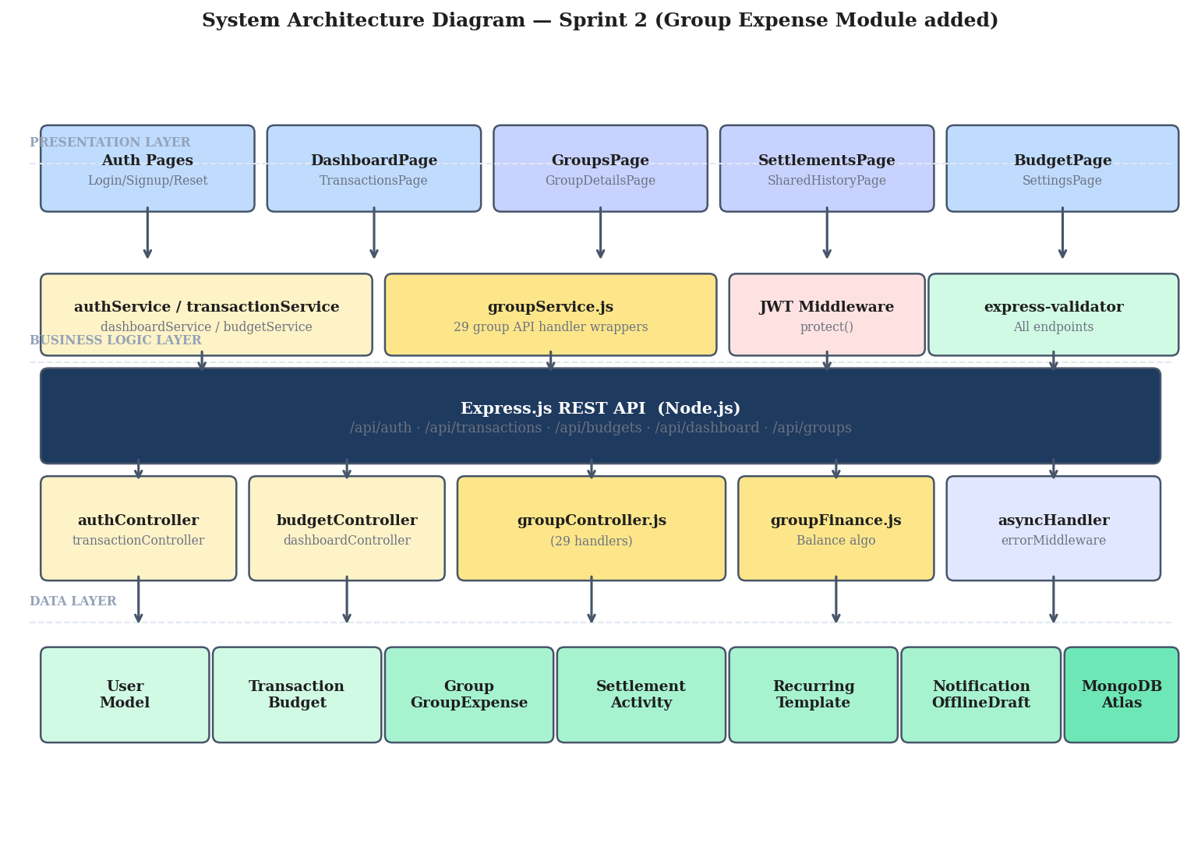
Figure 2.10 System Architecture Diagram – Sprint 2
2.2.3.3 Data Exchange Contract
Frequency of Data Exchanges:
- Real-Time: Adding a shared expense, recording a payment, and viewing balances all happen in real time over REST.
- On-Demand: Recurring rules can also be triggered manually using the Run Now action.
Data Sets:
- Group Data: name, baseCurrency, members, admin reference.
- GroupExpense Data: groupId, paidBy, title, amount, splitType, per-member splits.
- Settlement Data: fromUserId, toUserId, amount, status, payment history.
- Notification Data: userId, type, message, read state.
Mode of Exchanges:
- REST API: Endpoints exposed under /api/groups for all group operations.
- JSON: All payloads serialised as JSON.
- JWT: All endpoints under /api/groups are protected and require a valid Bearer token.
2.2.4 UI Design
The Sprint 2 UI extends the existing application with three new pages: GroupsPage, GroupDetailsPage, and SettlementsPage. The UI follows the same Tailwind-based design language used in Sprint 1.
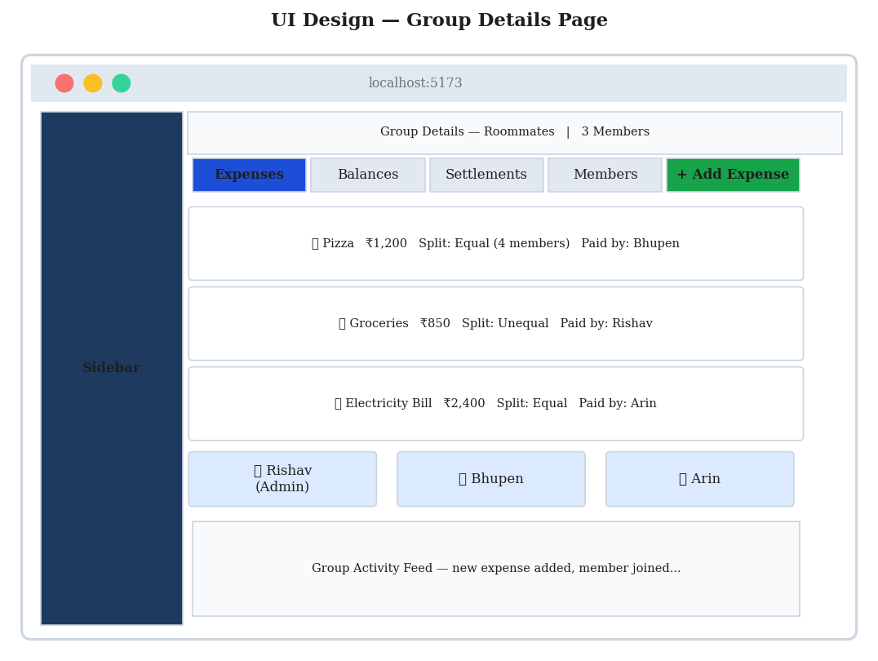
Figure 2.11 UI Design for Group Details Page
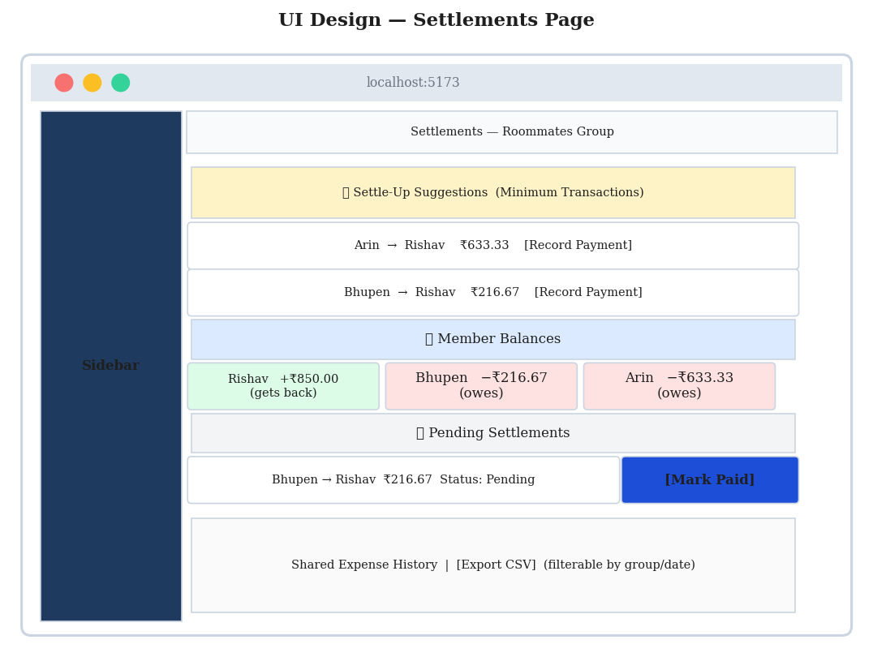
Figure 2.12 UI Design for Settlements Page
2.2.5 Functional Test Cases
Table 2.7 Detailed Functional Test Cases – Sprint 2
TC# | US | Scenario | Steps / Input | Expected Result | Status
TC-17 | US #9 | Create group | Name=Roommates, Currency=INR | Group created; user is admin | Pass
TC-18 | US #10 | Add member | Add member with name/email | Member count increases | Pass
TC-19 | US #11 | Equal split | Pizza, 1200, 4 members | Each share = 300 | Pass
TC-20 | US #11 | Mismatched splits | Amount=1000, splits=900 | Validation error | Pass
TC-21 | US #12 | View balances | Open Balances tab | Sum of balances = 0 | Pass
TC-22 | US #13 | Settle-up suggestions | Open suggestions | Minimum transactions shown | Pass
TC-23 | US #14 | Full settlement | Pay full amount | Status = settled | Pass
TC-24 | US #14 | Partial settlement | Pay half amount | Status = partially_settled | Pass
TC-25 | US #15 | Shared history | Open Shared History | All shared expenses listed | Pass
TC-26 | US #15 | CSV export | Click Export CSV | CSV downloaded | Pass
TC-27 | US #16 | Recurring rule | Monthly Rent, 12000 | Rule saved; next-run set | Pass
TC-28 | US #17 | Apply template | Apply Lunch template | Form auto-fills | Pass
TC-29 | US #18 | View notifications | Open bell icon | Unread items shown | Pass
TC-30 | US #18 | Mark notification read | Click a notification | Counter decreases | Pass

2.2.6 Daily Call Progress
Daily standups continued in Sprint 2 with the same cadence and discipline as Sprint 1. The Scrum Master maintained the MS Planner board and ensured that each member had clear tasks and unblockers.
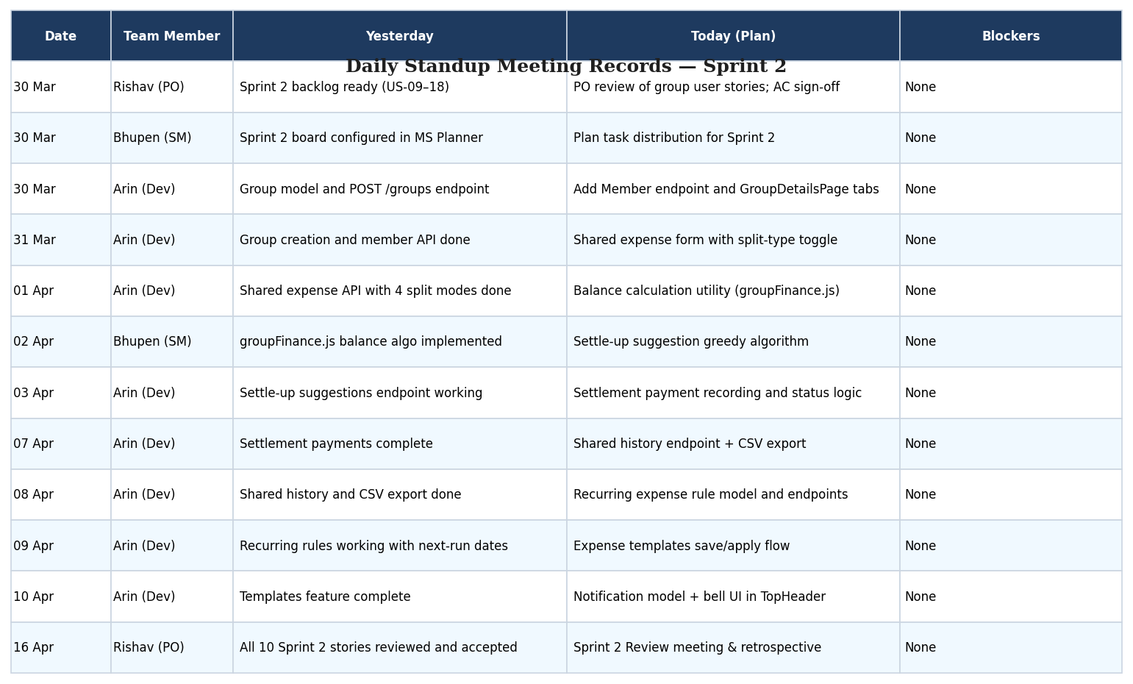
Figure 2.13 Standup Meetings – Sprint 2
2.2.7 Committed vs Completed User Stories
All ten user stories committed for Sprint 2 were completed within the planned timeline. The following table 2.8 summarises the committed and completed stories.
Table 2.8 Committed vs Completed Stories – Sprint 2
Status | Count | Percentage
Total user stories committed | 10 | 100%
Total user stories completed | 10 | 100%
Partially done | 0 | 0%
Not started | 0 | 0%

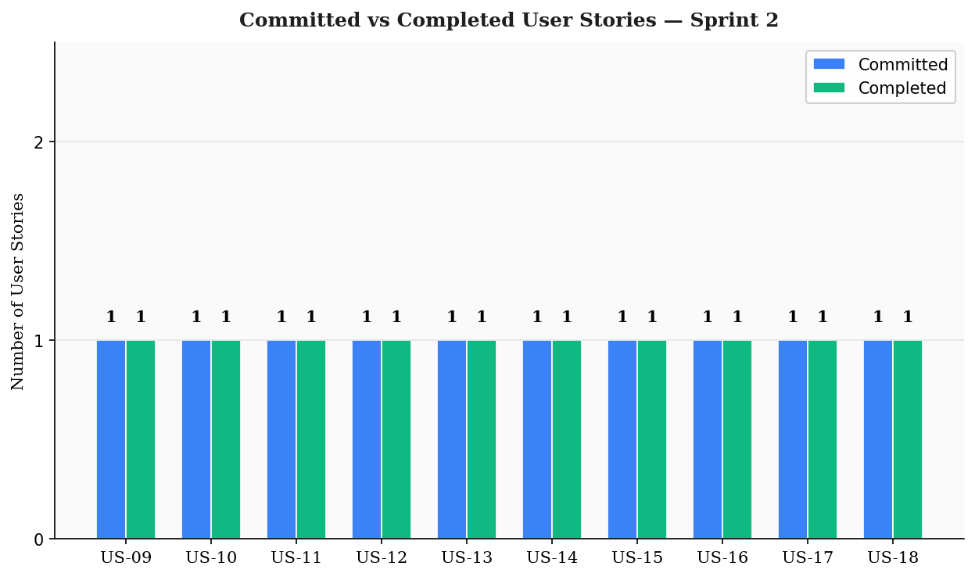
Figure 2.14 Bar Graph for Committed vs Completed – Sprint 2
2.2.8 Sprint Retrospective
What went well: All ten stories were completed; the settle-up algorithm worked correctly across multiple test scenarios; reusing the Sprint 1 authentication and CSV export logic saved considerable time; new pages integrated cleanly with existing layouts.
What did not go well: Validating split totals required additional rounding logic for percentage and shares modes; recurring rule edge cases needed extra test passes; the SettlementsPage UI required a redesign after early feedback.
Action items: Define UX wireframes earlier; add automated unit tests for the groupFinance utility; document split-type rounding rules; review database indexes for GroupExpense and Notification collections.
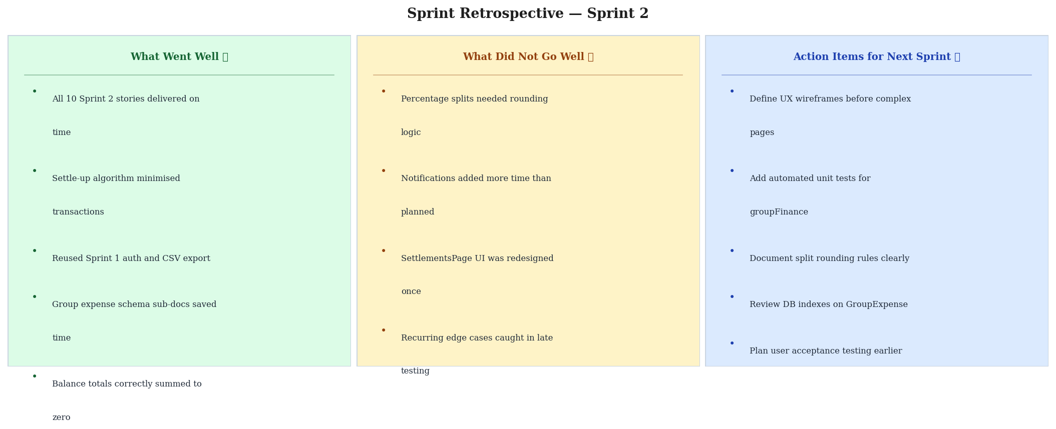
Figure 2.15 Sprint Retrospective – Sprint 2

CHAPTER 3
RESULTS AND DISCUSSIONS
3.1 Project Outcomes
The Personal Finance Tracker project successfully achieved all the goals defined in the product vision. By the end of the two-sprint cycle, the application offered a complete personal finance experience along with a fully functional group expense management module. The outcomes are summarised below and align with the goals outlined in Chapter 1.
- Personal Finance Module: Users can register, log in, and reset passwords securely. They can record income and expense transactions with category, date, and notes; filter, search, and export them as CSV; and edit or delete them as needed. Users see their monthly income, expense, and balance on a real-time dashboard backed by line and pie charts.
- Budget Management: Users can set per-category monthly budgets with a clear progress bar indicating utilisation, and an overspend indicator when limits are exceeded.
- Group Expense Management: Users can create groups, invite members, and log shared expenses using four split modes: equal, unequal, percentage, and shares. The system validates totals before saving the expense.
- Balances and Settlements: Per-member balances are computed in real time and optimised settle-up suggestions are produced using a greedy algorithm. Settlement payments (full or partial) update statuses and balances correctly.
- Productivity Features: Recurring expense rules, expense templates, shared expense history with CSV export, and in-app notifications enrich the user experience and reduce repetitive work.
- Engineering Quality: The codebase follows a clean layered architecture, uses JWT for authentication, leverages express-validator for request validation, and uses Mongoose schemas to enforce data integrity. All committed user stories were validated through manual functional test cases.
3.2 Committed vs Completed User Stories
Across both sprints, the team committed to a total of 18 user stories. All 18 were completed within the planned sprint durations, yielding a 100% completion rate. The summary across both sprints is shown below.
Sprint | Committed | Completed | Completion %
Sprint 1 | 8 | 8 | 100%
Sprint 2 | 10 | 10 | 100%
Total | 18 | 18 | 100%

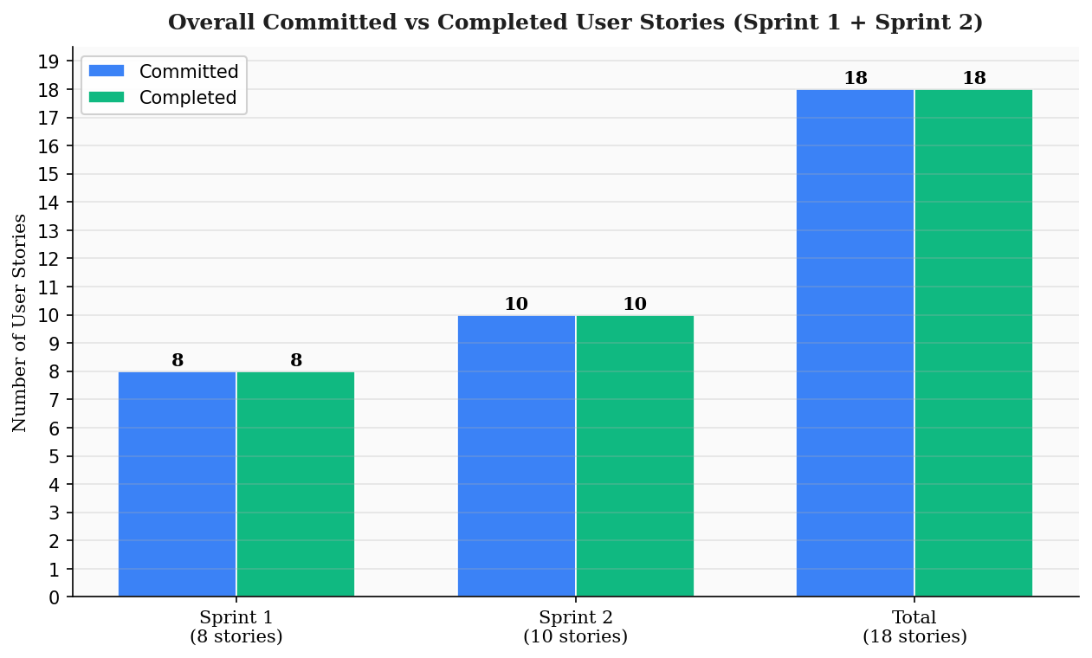
Figure 3.1 Overall Committed vs Completed User Stories

CHAPTER 4
CONCLUSIONS & FUTURE ENHANCEMENTS
4.1 Conclusion
The Personal Finance Tracker project delivered a working, end-to-end web application that combines personal expense tracking with group expense management in a single, cohesive product. The application addresses a real-world problem: most users lack a unified view of their personal finances and a fair, structured way to settle shared expenses with friends and family. By bringing both modules together, the project offers a meaningful alternative to spreadsheets, fragmented apps, and informal record-keeping.
From an engineering perspective, the project demonstrates the value of disciplined Agile practices and modern full-stack development. The team adopted MS Planner for backlog and sprint tracking, performed daily standups, and reviewed each sprint with retrospectives that fed actionable improvements into the next iteration. All 18 user stories were delivered with full acceptance-criteria coverage, validated through manual functional test cases.
The codebase is structured into clear layers — pages, services, controllers, models, and middleware — which makes it easy to extend. JWT-based authentication, request validation, and centralised error handling form a consistent, secure foundation across both sprints. The settlement algorithm minimises transaction count for clearing balances, providing a thoughtful, user-friendly outcome to a non-trivial computational problem.
4.2 Future Enhancements
Although the current scope of the project is complete, several enhancements have been identified for future iterations:
- Mobile Application: Build native iOS and Android apps using React Native to extend the platform beyond the web.
- Multi-Currency Support: Allow groups and users to operate in multiple currencies with real-time conversion.
- Bank / UPI Integration: Read transactions automatically from bank statements or UPI providers using secure APIs.
- AI-Driven Insights: Use machine learning to detect spending anomalies, recommend budgets, and forecast monthly savings.
- Email and Push Notifications: Extend the in-app notification system to email and push channels for offline reach.
- Two-Factor Authentication: Add TOTP-based 2FA for accounts holding sensitive financial data.
- Receipt OCR: Allow users to scan paper receipts and auto-fill the transaction form using OCR.
- Advanced Analytics: Add yearly summaries, year-over-year comparisons, and exportable PDF reports.
- Automated Test Suite: Add unit and integration tests using Jest and Supertest to complement the current manual test cases.
- Role-Based Group Permissions: Introduce admin / editor / viewer roles within groups for finer access control.

APPENDIX
A. PATENT DISCLOSURE FORM
A patent disclosure form was prepared and submitted as per the institute's requirements. The form lists the title of the invention, the names of the inventors, the field of technology (computer software – web applications), a brief description of the application, the novelty claims, and the supervisor's endorsement. A signed and dated copy is attached separately as part of the project submission.

B. SAMPLE CODING
The following code samples have been taken directly from the Personal Finance Tracker repository. They highlight the most representative pieces of the codebase across the frontend and the backend.
B.1 Backend – Express App Bootstrap (backend/app.js)
import cors from 'cors';
import express from 'express';
import helmet from 'helmet';
import morgan from 'morgan';
import authRoutes from './routes/authRoutes.js';
import transactionRoutes from './routes/transactionRoutes.js';
import budgetRoutes from './routes/budgetRoutes.js';
import dashboardRoutes from './routes/dashboardRoutes.js';
import groupRoutes from './routes/groupRoutes.js';
import { errorHandler, notFound } from './middleware/errorMiddleware.js';
const app = express();
const allowedOrigins = (process.env.CLIENT_URL || 'http://localhost:5173').split(',').map(o => o.trim());
app.use(cors({ origin: allowedOrigins, credentials: true }));
app.use(helmet());
app.use(express.json());
app.use(morgan('dev'));
app.use('/api/auth', authRoutes);
app.use('/api/transactions', transactionRoutes);
app.use('/api/budgets', budgetRoutes);
app.use('/api/dashboard', dashboardRoutes);
app.use('/api/groups', groupRoutes);
app.use(notFound);
app.use(errorHandler);
export default app;
B.2 Backend – Transaction Model (backend/models/Transaction.js)
import mongoose from 'mongoose';
const transactionSchema = new mongoose.Schema({
userId: { type: mongoose.Schema.Types.ObjectId, ref: 'User', required: true, index: true },
type: { type: String, enum: ['income', 'expense'], required: true },
title: { type: String, required: true, trim: true },
category: { type: String, enum: ['Food', 'Travel', 'Bills', 'Shopping', 'Health', 'Education', 'Income'], required: true },
amount: { type: Number, required: true, min: 0 },
date: { type: Date, required: true, default: Date.now },
notes: { type: String, default: '', trim: true },
paymentMethod: { type: String, default: 'UPI', trim: true },
}, { timestamps: true });
export default mongoose.model('Transaction', transactionSchema);
B.3 Frontend – React Router Setup (src/App.jsx)
export default function App() {
return (
<Routes>
<Route path="/" element={<RootRedirect />} />
<Route path="/login" element={<LoginPage />} />
<Route path="/signup" element={<SignUpPage />} />
<Route path="/dashboard" element={<ProtectedRoute><DashboardPage /></ProtectedRoute>} />
<Route path="/transactions" element={<ProtectedRoute><TransactionsPage /></ProtectedRoute>} />
<Route path="/budgets" element={<ProtectedRoute><BudgetAnalyticsPage /></ProtectedRoute>} />
<Route path="/groups" element={<ProtectedRoute><GroupsPage /></ProtectedRoute>} />
<Route path="/groups/:groupId" element={<ProtectedRoute><GroupDetailsPage /></ProtectedRoute>} />
<Route path="/settlements" element={<ProtectedRoute><SettlementsPage /></ProtectedRoute>} />
<Route path="/shared-history" element={<ProtectedRoute><SharedExpenseHistoryPage /></ProtectedRoute>} />
<Route path="/settings" element={<ProtectedRoute><SettingsPage /></ProtectedRoute>} />
</Routes>
);
}

C. PLAGIARISM REPORT
A plagiarism check was performed on the project report using the institute-approved tool. The plagiarism percentage is below the acceptable threshold defined by the University guidelines. A signed and dated plagiarism report is attached separately as part of the project submission.

[Plagiarism Report — Insert Image of Generated Report Here — Insert Image Here]

