IBM SKILLBUILD
DATA ANALYTICS WITH AI
ACADEMIC INTERNSHIP PROJECT REPORT

Superstore Sales & Profitability Analytics
with AI-Assisted Transaction Anomaly Detection

Project Profile
Dataset: Seven 11 Superstore • 9,994 transactions • 21 columns • 2014–2017
Technology: Python, pandas, NumPy, Matplotlib, scikit-learn, Jupyter Notebook
AI technique: Isolation Forest (unsupervised anomaly detection)

Submitted by
BHUPENDER SINGH
IBM SkillBuild Data Analytics with AI — Academic Internship Program
Conducted by BharatCares in association with AICTE

Academic Year: 2026

Certificate

This is to certify that Bhupender Singh has completed the project titled “Superstore Sales & Profitability Analytics with AI-Assisted Transaction Anomaly Detection” as an academic internship project under the IBM SkillBuild Data Analytics with AI Academic Internship Program, conducted by BharatCares in association with AICTE.
The project demonstrates the application of data preparation, exploratory data analysis, business analytics, visualization, and an unsupervised machine-learning technique for transaction anomaly detection. The work is documented in the accompanying Jupyter Notebook, requirements file, dataset, and README.

Place | Date | Student Signature | Supervisor / Mentor
Gurugram | 23-09-2026 | Bhupender Singh

Declaration

I, Bhupender Singh, declare that this project report presents the work carried out for the IBM SkillBuild Data Analytics with AI Academic Internship Program. The analysis, visualizations, and interpretation in this report are based on the supplied Seven 11 Superstore dataset and the accompanying project notebook. Wherever analytical methods are used, their purpose and implementation are described in this report.
Signature: ____________________ Date: ____________________

Acknowledgement

I would like to express my sincere gratitude to the IBM SkillBuild Data Analytics with AI Academic Internship Program, BharatCares, and AICTE for providing the opportunity to work on an applied data analytics project. I am thankful for the learning environment that enabled me to strengthen practical skills in Python, data analysis, visualization, and machine learning.
I also acknowledge the value of the Seven 11 Superstore transactional dataset, which provided a realistic business context for studying sales performance, profitability, customer and regional patterns, and unusual transactions.

Abstract

This project presents an end-to-end retail analytics study using the Seven 11 Superstore transaction dataset. The analysis covers data understanding and quality validation, feature engineering, exploratory data analysis, sales and profitability analysis, category and sub-category performance, regional and segment analysis, customer and product analysis, time-series trends, and discount-versus-profit relationships. An AI-assisted anomaly detection layer was added using the Isolation Forest algorithm to identify statistically unusual transactions based on Sales, Quantity, Discount, and Profit.
The dataset contains 9,994 transactions across 21 columns covering 2014–2017. Total recorded sales are $2,297,200.86, total profit is $286,397.02, and the overall profit margin is 12.47%. The analysis identified 1,871 loss-making transactions and the Isolation Forest model flagged 500 transactions (5% contamination setting) as anomalous.

Executive Summary

KPI / Indicator | Result
Transactions | 9,994
Orders | 5,009
Unique customers | 793
Unique products | 1,862
Sales | $2,297,200.86
Profit | $286,397.02
Overall profit margin | 12.47%
Loss-making transactions | 1,871
Discount–profit correlation | -0.219
AI anomalies | 500 (5.0%)

Management takeaway
The analysis shows a profitable business with growing annual sales, but profitability varies sharply by category and region. Technology and Office Supplies contribute substantially more profit than Furniture, while the Central region has the lowest regional profit margin. Discounting is negatively associated with profit, making pricing and discount governance an important management focus.

Table of Contents
1. Introduction
2. Project Objectives
3. Business Problem Statement
4. Dataset Description
5. Tools and Technologies
6. Project Methodology
7. Data Preparation and Quality Validation
8. Exploratory Data Analysis
9. Key Performance Indicators
10. Sales Analysis
11. Profitability Analysis
12. Category and Sub-Category Analysis
13. Regional Analysis
14. Customer and Segment Analysis
15. Time-Series Analysis
16. Discount vs Profit Analysis
17. Loss-Making Transaction Analysis
18. AI-Assisted Anomaly Detection
19. Business Insights
20. Business Recommendations
21. Project Deliverables
22. Limitations and Future Scope
23. Conclusion
24. References

1. Introduction
Retail businesses generate large volumes of transactional data containing information about customers, products, order dates, shipping, discounts, sales, and profit. Turning these records into actionable information requires a structured analytics workflow. This project applies such a workflow to the Seven 11 Superstore dataset and combines conventional business analytics with an AI-based anomaly detection method.
The project is designed as a practical academic internship deliverable. It demonstrates how a data analyst can move from raw transactional records to validated data, analytical KPIs, visual evidence, business insights, and a machine-learning based exception-monitoring layer.

2. Project Objectives
- Understand the structure, quality, and business meaning of the Superstore transaction data.
- Validate missing values, duplicates, data types, and date fields before analysis.
- Engineer analytical features that support trend, margin, discount, and anomaly analysis.
- Measure sales, profit, profit margin, orders, customers, products, and segment performance.
- Identify high- and low-performing categories, sub-categories, regions, customers, and products.
- Study monthly and yearly sales/profit trends and the relationship between discount and profit.
- Identify loss-making transactions and understand the categories and sub-categories associated with losses.
- Apply Isolation Forest to flag unusual transactions for human review.
- Translate analytical findings into practical business recommendations.

3. Business Problem Statement
The core business problem is to understand where revenue is being generated, where profit is being created or lost, and which transactions or operating patterns deserve additional attention. A sales number alone does not explain business health; management also needs profitability, margin, regional performance, product mix, customer value, discount effects, and exception indicators.

Analytical questions
Which categories and regions generate the most sales and profit? Which areas have weak margins? How does discounting relate to profit? Which products/sub-categories contribute to losses? Which transactions are unusual enough to warrant investigation?

4. Dataset Description
The project README identifies the source as the Seven 11 Superstore transactional dataset with 9,994 transactions, 21 columns, and a 2014–2017 time range across four U.S. regions. The dataset includes customer, geography, product, shipping, sales, quantity, discount, and profit fields.
Property | Description
Rows | 9,994 transactions
Columns | 21
Period | 2014–2017
Geography | United States
Regions | East, West, Central, South
Categories | Furniture, Office Supplies, Technology
Segments | Consumer, Corporate, Home Office
Key financial fields | Sales, Discount, Profit

Important Fields
Field | Business meaning
Order ID | Order identifier; one order can contain multiple line items.
Order Date / Ship Date | Order and shipment timing.
Customer ID / Name | Customer-level analysis.
Region / State / City | Geographic analysis.
Category / Sub-Category | Product hierarchy.
Sales | Revenue for a line item in USD.
Quantity | Units ordered.
Discount | Discount applied to a line item.
Profit | Profit generated by the line item; may be negative.

5. Tools and Technologies
Technology | Purpose
Python | Core programming and analytical workflow.
pandas | Data loading, cleaning, transformation, aggregation.
NumPy | Numerical operations.
Matplotlib | Charts and analytical visualizations.
scikit-learn | StandardScaler and Isolation Forest anomaly detection.
Jupyter Notebook | Interactive analysis, documentation, and reproducibility.

The supplied requirements file specifies pandas ≥1.5.0, NumPy ≥1.23.0, Matplotlib ≥3.6.0, scikit-learn ≥1.1.0, Jupyter ≥1.0.0, notebook ≥6.5.0, and ipykernel ≥6.16.0.

6. Project Methodology
Stage | Work performed
Data Loading | Load the CSV dataset into pandas and inspect its structure.
Data Understanding | Review columns, business meanings, dimensions, and data ranges.
Data Quality | Check missing values, duplicates, data types, and date validity.
Feature Engineering | Create derived analytical features used in trend, margin, discount, and loss analysis.
EDA | Study distributions, relationships, trends, categories, regions, segments, customers, and products.
KPI Analysis | Calculate sales, profit, margins, order/customer/product counts and other indicators.
Business Analysis | Interpret performance patterns and loss-making areas.
AI Detection | Standardize Sales, Quantity, Discount and Profit and apply Isolation Forest.
Visualization | Communicate findings through charts.
Recommendations | Convert evidence into practical management actions.

7. Data Preparation and Quality Validation
Data quality validation was performed before business interpretation. The supplied dataset contains 9,994 rows and 21 columns. In the completed project analysis, the dataset was confirmed to contain zero missing values and zero duplicate rows.
Quality Check | Result | Interpretation
Dataset dimensions | 9,994 × 21 | Expected project dataset size.
Missing values | 0 | No missing values detected in the supplied analysis.
Duplicate rows | 0 | No duplicate rows detected.
Date conversion | Completed | Order and ship dates converted for time analysis.
Profit sign | Positive / negative | Negative profit retained because it is analytically meaningful.

Feature Engineering
The notebook includes a dedicated feature-engineering stage. Derived variables support monthly analysis, profit-margin analysis, discount bands, loss identification, and AI anomaly detection. Retaining negative profit values is important because loss-making transactions are a central business question in this project.

8. Exploratory Data Analysis
The exploratory phase examines the distribution of financial performance across product categories, sub-categories, regions, customer segments, and time. The project notebook contains more than 25 visualizations covering these analytical dimensions.
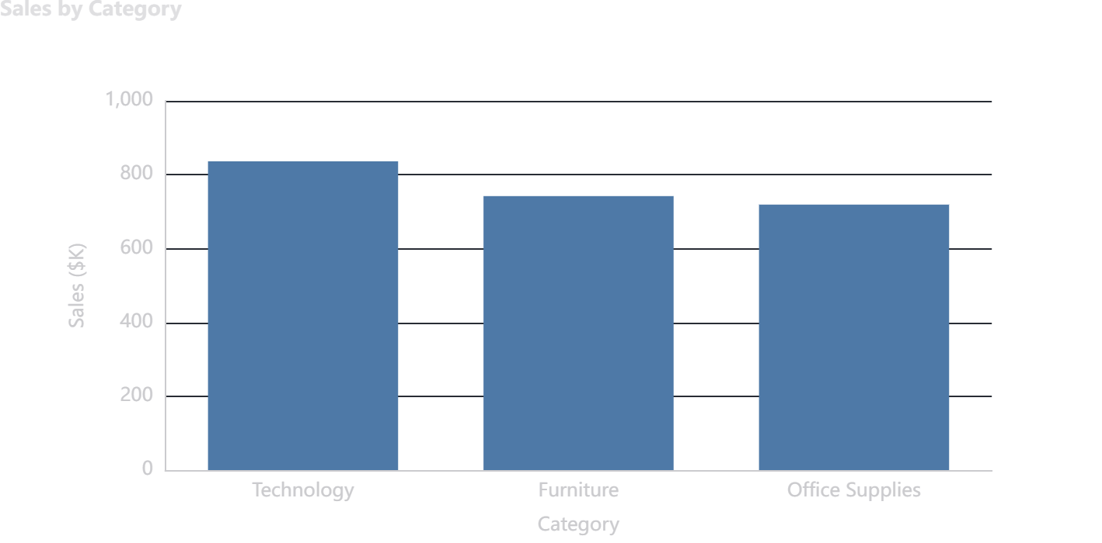
Figure 1. Sales by product category.
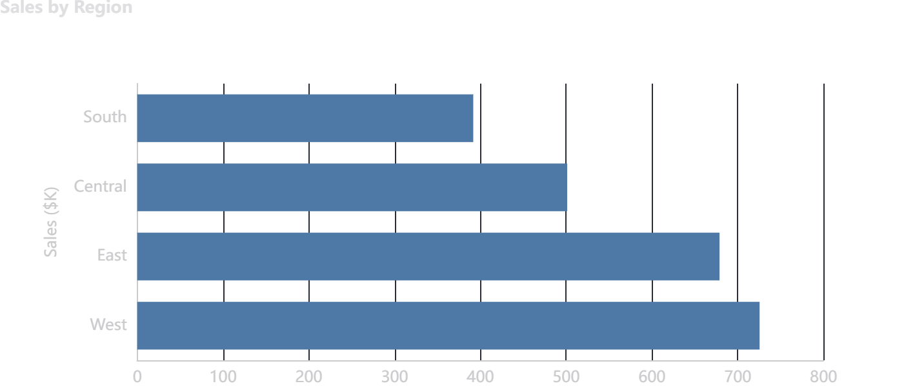
Figure 2. Sales by U.S. region.

9. Key Performance Indicators
KPI | Value | Interpretation
Total Sales | $2,297,200.86 | Total revenue represented in the dataset.
Total Profit | $286,397.02 | Aggregate profit across all line items.
Profit Margin | 12.47% | Profit as a percentage of sales.
Orders | 5,009 | Distinct orders.
Customers | 793 | Distinct customer IDs.
Products | 1,862 | Distinct product IDs.
Loss Transactions | 1,871 | Transactions with negative profit.
AI Anomalies | 500 | Transactions flagged by Isolation Forest.

These KPIs establish the baseline for deeper analysis. They should be read together rather than in isolation: sales volume indicates scale, while profit and margin indicate economic quality.

10. Sales Analysis
Technology records the highest category sales in the dataset, followed by Furniture and Office Supplies. Across regions, West records the highest sales, followed by East, Central, and South.
Category | Sales | Share of Sales
Technology | $836,154.03 | 36.4%
Furniture | $741,999.80 | 32.3%
Office Supplies | $719,047.03 | 31.3%

Figure 3. Category-level sales comparison.
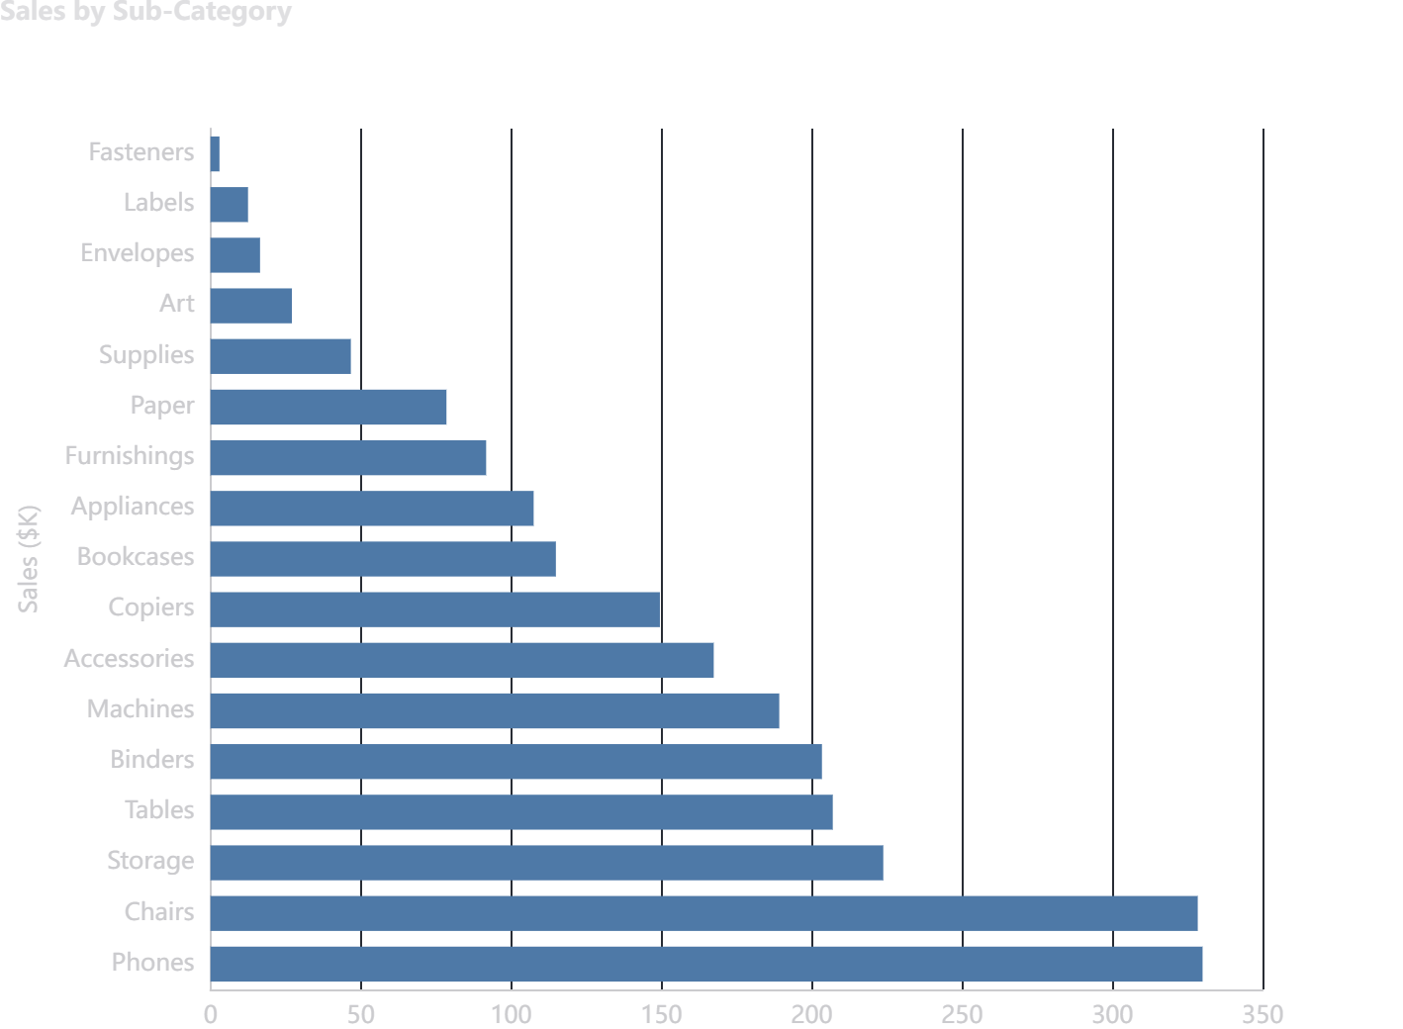
Figure 4. Sales by sub-category.

11. Profitability Analysis
Total profit is positive, but profitability is not evenly distributed. Technology contributes the highest profit, Office Supplies contributes the second-highest, and Furniture contributes substantially less profit relative to its sales volume.
Category | Sales | Profit | Profit Margin
Technology | $836,154.03 | $145,454.95 | 17.40%
Office Supplies | $719,047.03 | $122,490.80 | 17.04%
Furniture | $741,999.80 | $18,451.27 | 2.49%

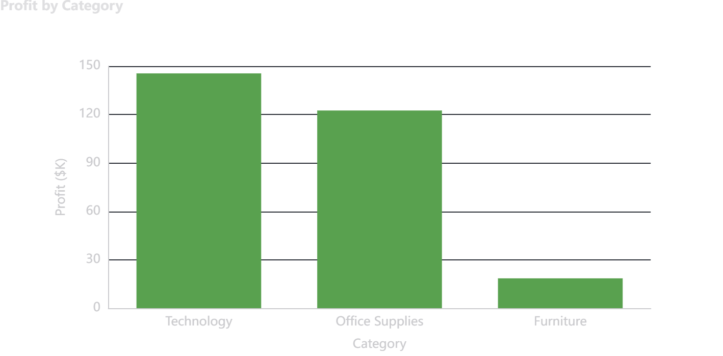
Figure 5. Profit by category.
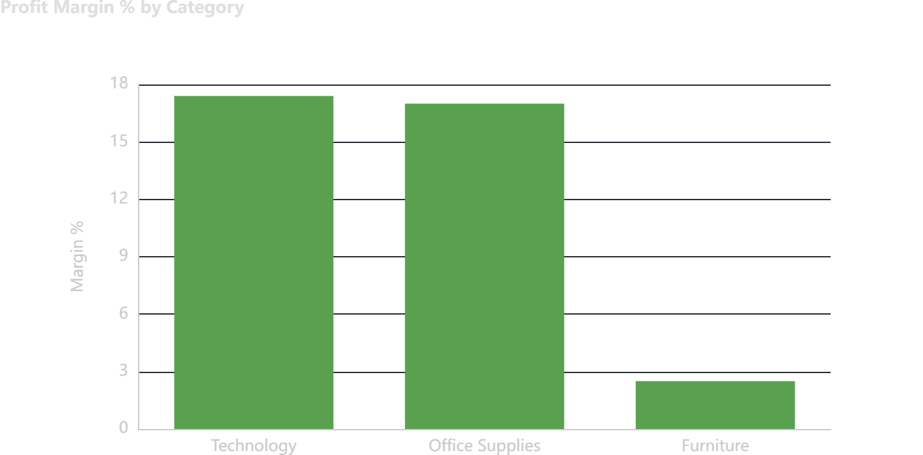
Figure 6. Profit margin percentage by category.
Furniture is the key profitability pressure point: its margin is approximately 2.49%, compared with 17.40% for Technology and 17.04% for Office Supplies.

12. Category and Sub-Category Analysis
Sub-category analysis provides a more detailed view of the category-level results. Tables and Bookcases are notable negative-profit sub-categories in the supplied data.
Sub-Category | Sales | Profit
Tables | $206,965.53 | $-17,725.48
Bookcases | $114,880.00 | $-3,472.56
Supplies | $46,673.54 | $-1,189.10
Fasteners | $3,024.28 | $949.52
Machines | $189,238.63 | $3,384.76
Labels | $12,486.31 | $5,546.25
Art | $27,118.79 | $6,527.79

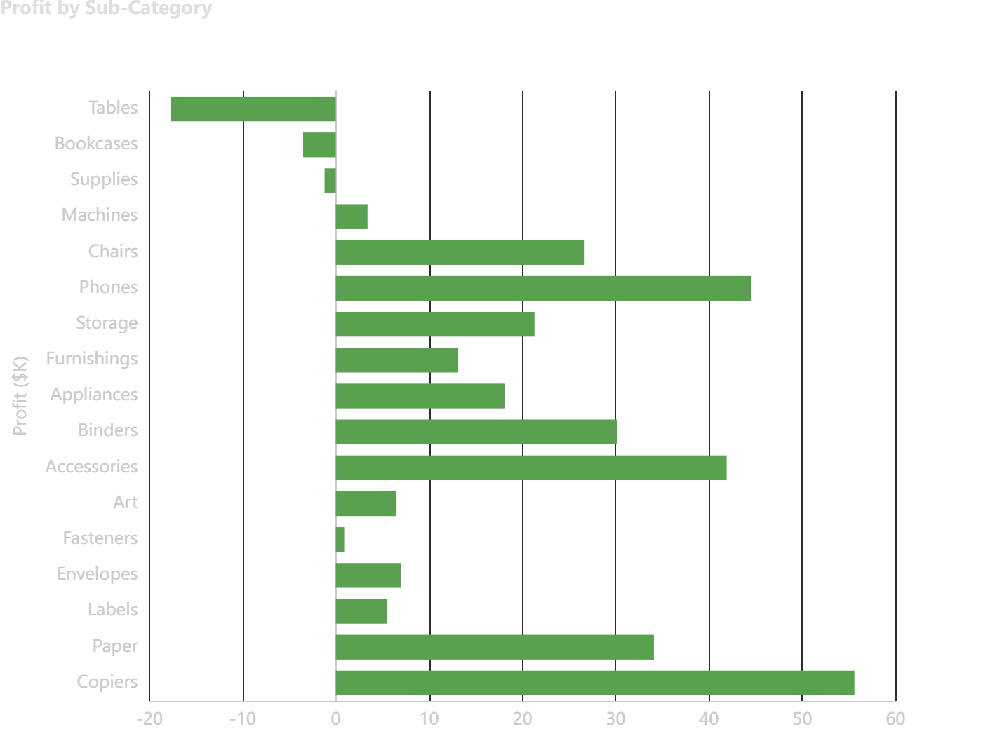
Figure 7. Profit by sub-category; negative values indicate loss-making sub-categories.
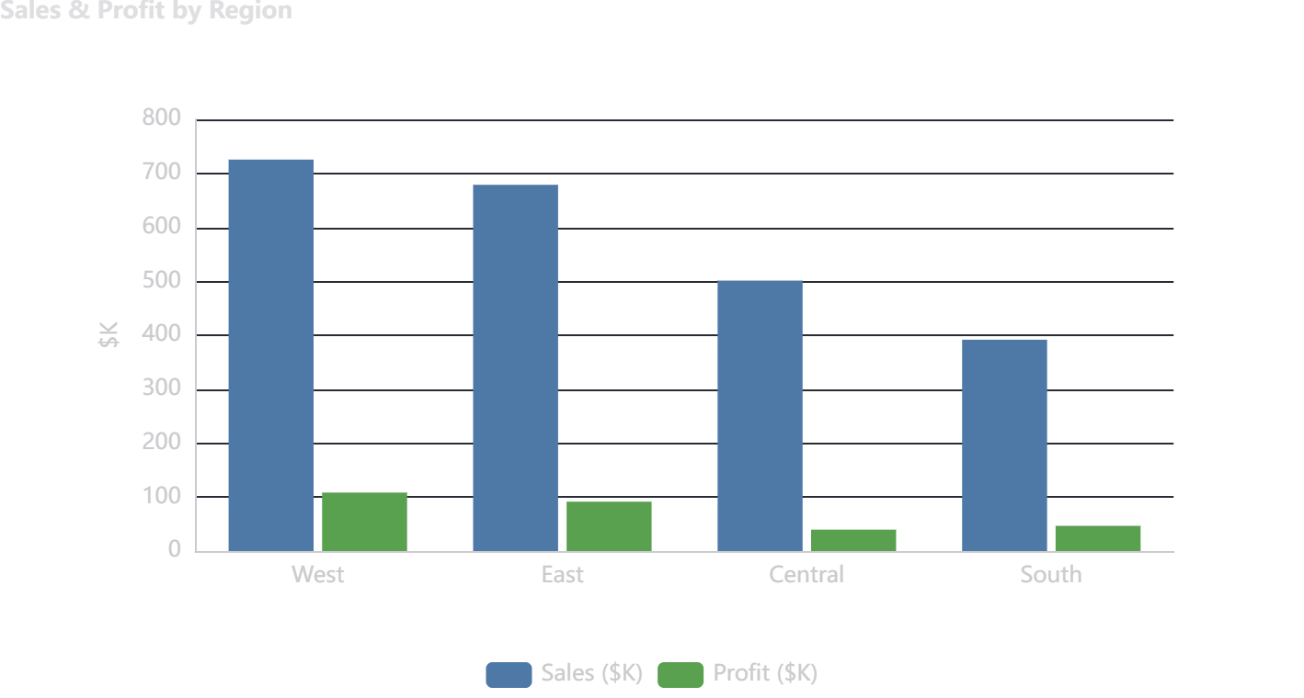
Figure 8. Sales and profit comparison by region.

13. Regional Analysis
Regional results show clear differences between revenue scale and profitability. West has the highest sales and profit and the highest regional profit margin among the four regions. Central has a lower profit margin despite substantial sales.
Region | Sales | Profit | Margin
West | $725,457.82 | $108,418.45 | 14.94%
East | $678,781.24 | $91,522.78 | 13.48%
Central | $501,239.89 | $39,706.36 | 7.92%
South | $391,721.91 | $46,749.43 | 11.93%

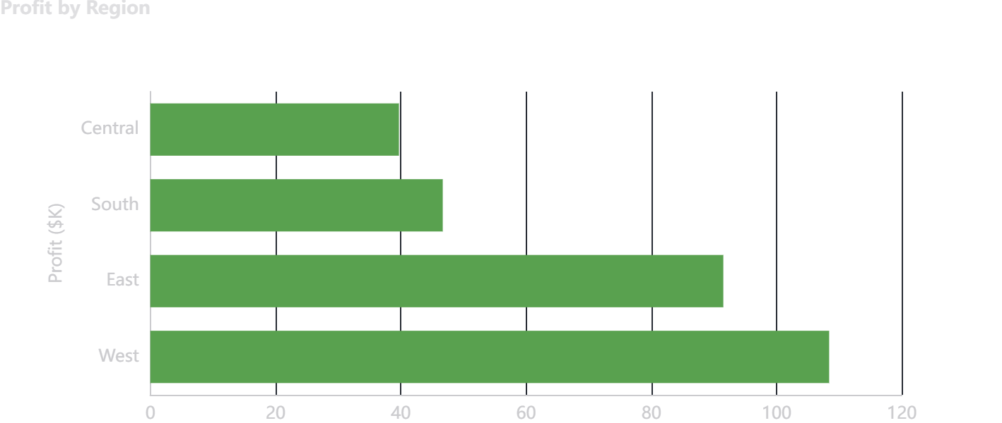
Figure 9. Profit by region.
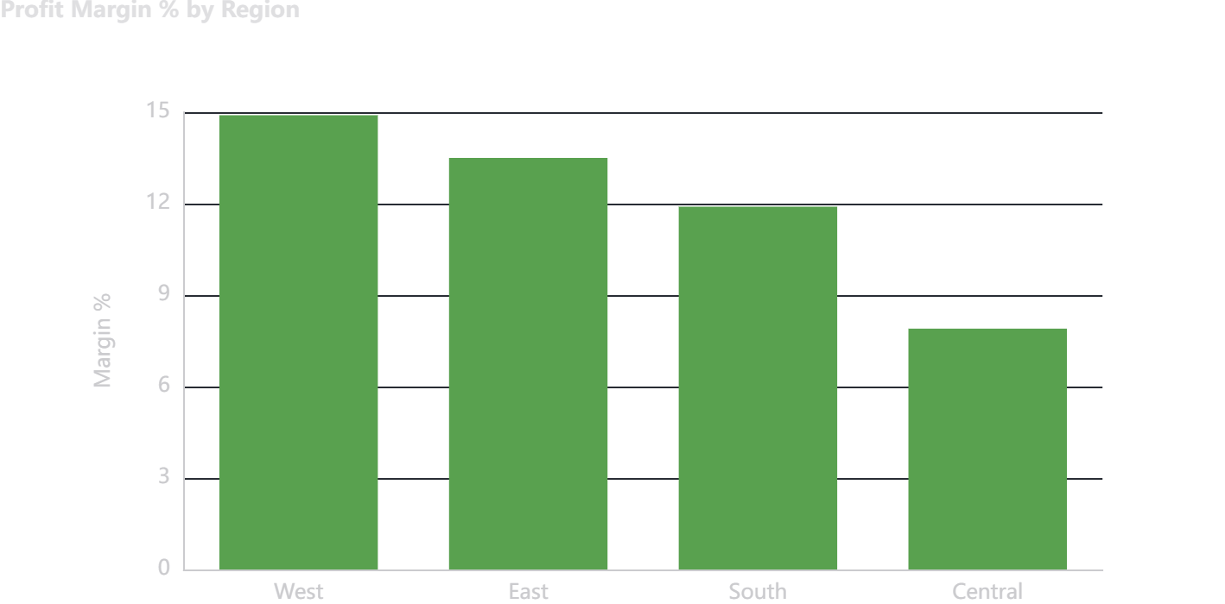
Figure 10. Profit margin percentage by region.

14. Customer and Segment Analysis
The dataset contains 793 unique customers. The Consumer segment generates the largest sales and profit in absolute terms. Corporate and Home Office have higher margins than Consumer in the supplied analysis.
Segment | Sales | Profit | Orders | Margin
Consumer | $1,161,401.34 | $134,119.21 | 2,586 | 11.55%
Corporate | $706,146.37 | $91,979.13 | 1,514 | 13.03%
Home Office | $429,653.15 | $60,298.68 | 909 | 14.03%

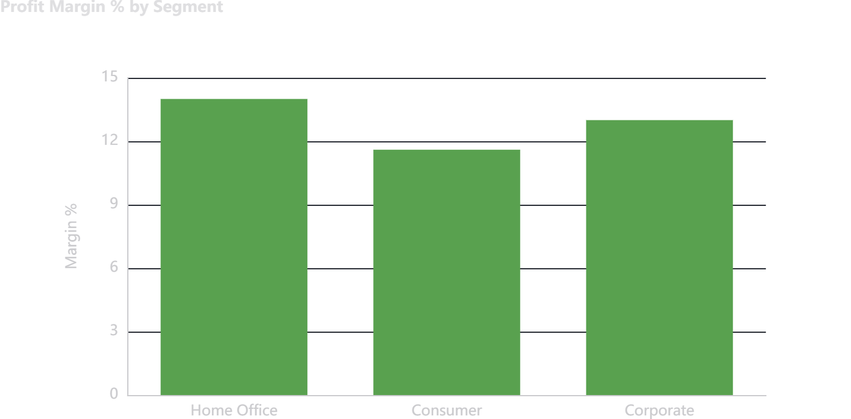
Figure 11. Profit margin by customer segment.

15. Time-Series Analysis
Annual sales increased from approximately $484.25K in 2014 to $733.22K in 2017. Annual profit also increased from approximately $49.54K to $93.44K over the same period.
Year | Sales | Profit
2014 | $484,247.50 | $49,543.97
2015 | $470,532.51 | $61,618.60
2016 | $609,205.60 | $81,795.17
2017 | $733,215.26 | $93,439.27

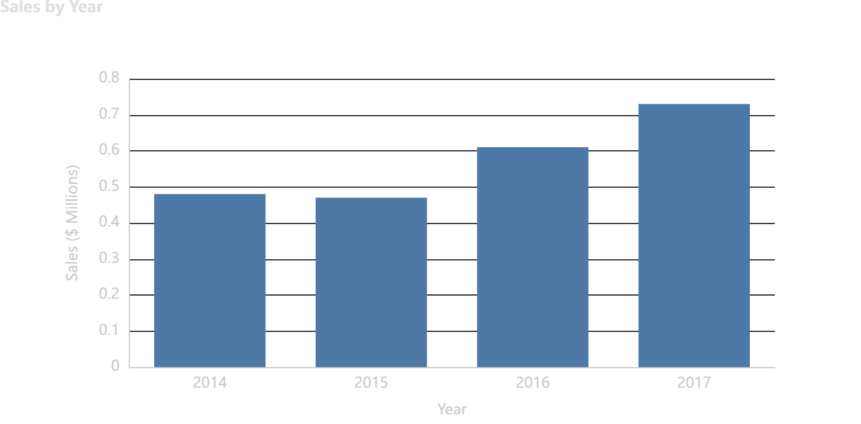
Figure 12. Annual sales trend.
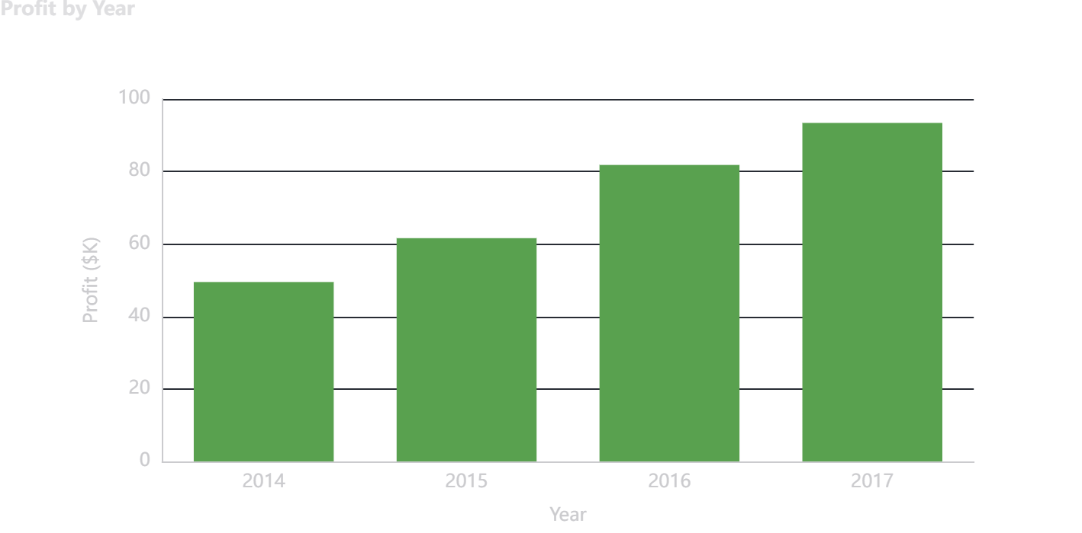
Figure 13. Annual profit trend.
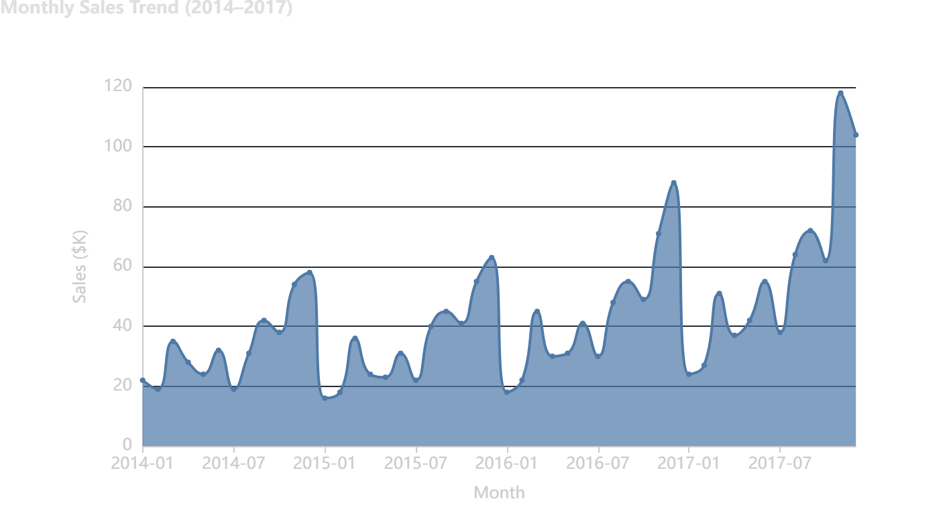
Figure 14. Monthly sales trend. Peak month in the supplied analysis: 2017-11 ($118,447.82).

16. Discount vs Profit Analysis
The Pearson correlation between Discount and Profit is -0.219. The negative value indicates that higher discount levels are associated with lower profit in the observed transactions. Correlation does not by itself prove causation, but it identifies discounting as an important variable for profitability review.
Interpretation
The notebook's business interpretation identifies discounts above 20% as a recurring loss-risk area and high-discount transactions (40%+) as a major source of loss-making transactions. These thresholds should be treated as analytical findings from this dataset rather than universal pricing rules.

17. Loss-Making Transaction Analysis
There are 1,871 transactions with negative profit, representing 18.7% of all transactions. The combined profit of these loss-making transactions is $-156,131.29.
Measure | Value
Loss-making transactions | 1,871
Share of transactions | 18.7%
Total loss amount | $-156,131.29
Average loss per loss transaction | $-83.45
Worst sub-category by total loss | Tables ($-17,725.48)

18. AI-Assisted Anomaly Detection
The project extends traditional analytics with an unsupervised machine-learning workflow using Isolation Forest from scikit-learn. The model is designed to isolate observations that are unusual relative to the rest of the data without requiring pre-labelled anomaly examples.
Model setting | Value
Algorithm | Isolation Forest
n_estimators | 100
contamination | 0.05 (5%)
random_state | 42
Input features | Sales, Quantity, Discount, Profit
Scaling | StandardScaler
Anomaly label | -1
Normal label | 1

After standardization of the four input features, the model flagged 500 transactions as anomalous and 9,494 as normal. The anomaly rate is exactly 5.0% under the configured 5% contamination setting.
An anomaly should not automatically be interpreted as fraud or an error. In this project, it means that the transaction has an unusual combination of the selected numerical features and should therefore be considered for business review.
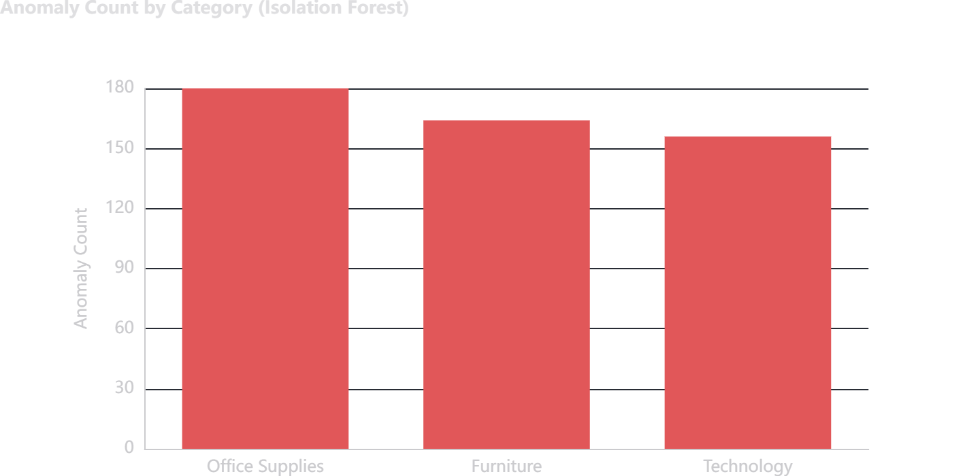
Figure 15. Anomaly count by category.
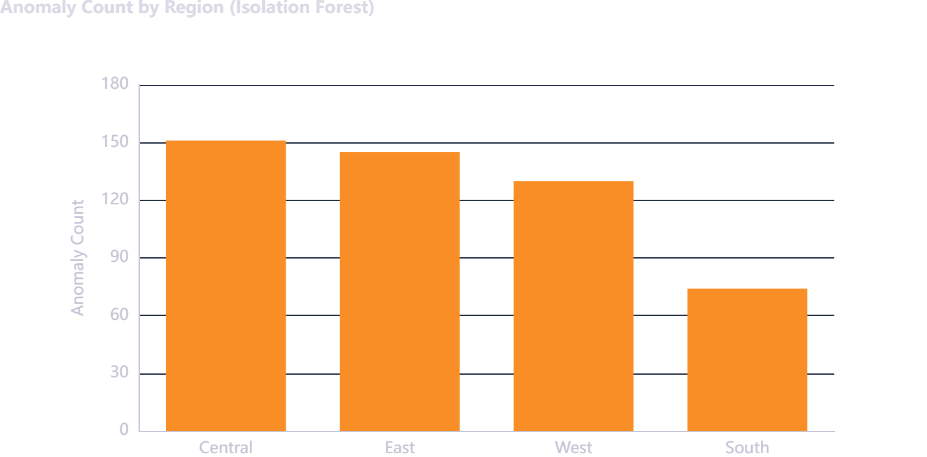
Figure 16. Anomaly count by region.

Anomaly Distribution
Category | Anomaly Count
Office Supplies | 180
Furniture | 164
Technology | 156

Region | Anomaly Count
Central | 151
East | 145
West | 130
South | 74

19. Business Insights
- Revenue increased year-on-year from 2014 through 2017 in the supplied dataset.
- Overall profit margin is approximately 12.5%, indicating that revenue scale and profit quality should be monitored together.
- Technology is the highest-profit category and has the highest category-level margin in the supplied results.
- Furniture has comparatively weak profitability, with Tables and Bookcases contributing negative profit.
- Discount and profit have a negative Pearson correlation in the dataset.
- West leads the regions in both sales and profit and records the highest regional margin.
- Central records the lowest regional profit margin among the four regions.
- Consumer is the largest segment by sales and profit, while Corporate and Home Office show higher margins.
- A substantial number of line-item transactions are loss-making, making transaction-level profit monitoring valuable.
- Isolation Forest flagged 500 transactions as statistically unusual using Sales, Quantity, Discount, and Profit.
- The anomaly results are concentrated across the major product categories and regions and can be used to prioritize review queues.
- Combining conventional BI metrics with anomaly detection creates a broader monitoring framework than either approach alone.

20. Business Recommendations

Establish discount governance
Use a defined discount approval policy and closely monitor discounts above the levels associated with losses in this dataset.

Review Furniture pricing
Audit Tables and Bookcases for pricing, cost, discount, and product-mix issues.

Expand high-margin Technology opportunities
Evaluate marketing, assortment, and retention opportunities around Technology while monitoring profitability.

Investigate Central-region margin pressure
Perform a regional discount, product-mix, and operational review to understand the lower margin.

Use customer profitability for retention
Combine revenue, profit, and order frequency to prioritize customer-retention activities.

Create an anomaly review queue
Route Isolation Forest outliers to human review for possible pricing errors, unusual order structures, data issues, or other business explanations.

Monitor profit alongside sales
Avoid evaluating growth solely on revenue; pair sales growth with profit and margin trends.

Review shipping economics
Compare shipping mode and customer value to understand whether expedited shipping is eroding profitability.

21. Project Deliverables
The internship submission instructions require four project files. The current project package contains the corresponding analytical artifacts.
Deliverable | Expected format | Project file
Code File | .ipynb / Jupyter Notebook | Superstore_Analytics.ipynb
Requirements File | .txt | requirements.txt
Project Report | .docx | Bhupender_Singh_Superstore_Project_Report.docx
README File | .md | README.md

The README describes the project structure, notebook sections, setup commands, AI methodology, and libraries used. The notebook contains the complete analytical workflow from data loading through final conclusions.

22. Limitations and Future Scope
- Isolation Forest is an unsupervised detector; a flagged transaction is an investigation candidate, not proof of fraud or error.
- The model uses only Sales, Quantity, Discount, and Profit. Additional operational or customer features could improve contextual analysis.
- Correlation between discount and profit does not establish causal impact on its own.
- The analysis is based on historical transactions from 2014–2017 and should not automatically be treated as current market performance.
- Future work could include an interactive Power BI dashboard, automated anomaly alerts, model monitoring, and scheduled reporting.
- Future modeling could compare Isolation Forest with Local Outlier Factor, One-Class SVM, or clustering-based approaches using validated evaluation criteria.

23. Conclusion
This project successfully demonstrates an end-to-end Data Analytics with AI workflow on a retail transaction dataset. The analysis moves from data quality and exploratory analysis to business KPIs, profitability diagnostics, regional and customer insights, time-series analysis, and AI-assisted anomaly detection.
The dataset contains 9,994 transactions across four years. It records $2,297,200.86 in sales and $286,397.02 in profit, giving an overall margin of 12.47%. The strongest profit contribution comes from Technology, while Furniture shows significant margin pressure. West has the strongest regional sales and profit results, whereas Central has the lowest regional margin.
The Isolation Forest model adds a practical exception-monitoring layer by flagging 500 unusual transactions. Together, the business analytics and AI components demonstrate how a data analyst can convert raw transaction records into structured evidence for decision support.
Final project outcome
The project provides a reproducible analytical workflow, business-facing visualizations, quantified KPIs, actionable areas for investigation, and an AI-assisted mechanism for prioritizing unusual transactions.

24. References
- Project dataset: Seven 11 Superstore.csv (supplied with the internship project).
- Project notebook: Superstore_Analytics.ipynb (supplied analytical workflow).
- Project README: README.md (project overview, dataset description, notebook structure, setup, AI methodology).
- Project requirements: requirements.txt (Python dependency specifications).
- scikit-learn Isolation Forest implementation used in the supplied notebook.
- IBM SkillBuild Data Analytics with AI — Academic Internship Project materials.

Appendix A — Figure Index
Figure 1. Sales by Category
Figure 2. Sales by Region
Figure 3. Profit by Category
Figure 4. Profit Margin % by Category
Figure 5. Profit by Sub-Category
Figure 6. Sales & Profit by Region
Figure 7. Profit by Region
Figure 8. Profit Margin % by Region
Figure 9. Profit Margin % by Segment
Figure 10. Sales by Year
Figure 11. Profit by Year
Figure 12. Monthly Sales Trend (2014–2017)
Figure 13. Anomaly Count by Category
Figure 14. Anomaly Count by Region

Appendix B — Technical Reproducibility
The project can be reproduced by installing the packages listed in requirements.txt, launching Jupyter Notebook, opening Superstore_Analytics.ipynb, and running the notebook from top to bottom. The supplied README specifies the setup commands and confirms the Isolation Forest configuration.
Suggested commands:
pip install -r requirements.txt
jupyter notebook

