MemoriAI – High‑Level Design (HLD) – Advanced
Version 2.0 • Owner: Group 3 (Ayvazoglu, Bovilla, Kondeti, Sejwal, Singh)
Date: 2025-10-15

1. Executive Summary
MemoriAI is an AI‑powered digital companion for Alzheimer’s care with three MVP pillars: Cognitive & Identity Assist, Daily Reminders & Safety, and Caregiver Dashboard. The design favors REST APIs, privacy by design, and guardrailed LLM usage.

2. Goals & Non‑Goals
Goals | Non‑Goals
Facts recall, adaptive reminders, caregiver summaries. | Diagnosis or clinical decision support.
Guardrailed LLM, RESTful APIs, privacy‑first data. | Training a foundation model or multi‑tenant SaaS.

3. Personas & Use Cases
P1 Patient • P2 Caregiver • P3 Clinician (read‑only) • P4 Admin
UC‑A Cognitive & Identity Assist; UC‑B Daily Reminders; UC‑C Caregiver Dashboard.

4. System Context
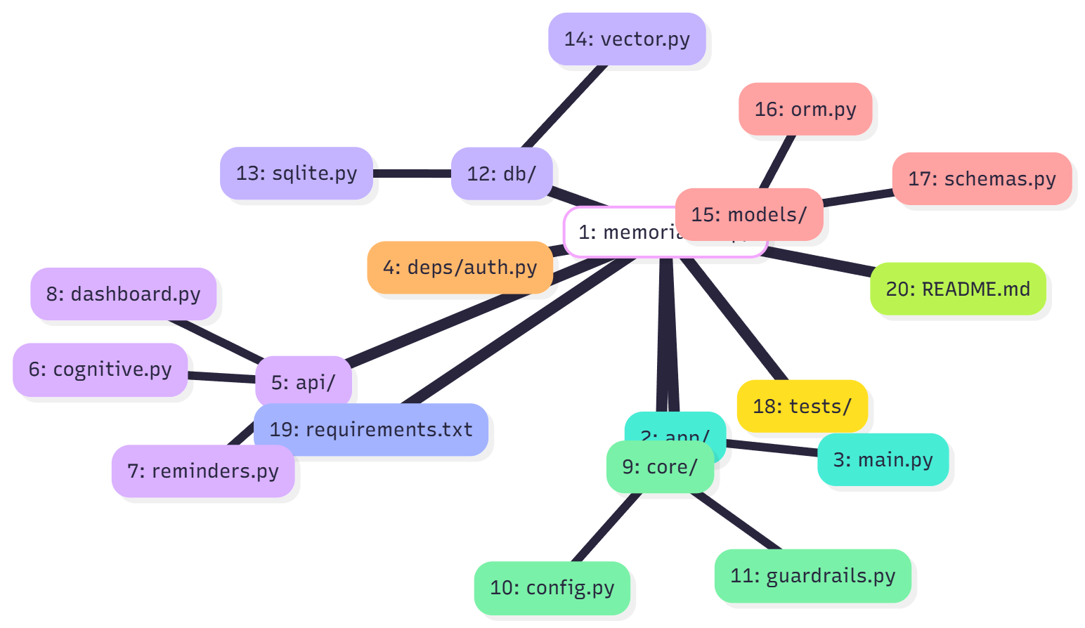

5. Architecture Overview
FastAPI services: Cognitive, Reminders, Dashboard. Data: SQLite + Vector DB (Mem4AI). Guarded LLM for phrasing only; identity recall is facts‑only.
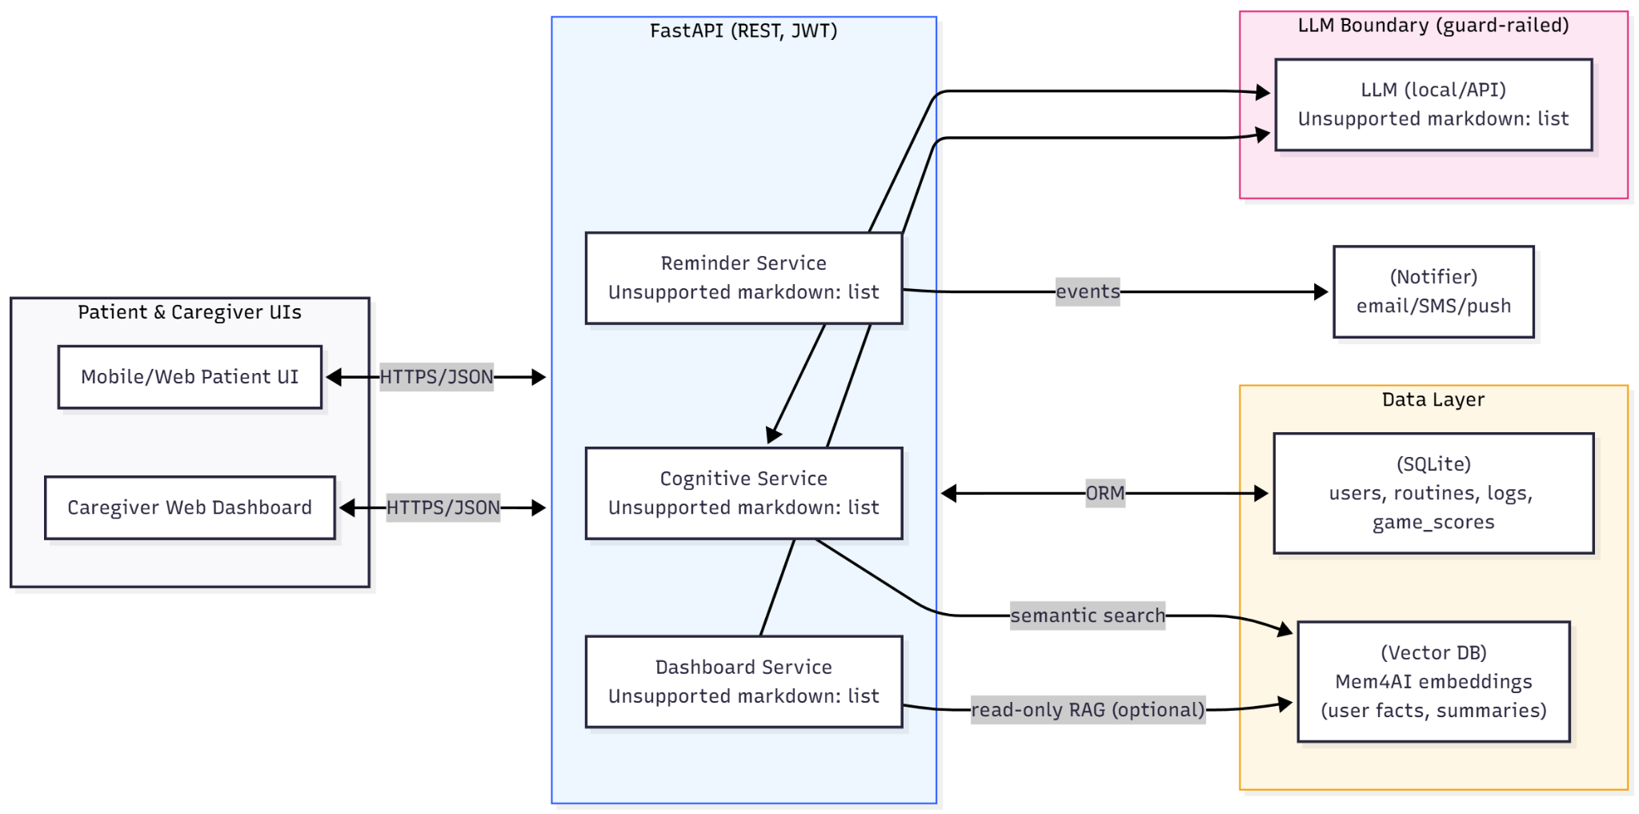

6. Component Responsibilities
Component | Responsibilities | Tech | Dependencies | Owner
Cognitive Service | facts recall, word‑aid, semantic search | FastAPI, LangChain | SQLite, VectorDB, LLM | AI Lead
Reminder Service | scheduling, notifications, adherence | FastAPI, APScheduler | SQLite, Notifier | Backend Dev
Dashboard Service | summaries, metrics | FastAPI, Pandas | SQLite (read) | Full‑stack
Auth/RBAC | JWT/OAuth2, roles | fastapi-security, pyjwt | SQLite | Backend Dev
Notifier | email/SMS push | SMTP/Twilio (mock ok) | Reminder | Full‑stack

7. Public API Contracts (MVP)
Service | HTTP | Route | Request→Response | Notes
Cognitive | POST | /cognitive/ask | {"q":"Who is Anna?"} → {"answer":"Anna is your granddaughter."} | facts only
Cognitive | POST | /cognitive/word-aid | {"prefix":"ila"} → {"suggestions":[...]} | semantic top‑K
Reminders | POST | /reminders | {"time":"14:00","text":"Take pills"} → 201 | create
Reminders | POST | /reminders/mark-done | {"id":123} → 200 | adherence
Dashboard | GET | /dashboard/summary?date=YYYY‑MM‑DD | → {"adherence":0.82,...} | no LLM

8. Data Model & Storage
Entity | Fields | Purpose | PII
users | id, role, name, email_hash, created_at | auth & ownership | low
routines | id, user_id, time, text, status | reminders | no
adherence_logs | id, routine_id, ts, status | tracking | no
game_scores | id, user_id, game, score, ts | trends | no
mem4ai_embeddings | vec_id, user_id, embedding, metadata | semantic memory | pseudo

9. Security, Privacy & Safety
Control | Implementation | Notes
AuthN/Z | OAuth2 + JWT; RBAC | Short‑lived tokens, refresh flow
Transport | TLS 1.2+ | HSTS / CSRF protections
Data at rest | SQLite encryption; secrets in env | Key rotation, least privilege
PII minimization | Only essential facts; user‑editable memory | Right‑to‑erase
AI guardrails | System prompts + refusal policies | No medical advice
Audit | Structured logs + access trails | ELK/CloudWatch when hosted

10. Reliability (SLOs) & Performance
Metric | Target | Validation
p95 latency | <1.5s | k6 load test
Uptime | 99% | health checks
Reminder on‑time | >98% | synthetic tests

11. CI/CD & Environments
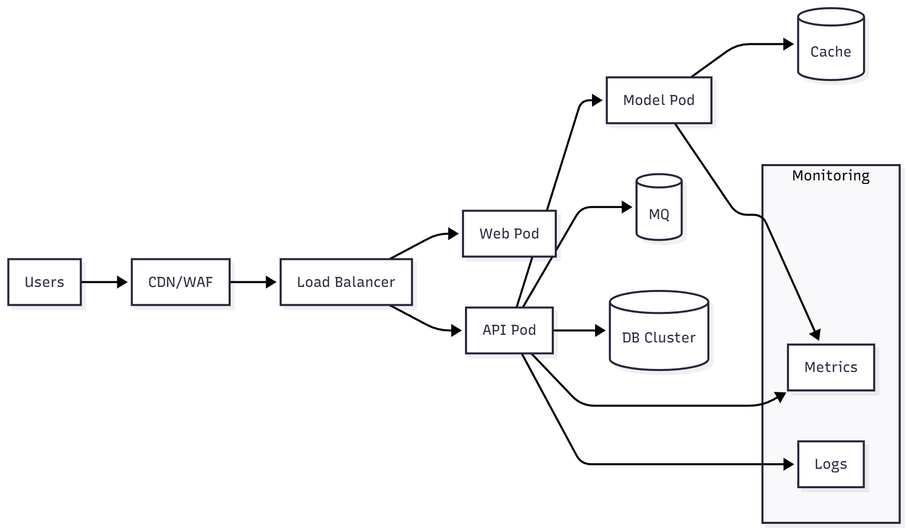
CI: GitHub Actions (lint, unit tests, security checks). CD: Docker build/push; compose/k8s manifests.

12. Key Flows
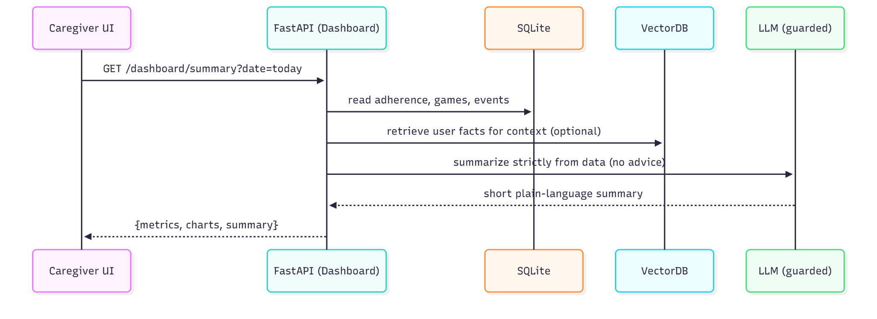
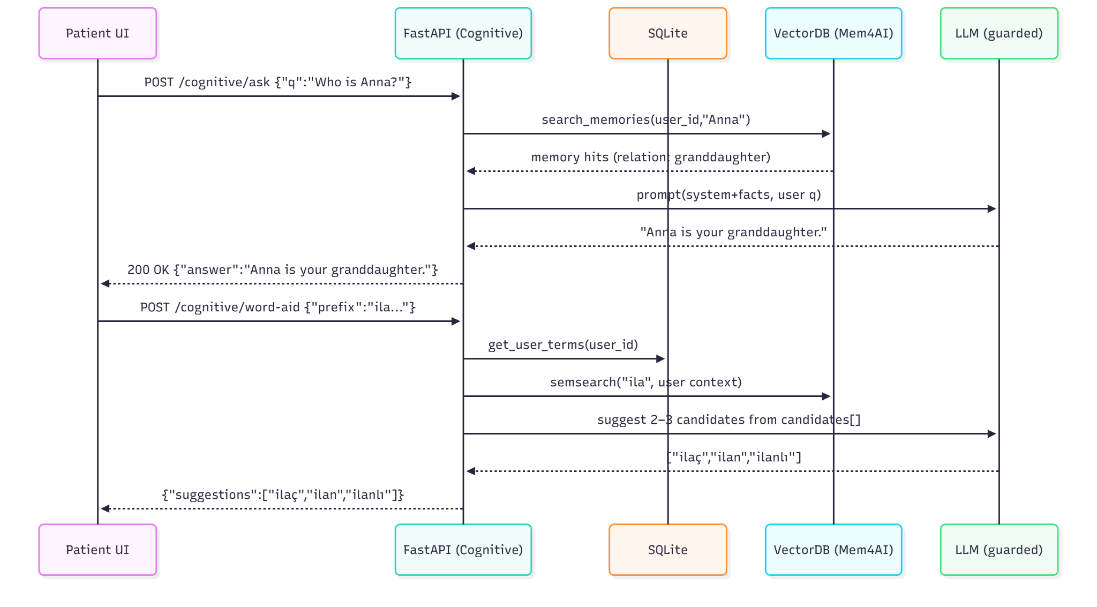
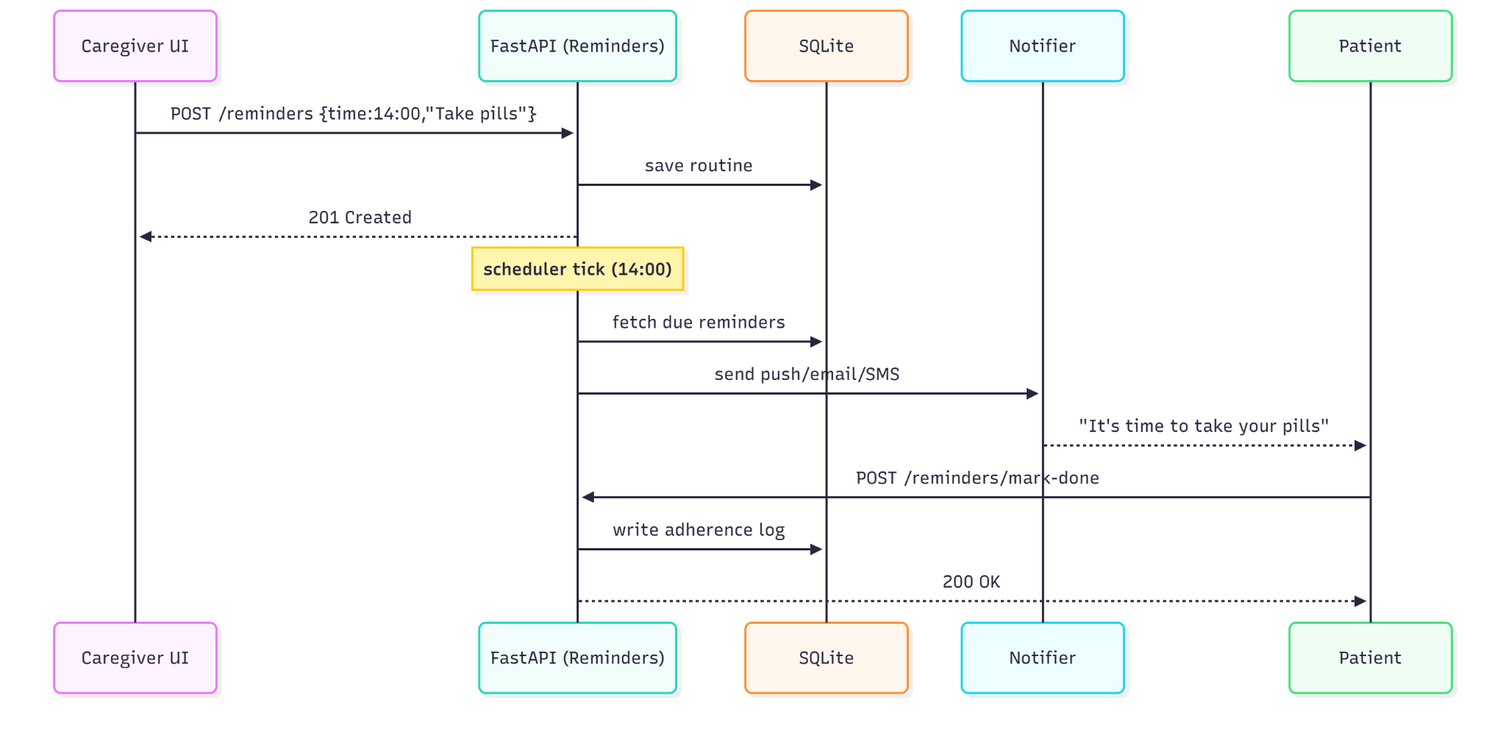

13. Detailed ERD & DDL
Entity | Column | Type | Constraint | Index
users | id | INTEGER | PK AUTOINCREMENT | PK_users
users | role | TEXT | NOT NULL CHECK(role IN ("patient","caregiver","admin")) | idx_users_role
users | name | TEXT | NOT NULL | idx_users_name
users | email_hash | TEXT | UNIQUE | idx_users_emailhash
users | created_at | DATETIME | DEFAULT CURRENT_TIMESTAMP
routines | id | INTEGER | PK AUTOINCREMENT | PK_routines
routines | user_id | INTEGER | FK -> users(id) | idx_routines_user
routines | time | TEXT | NOT NULL (HH:MM) | idx_routines_time
routines | text | TEXT | NOT NULL
routines | status | TEXT | CHECK(status IN ("active","paused")) | idx_routines_status
adherence_logs | id | INTEGER | PK AUTOINCREMENT | PK_adherence
adherence_logs | routine_id | INTEGER | FK -> routines(id) | idx_adherence_routine
adherence_logs | ts | DATETIME | NOT NULL | idx_adherence_ts
adherence_logs | status | TEXT | CHECK(status IN ("done","missed")) | idx_adherence_status
game_scores | id | INTEGER | PK AUTOINCREMENT | PK_games
game_scores | user_id | INTEGER | FK -> users(id) | idx_games_user
game_scores | game | TEXT | NOT NULL | idx_games_game
game_scores | score | INTEGER | NOT NULL
game_scores | ts | DATETIME | NOT NULL | idx_games_ts
mem4ai_embeddings | vec_id | TEXT | PK | PK_mem4ai
mem4ai_embeddings | user_id | INTEGER | FK -> users(id) | idx_mem4ai_user
mem4ai_embeddings | embedding | BLOB | NOT NULL
mem4ai_embeddings | metadata | TEXT | JSON string | idx_mem4ai_meta
SQLite DDL (excerpt) provided in Appendix A.

14. JWT Claims & RBAC Matrix
Claim | Type/Example | Notes
iss | https://auth.memoriai.local | Issuer
sub | user:123 | Subject (user id)
aud | memoriai-api | Audience
iat | 1697350000 | Issued at (epoch)
exp | 1697357200 | Expiry (epoch)
role | patient|caregiver|admin | RBAC role
scope | reminders:write reminders:read cognitive:read | Fine-grained scopes
ver | 1 | Token schema version
RBAC Matrix:
Role | Cognitive | Reminders | Dashboard | Admin
patient | ASK/READ | READ + ACK only | SELF metrics only | No
caregiver | ASK/READ | CRUD for assigned patient | FULL caregiver view | No
admin | READ logs | READ | READ | Yes: user mgmt, configs

15. Metrics & Dashboards
Panel | Metric | Source | Goal/Alert
API Health | p95 latency, error_rate | Prometheus + FastAPI middleware | Alert if p95 > 1.5s (5m)
Reminder Pipeline | sent, delivered, ack rate | SQLite + notifier logs | Ack ≥ 80%, delivery ≥ 98%
Cognitive Usage | ask_count, word_aid_accept_rate | App logs | Word-aid accept ≥ 70%
LLM Safety | refusal_count, hallucination_suspects | Guardrail logs | Zero medical advice
DB Health | DB size, slow queries | SQLite metrics | < 200ms query p95

16. Capacity Planning (Rough Sizing)
Assumptions: 100 DAU, 10 req/day → ~1,000 RPD. Burst: 5 RPS (1 min). Single node (2 vCPU, 4 GB RAM) sufficient. Scale plan: Postgres + hosted vector store + API replicas.
Resource | Baseline | Burst Target | Notes
CPU | < 40% | < 70% | Limited LLM calls; cache
Memory | < 1.5 GB | < 3 GB | Small vector index
Disk | < 1 GB | < 5 GB | SQLite + embeddings
Network | < 5 Mbps | < 20 Mbps | Notifications + API

17. Risk Matrix
Likelihood (L) and Impact (I) scored 1–5. Priority = L × I.
Risk | L | I | Priority | Mitigation | Owner
Hallucination in answers | 2 | 5 | 10 | Facts-only recall; guardrails; manual tests | AI Lead
Reminder delivery failures | 3 | 4 | 12 | Retries; ack flow; synthetic monitors | Backend Dev
PII leakage | 2 | 5 | 10 | Minimization; encryption; RBAC; audits | Security
Scope creep | 4 | 3 | 12 | MVP gates; change control; sprint planning | PM
Single-node failure | 2 | 4 | 8 | Backups; health checks; restart policy | DevOps

Flow Captions (Actor Clarification):
A) Caregiver Dashboard — Primary actor: **Caregiver**. System aggregates adherence and interactions; **Patient** is secondary (data source).
B) Cognitive & Identity / Word Aid — Primary actor: **Patient**. LLM is guardrailed; facts-only recall; caregiver is not required.
C) Daily Reminder Flow — Primary actor: **Patient** (receives notification and acknowledges). **Caregiver** configures reminders (secondary).

