1️⃣ Save the information
In Swagger, click the POST /profile/ endpoint → Execute.

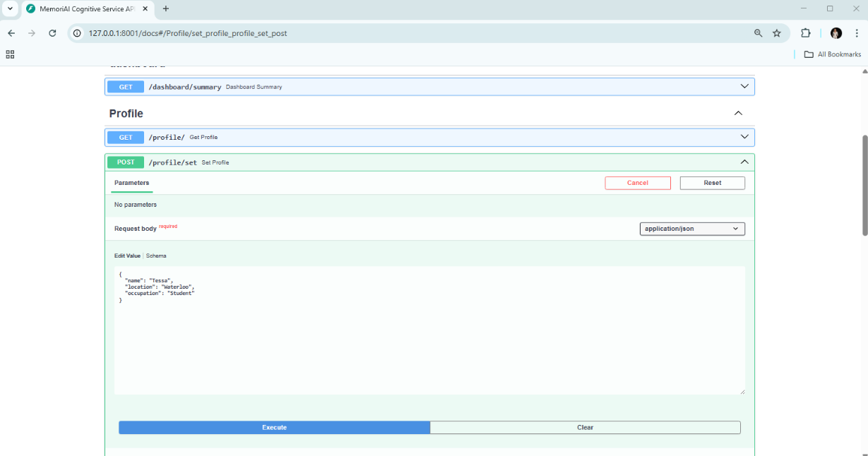

Step 1️⃣ – Verify the saved information.
Open Swagger, select the GET /profile/ endpoint, and click Execute.
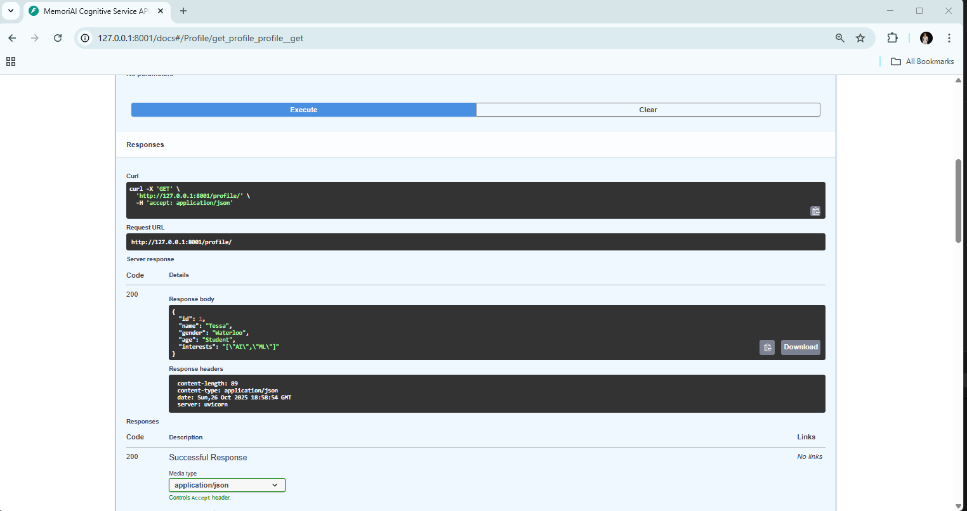

2️⃣ Test if the chatbot remembers this information
Start the chat application in the terminal:
python chat_in_terminal.py
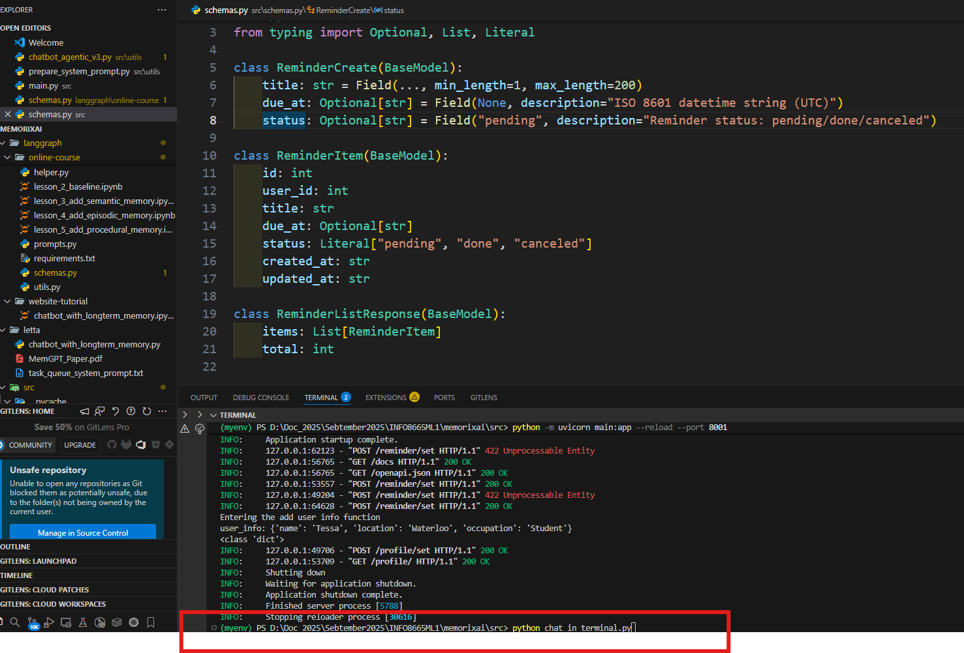

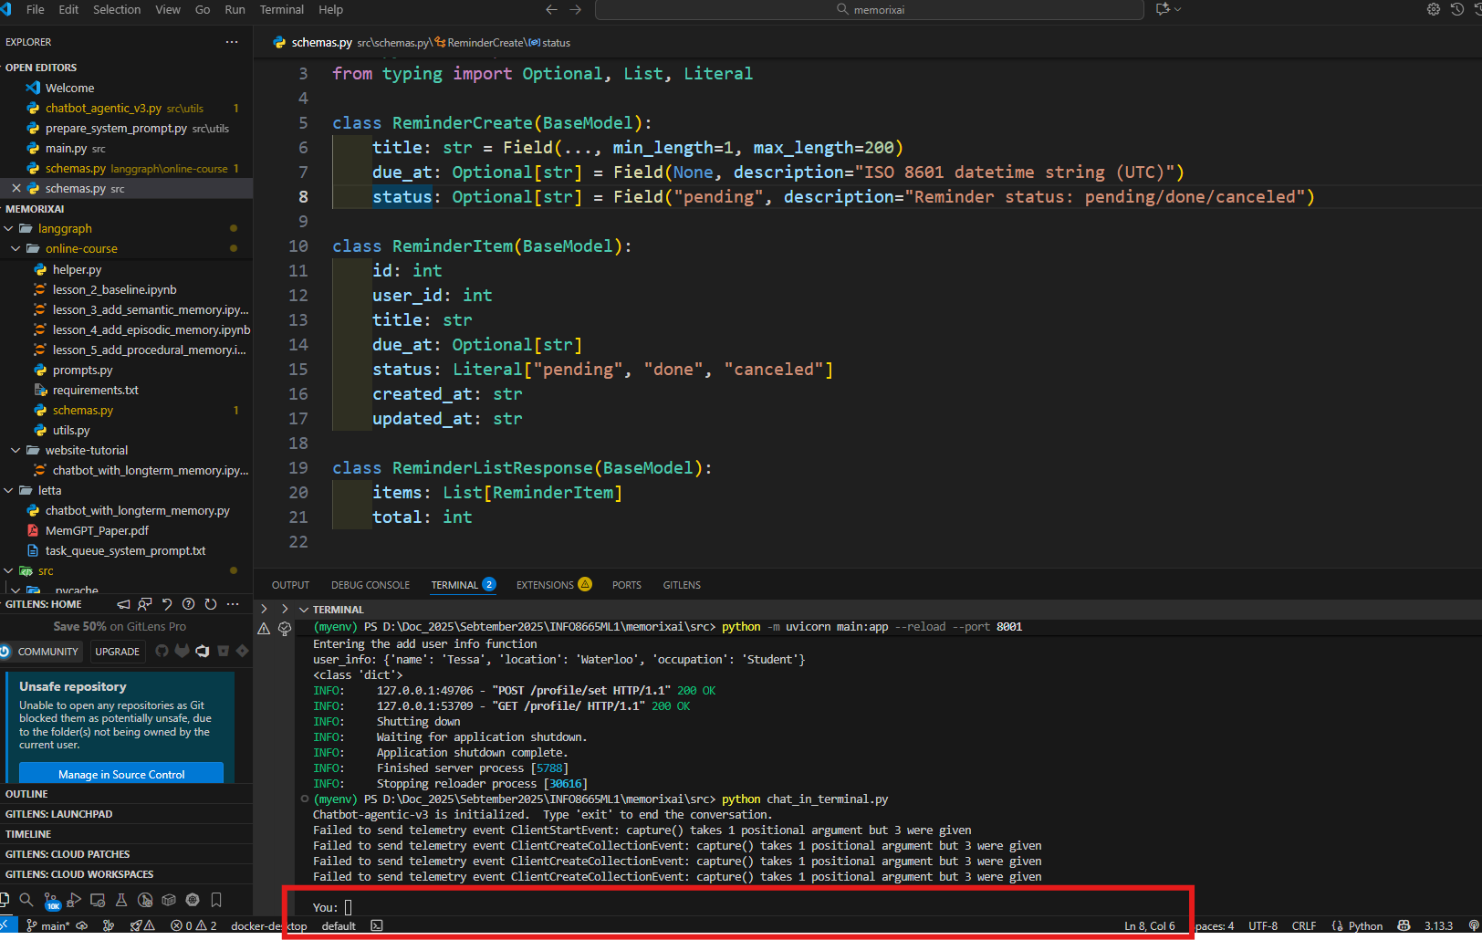

Then type the following messages in order:
Where do I live?

→ Expected answer: “You live in Waterloo.”
What is my occupation?

→ Expected answer: “You work as a Student.”
What is my name?

→ Expected answer: “Your name is Tessa.”

