
DevOps

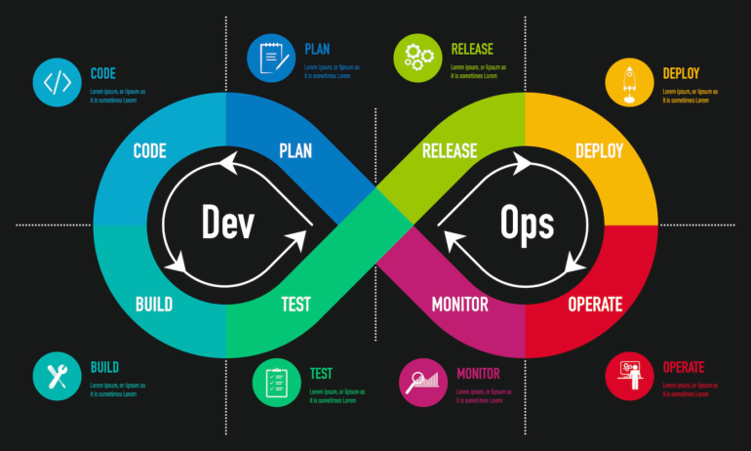
Practical File

Submitted To:
-Prof Bushra Jamal
Submitted By:
Name：Bhupendra Pratap Maurya
Student ID：41221032
Course: BCA V-Sem.

Practical-1
Aim:-git configuration and local commits

- Git init Create an empty Git repository or reinitialize an existing one
Created a directory named DevOps at Desktop and Initialized git in it using

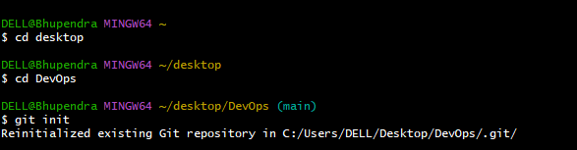

- git-config - Get and set repository or global options
Define author name & email id to be used for all commits in current repo.

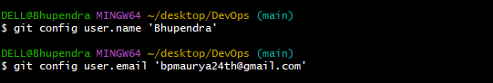

- git-status - Show the working tree status
List which files are staged, unstaged, and untracked.

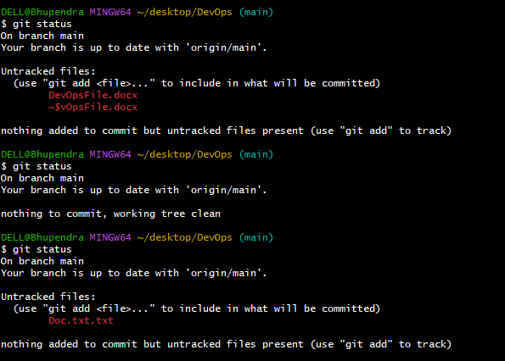

- Create a Git Hub account [https://github.com/BHUPENDRA240]
- Make a new repo. where you can upload your files and folders.

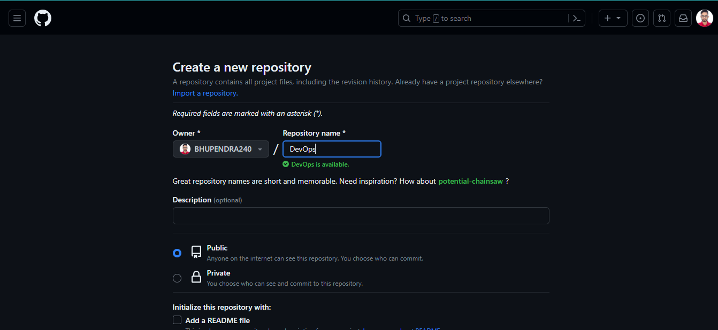

- Now copy the SSH link so that you can add your repo. From command line to the git hub.
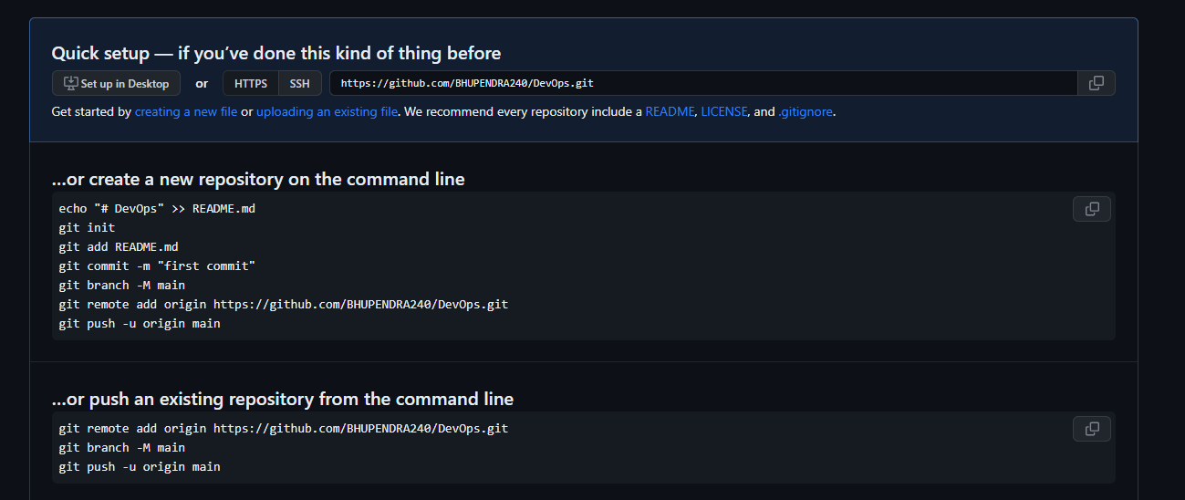

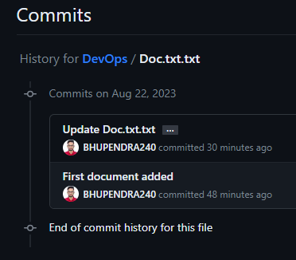
- commit-Record changes to the repository

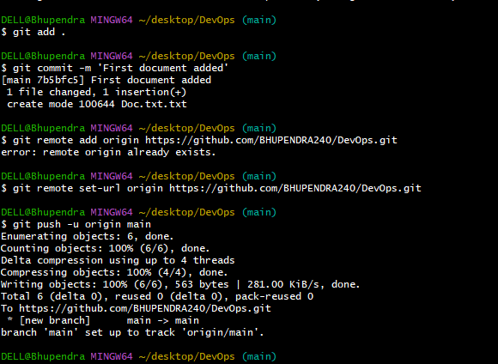

- remote-Create a new connection to a remote repo. After adding a remote, you can use as a shortcut for in other commands.

- Stage all changes in for the next commit. Replace <directory> with <file> a to change a specific file

- add- Add file contents to the index

- push- Update remote refs along with associated objects

