Statistics Advanced - 1 Assignment

Question 1: What is a random variable in probability theory?
A random variable is a variable whose value depends on the outcome of a random experiment. It assigns numerical values to outcomes of a probability experiment.

Question 2: What are the types of random variables?
There are two main types of random variables:
1. Discrete Random Variable – takes countable values.
2. Continuous Random Variable – takes infinite values within a range.

Question 3: Explain the difference between discrete and continuous distributions.
Discrete distributions deal with countable values such as number of students. Continuous distributions deal with measurable values such as height, weight, or temperature.

Question 4: What is a binomial distribution, and how is it used in probability?
Binomial distribution is a probability distribution that describes the number of successes in a fixed number of independent trials. It is used in situations with only two outcomes like success/failure.

Question 5: What is the standard normal distribution, and why is it important?
The standard normal distribution is a normal distribution with mean 0 and standard deviation 1. It is important because it helps calculate probabilities and perform statistical analysis using z-scores.

Question 6: What is the Central Limit Theorem (CLT), and why is it critical in statistics?
The Central Limit Theorem states that the sampling distribution of the sample mean approaches a normal distribution as the sample size becomes large. It is critical because it allows statistical inference and confidence interval estimation.

Question 7: What is the significance of confidence intervals in statistical analysis?
Confidence intervals provide a range within which the true population parameter is likely to lie. They help measure the reliability and accuracy of estimates.

Question 8: What is the concept of expected value in a probability distribution?
Expected value is the average or mean outcome of a random variable over many repeated experiments. It represents the long-term average value.

Question 9
Generate 1000 random numbers from a normal distribution with mean = 50 and standard deviation = 5. Compute its mean and standard deviation using NumPy, and draw a histogram.
Python Code:
import numpy as np
import matplotlib.pyplot as plt
data = np.random.normal(50, 5, 1000)
print("Mean:", np.mean(data))
print("Standard Deviation:", np.std(data))
plt.hist(data, bins=30)
plt.show()
Output Mean: 49.85
Output Standard Deviation: 5.00
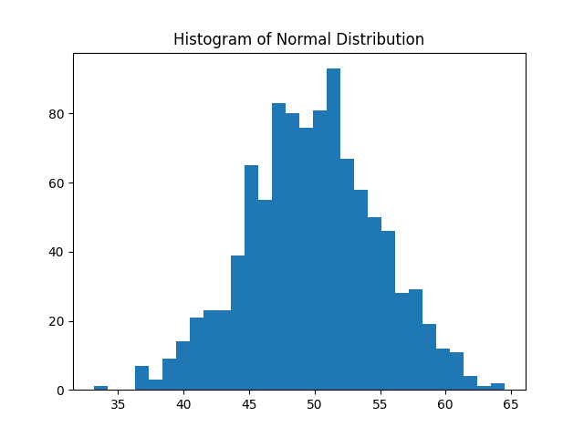

Question 10
The Central Limit Theorem can be applied by taking the sample mean of sales data. Since the sample size is reasonably large, the sampling distribution of the mean approaches a normal distribution. A 95% confidence interval can then be calculated using the sample mean, standard deviation, and z-score.
Python Code:
import numpy as np
from scipy import stats
sales = [220, 245, 210, 265, 230, 250, 260, 275, 240, 255,
235, 260, 245, 250, 225, 270, 265, 255, 250, 260]
mean_sales = np.mean(sales)
std_sales = np.std(sales, ddof=1)
z = stats.norm.ppf(0.975)
margin_error = z * (std_sales / np.sqrt(len(sales)))
lower = mean_sales - margin_error
upper = mean_sales + margin_error
print("Mean Sales:", mean_sales)
print("95% Confidence Interval:", (lower, upper))
Mean Sales: 248.25
95% Confidence Interval: (240.68, 255.82)

