WholeCart — QA Release Pack

Questions & Assumptions Log
Application: WholeCart
Assessment basis: supplied application URL, supplied role credentials, and the provided Catalogue screenshot. Execution note: the application endpoint was not reachable from the QA execution environment during this preparation run, so live execution results are explicitly marked as pending/blocked rather than fabricated.

1. Open Questions
ID | Question | Owner | Status
Q-01 | What is the authoritative business rule for buyer/seller/operator permissions on Catalogue, Cart, Orders, Invoices and Statements? | Product/BA | Open
Q-02 | Are prices stored/displayed tax-exclusive by design, and where is GST calculated—line, order, invoice, or all three? | Product/Finance | Open
Q-03 | What are the supported order lifecycle states and permitted state transitions? | Product/Operations | Open
Q-04 | Can buyers order fractional quantities, or only whole case/piece quantities? | Product | Open
Q-05 | How is inventory reserved/released, and what happens when stock changes between cart and checkout? | Product/Backend | Open
Q-06 | What is the authoritative API specification (OpenAPI/Swagger), including authentication and error contracts? | Engineering | Open
Q-07 | What are the expected invoice/statement calculation and reconciliation rules, including rounding? | Finance | Open
Q-08 | Are catalogue search/filter results paginated, and what are the performance targets for 500+ products? | Engineering | Open
Q-09 | Which browsers/devices are in release scope? | Release/QA | Open
Q-10 | What are the target availability, response-time and concurrency SLOs for the application? | Engineering/SRE | Open

2. Assumptions Used for Test Design
- WholeCart is a B2B e-commerce workflow with buyer, seller and operator personas.
- Catalogue is the product master/search surface; Cart is the purchasing workspace; Orders are transactional history; Invoices and Statements are financial documents/reconciliation surfaces.
- Seller and operator roles have elevated capabilities compared with buyers, but exact authorization rules are not yet documented.
- Product pricing includes piece and case representations and tax percentages; the screenshot visibly states that prices exclude tax.
- Authentication is username/password based using the credentials supplied for test execution.
- The supplied data set contains at least 542 catalogue products at the time of the screenshot.
- API and UI automation should be environment-configurable rather than hard-coded to a specific server state.
- No real customer payment gateway is assumed unless confirmed; checkout/payment scenarios are therefore designed as configurable coverage.
- All financial calculations require deterministic rounding and must be reconciled across Catalogue, Cart, Order, Invoice and Statement.

3. Evidence & Limitations
The supplied screenshot establishes the visible Catalogue structure: search by name/SKU, category filter, product/SKU/category, piece price, case price, tax percentage, product count, and navigation to Cart/Orders/Invoices/Statements. It does not establish hidden business rules or backend/API behavior.
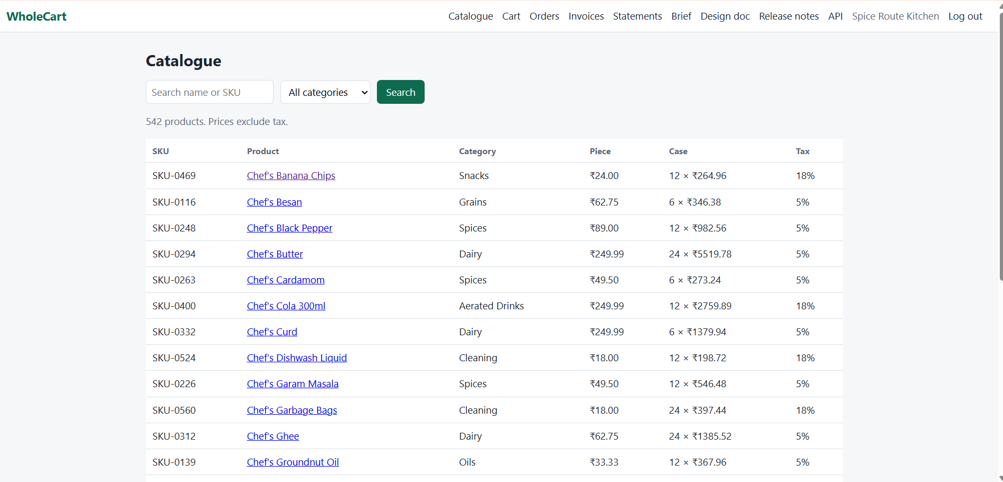
Evidence E-01 — supplied Catalogue screenshot.

