CHARLES DARWIN UNIVERSITY
HIT140 Foundations of Data Science
Assessment 3: Group Project Report
Objective 2 — Linear regression models of FIFA World Cup 2026 match outcomes
Group members (same group as Assessment 2)
Name | Student ID | Contribution
Bhupraj Tamang

Python code and dataset: https://github.com/BhuprajTmg/data-project/tree/cursor/assessment3-submission-0741
Run order: python code/clean_data.py then python code/analytics.py

1. Introduction
This report answers Objective 2 of the HIT140 project brief. The task is to predict FIFA World Cup 2026 match outcomes using only information that is known before kick-off. The tournament was hosted by Canada, Mexico and the United States from 11 June to 19 July 2026. Forty-eight teams played 104 official matches. Spain defeated Argentina 1–0 after extra time in the final.
We fit two ordinary least squares (OLS) linear regression models. Model 2.1 predicts the goal difference of a match (team 1 goals minus team 2 goals) using 104 rows and eight explanatory variables. Model 2.2 predicts the number of goals scored by one team in one match using 208 rows (two rows per match) and eight explanatory variables. The brief allows at most four of those variables to be shared. Every predictor is known before the referee starts the game. Shots, possession, cards in that match, and other in-match events are excluded because they would leak the result we are trying to predict.
All wrangling, modelling and figures were produced in Python. Microsoft Excel was used only to store the original raw tables. Both models use an 80/20 training/test split, random seed 42, and significance level α = 0.05.

2. Data and cleaning

2.1 Original data
The original workbook is data/original/fifa_data_original.xlsx. It contains three sheets compiled from the FIFA match centre, Wikipedia, Transfermarkt and the FIFA ranking freeze of 11 June 2026. The matches sheet has 104 games (date, stage, teams, scores, attendance). The teams sheet has 48 national sides (ranking, confederation, host flag, previous titles, previous World Cup appearances, squad value in EUR million, average age). The players sheet has 1,016 players who featured. Players are not used as regression predictors. They are a quality check: 294 player goals plus 14 own goals equal the official 308-goal tournament total, and 15 red cards match the official count.

2.2 Cleaning steps
Cleaning is in code/clean_data.py. Country names are mapped to one spelling so the three tables join (for example United States → USA, Turkey → Turkiye, Czech Republic → Czechia). Dates are parsed. Numeric fields are coerced. Duplicate match numbers, team names and player–team rows are dropped. The host flag is stored as 0/1. Knockout matches have no group, so the 32 blank group cells are labelled “Not applicable”. Penalty winner is blank unless the match went to penalties; those blanks are also labelled “Not applicable”. After cleaning there are no missing values in the three tables. The cleaned files are saved in data/cleaned/.

2.3 Feature construction for the two models
A knockout flag is 1 if the stage is Round of 32 through the Final (32 matches) and 0 for the group stage (72 matches). Rest days are the number of days since that team’s previous tournament match. A first match has no previous date, so those 48 opening games are filled with the median rest from the rest of the tournament (5 days). That fill uses the published schedule, not the score.
Shared variables (exactly four): knockout, FIFA rank, squad market value, and rest days. Unique to Model 2.1: age_diff, titles_diff, host_diff, same_confed. Unique to Model 2.2: team_appearances, opp_appearances, is_uefa, days_into_tournament (days since 11 June, from the calendar). Model 2.1 stores rank, value and rest as team-1-minus-team-2 differences. Model 2.2 stores them as the team’s own rank, value and rest. A smaller FIFA rank number means a stronger team.

3. Linear Regression 2.1 — goal difference
The target is goal_diff. The sample is 104 matches, split into 83 training matches and 21 test matches. Training R² = 0.493 (adjusted R² = 0.438). On the held-out matches, test R² = 0.306, RMSE = 1.57 goals and MAE = 1.18 goals. The model describes about half of the training variation. Test fit is lower, which is expected with 21 held-out matches, but the predictions are still better than using the mean.
Table 1. OLS coefficients for Model 2.1 (training sample). An asterisk marks p < 0.05.
Variable | Coefficient | p-value | Interpretation
Intercept | +0.184 | 0.383 | Not significant
rank_diff * | −0.0232 | 0.002 | Better FIFA rank for team 1 → more net goals
value_diff * | +0.0017 | 0.004 | EUR 1 billion extra squad value ≈ +1.7 net goals
rest_diff | +0.172 | 0.641 | Not significant
knockout | −0.726 | 0.097 | Knockouts look tighter (marginal only)
age_diff | +0.113 | 0.427 | Not significant (unique to 2.1)
titles_diff | −0.132 | 0.336 | Not significant (unique to 2.1)
host_diff | +0.366 | 0.494 | Not significant (unique to 2.1)
same_confed | +0.218 | 0.684 | Not significant (unique to 2.1)

Only rank_diff and value_diff are significant at 5%. The rank coefficient is negative because rank 1 is better than rank 20. If team 1 is stronger, rank_diff is negative; a negative coefficient then predicts a positive goal difference for team 1. Squad value has the expected sign: the richer squad is predicted to outscore the poorer one. Age, titles, host and same confederation add little once rank and value are already in the model. They are kept because the brief asked for eight thoughtful variables, not a search for small p-values.

4. Linear Regression 2.2 — goals scored by one team
The target is goals scored by that team in that match. The sample is 208 rows, split into 166 training rows and 42 test rows. Training R² = 0.264 (adjusted R² = 0.227). Test R² = 0.074, RMSE = 1.34 and MAE = 1.01. Test fit is weak. Two reasons explain this. First, a single team’s goal count is noisier than a match margin. Second, the sharing rule stops opponent rank and opponent value from appearing in this model. The weak test R² is reported rather than breaking the four-shared-variable limit.
Table 2. OLS coefficients for Model 2.2 (training sample). An asterisk marks p < 0.05.
Variable | Coefficient | p-value | Interpretation
Intercept | +3.14 | 0.000 | Baseline when other X = 0
team_rank * | −0.0133 | 0.037 | Better own rank → more goals
team_value | +0.0003 | 0.535 | Not significant (shared idea: value)
rest_days | −0.207 | 0.102 | Not significant (shared idea: rest)
knockout | −0.372 | 0.313 | Not significant (shared idea: knockout)
team_appearances | +0.015 | 0.558 | Own prior World Cup appearances
opp_appearances * | −0.0645 | 0.000 | More World Cup history for the opponent → fewer goals
is_uefa | +0.303 | 0.241 | UEFA dummy, not significant
days_into_tournament | +0.008 | 0.668 | Schedule day, not significant

Two coefficients are significant: team_rank and opp_appearances. A better-ranked team scores more. Facing an opponent with more previous World Cups is linked to about 0.06 fewer goals per extra appearance. Value, rest, knockout, UEFA membership and calendar day are not significant after those two variables are included.

5. Visualisation
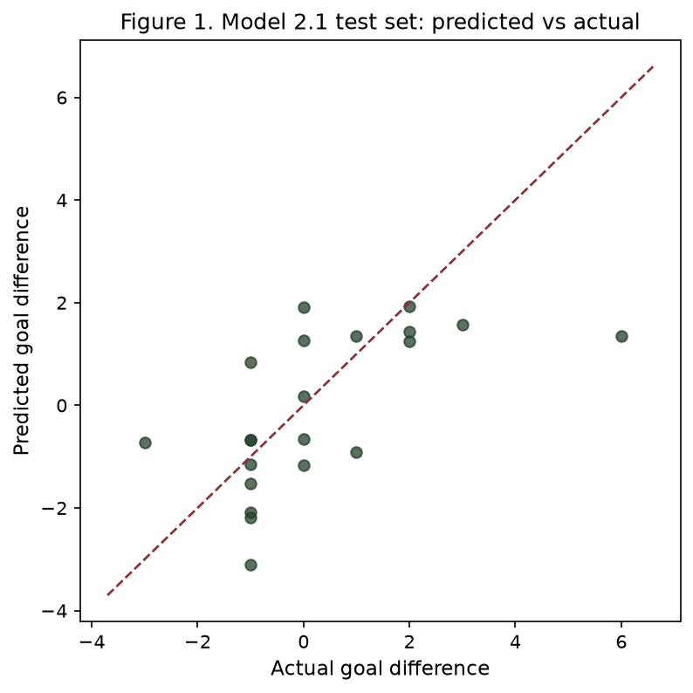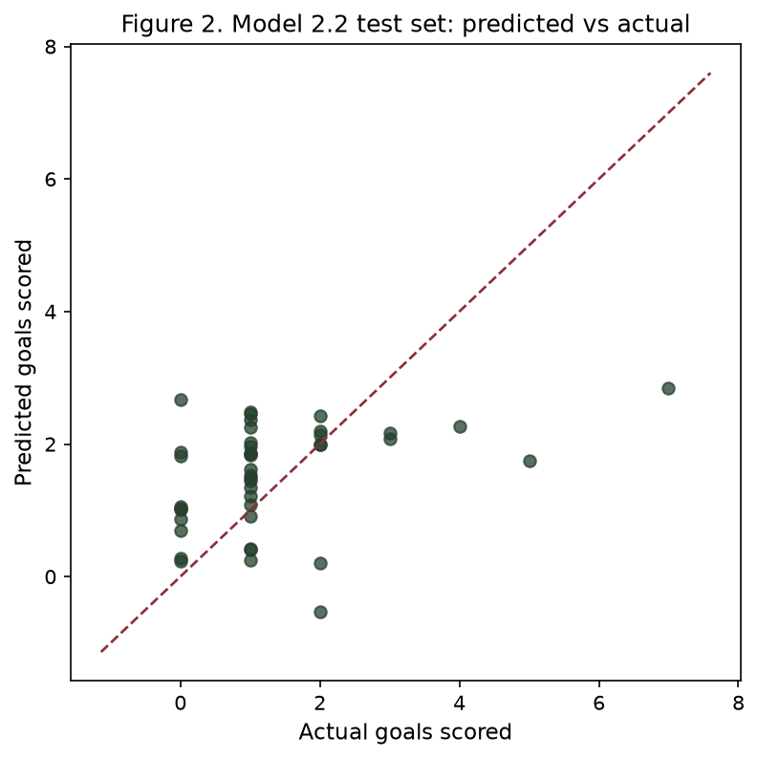
Figure 1 (left) and Figure 2 (right). Test-set predicted versus actual values. Left: Model 2.1 goal difference. Right: Model 2.2 team goals. The dashed line is a perfect prediction. Both charts were produced by code/analytics.py.

6. Diagnostics, limitations and conclusion

6.1 Diagnostics
The largest variance inflation factor, excluding the intercept, is 3.30 in Model 2.1 and 3.44 in Model 2.2. Both are below 5, so multicollinearity is not a problem. Shapiro–Wilk tests on the training residuals give p = 0.937 for Model 2.1 (consistent with normal residuals) and p = 0.017 for Model 2.2 (residuals are not normal). Goals are small counts (0, 1, 2, 3…), so OLS is a blunt tool. The brief asked for linear regression, which is why OLS is used. A Poisson model would be a reasonable next step for Model 2.2.

6.2 Limitations
Five limitations should be kept in mind. First, the 208 rows in Model 2.2 are not independent, because two rows come from the same match; this can make standard errors look too small. Model 2.1 does not have that problem. Second, Transfermarkt squad values and average ages are a snapshot and can move with the pull date; rankings, scores and titles do not. Third, the test set for Model 2.1 is only 21 matches, so test R² = 0.306 is a rough check. Fourth, first-match rest is a median fill. Fifth, the eight variables were chosen in advance. Dropping the non-significant ones after seeing p-values would be p-hacking.

6.3 Conclusion
With only pre-match information, FIFA ranking is the most stable signal. In Model 2.1, the rank gap and the squad-value gap are the significant drivers of goal difference. In Model 2.2, own rank and the opponent’s World Cup history are the significant drivers of goals scored. The goal-difference model predicts held-out matches much better (test R² 0.31 versus 0.07). That gap is partly because a match margin is easier than a count, and partly because the four-variable sharing rule blocks opponent rank from appearing in both models.

