**I.** **Revising the Select Query 1**

Query all columns for all American cities in **CITY** with populations larger than 100000. The *CountryCode* for America is USA.

**Input Format**

The **CITY** table is described as follows:

Image for post

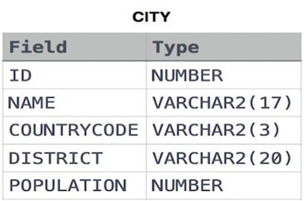

**SELECT * FROM CITY WHERE COUNTRYCODE = ‘USA’ AND POPULATION > 100000;**

**II.** **Revising the Select Query 2**

Query the names of all American cities in **CITY** with populations larger than 120000. The *CountryCode* for America is USA.

**Input Format**

The **CITY** table is described as follows:

Image for post

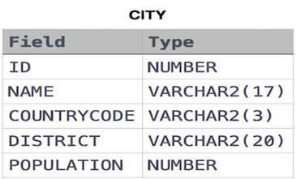

**SELECT NAME FROM CITY WHERE COUNTRYCODE = ‘USA’ AND POPULATION > 120000;**

**III.** **Select All**

Query all columns (attributes) for every row in the **CITY** table.

**Input Format**

Image for post

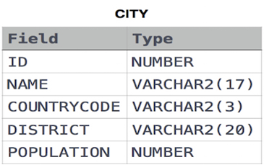

**SELECT * FROM CITY;**

**IV.** **Select By ID**

Query all columns for a city in **CITY** with the *ID* 1661.

**Input Format**

Image for post

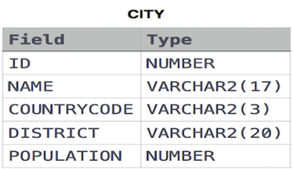

**SELECT * FROM CITY WHERE ID = 1661;**

**V.** **Japanese Cities’ Attributes**

Query all attributes of every Japanese city in the **CITY** table. The *COUNTRYCODE* for Japan is JPN.

**Input Format**

Image for post



**SELECT * FROM CITY WHERE COUNTRYCODE = ‘JPN’;**

**VI.** **Japanese Cities’ Names**

Query the names of all the Japanese cities in the **CITY** table. The *COUNTRYCODE* for Japan is JPN.

**Input Format**

Image for post



**SELECT NAME FROM CITY WHERE COUNTRYCODE = ‘JPN’;**

**VII.** **Weather Observation Station 1**

Query a list of *CITY* and *STATE* from the **STATION** table.

**Input Format**

The **STATION** table is described as follows:

Image for post

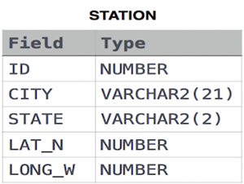

where *LAT_N* is the northern latitude and *LONG_W* is the western longitude.

**SELECT CITY, STATE FROM STATION;**

**VIII.** **Weather Observation Station 3**

Query a list of *CITY* names from **STATION** with even *ID* numbers only. You may print the results in any order but must exclude duplicates from your answer.

**Input Format**

The **STATION** table is described as follows:

Image for post



where *LAT_N* is the northern latitude and *LONG_W* is the western longitude.

**SELECT DISTINCT CITY FROM STATION WHERE MOD(ID, 2) = 0;**

**IX.** **Weather Observation Station 4**

Let **N** be the number of *CITY* entries in **STATION**, and let **N’** be the number of distinct *CITY* names in **STATION**; query the value of **N-N’** from **STATION**. In other words, find the difference between the total number of *CITY* entries in the table and the number of distinct *CITY* entries in the table.

**Input Format**

The **STATION** table is described as follows:

Image for post

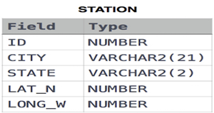

where *LAT_N* is the northern latitude and *LONG_W* is the western longitude.

**SELECT COUNT(CITY) — COUNT(DISTINCT CITY) FROM STATION ;**

**X.** **Weather Observation Station 5**

Query the two cities in **STATION** with the shortest and longest *CITY* names, as well as their respective lengths (i.e.: number of characters in the name). If there is more than one smallest or largest city, choose the one that comes first when ordered alphabetically.

**Input Format**

The **STATION** table is described as follows:

Image for post

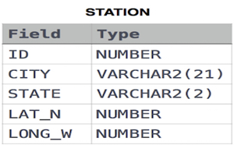

where *LAT_N* is the northern latitude and *LONG_W* is the western longitude.

**SELECT * FROM (SELECT DISTINCT city, LENGTH(city) FROM station ORDER BY LENGTH(city) ASC, city ASC) WHERE ROWNUM = 1 UNIONSELECT * FROM (SELECT DISTINCT city, LENGTH(city) FROM station ORDER BY LENGTH(city) DESC, city ASC) WHERE ROWNUM = 1;**

**XI.** **Weather Observation Station 6**

Query the list of *CITY* names starting with vowels (i.e., a, e, i, o, or u) from **STATION**. Your result *cannot* contain duplicates.

**Input Format**

The **STATION** table is described as follows:

Image for post

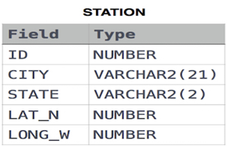

where *LAT_N* is the northern latitude and *LONG_W* is the western longitude.

**SELECT DISTINCT city FROM station WHERE city LIKE ‘A%’ OR city LIKE ‘E%’ OR city LIKE ‘I%’ OR city LIKE ‘O%’ OR city LIKE ‘U%’;**

**XII.** **Weather Observation Station 7**

Query the list of *CITY* names ending with vowels (a, e, i, o, u) from **STATION**. Your result *cannot* contain duplicates.

**Input Format**

The **STATION** table is described as follows:

Image for post

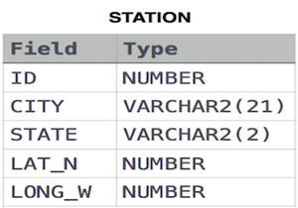

where *LAT_N* is the northern latitude and *LONG_W* is the western longitude.

**SELECT DISTINCT city FROM station WHERE city LIKE ‘%a’ OR city LIKE ‘%e’ OR city LIKE ‘%i’ OR city LIKE ‘%o’ OR city LIKE ‘%u’;**

**XIII.** **Weather Observation Station 8**

Query the list of *CITY* names from **STATION** which have vowels (i.e., *a*, *e*, *i*, *o*, and *u*) as both their first *and* last characters. Your result cannot contain duplicates.

**Input Format**

The **STATION** table is described as follows:

Image for post

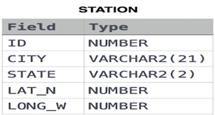

where *LAT_N* is the northern latitude and *LONG_W* is the western longitude.

**SELECT DISTINCT city FROM (SELECT DISTINCT city FROM station WHERE city LIKE ‘A%’ OR city LIKE ‘E%’ OR city LIKE ‘I%’ OR city LIKE ‘O%’ OR city LIKE ‘U%’) WHERE city LIKE ‘%a’ OR city LIKE ‘%e’ OR city LIKE ‘%i’ OR city LIKE ‘%o’ OR city LIKE ‘%u’;**

**XIV.** **Weather Observation Station 9**

Query the list of *CITY* names from **STATION** that *does not start* with vowels. Your result cannot contain duplicates.

**Input Format**

The **STATION** table is described as follows:

Image for post

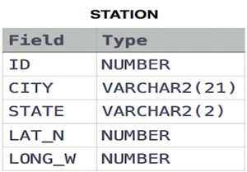

where *LAT_N* is the northern latitude and *LONG_W* is the western longitude.

**SELECT DISTINCT city FROM station WHERE NOT (city LIKE ‘A%’ OR city LIKE ‘E%’ OR city LIKE ‘I%’ OR city LIKE ‘O%’ OR city LIKE ‘U%’);**

**XV.** **Weather Observation Station 10**

Query the list of *CITY* names from **STATION** that *do not end* with vowels. Your result cannot contain duplicates.

**Input Format**

The **STATION** table is described as follows:

Image for post

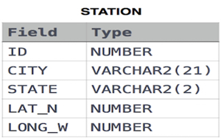

where *LAT_N* is the northern latitude and *LONG_W* is the western longitude.

**SELECT DISTINCT city FROM station WHERE NOT (city LIKE ‘%a’ OR city LIKE ‘%e’ OR city LIKE ‘%i’ OR city LIKE ‘%o’ OR city LIKE ‘%u’);**

**XVI.** **Weather Observation Station 11**

Query the list of *CITY* names from **STATION** that either do not start with vowels or do not end with vowels. Your result cannot contain duplicates.

**Input Format**

The **STATION** table is described as follows:

Image for post

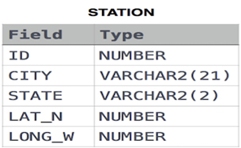

where *LAT_N* is the northern latitude and *LONG_W* is the western longitude.

**SELECT DISTINCT city FROM station WHERE(NOT (city LIKE ‘A%’ OR city LIKE ‘E%’ OR city LIKE ‘I%’ OR city LIKE ‘O%’ OR city LIKE ‘U%’)OR NOT(city LIKE ‘%a’ OR city LIKE ‘%e’ OR city LIKE ‘%i’ OR city LIKE ‘%o’ OR city LIKE ‘%u’));**

**XVII.** **Weather Observation Station 12**

Query the list of *CITY* names from **STATION** that *do not start* with vowels and *do not end* with vowels. Your result cannot contain duplicates.

**Input Format**

The **STATION** table is described as follows:

Image for post



where *LAT_N* is the northern latitude and *LONG_W* is the western longitude.

**SELECT DISTINCT city FROM station WHERE NOT((city LIKE ‘A%’ OR city LIKE ‘E%’ OR city LIKE ‘I%’ OR city LIKE ‘O%’ OR city LIKE ‘U%’)OR (city LIKE ‘%a’ OR city LIKE ‘%e’ OR city LIKE ‘%i’ OR city LIKE ‘%o’ OR city LIKE ‘%u’));**

**XVIII.** **Higher Than 75 Marks**

Query the *Name* of any student in **STUDENTS** who scored higher than *Marks*. Order your output by the *last three characters* of each name. If two or more students both have names ending in the same last three characters (i.e.: Bobby, Robby, etc.), secondary sort them by ascending *ID*.

**Input Format**

The **STUDENTS** table is described as follows:

Image for post

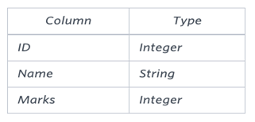

The *Name* column only contains uppercase (A-Z) and lowercase (a-z) letters.

**SELECT name FROM students WHERE marks > 75 ORDER BY SUBSTR(name, LENGTH(name)-2, 3), id;**

**XIX.** **Employee Names**

Write a query that prints a list of employee names (i.e.: the *name* attribute) from the **Employee** table in alphabetical order.

**Input Format**

The **Employee** table containing employee data for a company is described as follows:

Image for post

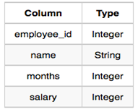

where *employee_id* is an employee’s ID number, the *name* is their name, *months* is the total number of months they’ve been working for the company, and *salary* is their monthly salary.

**SELECT name FROM employee ORDER BY name;**

**XX.** **Employee Attributes**

Write a query that prints a list of employee names (i.e.: the *name* attribute) for employees in **Employee** having a salary greater than per month who have been employees for less than months. Sort your result by ascending *employee_id*.

**Input Format**

The **Employee** table containing employee data for a company is described as follows:

Image for post



where *employee_id* is an employee’s ID number, the *name* is their name, *months* is the total number of months they’ve been working for the company, and *salary* is their monthly salary.

**SELECT name FROM employee WHERE salary > 2000 AND months < 10 ORDER BY employee_id;**

**XXI.** **Types of Triangles**

Write a query identifying the *type* of each record in the **TRIANGLES** table using its three side lengths. Output one of the following statements for each record in the table:

**Equilateral**: It’s a triangle with 3 sides of equal length.

**Isosceles**: It’s a triangle with 2 sides of equal length.

**Scalene**: It’s a triangle with 3 sides of differing lengths.

**Not A Triangle**: The given values of *A*, *B*, and *C* don’t form a triangle.

**Input Format**

The **TRIANGLES** table is described as follows:

Image for post

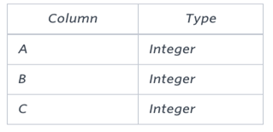

Each row in the table denotes the lengths of each of a triangle’s three sides.

**select if(A+B<=C or B+C<=A or A+C<=B,’Not A Triangle’,if(A=B and B=C,’Equilateral’,if(A=B or B=C or A=C,’Isosceles’,’Scalene’)))from TRIANGLES as T;VII.** **The PADS**

**XXII.** **The PADS**

Generate the following two result sets:

Query an *alphabetically ordered* list of all names in **OCCUPATIONS**, immediately followed by the first letter of each profession as a parenthetical (i.e.: enclosed in parentheses). For example: AnActorName(A), ADoctorName(D), AProfessorName(P), and ASingerName(S).

Query the number of occurrences of each occupation in **OCCUPATIONS**. Sort the occurrences in *ascending order*, and output them in the following format:

There are a total of [occupation_count] [occupation]s.

where [occupation_count] is the number of occurrences of occupation in **OCCUPATIONS** and [occupation] is the *lowercase* occupation name. If more than one *Occupation* has the same [occupation_count], they should be ordered alphabetically.

**Note:** There will be at least two entries in the table for each type of occupation.

**Input Format**

The **OCCUPATIONS** table is described as follows:

Image for post

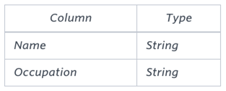

*The occupation* will only contain one of the following values: **Doctor**, **Professor**, **Singer,** or **Actor**.

**SELECT concat(NAME,concat(“(“,concat(substr(OCCUPATION,1,1),”)”))) FROM OCCUPATIONS ORDER BY NAME ASC;SELECT “There are a total of “, count(OCCUPATION), concat(lower(occupation),”s.”) FROM OCCUPATIONS GROUP BY OCCUPATION ORDER BY count(OCCUPATION), OCCUPATION ASC**

**XXIII.** **Occupations**

Pivotthe *Occupation* column in **OCCUPATIONS** so that each *Name* is sorted alphabetically and displayed underneath its corresponding *Occupation*. The output column headers should be *Doctor*, *Professor*, *Singer*, and *Actor*, respectively.

**Note:** Print **NULL** when there are no more names corresponding to an occupation.

**Input Format**

The **OCCUPATIONS** table is described as follows:

Image for post

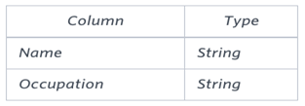

*The occupation* will only contain one of the following values: **Doctor**, **Professor**, **Singer,** or **Actor**.

**set @r1=0, @r2=0, @r3=0, @r4=0;select min(Doctor), min(Professor), min(Singer), min(Actor)from(select case when Occupation=’Doctor’ then (@r1:=@r1+1) when Occupation=’Professor’ then (@r2:=@r2+1) when Occupation=’Singer’ then (@r3:=@r3+1) when Occupation=’Actor’ then (@r4:=@r4+1) end as RowNumber,case when Occupation=’Doctor’ then Name end as Doctor,case when Occupation=’Professor’ then Name end as Professor,case when Occupation=’Singer’ then Name end as Singer,case when Occupation=’Actor’ then Name end as Acto from OCCUPATIONS order by Name) Temp group by RowNumber;**

**XXIV.** **Binary Tree Nodes**

You are given a table, *BST*, containing two columns: *N*and *P,* where *N* represents the value of a node in *Binary Tree*, and *P* is the parent of *N*.

Image for post

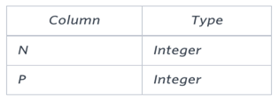

Write a query to find the node type of *Binary Tree* ordered by the value of the node. Output one of the following for each node:

*Root*: If node is root node.

*Leaf*: If node is leaf node.

*Inner*: If node is neither root nor leaf node.

**SELECT N, IF(P IS NULL,’Root’,IF((SELECT COUNT(*) FROM BST WHERE P=B.N)>0,’Inner’,’Leaf’)) FROM BST AS B ORDER BY N;**

**XXV.** **New Companies**

Amber’s conglomerate corporation just acquired some new companies. Each of the companies follows this hierarchy:

Image for post

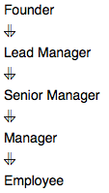

Given the table schemas below, write a query to print the *company_code*, *founder* name, total number of *lead* managers, total number of *senior* managers, total number of *managers*, and total number of *employees*. Order your output by ascending *company_code*.

**Note:**

The tables may contain duplicate records.

The *company_code* is string, so the sorting should not be **numeric**. For example, if the *company_codes* are *C_1*, *C_2*, and *C_10*, then the ascending *company_codes* will be *C_1*, *C_10*, and *C_2*.

**Input Format**

The following tables contain company data:

*Company:* The *company_code* is the code of the company and *founder* is the founder of the company.

Image for post

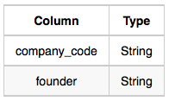

*Lead_Manager:* The *lead_manager_code* is the code of the lead manager, and the *company_code* is the code of the working company.

Image for post

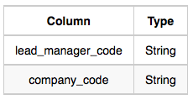

*Senior_Manager:* The *senior_manager_code* is the code of the senior manager, the *lead_manager_code* is the code of its lead manager, and the *company_code* is the code of the working company.

Image for post

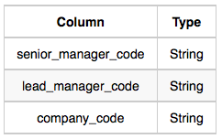

*Manager:* The *manager_code* is the code of the manager, the *senior_manager_code* is the code of its senior manager, the *lead_manager_code* is the code of its lead manager, and the *company_code* is the code of the working company.

Image for post

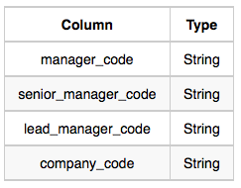

*Employee:* The *employee_code* is the code of the employee, the *manager_code* is the code of its manager, the *senior_manager_code* is the code of its senior manager, the *lead_manager_code* is the code of its lead manager, and the *company_code* is the code of the working company.

Image for post

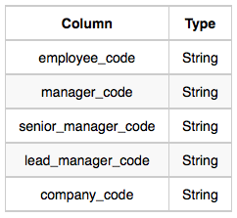

**select c.company_code, c.founder, count(distinct lm.lead_manager_code), count(distinct sm.senior_manager_code), count(distinct m.manager_code), count(distinct e.employee_code) from Company c, Lead_Manager lm, Senior_Manager sm, Manager m, Employee ewhere c.company_code = lm.company_code and lm.lead_manager_code = sm.lead_manager_code and sm.senior_manager_code = m.senior_manager_code and m.manager_code = e.manager_code group by c.company_code, c.founderorder by c.company_code**

**XXVI.** **Draw The Triangle 2**

*P(R)* represents a pattern drawn by Julia in *R* rows. The following pattern represents *P(5)*:

*

* *

* * *

* * * *

* * * * *

Write a query to print the pattern *P(20)*.

**set @row := 0;select repeat(‘* ‘, @row := @row + 1) from information_schema.tables where @row < 20**