Name : Vedika Liladhar Bhusari

Roll No. : 10

Branch : IT(TE)

Seat No. : T400290466

**ASSIGNMENT**

1. **Illustrate the need of Bower Package.**

In modern web development, managing frontend dependencies such as CSS frameworks (like Bootstrap), JavaScript libraries (like jQuery), and UI toolkits is a common task. Traditionally, developers had to manually download these libraries, extract them, and include them in their project directories. This process was not only time-consuming but also prone to errors such as version mismatches, missing files, and difficulty in updating libraries. As web projects grew larger and more complex, this manual method became inefficient and unmanageable.

* Manual Dependency Management is Tedious

Developers previously had to manually download, unzip, and manage libraries like Bootstrap, jQuery,

* Error-Prone Process

Version mismatches, missing files, and inconsistent project setups were common issues.

* Bower Provides a Package Management Solution

Bower automates the installation and management of frontend packages using simple commands.

* Centralized Dependency Folder

All installed libraries are stored in a single bower_components/ folder for easy access and organization.

* Generates bower.json File

Tracks all installed packages and their versions, ensuring project consistency across environments.

* Easy to Update Libraries

All packages can be updated with a single bower update command.

Version Control

Developers can lock versions of libraries to prevent unexpected changes.

* Reproducibility Across Systems

Other developers can install the exact same dependencies by running bower install.

* Great for Static and Educational Projects

Bower is lightweight and perfect for simple websites, academic assignments, or small demos.

* Improves Project Maintainability

Simplifies the overall development process, saves time, and keeps the frontend organized.

**2. Implement small application which will make use of mentioned package (I/p, O/p).**

**Input:**

<!DOCTYPE html>

<html lang="en">

<head>

<meta charset="UTF-8">

<title>Bower Project</title>

<meta name="viewport" content="width=device-width, initial-scale=1">

<linkhref="**bower_components/bootstrap/dist/css/bootstrap.min.css**" rel="stylesheet">

<linkhref="https://fonts.googleapis.com/css2?family=Poppins:wght@400;600&display=swap" rel="stylesheet">

<style>

body {

font-family: 'Poppins', sans-serif;

background-color: #f8f9fa;

}

.navbar-brand {

font-weight: 600;

color: #28a745;

}

.hero-section {

background-color: #d8f3dc;

border-radius: 10px;

padding: 3rem 2rem;

margin-top: 20px;

}

.hero-section img {

max-width: 100%;

border-radius: 10px;

}

.category-card img {

height: 100px;

object-fit: contain;

}

.category-card {

border: 1px solid #e2e2e2;

border-radius: 10px;

transition: transform 0.3s ease;

}

.category-card:hover {

transform: scale(1.03);

}

</style>

</head>

<body>

<!-- Navbar -->

<nav class="navbar navbar-expand-lg navbar-light bg-white shadow-sm">

<div class="container">

<a class="navbar-brand" href="#">🛒 FreshCart</a>

<button class="navbar-toggler" type="button" data-bs-toggle="collapse"

data-bs-target="#navbarNav">

<span class="navbar-toggler-icon"></span>

</button>

<div class="collapse navbar-collapse justify-content-between" id="navbarNav">

<form class="d-flex mx-auto w-50">

<input class="form-control me-2" type="search" placeholder="Search for products..."

aria-label="Search">

</form>

<ul class="navbar-nav">

<li class="nav-item"><a class="nav-link" href="#">Account</a></li>

<li class="nav-item"><a class="nav-link" href="#">Cart</a></li>

</ul>

</div>

</div>

</nav>

<!-- Hero Section -->

<div class="container hero-section mt-4">

<div class="row align-items-center">

<div class="col-md-6">

<h1 class="mb-3">SuperMarket Daily <br><strong>Fresh Grocery</strong></h1>

<p>Introduced a new model for online grocery shopping and convenient home delivery.</p>

<a href="#" class="btn btn-dark mt-3">Shop Now</a>

</div>

<div class="col-md-6 text-center">

<img src="shopping1.jpg" alt="Grocery banner">

</div>

</div>

</div>

<!-- Featured Categories -->

<div class="container my-5">

<h3 class="mb-4">Featured Categories</h3>

<div class="row g-3">

<!-- Example category cards -->

<div class="col-6 col-md-2">

<div class="p-3 bg-white text-center category-card">

<img src="dairy1.jpg" alt="Dairy">

<p class="mt-2">Dairy & Breads</p>

</div>

</div>

<div class="col-6 col-md-2">

<div class="p-3 bg-white text-center category-card">

<img src="snacks.jpg" alt="Snacks">

<p class="mt-2">Snack & Munchies</p>

</div>

</div>

<div class="col-6 col-md-2">

<div class="p-3 bg-white text-center category-card">

<img src="biscuit.jpeg" alt="Biscuits">

<p class="mt-2">Bakery & Biscuits</p>

</div>

</div>

<div class="col-6 col-md-2">

<div class="p-3 bg-white text-center category-card">

<img src="instant.jpg" alt="Instant Food">

<p class="mt-2">Instant Food</p>

</div>

</div>

<div class="col-6 col-md-2">

<div class="p-3 bg-white text-center category-card">

<img src="tea.jpeg" alt="Tea">

<p class="mt-2">Tea, Coffee & Drinks</p>

</div>

</div>

<div class="col-6 col-md-2">

<div class="p-3 bg-white text-center category-card">

<img src="atta.jpg" alt="Atta">

<p class="mt-2">Atta, Rice & Dal</p>

</div>

</div>

</div>

</div>

<script src="**bower_components/bootstrap/dist/js/bootstrap.bundle.min.js**"></script>

</body>

</html>

**Output :**

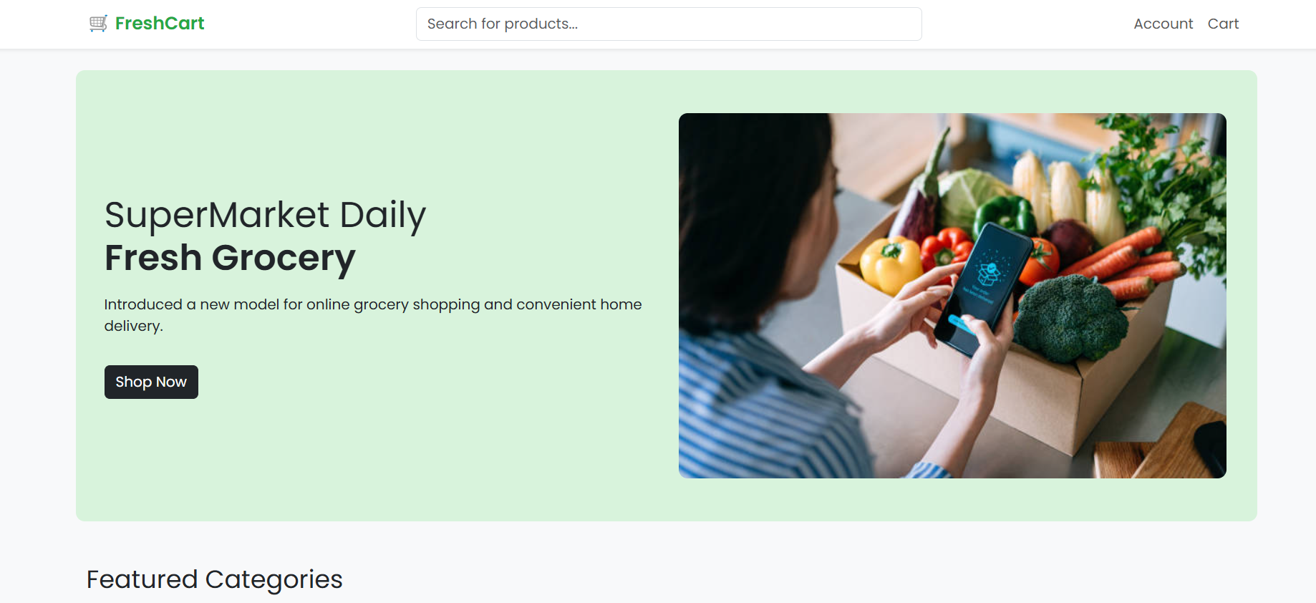

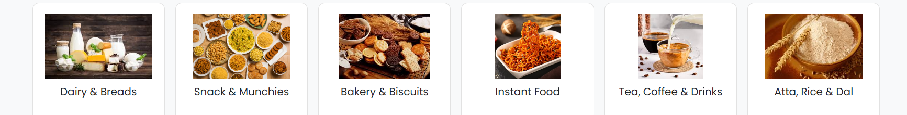

**3.** **Illustrate the need for code of ethics.**

A Code of Ethics is a vital framework that outlines the moral principles and professional standards expected of individuals within an organization, profession, or society. Its primary purpose is to guide behavior, promote integrity, and ensure accountability in decision-making and actions. In any professional setting—be it in business, medicine, engineering, or information technology—a clearly defined code of ethics helps maintain trust among clients, colleagues, and the public. It acts as a moral compass in situations where the right course of action may not be immediately clear. For example, in the tech industry, a code of ethics can help guide decisions around data privacy, user consent, and algorithmic fairness.

* Guides Professional Behavior

Helps individuals make ethical decisions and act responsibly in uncertain situations.

* Builds Trust and Credibility

Enhances trust among clients, customers, colleagues, and the public.

* Promotes Fairness and Justice

Encourages equal treatment, respect, and non-discrimination in professional settings.

* Protects Against Misconduct

Reduces the risk of unethical practices, corruption, or legal issues.

* Handles Ethical Dilemmas in Complex Situations

Useful in areas like data privacy, AI ethics, environmental responsibility, and more.

* Strengthens Organizational Culture

Promotes values such as honesty, accountability, and transparency.

* Provides a Common Ethical Framework

Ensures everyone in an organization understands and follows shared moral standards.

* Supports Continuous Improvement

Encourages reflection on one’s behavior and commitment to personal and professional growth.