Practical No : 1

Terminal 1 :

javac *.java
rmiregistry

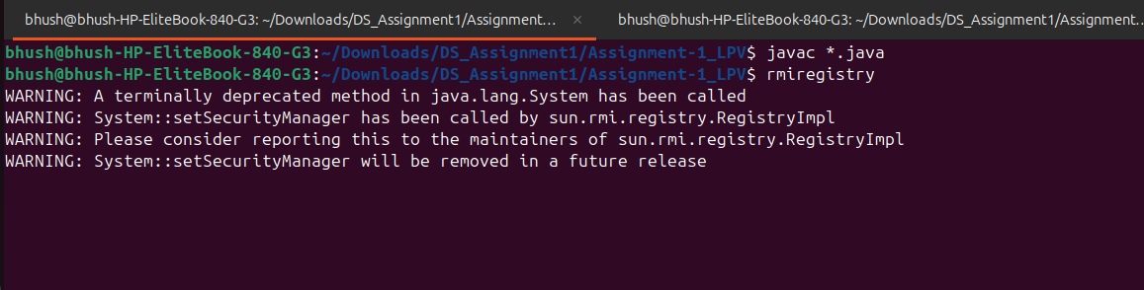

Terminal 2 :

javac Server.java
java Server

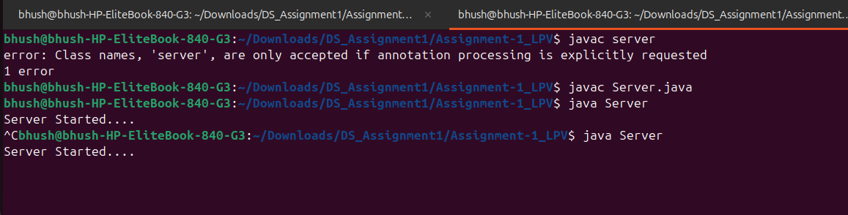

Terminal 3 :

java Client
Enter 1st String : abc
Enter 2nd String : xyz
then Output

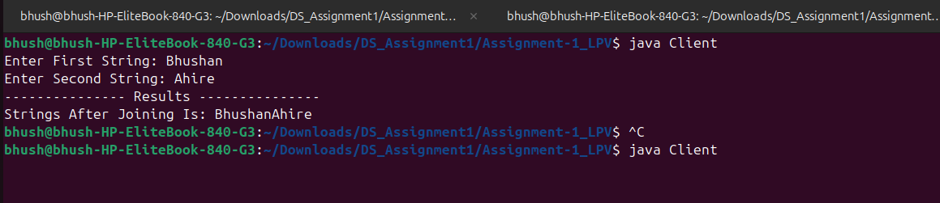

Practical No : 2
Terminal 1:-

idlj -fall Calc.idl
orbd -ORBInitialPort 1050 &
java CalcServer -ORBInitialPort 1050 -ORBInitialHost localhost

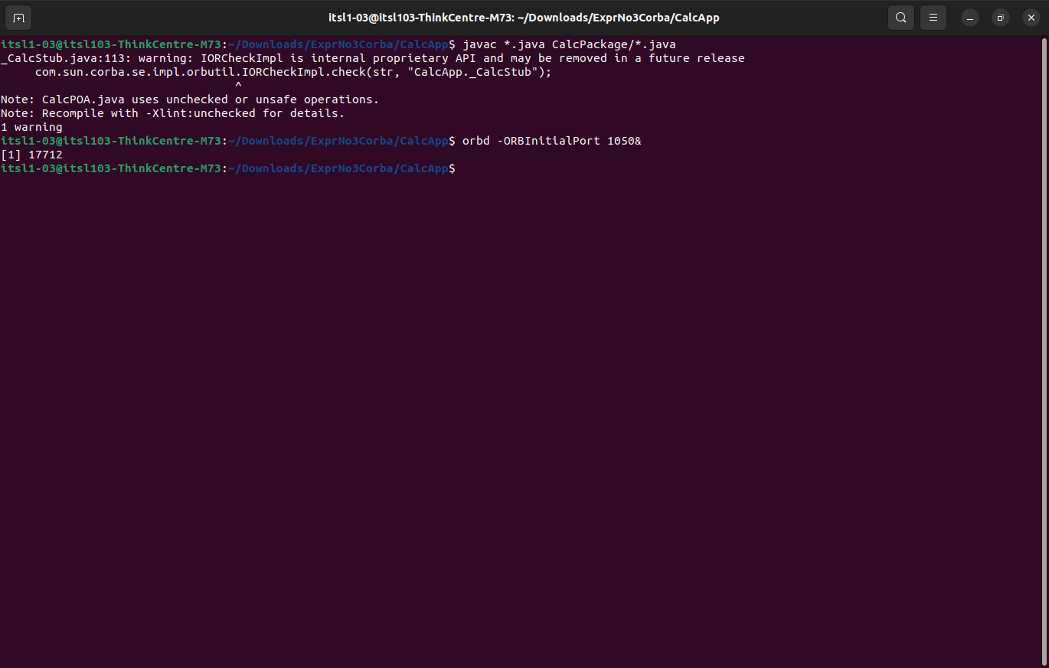

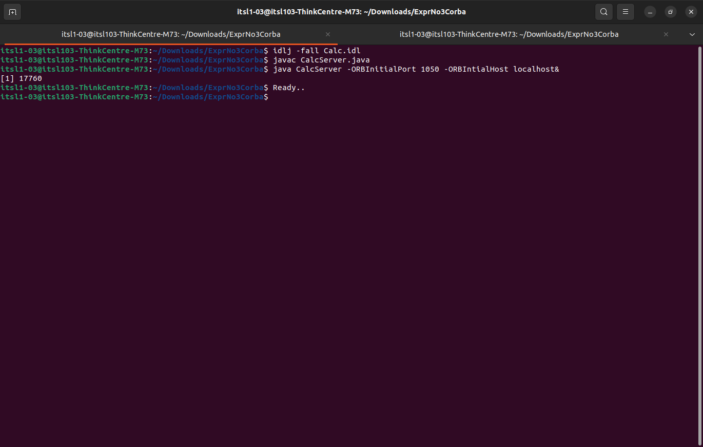

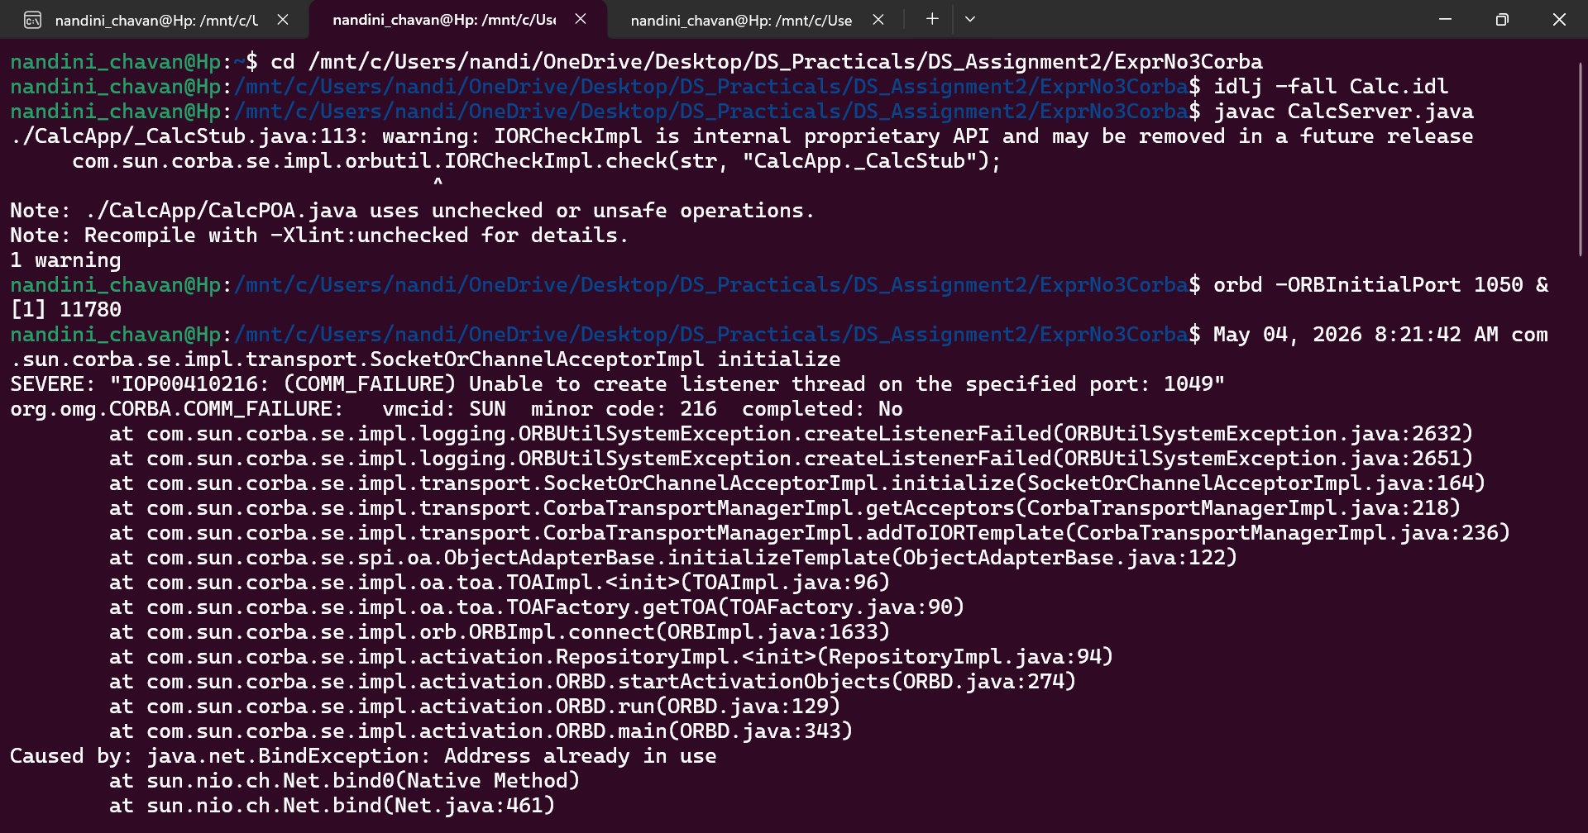

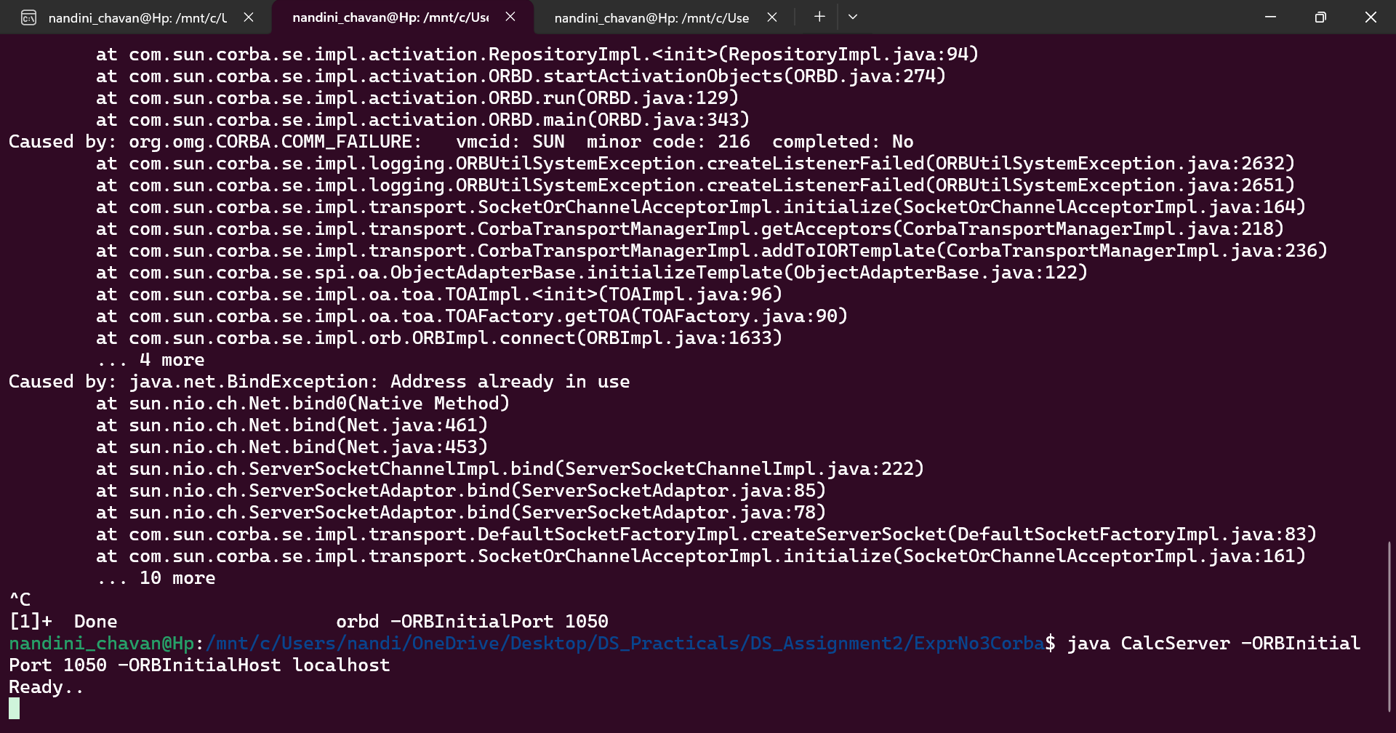

Terminal 2:-

java CalcClient -ORBInitialPort 1050 -ORBInitialHost localhost

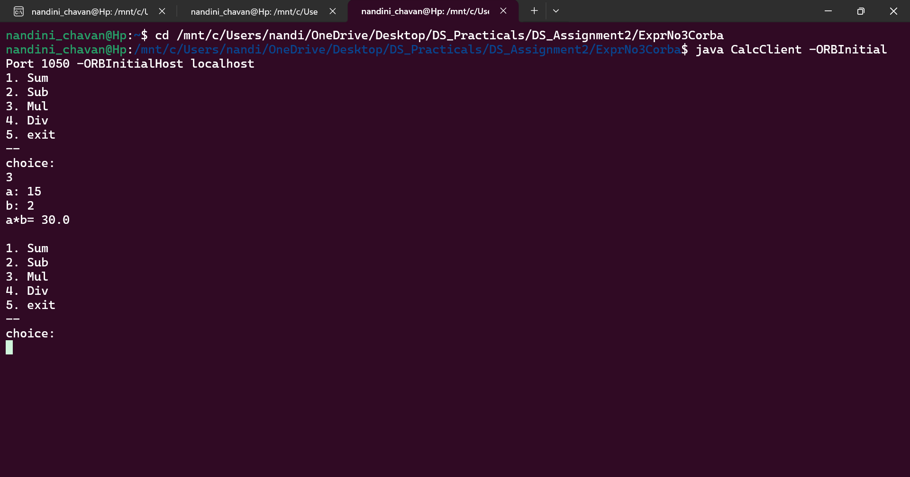

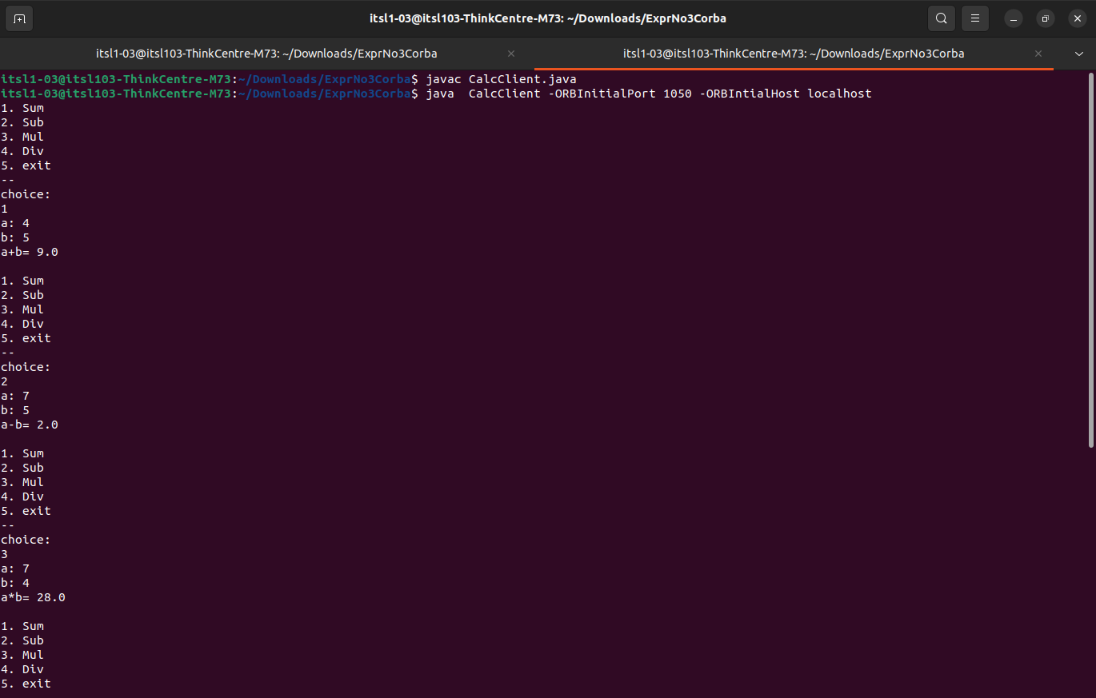

steps to run the program Steps Of Execution :

#Open First Terminal.
idlj -fall Calc.idl //create a calcapp folder
#Now open terminal in calcapp folder.
javac .java CalcPackage/.java
orbd -ORBInitialPort 1050&
#Now go to first terminal where you typed 'idlj -fall Calc.idl' this command.
javac CalcServer.java
java CalcServer -ORBInitialPort 1050 -ORBInitialHost localhost&
#In the same terminal add one more new terminal.
javac CalcClient.java
java CalcClient -ORBInitialPort 1050 -ORBInitialHost localHost

Practical No : 3

installation :
sudo apt update
sudo apt install mpich

Terminal 1 :
mpicc -o sum1_mpi sum1_mpi.c
mpirun -np 4 ./sum1_mpi

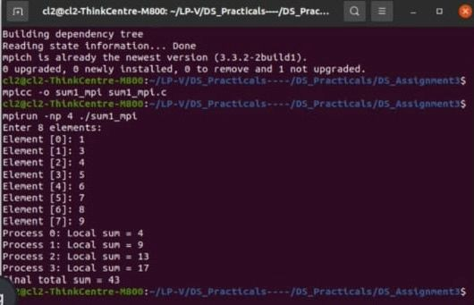

Terminal 2 :-

sudo apt install gcc
gcc -fopenmp -o sum1_omp sum_1_omp.c
./sum1_omp
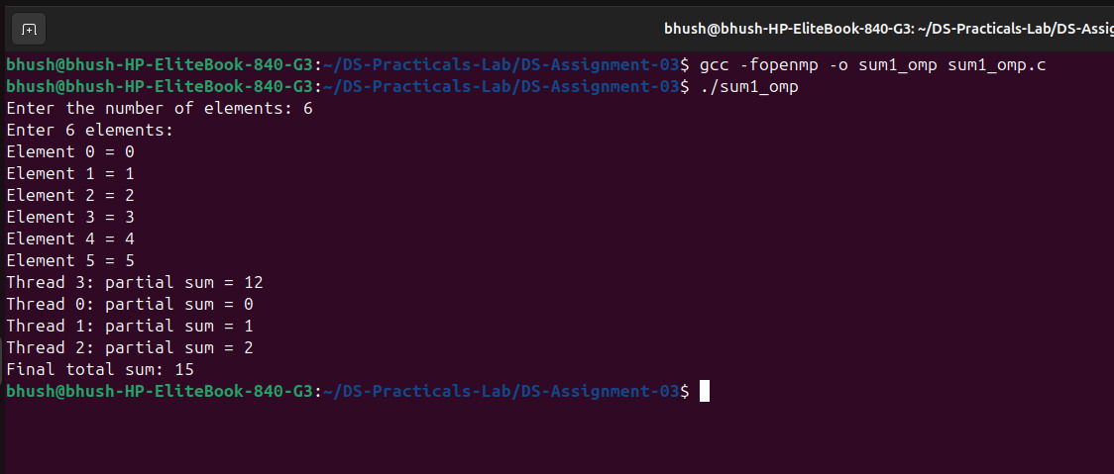

Practical No : 4

installation :
sudo apt install python-is-python3

Terminal 1 :
python3 server.py

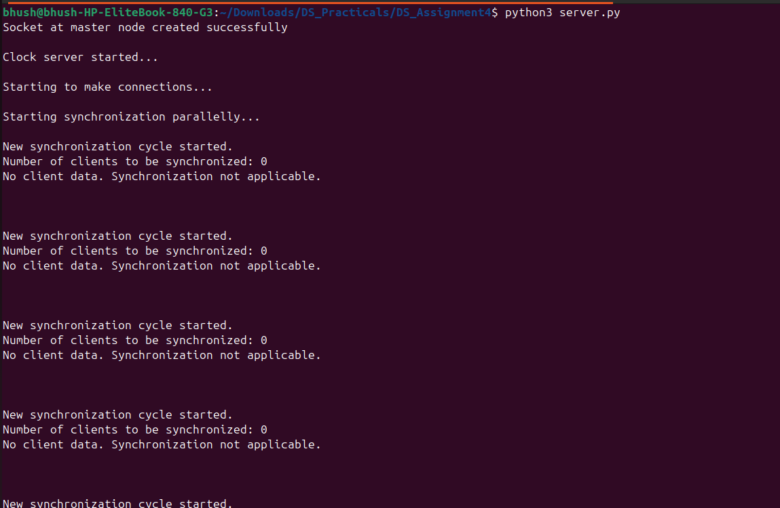

Terminal 2 :
python3 client.py

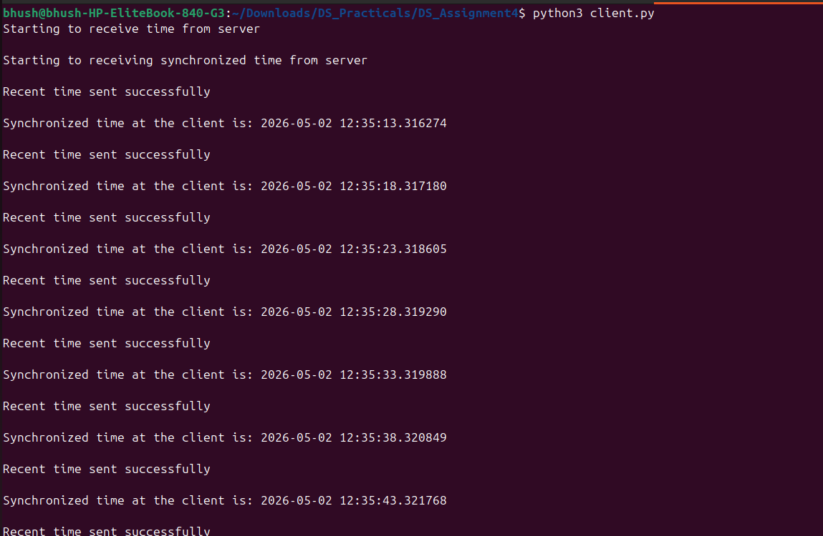

Practical No:5

Practical No : 5

Terminal 1:

javac tokenring.java
java tokenring

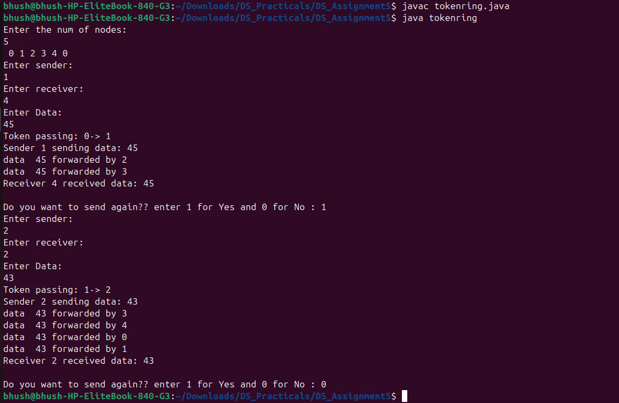

Practical No : 6

Terminal 1 :

javac Bully.java
java Bully

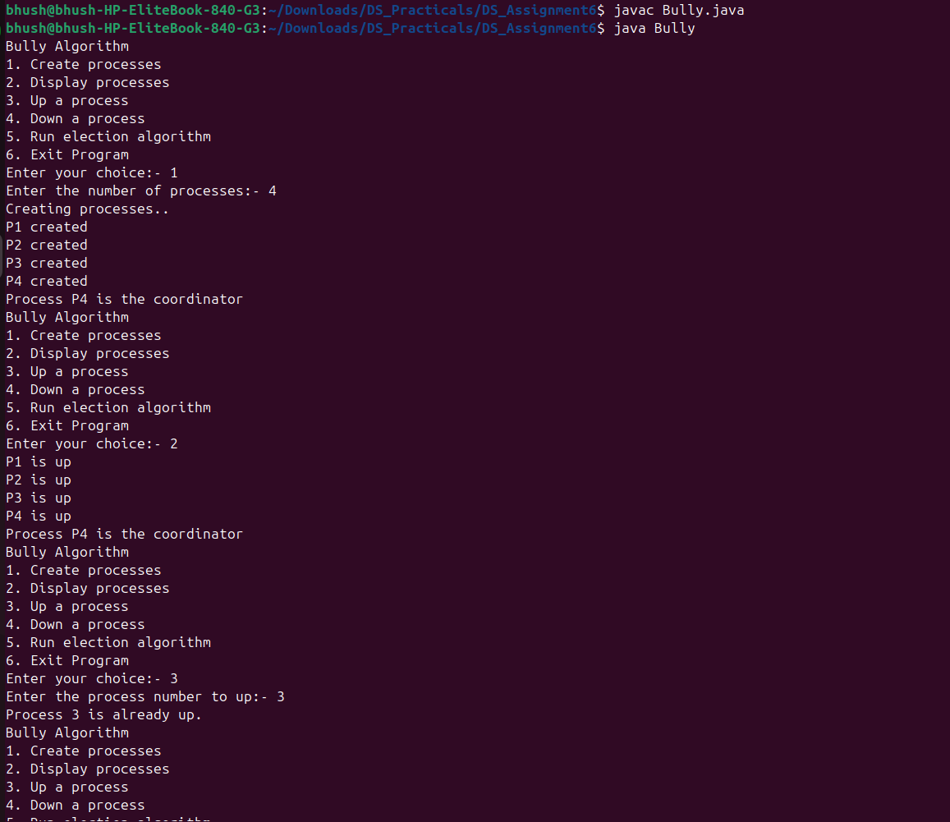

Terminal No : 2
javac Ring.java
java Ring
