AI Dashboard Generator
Project Report

1. Project Overview
The AI Dashboard Generator is an AI-powered business intelligence application that automatically generates interactive dashboards from uploaded Excel datasets. Users can upload datasets containing sales, employee, finance, inventory, or other tabular data. The system preprocesses data using Pandas, analyzes dataset metadata using a Large Language Model (LLM), and dynamically generates KPIs, chart recommendations, and dashboard visualizations without hardcoded business logic.

2. Objectives
• Automate dashboard generation from any Excel dataset.
• Perform intelligent dataset analysis using LLMs.
• Generate meaningful KPIs dynamically.
• Recommend suitable charts based on dataset structure.
• Build interactive dashboards without predefined schemas.
• Support multiple dataset domains using a generic architecture.

3. Technologies Used
Frontend: React.js, Tailwind CSS, Highcharts React
Backend: FastAPI, Python, Pandas
AI/LLM: OpenRouter, LangChain
Data Processing: Pandas, OpenPyXL
Visualization: Highcharts v5
Other: Axios, CORS Middleware

4. System Architecture
React Frontend → Axios API Layer → FastAPI Backend → Pandas Preprocessing → OpenRouter LLM → KPI & Chart Engine → Dynamic Dashboard

5. Modules and Features
Excel Upload Module:
• Upload .xlsx and .xls files
• Supports datasets from multiple domains
Data Preprocessing Module:
• Missing value detection
• Duplicate detection
• Datatype identification
• Dataset summarization
LLM Analytics Module:
• Dataset type identification
• Dimension and measure detection
• KPI recommendation
• Chart recommendation
Dashboard Module:
• Dynamic KPI cards
• Interactive charts
• Automatic dashboard generation
• Responsive UI
Visualization Module:
• Bar, Line, Column, Pie, Scatter, Area charts
• Highcharts integration

6. Workflow
1. User uploads an Excel file.
2. Backend preprocesses data using Pandas.
3. Metadata is sent to the LLM.
4. LLM returns KPI and chart configurations.
5. Pandas computes KPI values and chart data.
6. React renders the final dashboard dynamically.

7. API Endpoints
POST /dashboard/upload
GET /dashboard/latest

8. LLM Workflow
1. Extract dataset metadata.
2. Send metadata to OpenRouter via LangChain.
3. LLM identifies dimensions and measures.
4. LLM suggests KPIs and chart types.
5. Backend executes the instructions using Pandas.
6. Frontend renders the generated dashboard.

9. Challenges Faced
• Handling unknown dataset schemas.
• Preventing LLM from generating invalid columns.
• Dynamic chart generation for different datasets.
• Ensuring chart diversity.
• Handling unsupported chart types.
• Building a generic dashboard engine.

10. Solutions Implemented
• Strict prompt engineering for reliable LLM output.
• Validation of LLM-generated columns.
• Generic KPI and chart engines.
• Dynamic React rendering components.
• Pandas-based aggregation engine.
• Restriction of unsupported chart types.

11. Screenshots
Screenshot 1:
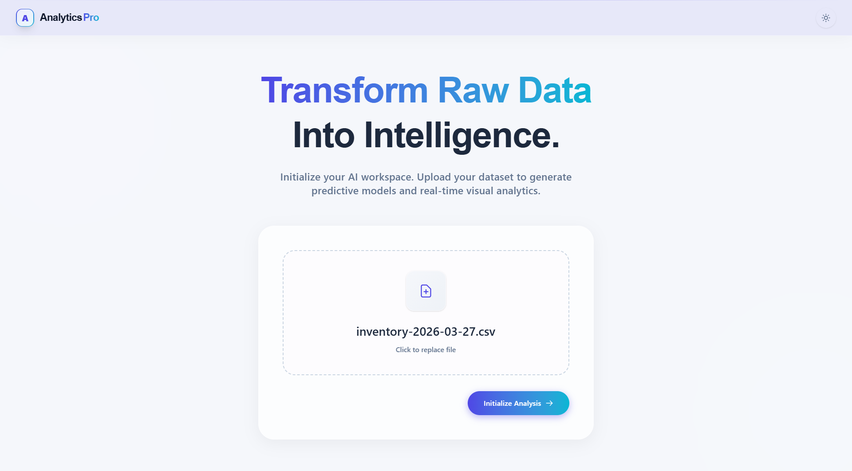
______________________________________________________________________________
Screenshot 2:
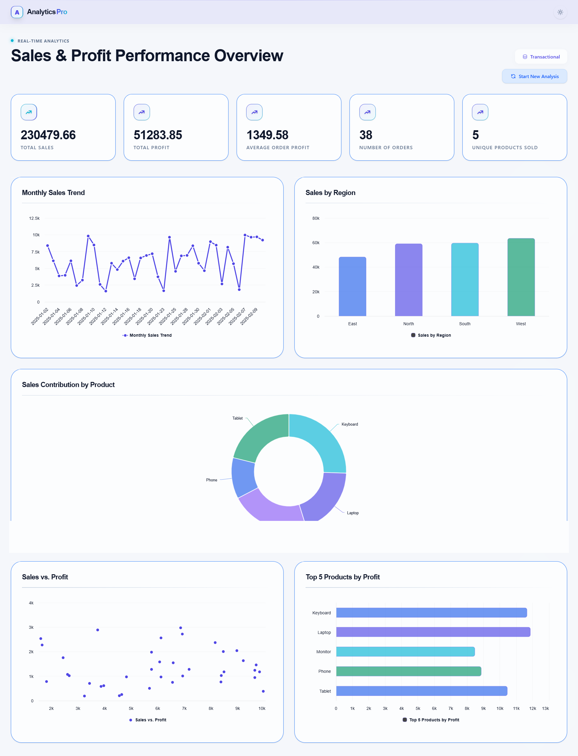
______________________________________________________________________________

12. Future Scope
• Natural language querying over dashboards.
• Export dashboards as PDF.
• Dashboard template customization.
• User authentication and dashboard saving.
• Real-time streaming analytics.
• Cloud deployment and sharing.

13. Conclusion
The AI Dashboard Generator demonstrates the integration of Generative AI with business intelligence. The project showcases full-stack development, data preprocessing, prompt engineering, dynamic visualization, and AI-driven analytics to automatically generate meaningful dashboards from diverse datasets.

