A
PROJECT REPORT ON

“SETU Digital System”

SUBMITTED TOWARDS THE SANJIVANI UNIVERSITY, KOPARGAON, PARTIAL FULFILLMENT OF THE REQUIREMENTS FOR THE AWARD
B.TECH IN COMPUTER SCIENCE & ENGINEERING

Submitted By

AKANKSHA NAIK 2124UCEF2049

SAKSHI AMBRE 2124UCEF2044

SARTHAK AMBRE 2124UCEM2043

GAURI DHANGAR 2124UCEF2093

TEJAS WAGH 2124UCEM2013
UNDER THE GUIDANCE OF

PROF. JYOTIMOYEE MAM



SANJIVANI UNIVERSITY KOPARGAON-423603 COMPUTER SCIENCE & ENGINEERING

April,2025

DEPARTMENT OF COMPUTER SCIENCE & ENGINEERING
Sanjivani University, Kopargaon


CERTIFICATE
This is to certify that the project work entitled

“SPILL MANAGEMENT SYSTEM”
Submitted By

AKANKSHA NAIK 2124UCEF2049

SAKSHI AMBRE 2124UCEF2044

SARTHAK AMBRE 2124UCEM2043

GAURI DHANGAR 2124UCEF2093

TEJAS WAGH 2124UCEM2013
Submitted towards the partial fulfilment of the requirements of Sanjivani University for the award of Computer Science & Engineering.

Prof. Jyotimoyee Kalita Dr.Mahendra Gawali

(Project Guide) (HOD CSE)

Date: / /
Place: Kopargaon

SANJIVANI UNIVERSITY, KOPARGAON


EXAMINERS CERTIFICATE
This is to certify that the project work entitled

“SPILL MANAGEMENT SYSTEM”

Submitted by

AKANKSHA NAIK 2124UCEF2049

SAKSHI AMBRE 2124UCEF2044

SARTHAK AMBRE 2124UCEM2043

GAURI DHANGAR 2124UCEF2093

TEJAS WAGH 2124UCEM2013
For the partial of the requirement of B.Tech In Computer Science & Engineering is examined and certified.

Prof.Jyotimoyee Kalita
(Project Guide)

Date: / / Place: Kopargaon

DECLARATION BY THE CANDIDATE

I hereby declare that the report entitled “Spill Management System” in Computer Science and Engineering is my original work carried out under the supervision of the project guide at the Department of Computer Science and Engineering, Sanjivani University, Kopargaon.
I further declare that, to the best of my knowledge, this report does not contain any part of any work that has been submitted for the award of any diploma or degree in this University or any other institution without proper citation and acknowledgement.
.

Name Signature

AKANKSHA NAIK 2124UCEF2049

SAKSHI AMBRE 2124UCEF2044

SARTHAK AMBRE 2124UCEM2043

GAURI DHANGAR 2124UCEF2093

TEJAS WAGH 2124UCEM2013

CERTIFICATE OF THE GUIDE

This is to certify that the work entitled “SETU Digital System” is a project carried out by a student under my guidance and supervision for the Bachelor of Technology in Computer Science and Engineering at Sanjivani University, Kopargaon , India. I further certify that the project has been completed in accordance with the academic requirements and has been duly approved by the Guide and Project Coordinator.
To the best of us knowledge and belief the project report:

- Embodies the work of the candidate himself.
- Has duly been completed.
- Fulfill the requirement of the requisites of the Department of Computer Science and Engineering

Prof.Jyotimoyee Kalita
(Name & Signature of the Guide)

Place: Kopargaon Date: …………….

ACKNOWLEDGEMENT

As a student of Bachelor of Technology (B.Tech) in Computer Science and Engineering at Sanjivani University, Kopargaon, I take this opportunity to express my sincere gratitude to all those who have supported and guided me throughout the successful completion of my project titled “SETU Digital System.”
This project has been an enriching journey that combined technical learning with practical implementation in the field of e-Governance. I am deeply thankful to my project guide and academic mentors for their continuous guidance, valuable suggestions, and constructive feedback. Their expertise and encouragement helped me overcome challenges and successfully complete this project in a structured and efficient manner.
I would like to express my heartfelt appreciation to all the faculty members of the Department of Computer Science and Engineering for providing a strong academic foundation and fostering an environment of innovation, creativity, and critical thinking. Their support has played a significant role in shaping my technical knowledge and skills.
I am also grateful to the technical and support staff for their timely assistance in providing the necessary resources, tools, and infrastructure required during the development and implementation of this project. Their cooperation ensured the smooth execution of various stages of the system.
I extend my sincere thanks to the management and leadership of Sanjivani University for creating a platform that encourages research, innovation, and practical learning. Their vision has been instrumental in motivating students to develop real-world solutions like the SETU Digital System.
I would also like to acknowledge my friends and peers for their constant support, motivation, and valuable discussions that contributed to improving the quality of this project.
Finally, I express my deepest gratitude to my family for their unwavering support, patience, and encouragement throughout this journey. Their belief in me has been a constant source of strength and inspiration.
The successful completion of the “SETU Digital System” project is the result of the collective efforts and support of many individuals. I am truly thankful for the opportunity to learn, innovate, and contribute towards building a digital solution that enhances transparency, efficiency, and accessibility in government service delivery.

ABSTRACT

The SETU Digital System is an advanced e-Governance platform developed to streamline and modernize the delivery of government citizen services through complete digital transformation. In many regions, essential services such as income certificates, residence certificates, and welfare scheme applications still rely on manual or semi-digital processes. These traditional methods often result in delays, lack of transparency, increased workload for government officials, and inconvenience for citizens due to repeated visits to government offices. This project aims to overcome these challenges by introducing a fully digital, efficient, and user-centric system that ensures real-time processing and improved service accessibility.
The system integrates modern web and mobile technologies to provide a centralized platform where citizens can apply for services online, upload necessary documents, track application status in real time, respond to verification queries, and download approved certificates. The platform follows a structured, multi-level workflow involving different roles such as citizens, SETU operators, verification officers, and administrators. Each role is assigned specific responsibilities to ensure smooth coordination, accountability, and efficient processing of applications.
At the core of the system, SETU operators verify submitted applications by checking document completeness and eligibility criteria. Verified applications are then forwarded to authorized officers for final review, approval, or rejection based on predefined government rules. Upon approval, the system generates digitally signed certificates embedded with QR code verification, ensuring authenticity and security. Additionally, the platform includes features such as role-based access control, audit logs, grievance redressal mechanisms, and performance monitoring dashboards.
The SETU Digital System significantly enhances operational efficiency by reducing manual intervention, minimizing processing time, and improving transparency at every stage of service delivery. It is scalable and can be implemented across various government departments to support multiple citizen services. By leveraging digital technologies and structured workflows, this system contributes to the development of smart governance and aligns with national initiatives focused on digital transformation and citizen-centric service delivery.

Index
- INTRODUCTION
- LITERATURE REVIEW
- PROBLEM STATEMENT
- OBJECTIVES
  - SCOPE
- SOFTWARE REQUIREMENT
- SYSTEM DESIGN
- CONCLUSION ..
- FUTURE SCOPE
- REFERENCE
INTRODUCTION

In today’s rapidly evolving digital era, the demand for efficient, transparent, and accessible government services has become increasingly important. Governments across the world are focusing on digital transformation to improve public service delivery and enhance citizen satisfaction. However, in many regions, essential citizen services such as income certificates, residence certificates, and welfare scheme applications are still managed through manual or semi-digital processes. These traditional systems often lead to delays, lack of transparency, increased administrative burden, and inconvenience for citizens.
Conventional service delivery methods require citizens to visit government offices multiple times for application submission, document verification, and status updates. This not only consumes time and resources but also creates inefficiencies in workflow management. Additionally, the absence of proper tracking mechanisms and centralized systems makes it difficult for both citizens and authorities to monitor application progress, leading to uncertainty and reduced accountability.
To overcome these challenges, the concept of a digital e-Governance platform has been introduced. The SETU Digital System is designed to automate and streamline the complete lifecycle of citizen service delivery through a secure and role-based approach. The system enables citizens to apply for services online, upload required documents, track real-time application status, and receive digitally signed certificates without the need for physical visits.
The platform integrates modern technologies such as web and mobile applications, secure authentication mechanisms, and centralized databases to ensure efficient data management and communication between different stakeholders. It follows a structured workflow involving multiple roles, including citizens, SETU operators, verification officers, and administrators. Each role performs specific functions, ensuring smooth coordination, transparency, and accountability throughout the process.
Furthermore, the system provides features such as real-time status tracking, audit logs, grievance handling, and performance monitoring dashboards. These functionalities not only improve operational efficiency but also help maintain proper records and ensure compliance with governance standards. By reducing manual intervention and enabling continuous monitoring, the system enhances reliability and service quality.
The development of the SETU Digital System is highly relevant in today’s context, where digital governance and citizen-centric services are key priorities. It aligns with national digital initiatives and contributes to building a transparent, efficient, and accessible governance framework. By leveraging technology to simplify complex administrative processes, this system aims to bridge the gap between citizens and government services while promoting efficiency, accountability, and ease of access

LITERATURE REVIEW

Title (Year) | Methodology | Performance Metric | Limitations / Future Scope
A Study of Citizen Satisfaction for e-Government Services (2020) | Survey-based quantitative research using structured questionnaires; statistical analysis to evaluate citizen satisfaction and service quality factors | Satisfaction score, usability, accessibility, reliability, service quality indicators, hypothesis testing | Limited respondents and region-specific study; future work suggests larger samples, broader coverage, and enhanced service features
Multi-Factor Authentication for e-Government Services using a Smartphone Application and Biometric Identity Verification (2020) | Proposed multi-factor authentication model integrating OTP + biometric verification (fingerprint/facial recognition) via smartphone app and kiosk-based enrollment | Security strength, authentication reliability, reduced password vulnerabilities, improved identity assurance | Requires physical kiosk setup; deployment cost; dependency on biometric hardware; future scope includes scalability and broader mobile integration
Digitalization Era: Website Based E-Government (2021) | Quantitative evaluation of government websites using scoring method (1 = available, 0 = not available) across transparency, effectiveness, efficiency, and social media criteria | Percentage scores for transparency, effectiveness, efficiency, accessibility, website functionality | Many websites inactive or incomplete; low transparency; future work suggests improving content updates, interactivity, and service integration

PROBLEM STATEMENT

Many government citizen services, such as income certificates, residence certificates, and welfare applications, still rely on manual or semi-digital processes. This results in long delays, repeated visits to offices, lack of transparency, and inefficiency for both citizens and government staff. There is a need for a secure, automated, and role-based digital system that allows citizens to apply, track, and receive certificates online, while improving accountability, transparency, and service efficiency.

OBJECTIVES
The primary objective of the SETU Digital System is to develop a secure, efficient, and user-friendly e-Governance platform that digitizes and streamlines the delivery of government citizen services. The system aims to reduce manual effort, improve transparency, and enhance overall service efficiency.
Specific Objectives:
- To digitize government services
Develop an online platform that allows citizens to apply for services such as income certificates, residence certificates, and welfare schemes without visiting government offices.
- To reduce processing time
Minimize delays by automating application submission, verification, and approval workflows.
- To ensure transparency and accountability
Provide real-time application status tracking and maintain audit logs for all activities performed within the system.
- To implement role-based access control
Define and manage different user roles such as citizens, SETU operators, officers, and administrators to ensure secure and structured workflow management.
- To enable secure authentication and data protection
Use technologies like JWT to ensure secure login, data privacy, and controlled system access.
- To simplify document management
Allow users to upload, verify, and manage documents digitally, reducing paperwork and chances of data loss.
- To provide digital certificate generation
Generate digitally signed certificates with QR code verification for authenticity and easy validation.
- To improve user experience
Design an intuitive and responsive interface that is easy to use for both citizens and government officials.
- To enable grievance handling and communication
Provide mechanisms for raising queries, resolving issues, and improving communication between users and authorities.

1. Application Design and Development
The SETU Digital System is designed and developed using modern technologies to ensure efficiency, scalability, and user-friendly interaction. The system includes both mobile and web-based interfaces, developed using Flutter for cross-platform accessibility, enabling citizens and officials to access services seamlessly from various devices such as smartphones, tablets, and desktops.
The frontend of the application focuses on providing a clean, intuitive, and responsive user interface that simplifies the process of applying for government services. Citizens can easily register, log in, select services, fill application forms, upload documents, and track application status in real time. The interface is designed to enhance usability and ensure accessibility for users with varying levels of technical knowledge.
The backend is developed using Java and Spring Boot, which handle business logic, data processing, and secure communication between the frontend and the database. REST APIs are used to enable smooth interaction between different components of the system, ensuring real-time data exchange and efficient performance.
The system incorporates secure authentication using JWT (JSON Web Tokens), ensuring that only authorized users can access specific functionalities based on their roles. Role-based dashboards are provided for citizens, SETU operators, officers, and administrators, allowing each user to perform their designated tasks efficiently.
Additionally, the platform supports features such as real-time application tracking, document verification workflows, query management, and certificate generation. The integration of MySQL as the database management system ensures secure storage, quick retrieval, and efficient management of application data.
Overall, the application is designed to provide a scalable and reliable digital solution that can be extended to support multiple government departments and services while maintaining high performance, security, and usability standards.

SOFTWARE REQUIREMENTS
Software:
- Programming Language: Java (for backend development), Dart (for Flutter frontend)
- Frontend: Flutter (for cross-platform mobile and web application)
- Backend Framework: Spring Boot (for building RESTful APIs and handling business logic)
- Database: MySQL (for storing user data, applications, documents, and system records)
- API Communication: REST APIs (for seamless frontend–backend interaction)
- Authentication & Security: JWT (JSON Web Tokens) for secure login and role-based access control

HARDWARE (MINIMUM REQUIREMENTS):
- Processor: Intel i3 or above
- RAM: 4 GB minimum (8 GB recommended)
- Storage: 256 GB or above
- Device Support: Smartphone / Laptop / Desktop with internet connectivity

TOOLS & TECHNOLOGIES:
- IDE: Visual Studio Code / IntelliJ IDEA / Android Studio
- Version Control: GitHub (for code management and collaboration)
- API Testing Tool: Postman (for testing REST APIs)
- Database Tool: MySQL Workbench / phpMyAdmin
- Design Tools (optional): Figma / Canva (for UI/UX design)

FLOW CHART

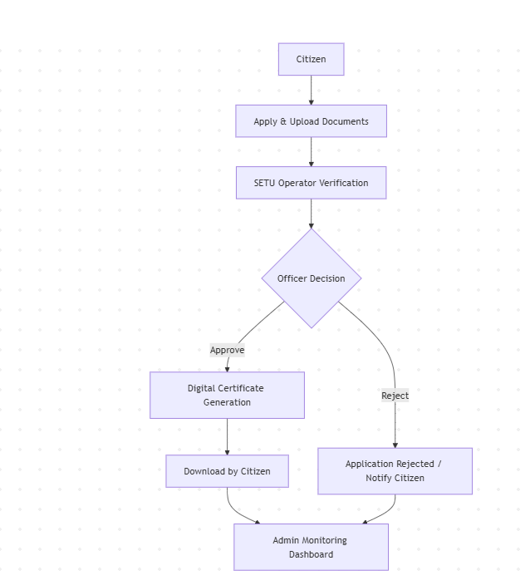

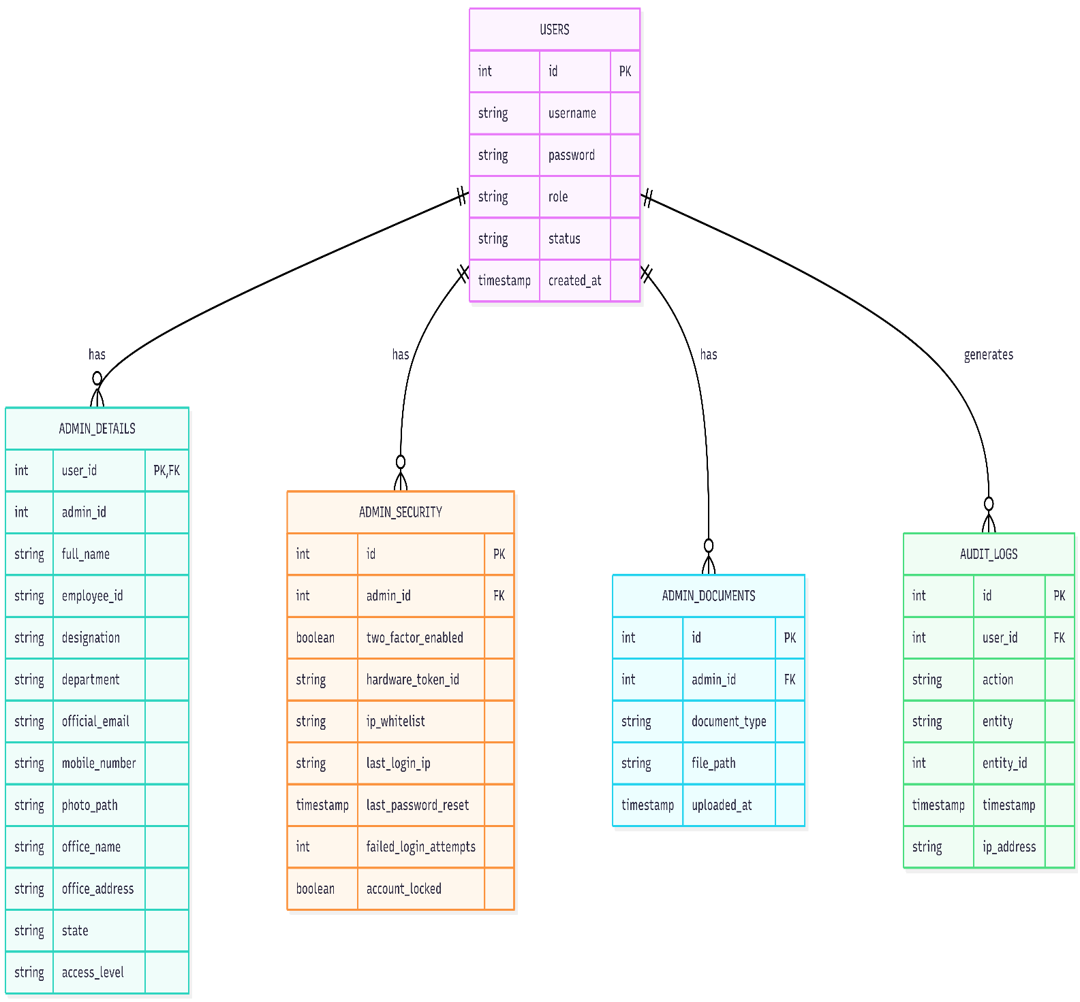

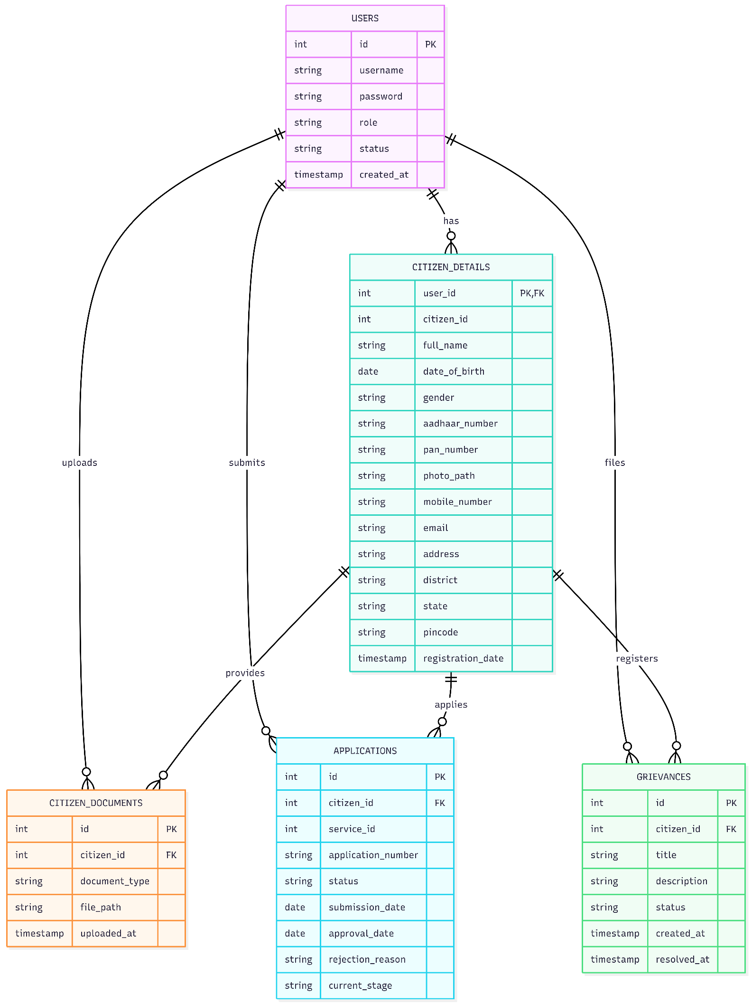

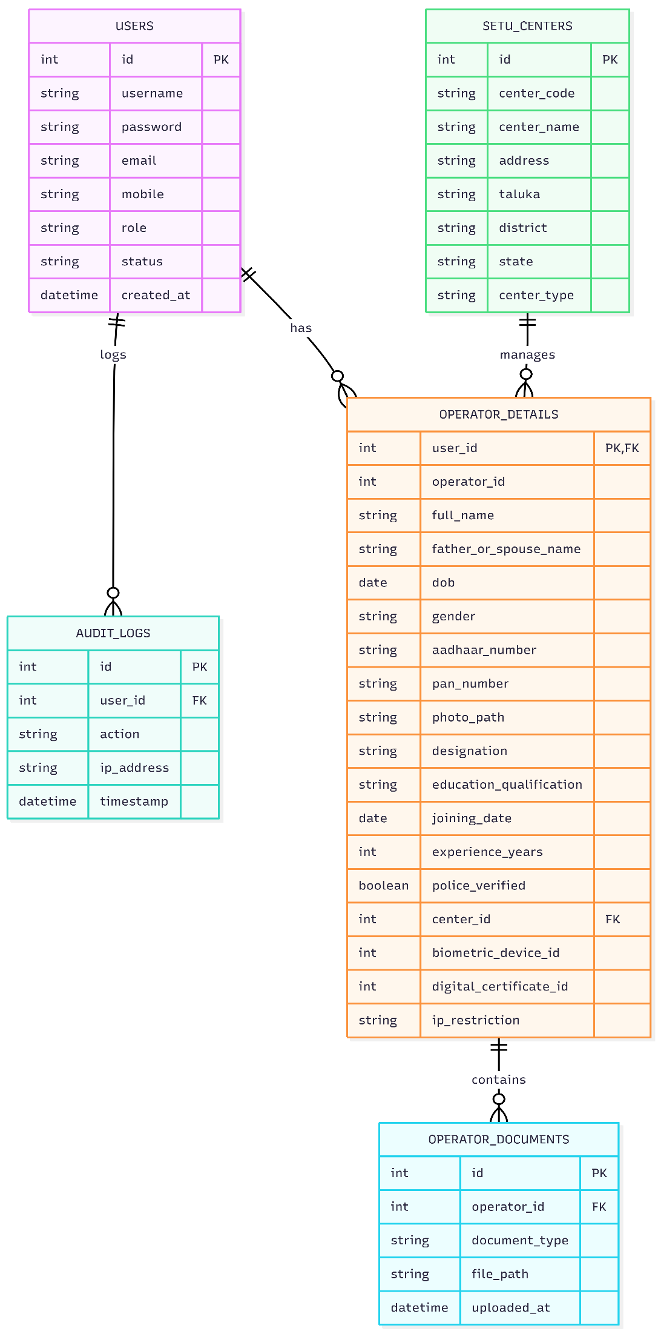

SYSTEM ARCHITECTURE

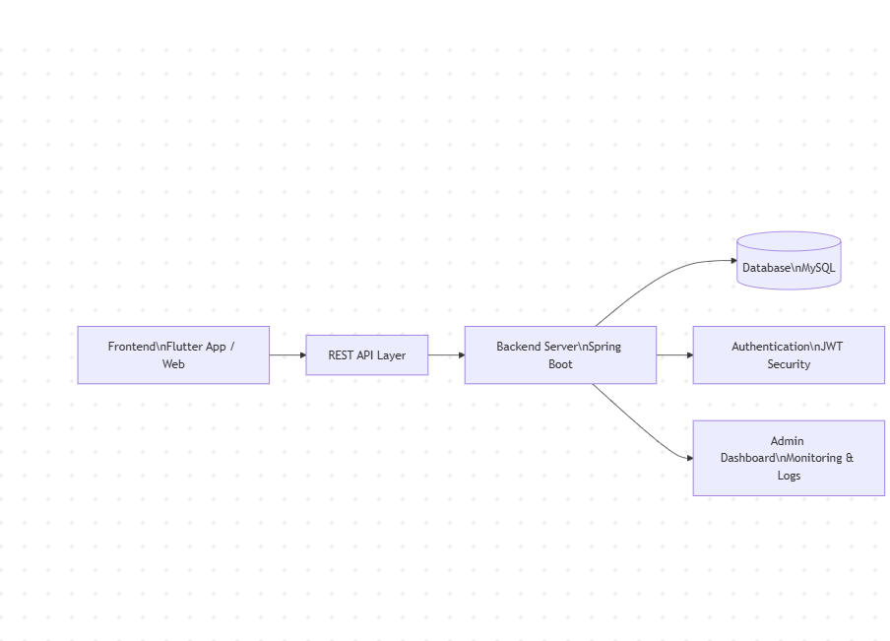

ADVANTAGES
- Reduced Processing Time
The system automates application submission, verification, and approval processes, significantly reducing delays compared to manual systems.
- Improved Transparency
Citizens can track their application status in real time, ensuring complete visibility at every stage of the process.
- Enhanced Accessibility
Services can be accessed anytime and from anywhere through mobile or web applications, reducing the need for physical visits to government offices.
- Role-Based Workflow Management
Clearly defined roles such as citizens, SETU operators, officers, and administrators ensure structured and efficient handling of applications.
- Secure Data Management
Implementation of secure authentication (JWT) and database systems ensures data privacy and protection against unauthorized access.
- Digital Document Handling
Eliminates paperwork by allowing users to upload, store, and verify documents digitally, reducing the risk of data loss or damage.
- Automated Certificate Generation
Digitally signed certificates with QR code verification ensure authenticity and easy validation.
- Audit Logs and Accountability
All activities are recorded, helping in tracking actions, improving accountability, and preventing misuse.
- User-Friendly Interface
Simple and intuitive design makes the system easy to use for both citizens and government officials.
- Scalability
The system can be expanded to include additional services, departments, and users as required.

LIMITATIONS
- Dependence on Internet Connectivity
The system requires a stable internet connection, which may be a challenge in rural or remote areas.
- Initial Setup Cost
Development, deployment, and maintenance of the system may require significant initial investment.
- Digital Literacy Requirement
Some users may find it difficult to use the system due to lack of technical knowledge or experience with digital platforms.
- Data Security Risks
Although security measures are implemented, there is always a risk of cyber threats if not properly maintained and updated.
- System Downtime Issues
Server failures or technical issues can temporarily disrupt access to services.
- Resistance to Change
Government staff and citizens accustomed to traditional methods may initially resist adopting the new digital system.
- Maintenance and Updates
Regular system maintenance and updates are required to ensure smooth functioning and security.
RESULT AND DISCUSSION

The SETU Digital System was developed and tested to evaluate its effectiveness in digitizing and streamlining government citizen service delivery. The system enables citizens to apply for services online, upload documents, track application status, and receive digitally signed certificates. During testing, the platform successfully handled multiple user roles, processed applications through different workflow stages, and maintained accurate records of all activities.

The results indicate that the system significantly improves efficiency compared to traditional manual processes. In conventional systems, delays often occur due to paperwork, lack of coordination, and repeated physical visits. However, this system ensures that application data is instantly available to SETU operators and verification officers, enabling faster processing and decision-making. The structured workflow and automation reduce processing time and improve overall service delivery.

Another important observation is the improvement in transparency and accountability. Citizens can track the real-time status of their applications, which reduces uncertainty and enhances trust in the system. Additionally, the implementation of audit logs ensures that every action performed by users is recorded, making it easier to monitor activities and prevent misuse. The centralized database allows efficient storage and retrieval of application data, which helps in generating reports and analyzing system performance.

The system also enhances communication between citizens and authorities through query and response mechanisms. If any discrepancies are found during verification, users are notified and can respond promptly, reducing delays and improving accuracy. The digital generation of certificates with QR code verification ensures authenticity and eliminates the need for physical document collection.

However, the discussion also highlights certain limitations. The system is dependent on internet connectivity, which may affect accessibility in rural or low-network areas. Additionally, users with limited digital literacy may face challenges while using the platform. The system also requires regular maintenance and security updates to prevent potential cyber threats and ensure smooth functioning.

These limitations can be addressed in future enhancements by incorporating offline support features, improving user interface design for better accessibility, and strengthening security mechanisms. Integration with additional government databases and services can further enhance system capabilities.

Overall, the SETU Digital System demonstrates a practical, efficient, and scalable approach to modernizing government service delivery. It bridges the gap between citizens and government authorities by providing a transparent, reliable, and user-friendly digital platform, contributing significantly to the advancement of e-Governance.

CONCLUSION

The SETU Digital System provides an effective and comprehensive solution for digitizing government citizen service delivery. It simplifies the process of applying for services, uploading documents, tracking application status, and receiving digitally signed certificates through a structured, role-based, and user-friendly platform. The system reduces manual effort, minimizes physical visits to government offices, and ensures faster processing of applications. By maintaining accurate records, providing real-time status tracking, and incorporating audit logs, the system promotes transparency and accountability among all stakeholders.
The implementation of this system significantly improves operational efficiency and citizen satisfaction. Citizens gain easier access to essential services, while government authorities benefit from streamlined workflows, reduced administrative burden, and better coordination among departments. The digital nature of the platform also ensures secure handling of sensitive data, reducing the risk of document loss or manipulation.
However, the current system has certain limitations. It relies on stable internet connectivity, which may affect accessibility in remote areas. Some users may face challenges due to limited digital literacy, and regular maintenance is required to ensure security and smooth functioning. Additionally, integration with external government databases and additional services is still limited, which may restrict the scope of automation.

FUTURE SCOPE
The SETU Digital System has significant potential for future enhancements, including:
- Integration with additional government departments and services to create a unified digital platform for all citizen services.
- Offline support and mobile optimization to improve accessibility for users in rural or low-connectivity regions.
- Advanced data analytics and reporting to help administrators identify trends, improve decision-making, and optimize resource allocation.
- Artificial Intelligence (AI) and Machine Learning (ML) features for predictive analysis, fraud detection, and automated eligibility checks.
- Enhanced security mechanisms, including multi-factor authentication and real-time threat monitoring, to protect sensitive citizen data.
- Mobile app notifications and alerts to keep citizens informed about application status and queries.
- Scalable architecture to support future growth and increasing user loads without compromising performance.
Overall, the SETU Digital System demonstrates how technology can transform government service delivery by making it more efficient, transparent, and citizen-centric. With continuous improvements and integration of advanced technologies, the system has the potential to become a vital tool in the digital governance framework, fostering accountability, accessibility, and convenience for citizens and authorities alike.

REFERENCE

- Kumar, A., & Singh, R. (2020). Smart Waste Management System using IoT. International Journal of Engineering Research.
- Sharma, P., et al. (2019). Urban Waste Monitoring using Smart Technologies. IEEE Conference Proceedings.
- Gupta, V., & Jain, S. (2021). Efficient Waste Collection using Data Analytics. Journal of Environmental Management.
- World Bank. (2018). What a Waste 2.0: A Global Snapshot of Solid Waste Management.
- United Nations Environment Programme. (2020). Waste Management Outlook Report.
- Sharma, A., & Verma, P. (2021). E-Governance in India: Challenges and Opportunities. International Journal of Computer Applications.
- Singh, R., & Mehta, S. (2020). Digital Transformation in Citizen Services using Web Applications. Journal of E-Governance Studies.
- Ministry of Electronics and Information Technology, Government of India. (2020). Digital India: Citizen Service Delivery Guidelines.
- Joshi, V., & Rao, K. (2019). Role-Based Access Control in E-Governance Systems. International Journal of Information Security and Privacy.

