NAME: BHUSHAN PANDE  
MIT WPU

PRN NO: S1032180117

**PROJECT ON IMAGE PROCESSING**

**AIM: TO CREATE IMAGE PROCESSING**

**PROCESS FLOW: USING OPEN CV AND TESSERACT**

**INFERENCE: THIS MODEL WAS TESTED ON OTHER IMAGES AND WAS ABLE TO SHOW BEST RESULTS WITH COMPARISION TO THE OTHER MODELS.**

**1] IMPORTING LIBRARIES AND SETTING UP TESSERACT**

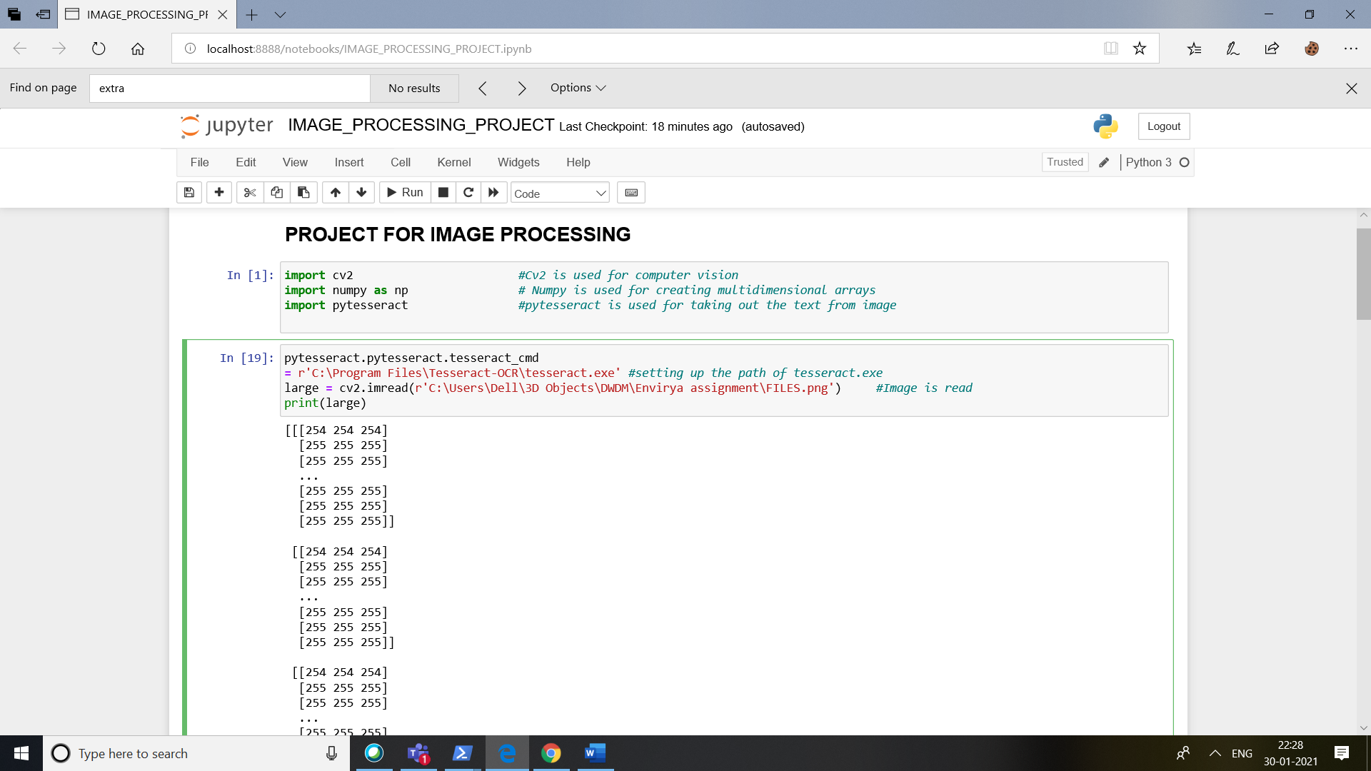

**2]** **CONVERSION OF IMAGES**

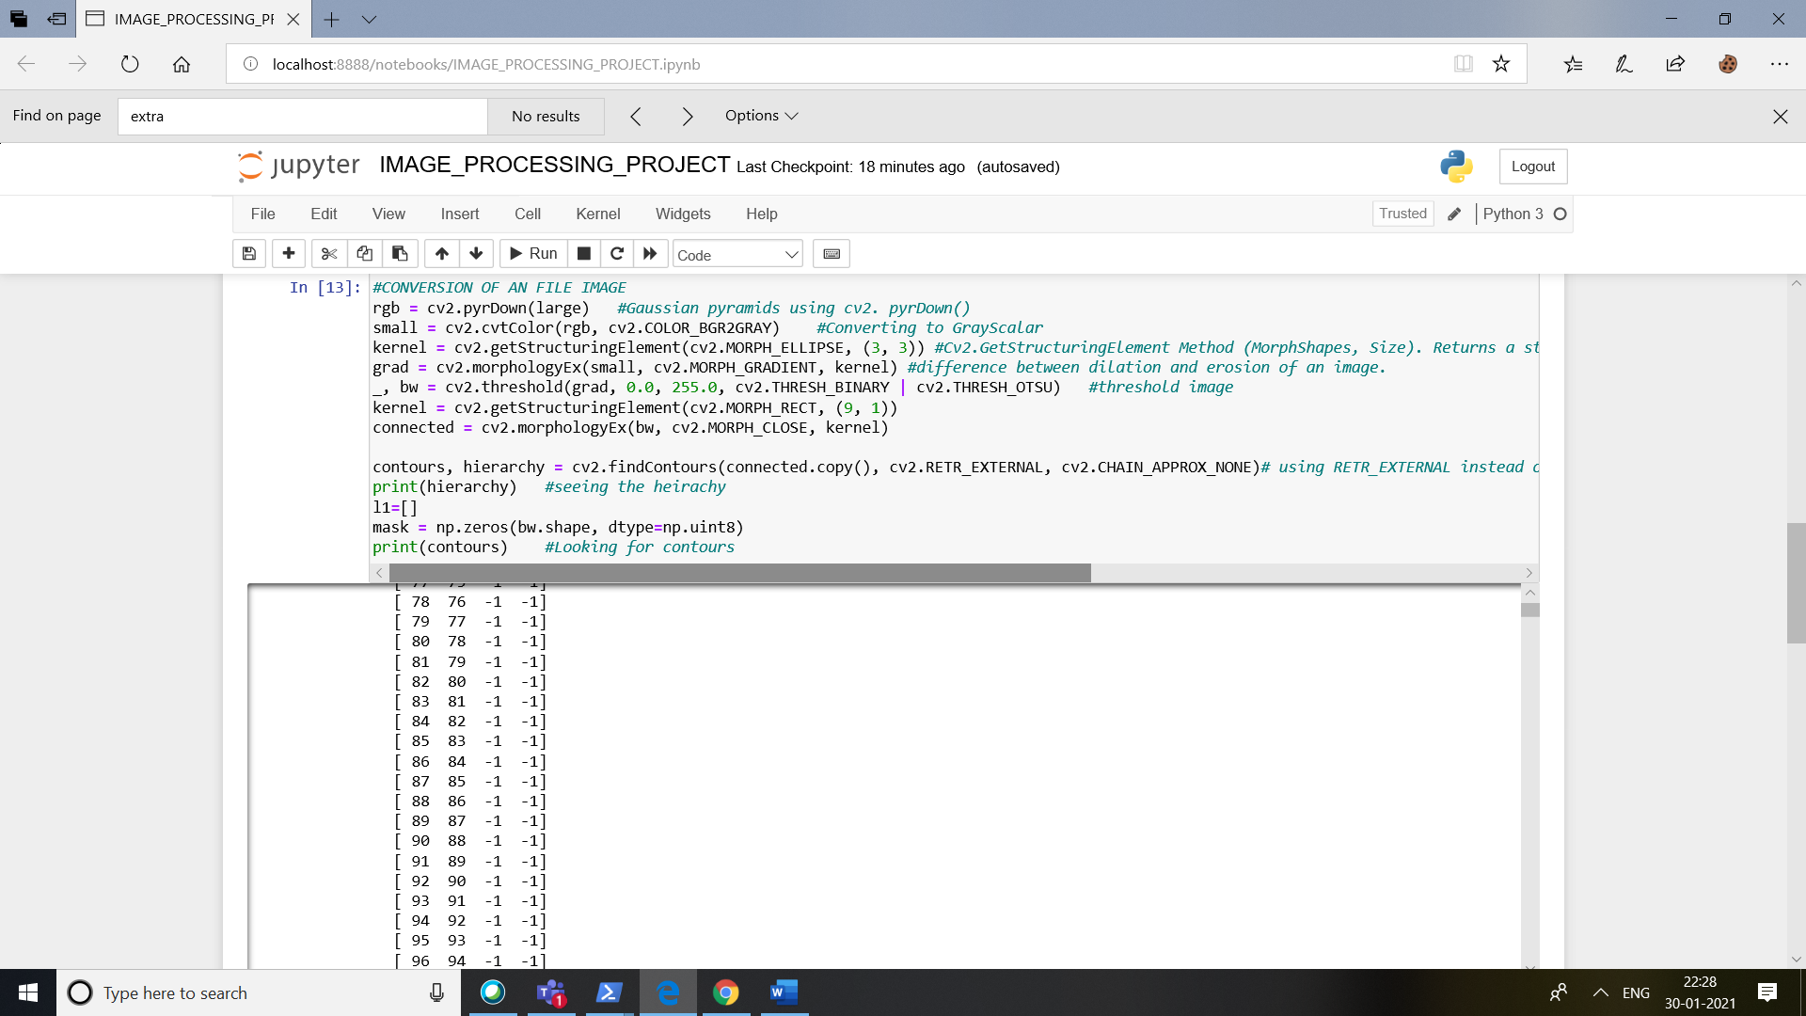

**3] USING OPENCV TO PREDICT TEXT THROUGH RECTANGLES**

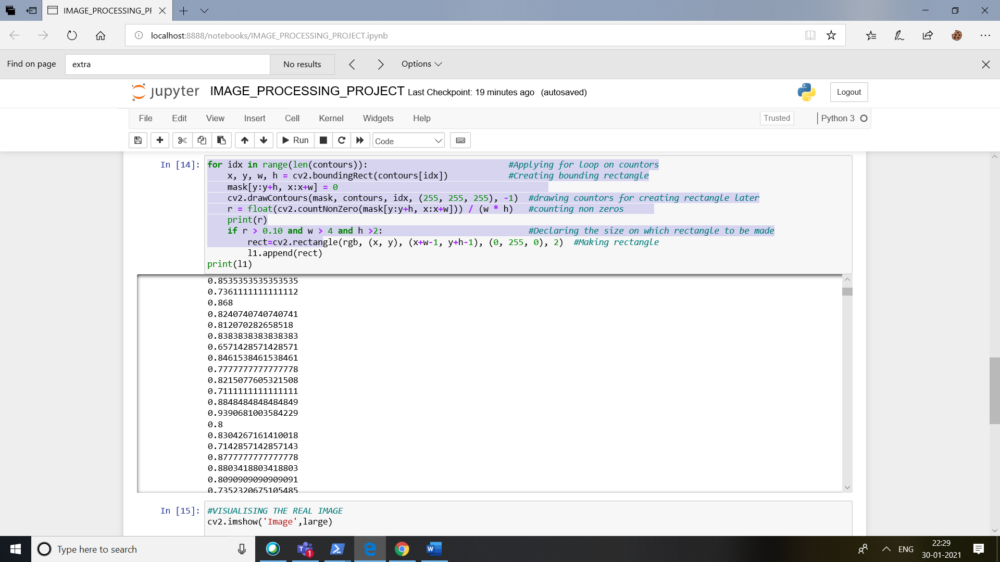

**4]VISUALISING IMAGES**

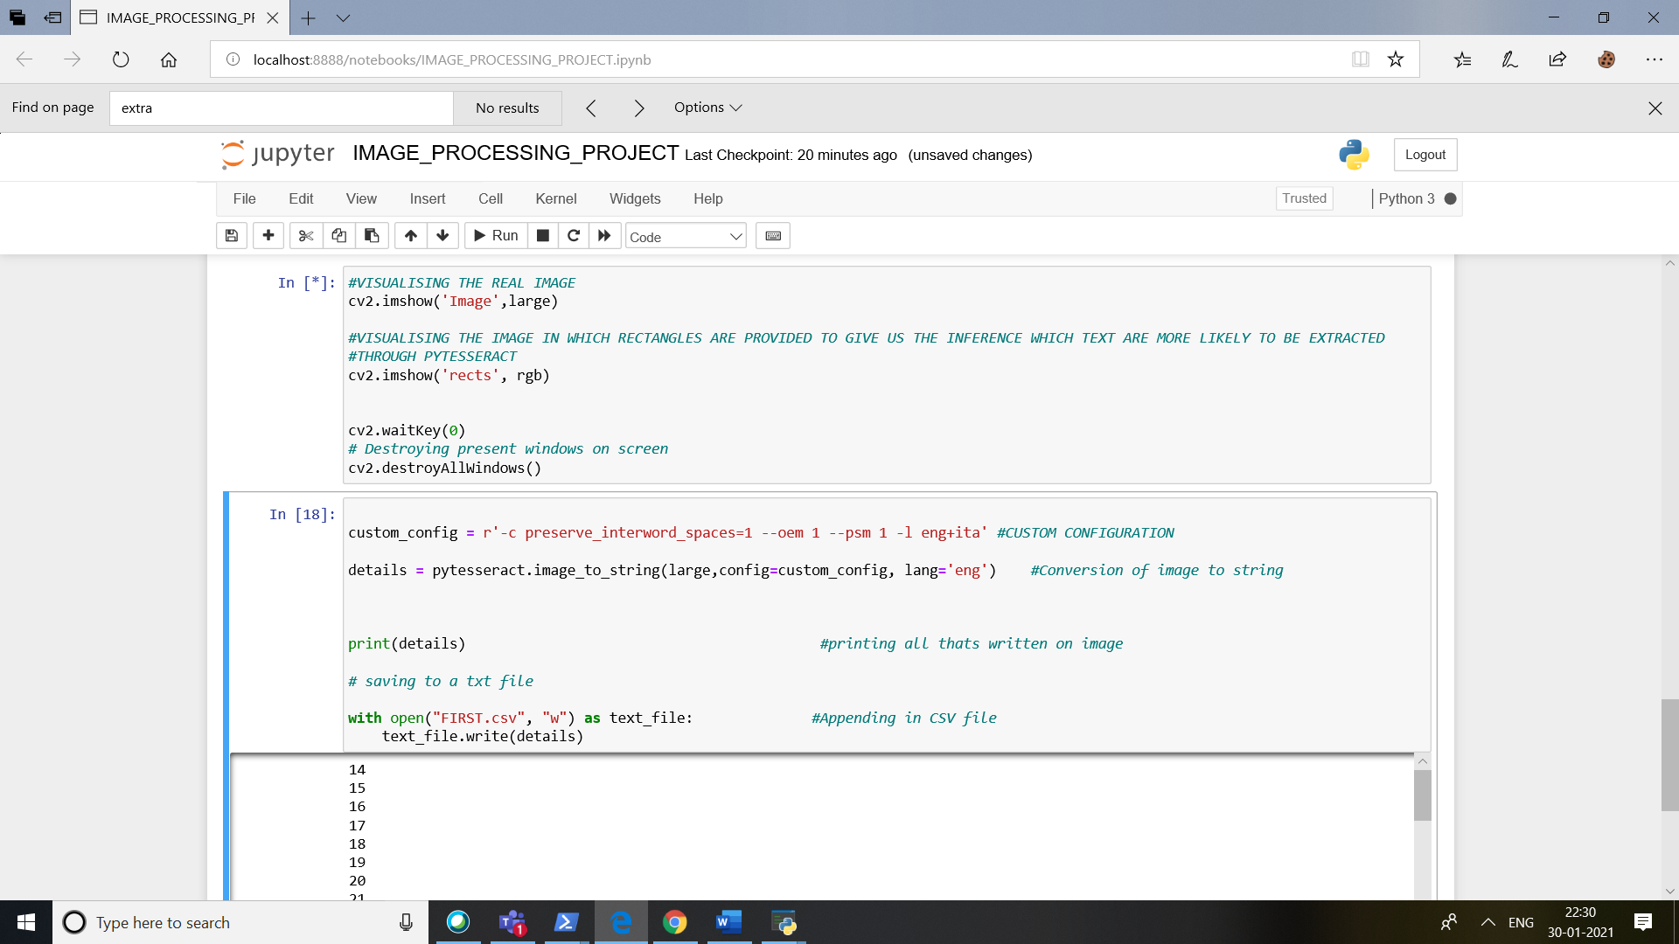

**4.1] REAL IMAGE**

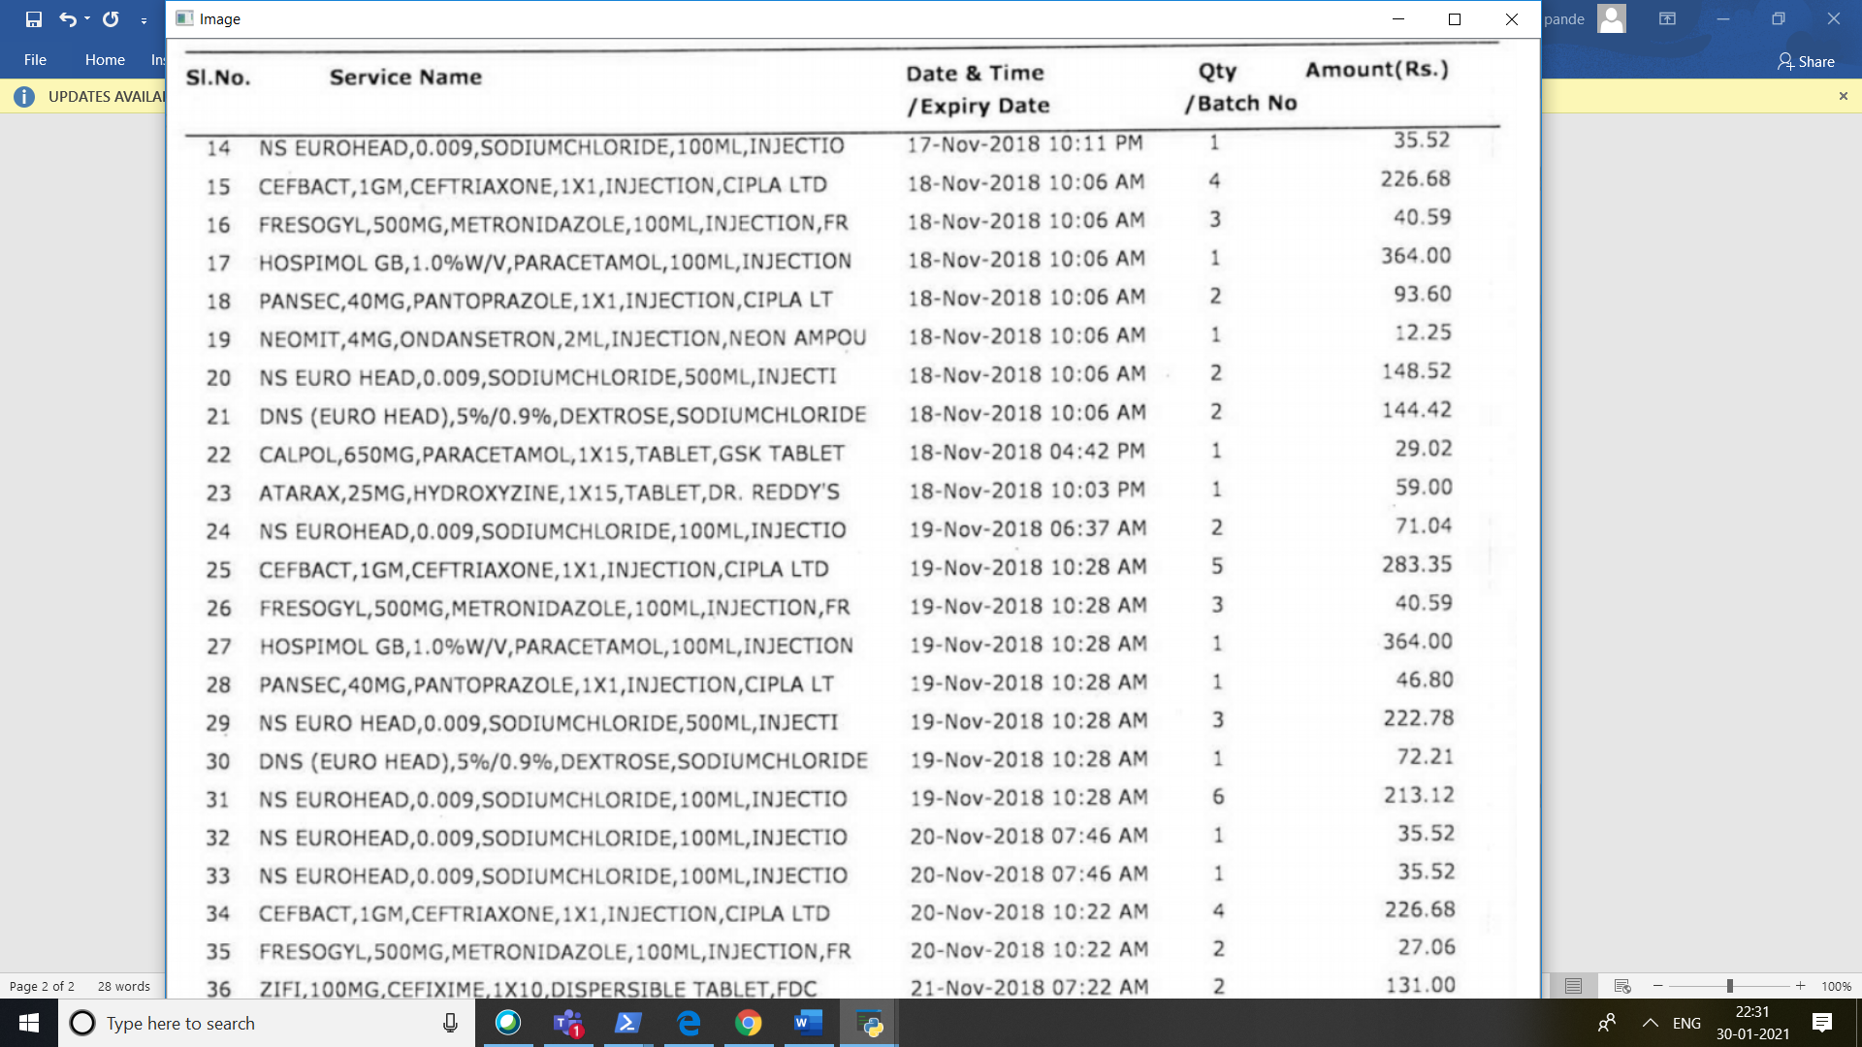

**4.2] OPENCV CAPTURE OF TEXT**

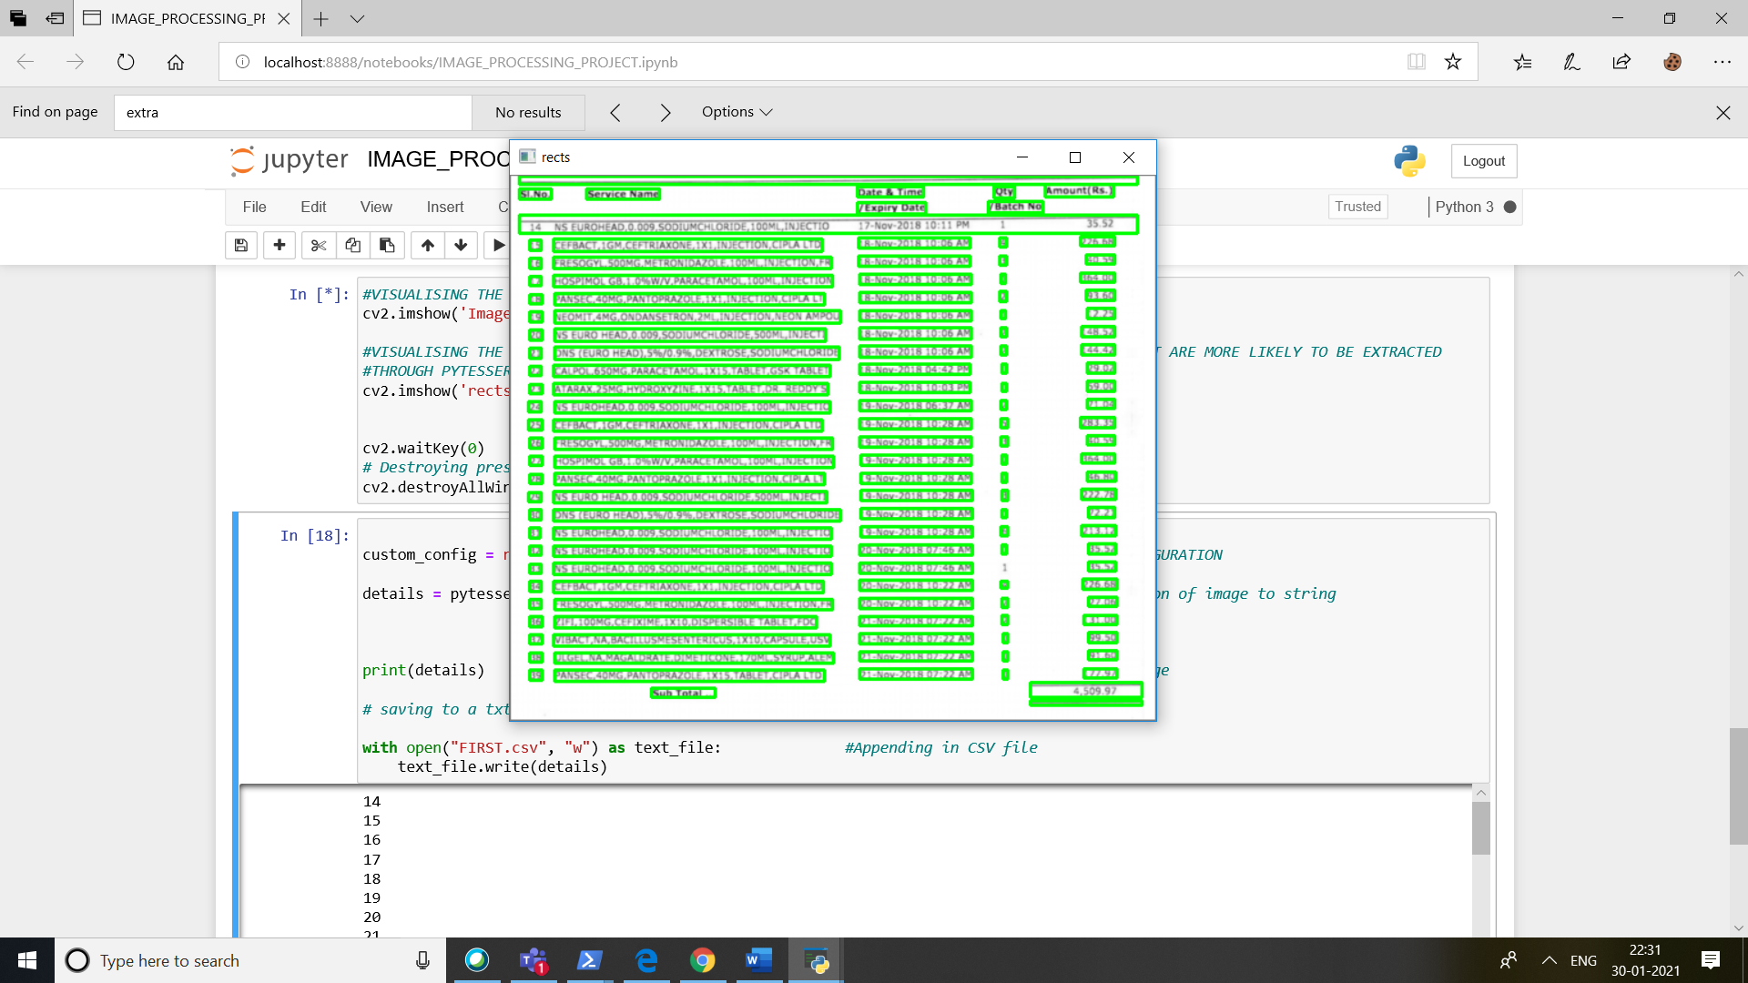

**5] APPENDING TEXT TO CSV FILE**

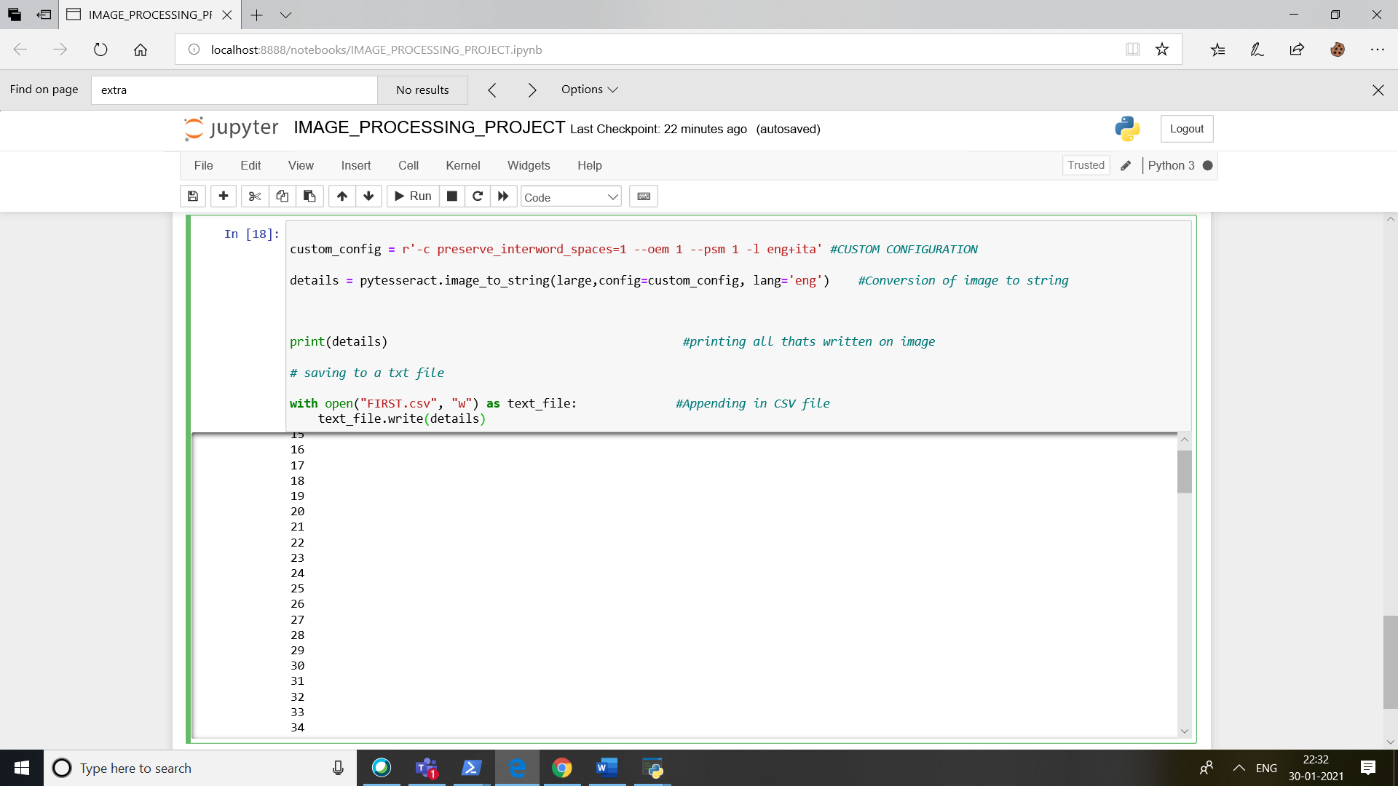

**6] CSV FILE AT OUTPUT**

**6.1] SLNO AT OUTPUT**

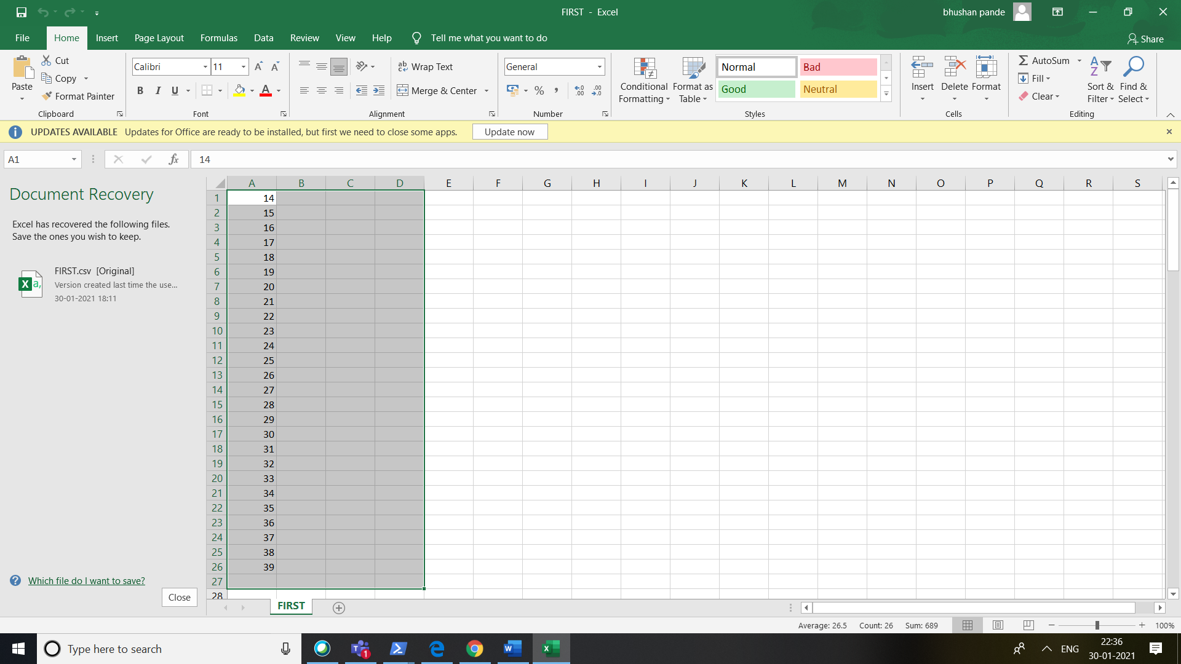

**6.2] OTHER FOUR COLUMNS**

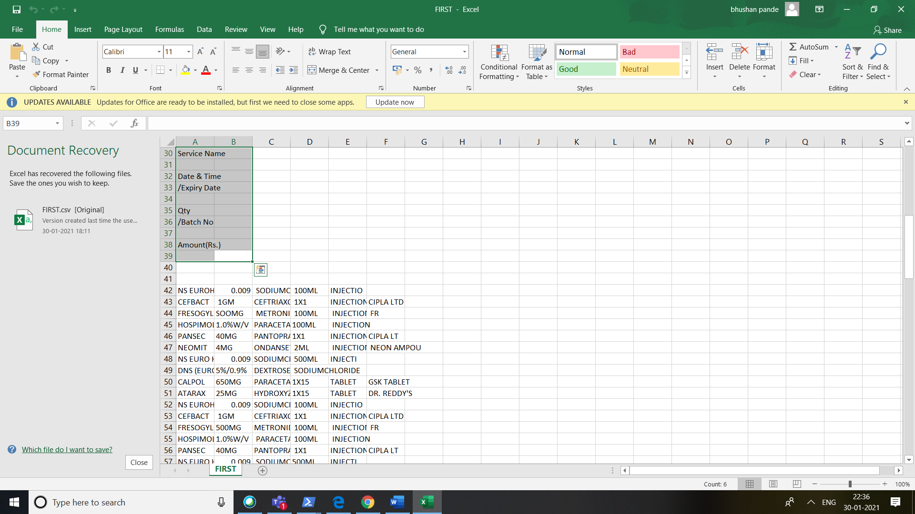

**6.3] DATA IN THE FOUR COLUMNS**

**(IMPORTANT DATA CAPUTRED)**

**6.3.1] DATA IN FIRST**

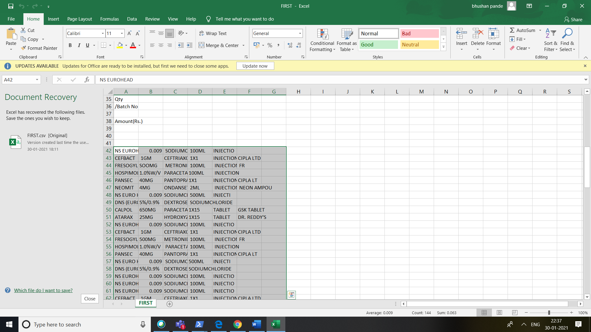

**6.3.2] DATA IN LAST COLUMN**

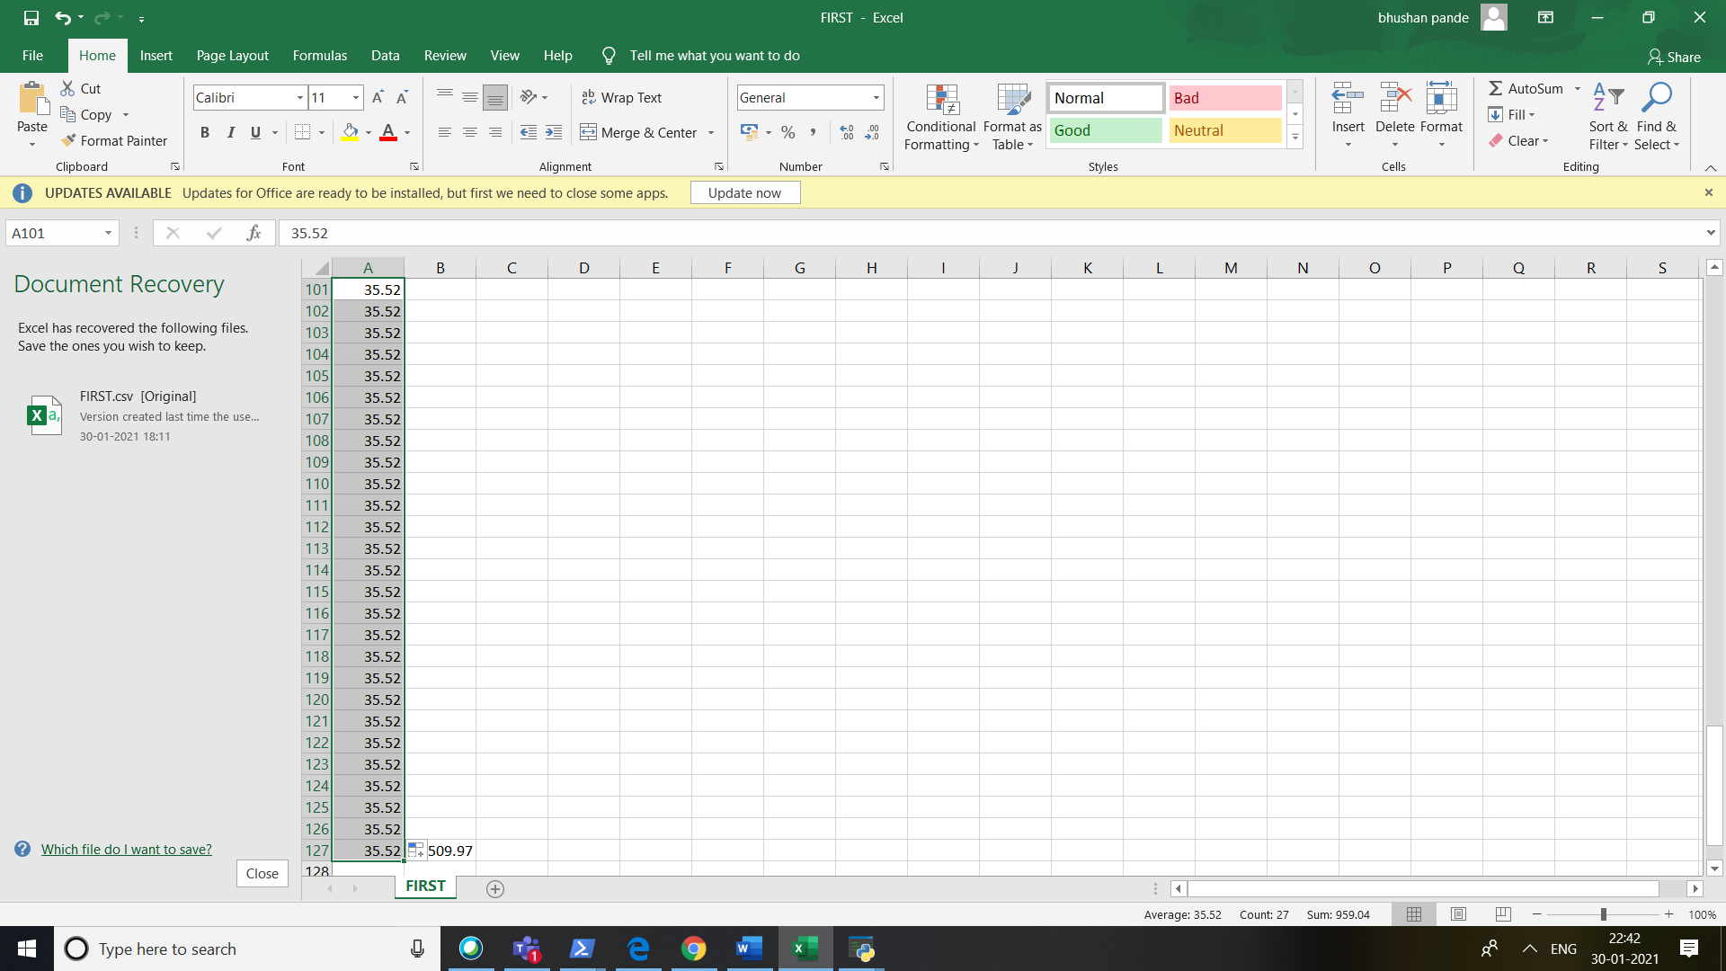

**CONCLUSION: IN THIS PROJECT I WAS ABLE TO TAKE OUT THE IMPORTANT DATA FROM IMAGE  
AND WAS ABLE TO PUT THAT INTO AN EXCEL SHEET(CSV FILE).**