**MVC**

Q: What is ASP .net MVC Core?

A: It is open source. Cross platform web development framework to develop Web application created by Microsoft.

Q: Explain MVC architecture

A: Model : This layer has the business logic so when you look at the model

Views: is where we have UI

Controller : it connects our model and view. Controller is binding layer, it binds the model and the view

Q: Explains the importance of wwwroot folder?

A: It is a very spl folder in MVC core project wherein we can store static content like CSS, images, JS

Q: Whats the importance of appsettings.json?

A: it helps us to store configurations data or the confgurations of the project.

Ex: connections strings, version numbers

Q: How to read confgurations from appseettings.json?

A: We need to call Iconfguration interface. This IConfigurations interface belongs to Microsoft.Extension.Configuration namespace. Wherever we need to read the configuration we need to provide the IConfiguration in the constructor. In the constructor we provide the Ionfigurations as a parameter. This IConfigurations then is dependency injected.ie. readymade object is injected by MVC core out here then you can say I want to read connection

Q: List out different type of return types of controller action methods?

A: View Results, Javascript Result, JSON result ,Redirect result, Content reult

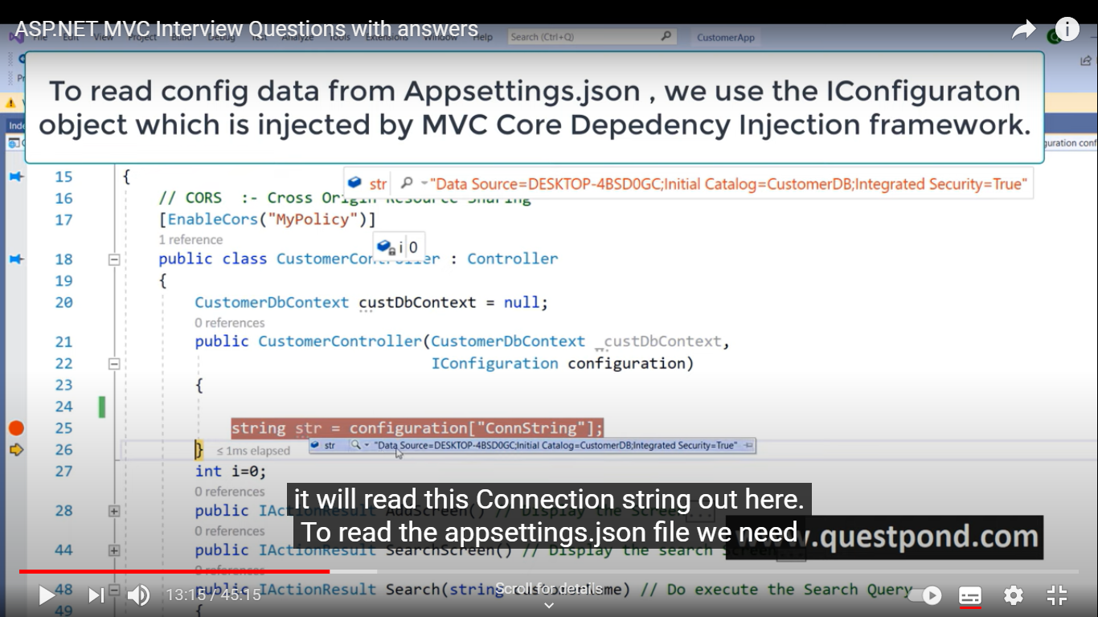

Q: What is dependency injection?

A: It is a practice of providing Dependent object from outside rather that the class creating using the new keyword

Q: Why we need DI?

A: We have better decoupled system. Change at one place and the changes are reflected across the application seamlessly

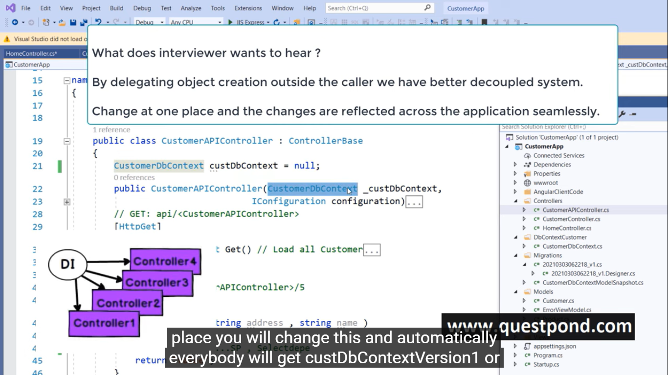

Q: How do u implement DI

A: We need to provide DI objects in ConfigureServices method using, scoped, Singleton or Transient

Services.Addscoped<CustomerDbcontext>();

Services.Addscoped<CustomerDbcontext, cusomerDBConetcnewversion>();//if new version comes up

Q what are the ways to do dependency Injection in ASP.NET MVC core? Or difference between Scoped vs Transeint vs singleton

A:

1. AddScroped : It instancties object per request

Public Hcontroller(Cust obj, cust obj1)

{

}

In above example when the request is raised same instance will will instiated for both the objects

1. AddTransient : Add transient inject new instance for every dependency injection object

Public Hcontroller(Cust obj, cust obj1)

{

}

In above example, when request is raised two different instance weill be raised for above objects. Instance 1 for obj and instance 2 for obj 1. If another request is raised then again new instance will be create for these objects namely instance 3 and 4 respectively.

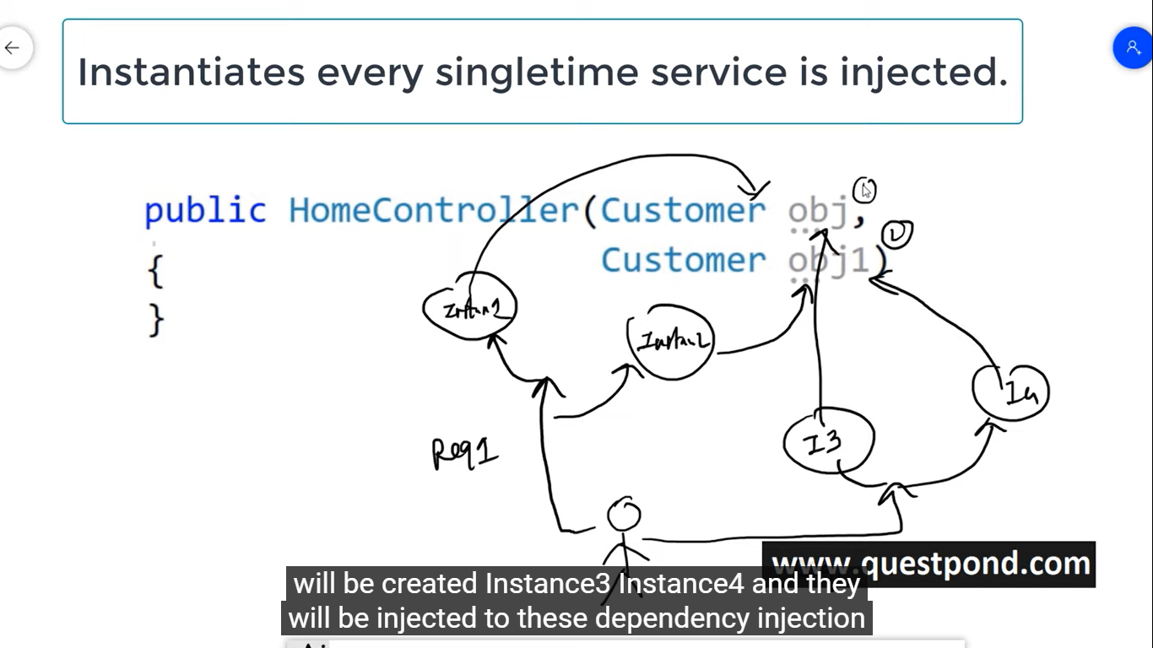

1. AddSingleton: only one object is created for whole application i.e for whole application lifecyle only one global instance is created.

Public Hcontroller(Cust obj, cust obj1)

{

}

In above example, if any request is raise then same instance which was created will be sent to an object.

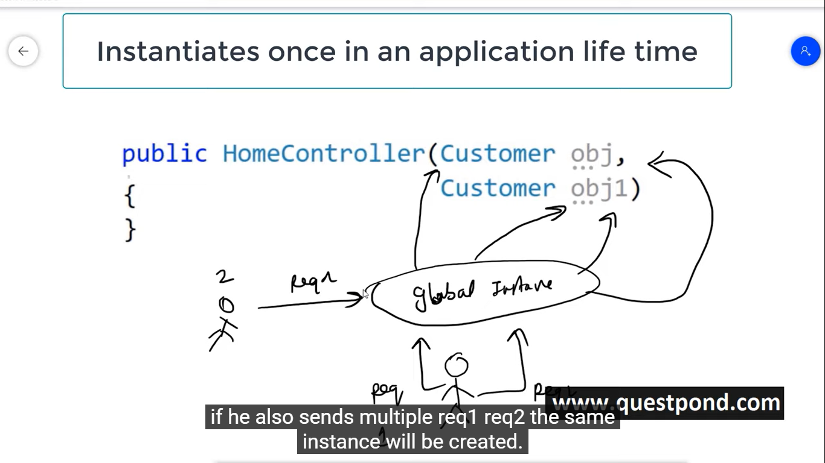

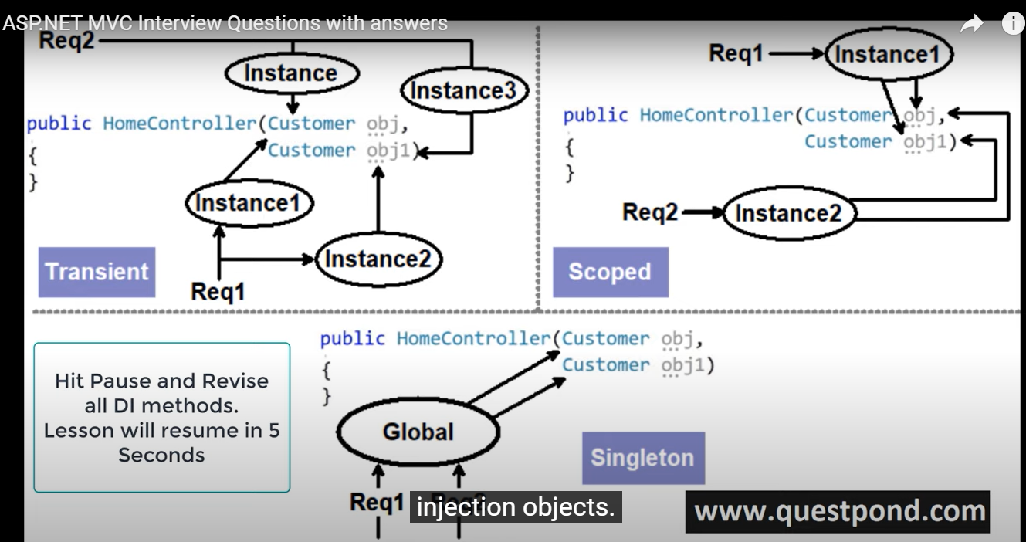

Q: Explain the Middleware

A: when an user hits and website it first hits the controller

Step2: then controller takes he data from model

Step 3: this data is applied on view

Step 4: that is send as an HTML to the browser

If we want to pre-process the logic that’s where the middleware comes into picture

In other words Middleware comes into picture in the request pipleline before the request hits the controller

It helps us to execute pre-processing logic before controller is executed.

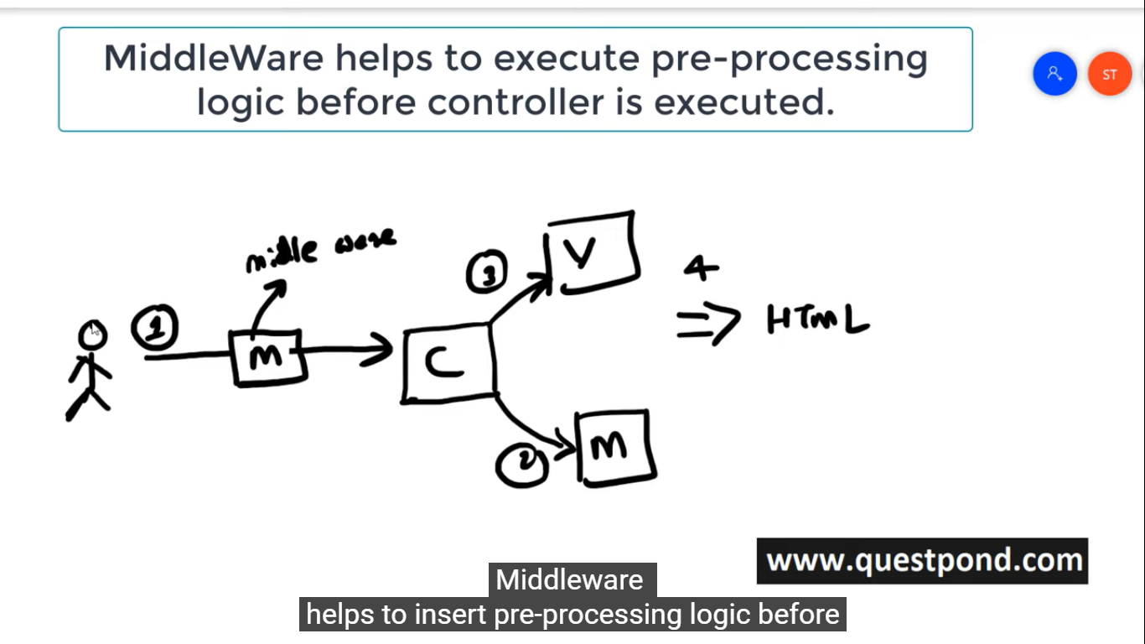

Q: How do we implement middleware.

A:

Step 1: we need to add Middleware class.

Step 2: It is usually used for authentication or authorization

Step 3: When the class is created we have invoke method. In this method we writes out pre-processing logic

Step 4: To place this middleware in pipeline we need go in startup.cs

Step 5: Then in it we need to go in configuration method. In it we need to type app.UseMiddleware<Nameof urMiddleware>

Q: use of Startup.cs or what is the use of configured services or configured method? Or what is the difference between configure or configgurservices?

A: It helps us to configure our DI and middleware

Confgure services helps to configure our DI objects

Configure method helps us to configured our middleware

Q: What is Razor?

A: It is view engine. It allows us to writes server side code and HTML in web pages.

@{

Int i-0;

}

Q. How can we pass Model object to the view?

A: we can use return view (<View Name>, <2nd parameter is object>)

Q. What are strongly type views ?

A: Strongly type View are the azor views where we get Model intelligence and to to create a strongly type view we need to create @model and then its type. PFB snippet.

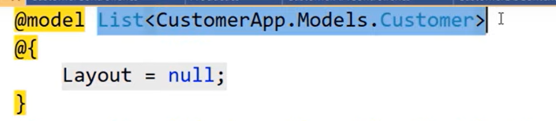

@foreach(var cust in Model)

{

<tr>

<td> cust.CustomerName<td>

<td>cust.add<td>

</tr>

}

Q What exactly is the ViewModel?

A: In a view we can use only one model. Two avoid this we create a View Model. We create a wrapper class which is wrapped around multiple models

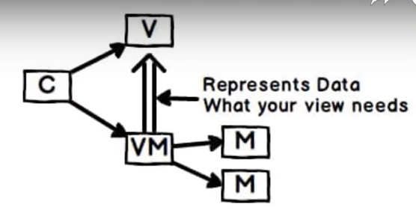

Public class Customer

{ public string name {get;set;}

Public class Product

{public string name {get;set;}

Public class CustomerViewModel

{

Public Customer customer{get;set;}

Public List< Product> product{get;set;}

}

Q:What is Kestrl Web server?

A: It is a free open source web server which ships with ASP.Net core

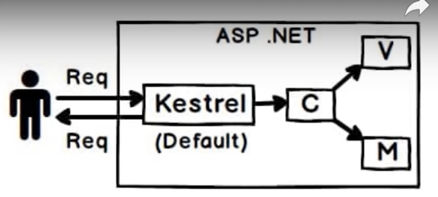

Q: Why Kestrel when Microsoft already had IIS?

A: ASP.net Core is suppose to run cross platform while IIS web server runs only on Windows.

Q: Does Kestrel replace IIS?

A: No, In production we use the revrse proxy architecture we use both IIS and kestrel together .

In reverse proxy architecture, if any enduser send a request then this request 1st goes to strong time tested server like IIS/Apache then this time tested server fwrded this request to kesrl and kestrl will fwrd this request to MVC. Then it will send the request to back.

Kerstrl is the part of MVC .Net Core. Default Webserver.

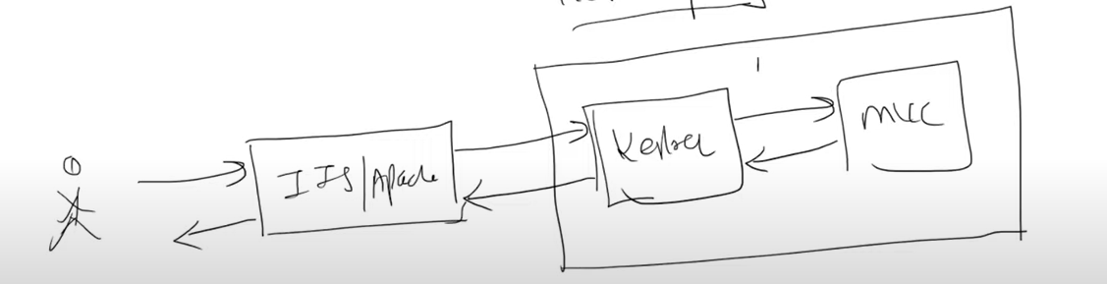

Q: What are cookies ?

A: Cookies are text file with small piece of data which is stored at end user’s browser. So that website can store information in cookie like what we are liking and surfing .

Q: What is session management and why we need it?

A: HTTP is stateless protocol. Sesson management is wherein we want to maintain states between the requests. We use session management techniques in MVC.

Q where ways of doing session management?

A:

1. Session variable:
2. ViewData
3. TempData
4. ViewBag

Q: MVC routing?

A: URLs in MVC are mapped with action methods and controller instead of physical files in system. Using this controller can handle specific requests so first request is being sent to the routing engines and then across the routes it is sent to the controller

Q What are the filters?

A: Sometimes we want to execute some logic either before the execution of the action method or after the execution. We can use Action filters for the same.

Filter define the logic which is executed before or after the execution of the action method. Action filters are attribues which we can apply to the action methods

Q: Type of Filters?

A: Authorization filters:

Q what is patrial view?

A: