Problem Statement & Dataset Overview
Title : Aadhaar Age Disparity Analysis Across Indian States
Problem Statement
The Aadhaar enrollment distribution across age groups varies significantly across Indian states. This study identifies age-wise disparities in enrollment progression from early childhood to adulthood and evaluates how effectively states ensure continuity of Aadhaar inclusion across life stages.
Objectives
- Analyze state-wise Aadhaar enrollment across age groups (0–5, 5–17, 18+)
- Quantify transition gaps using normalized disparity metrics
- Compare states based on child transition and adult inclusion performance
- Visualize insights through an interactive Power BI dashboard
Dataset Description
- Source: Aadhaar enrollment data (state-wise)
- Attributes:
  - Age groups: 0–5 years, 5–17 years, 18+ years
  - Derived metrics: percentage share, disparity scores

Author: Bhushan Parab
Undergraduate Student (B.TECH IT), SIES GST

Analysis Approach
State-wise Aadhaar enrollment data was aggregated and normalized into percentage distributions to ensure fair comparison across states with varying population sizes. Two disparity metrics were derived to evaluate age-based enrollment continuity.
Power BI Visuals Used
- Filled Map – State-wise Adult Inclusion Gap
- Clustered Bar Charts – Child Transition Disparity & Adult Inclusion Gap
- Stacked Bar Chart – Age-wise Aadhaar enrollment composition
- Slicers – State-level filtering
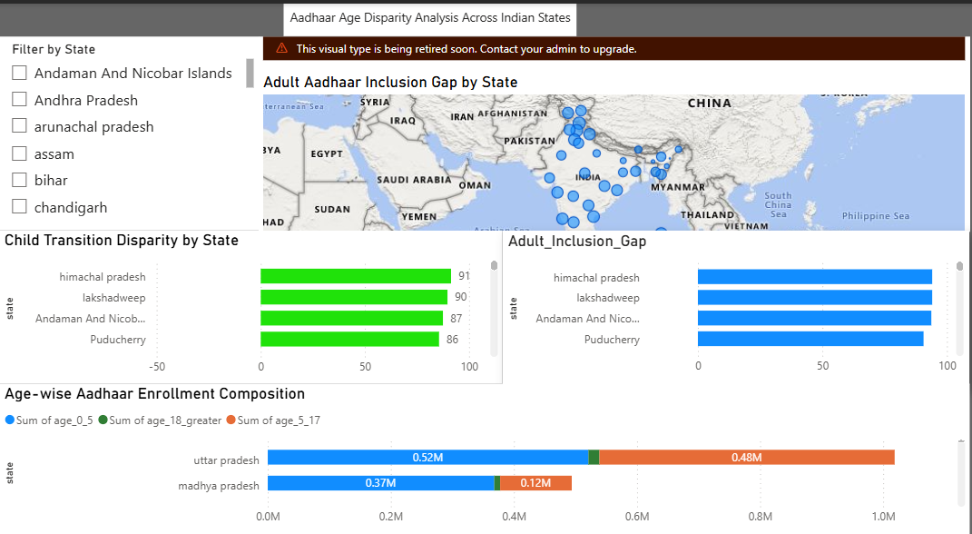

Metric Definitions & Analysis Explanation
1. Child Transition Disparity (CTD)
Formula:
CTD = % (Age 0–5) − % (Age 5–17)
Interpretation:
- High positive value → Strong early enrollment, weak transition to school-age
- Near zero → Balanced transition
- Negative value → Better retention in 5–17 age group
✔️ Lower CTD is better

2. Adult Inclusion Gap (AIG)
Formula:
AIG = % (Age 0–5) − % (Age 18+)
Interpretation:
- High value → Weak conversion of early enrollments into adults
- Low or negative value → Strong adult inclusion
✔️ Lower AIG is better

Why Percentages (Normalization)?
- States vary greatly in population size
- Percentages allow fair comparison
- Prevent large states from dominating results

Solution & Insights
Why the Dual-Metric Approach is Better
Traditional Aadhaar enrollment analysis often relies on overall enrollment counts, which can hide age-specific gaps. The dual-metric approach used in this study separates enrollment challenges into two distinct stages:
- Child Transition Disparity (CTD) highlights whether early Aadhaar enrollment (0–5 years) successfully transitions into school-age coverage (5–17 years).
- Adult Inclusion Gap (AIG) identifies whether early enrollment efforts translate into sustained Aadhaar inclusion in adulthood (18+ years).
By analyzing both metrics independently, UIDAI can distinguish between short-term transition issues and long-term inclusion gaps, enabling more precise and targeted interventions rather than one-size-fits-all enrollment drives.

Policy-Relevant Insights
- Early Enrollment ≠ Long-Term Inclusion
Several states demonstrate strong Aadhaar enrollment in the 0–5 age group but show significant drop-offs in adult enrollment. This indicates that early-child Aadhaar creation alone is insufficient without follow-up mechanisms.
- School-Age Transition is a Critical Bottleneck
High Child Transition Disparity values suggest missed opportunities during school admissions, mid-day meal schemes, or scholarship enrollment stages where Aadhaar linkage could be reinforced.
- Regional Differences Require Customized Strategies
Northeastern and smaller states show different disparity patterns compared to larger states, indicating that enrollment strategies must be region-specific rather than population-driven.

Proposed Solution Framework
1. Targeted Enrollment Interventions
- High CTD States:
Integrate Aadhaar verification and update drives at schools during admissions, examinations, and scholarship registration periods.
- High AIG States:
Focus on adult enrollment through employment centers, welfare scheme onboarding, and mobile enrollment units.
2. Age-Specific Monitoring Dashboard
UIDAI can operationalize this approach by:
- Maintaining a state-wise age disparity dashboard
- Tracking CTD and AIG annually
- Flagging states that cross predefined disparity thresholds
3. Policy Feedback Loop
- States showing persistent high disparity can be prioritized for:
  - Awareness campaigns
  - Administrative audits
  - Process simplification for Aadhaar updates

Code & Reproducibility
GitHub Repository:
https://github.com/Bhushan0455/Age-Disparity-Index

Conclusion:
This study demonstrates that age-wise disparity analysis provides deeper insight into Aadhaar enrollment effectiveness than aggregate metrics alone. The dual-metric framework enables UIDAI to identify specific transition gaps and implement targeted, data-driven enrollment strategies, reinforcing Aadhaar’s role as a lifelong and inclusive identity system.

