**Name : Bhushan Ravindrakumar Upwanshi**

**Roll No. : 243136**

**PRN : 240341220044**

1. Whoami



1. hostname



1. nano



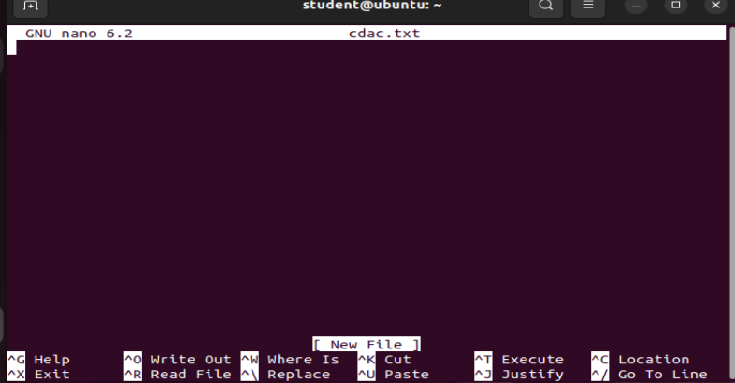

1. Cat cdac.txt



1. History

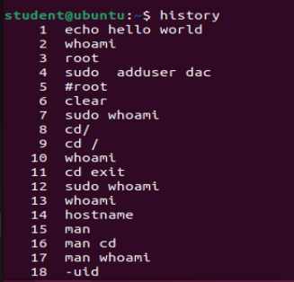

1. mkdir

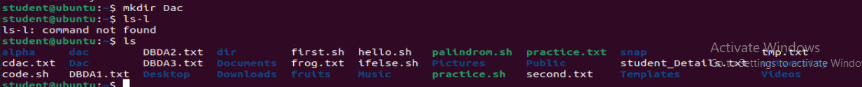

1. pwd



1. ls



1. ls –l

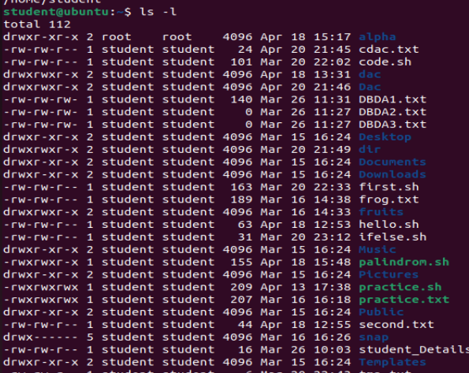

1. touch

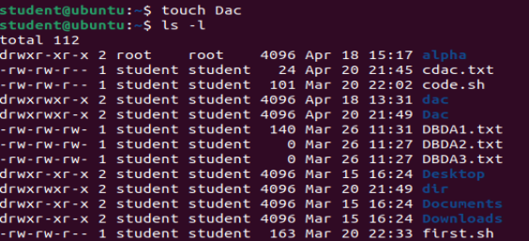

1. man man

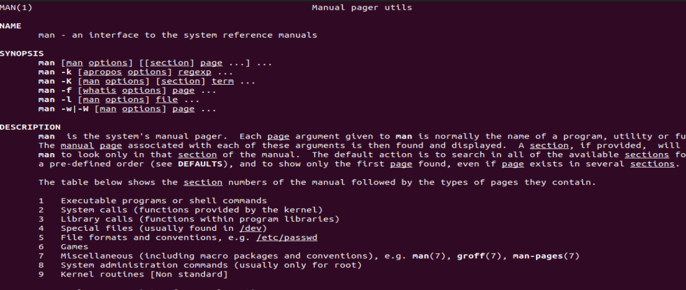

1. what is



1. echo “Hello”

\

1. echo –e “Hello\nWorld”



1. echo –n “Welcome to Iacsd”



1. which nano



1. rm Dac

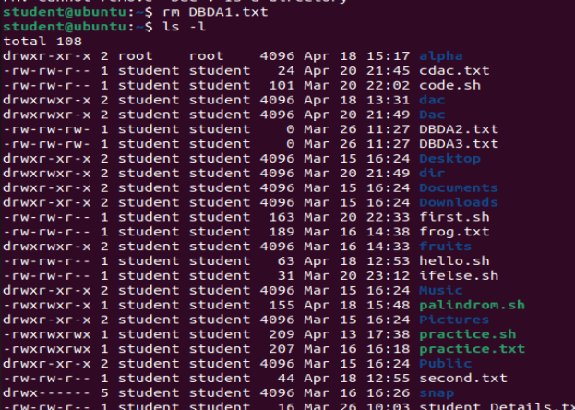

1. cd Dac



1. ls –a



1. 21. rmdir Dac

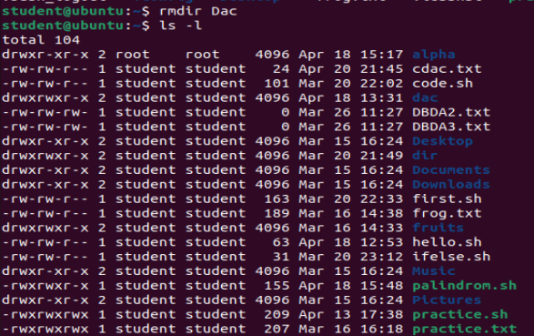

1. mkdir apple mango orange

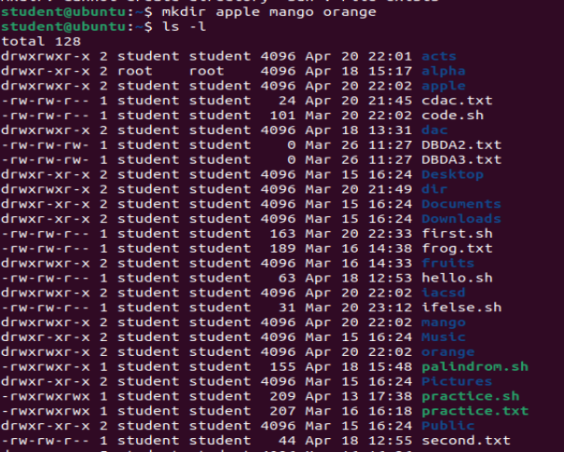

1. wc frog.txt



1. Wc –l frog.txt



1. wc –c frog.txt



1. wc –w frog.txt



1. chmod frog.txt





1. Shell scripting for pyramid structure

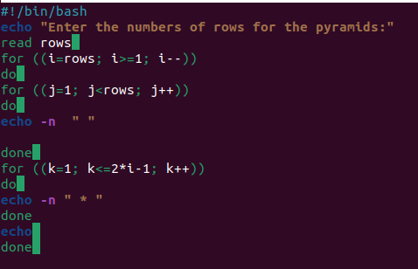

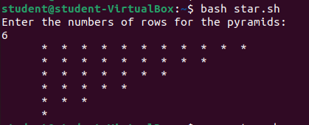

1. Shell scripting for greater number.

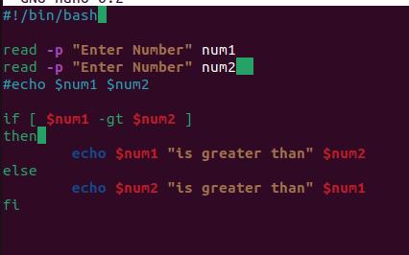

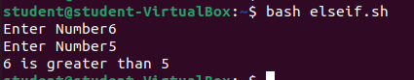

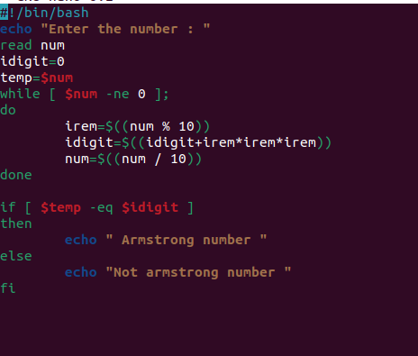Armstrong number

Palindrome Number

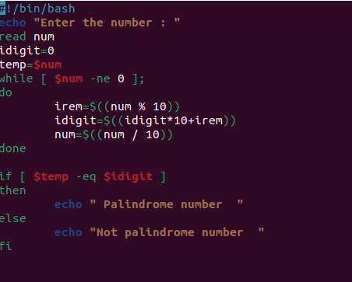

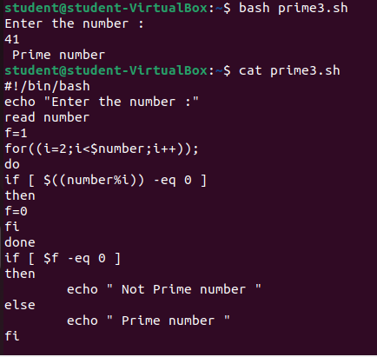Prime Number

Even & odd

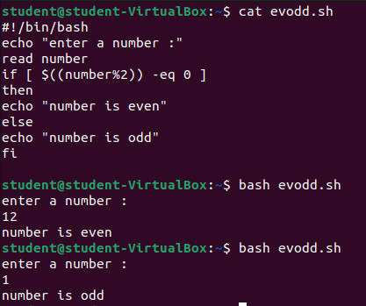

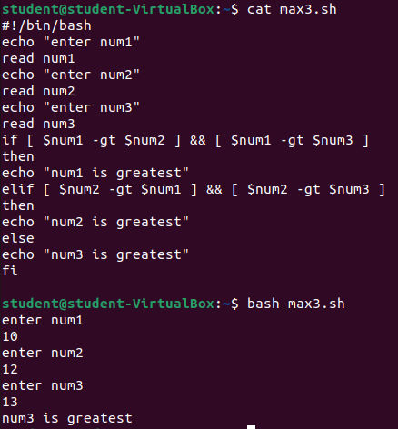Greatest of three number

Factorial of number

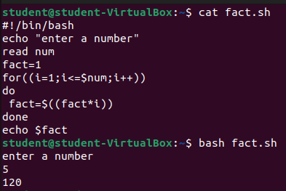

Triangle pattern

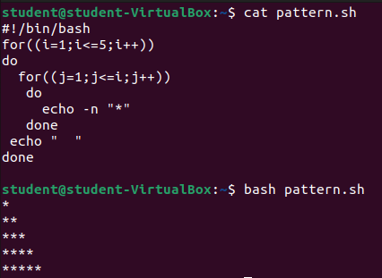

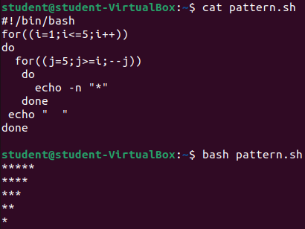

Addition of two number

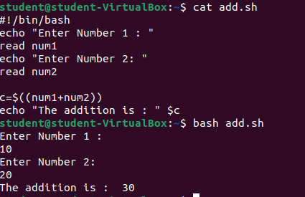

Switch :

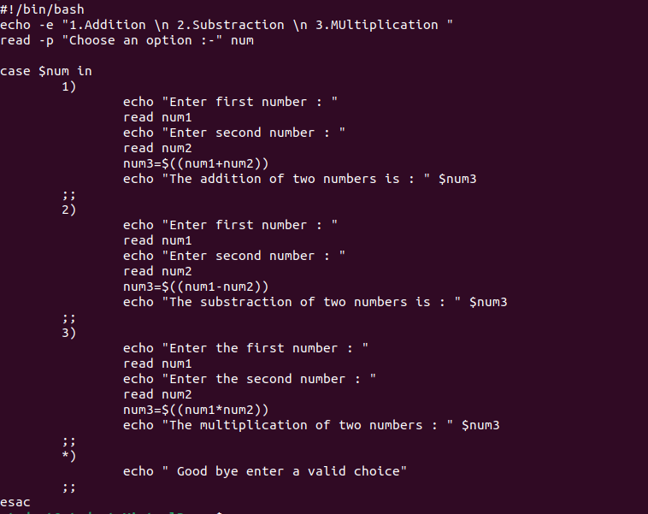

Square pattern

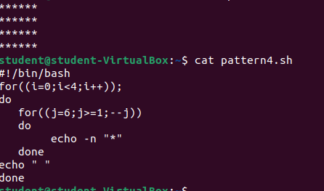

Greatest of two number :

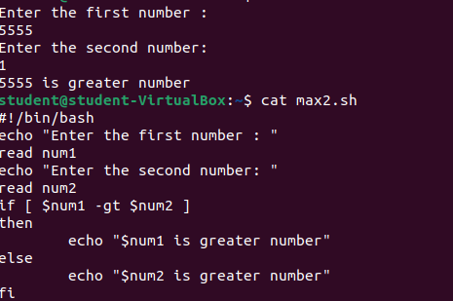

Positive and negative number :

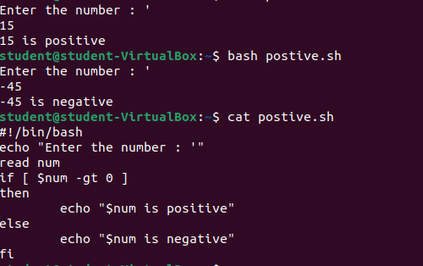

Divisible by 5 and 11

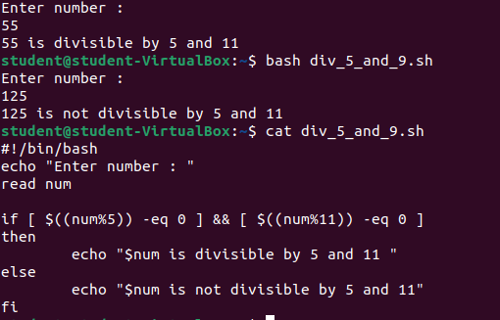

Leap year

