**Name : Bhushan Ravindrakumar Upwanshi**

**Roll No. : 243136**

**PRN : 240341220044**

1. To configure name

git config --global user.name “name of the user”



1. To configure email

git config --global user.email “email of the user “



1. To clone the git

git clone <https://github.com/BhushanUpwanshi/CPP.git>

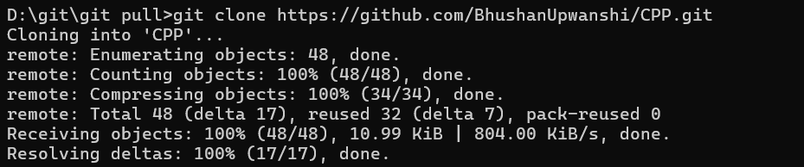

1. to check the git status

git status

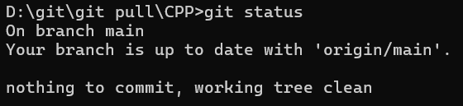

1. for staging (for adding files )

git add



1. to commit changes

git commit -m “ committing message ”

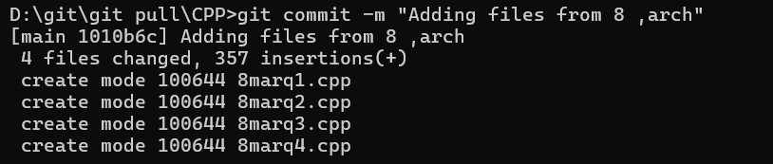

1. for pushing

git pushing

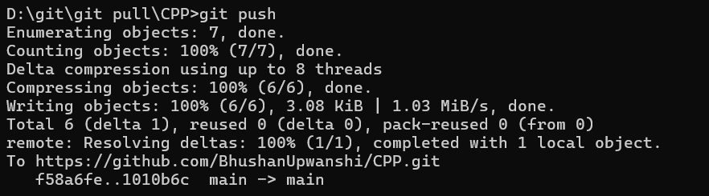

1. to initialize the git ( to start yje git)

git init



1. for pulling

git pull

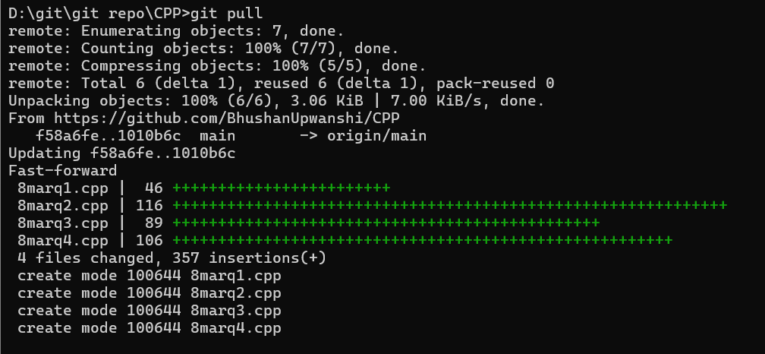

1. fro checking the available branches

git branch

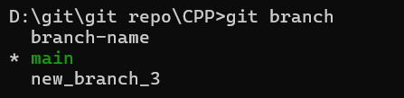

1. for creating a branch

git branch branchName

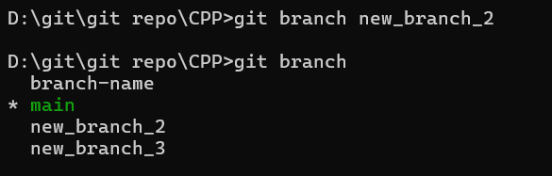

1. for switching between branches

git checkout branchName

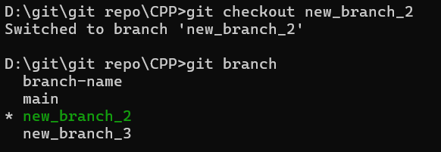

1. to creating and switching branch in one step

git checkout -b newBranchName



1. to merge branch

git checkout branchName

git merge branchYouWantToMerge

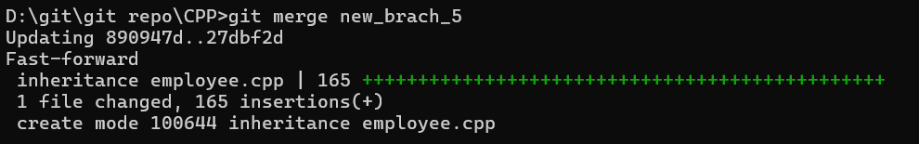

1. to delete a branch

git branch -d branchName



1. to find the version of node js or to check if node js is installed or not

node -v



1. to install node package manager (npm)

node install

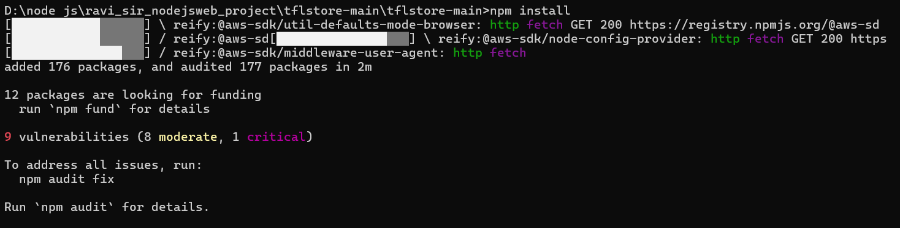

1. to start the node server (to launch local server)

node server.js



1. to check the server is running or not

localhost:8000

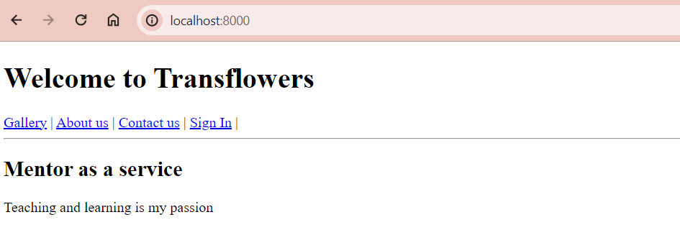

DOCKER CONTAINER deployment

1. update apt

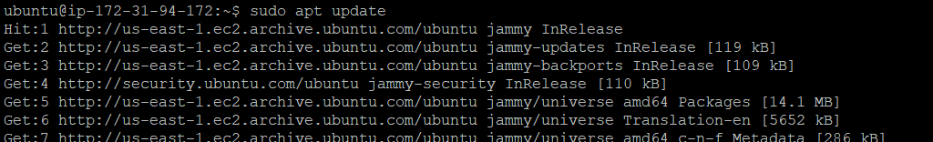

1. install docker

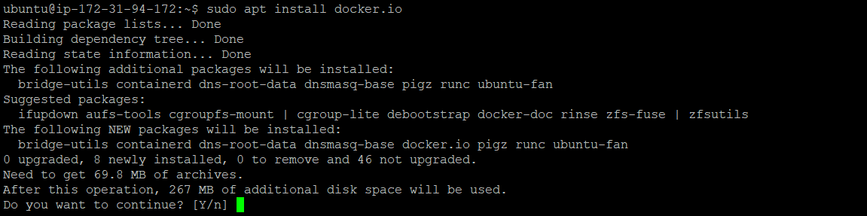

1. to ckeck docker version ( to ckeck if docker in installed )

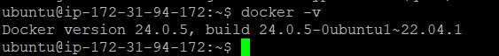

1. to check running dockers



1. to check docker images

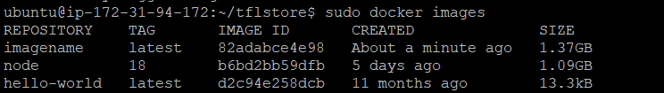

1. to pull a docker image from dockerhub

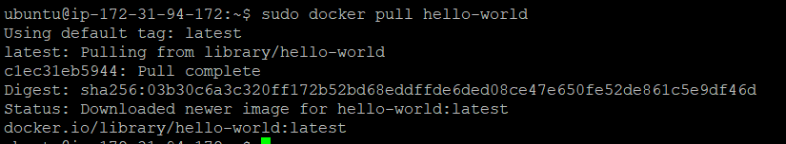

1. to create an image

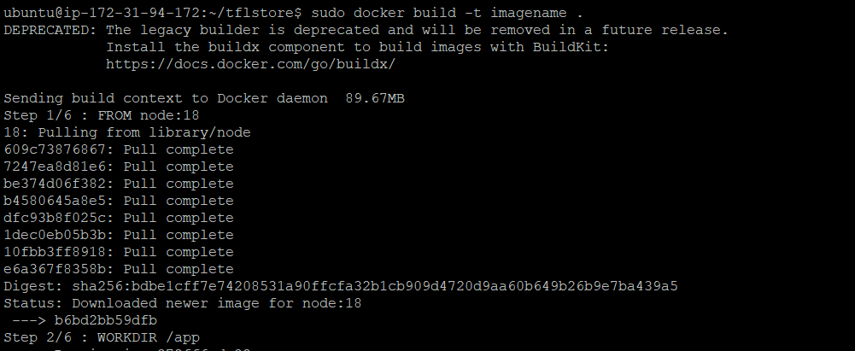

1. to deploy containers





1. type ip_address : port_no in browser

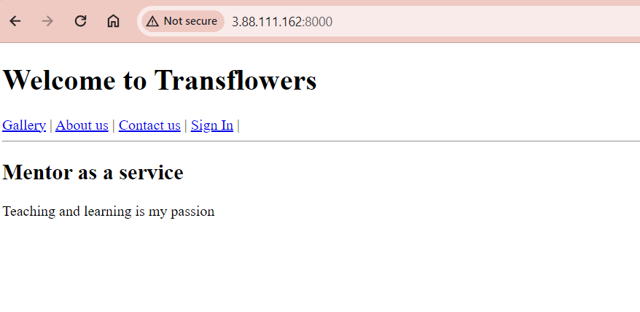

1. to install npm

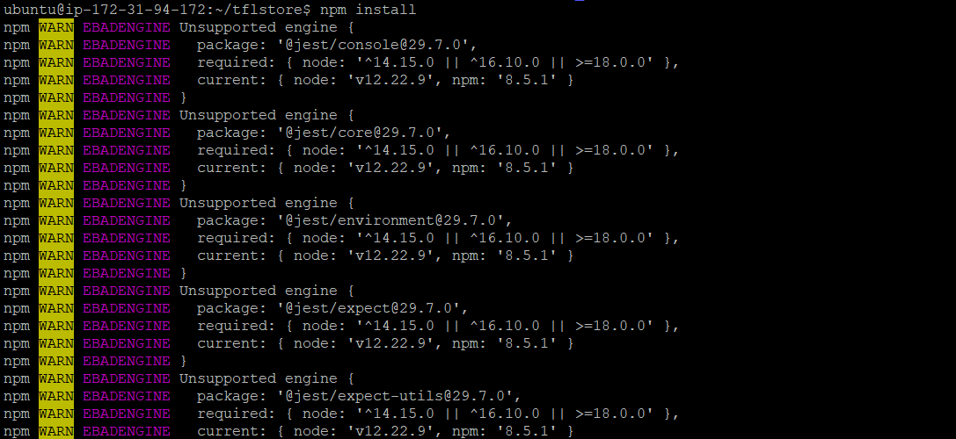

1. to deploy server



1. in browser

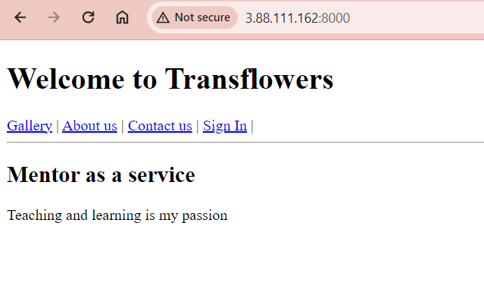

JIRA

1. to create new project

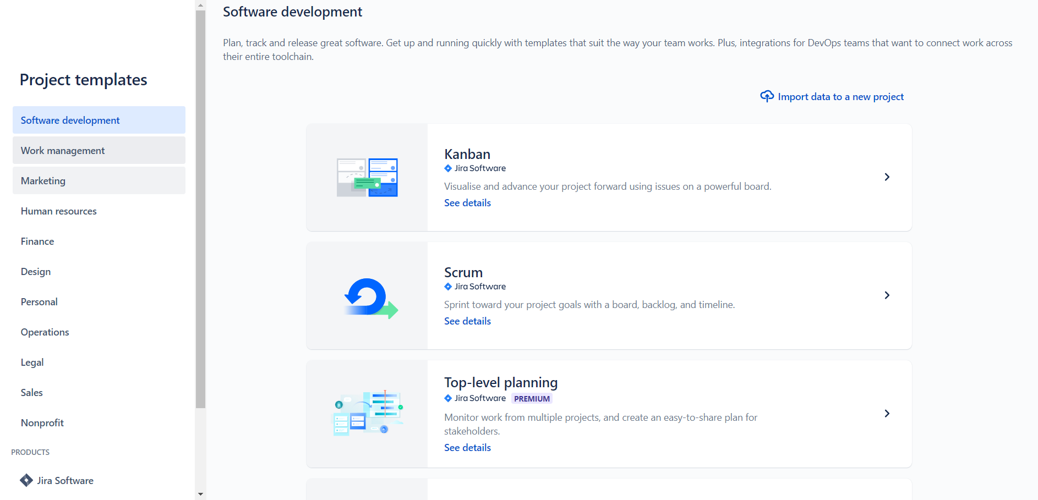

1. templets

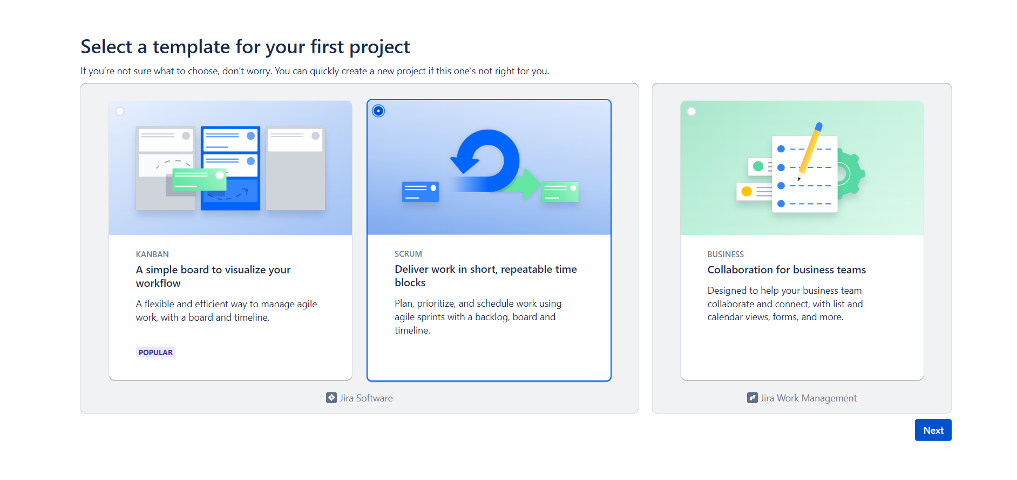

1. suggested tools

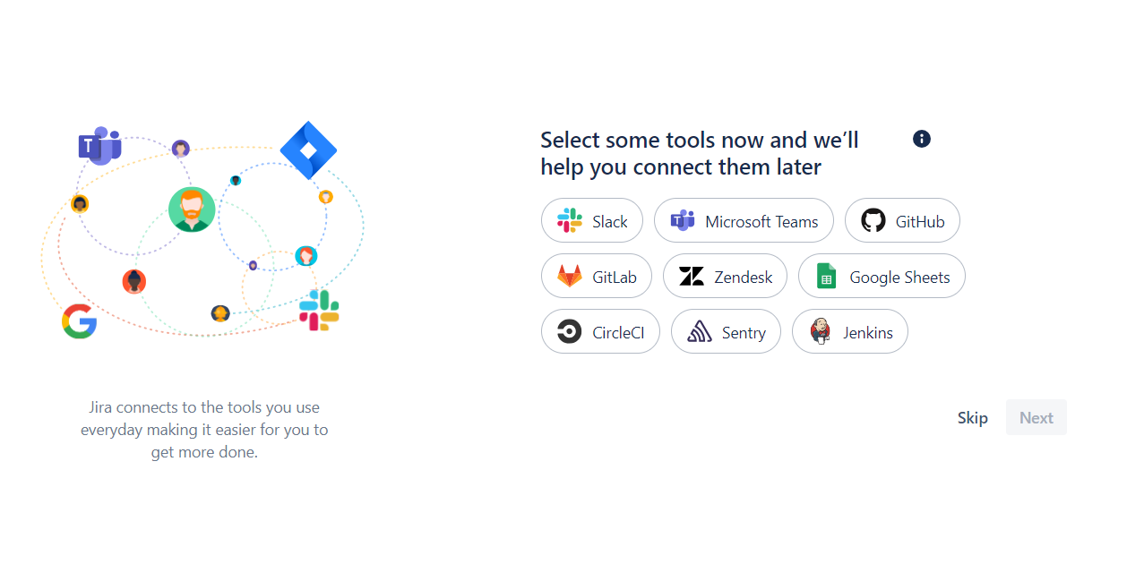

1. adding user

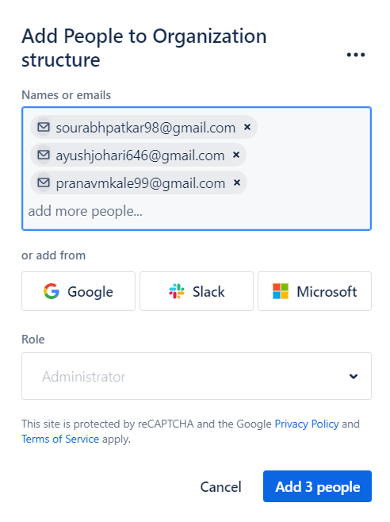

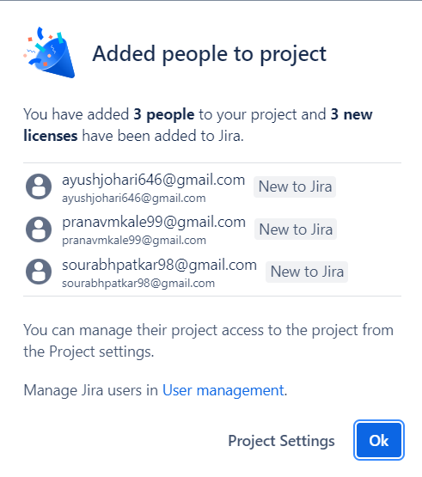

1. Creating backlog

Creating issue

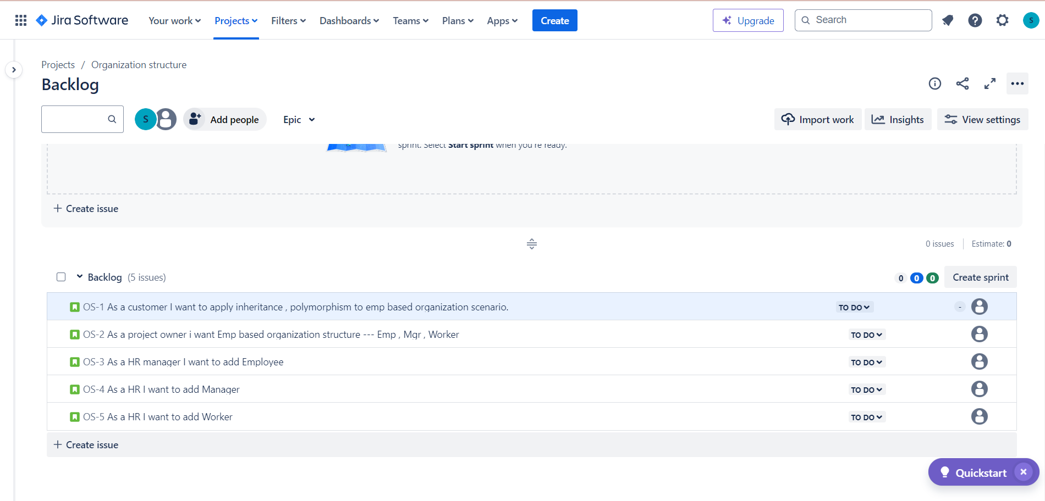

1. Creating sprint

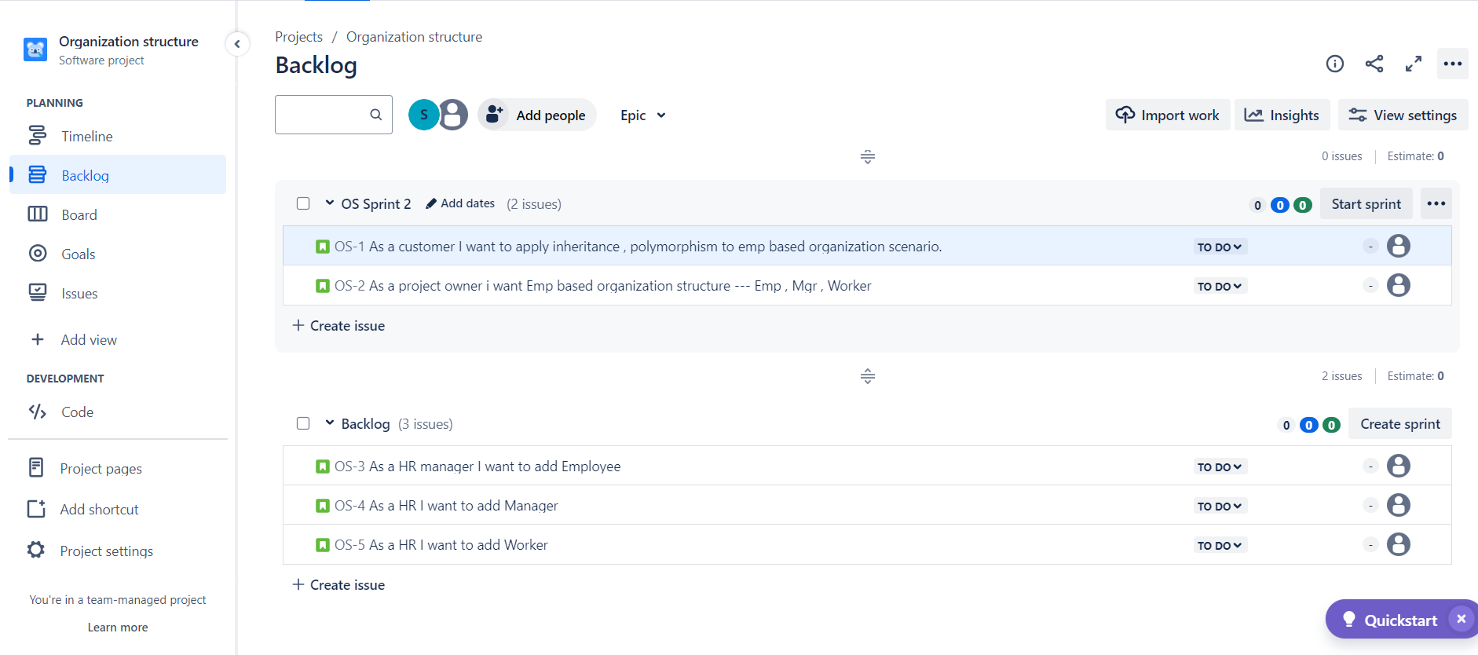

1. Edit sprint

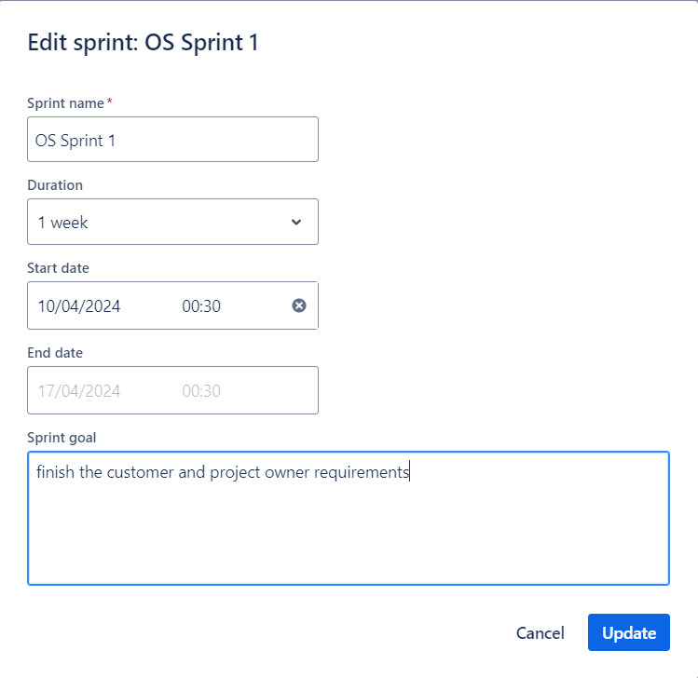

1. Sprint Board

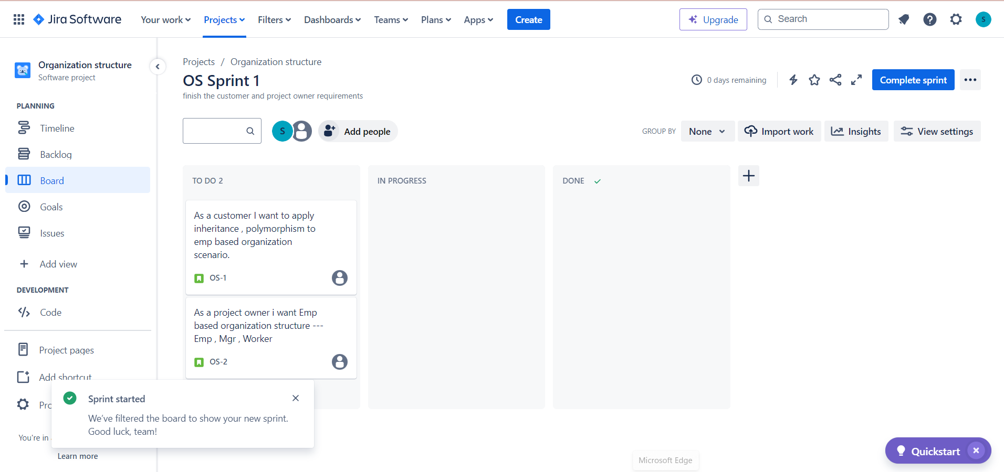

1. Sprint in progress and done

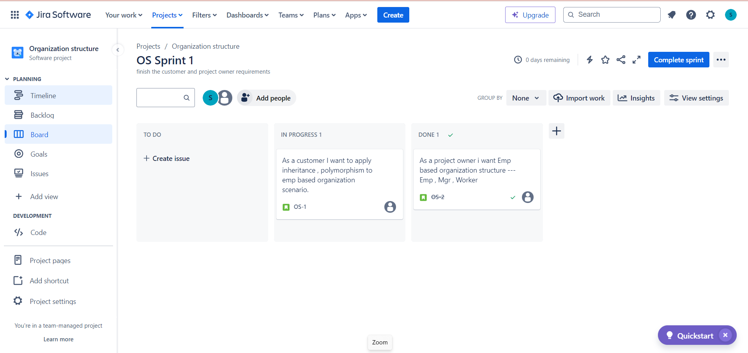

1. Completed sprint 1 with one backlog

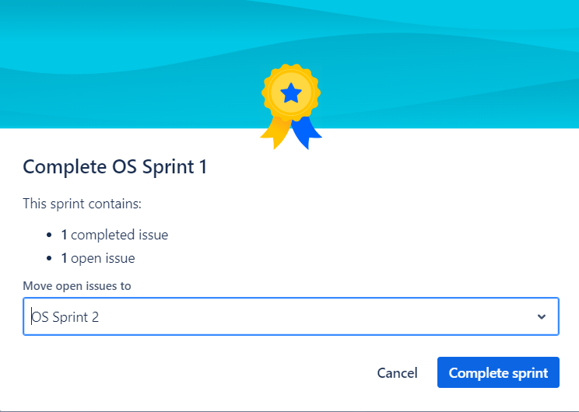

1. Sprint 2 with previous in progress task

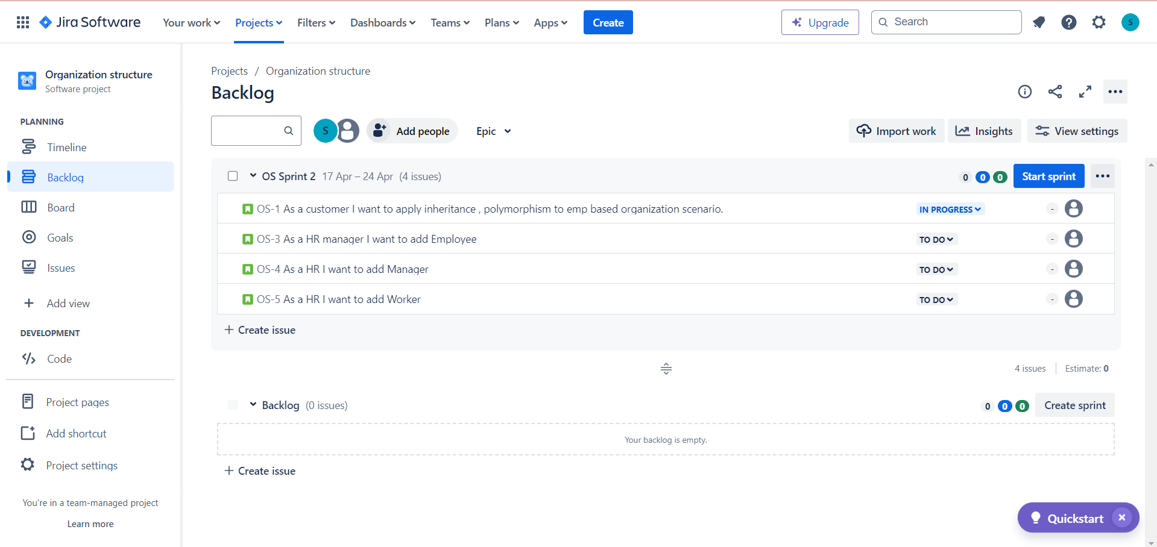

1. Second sprint start

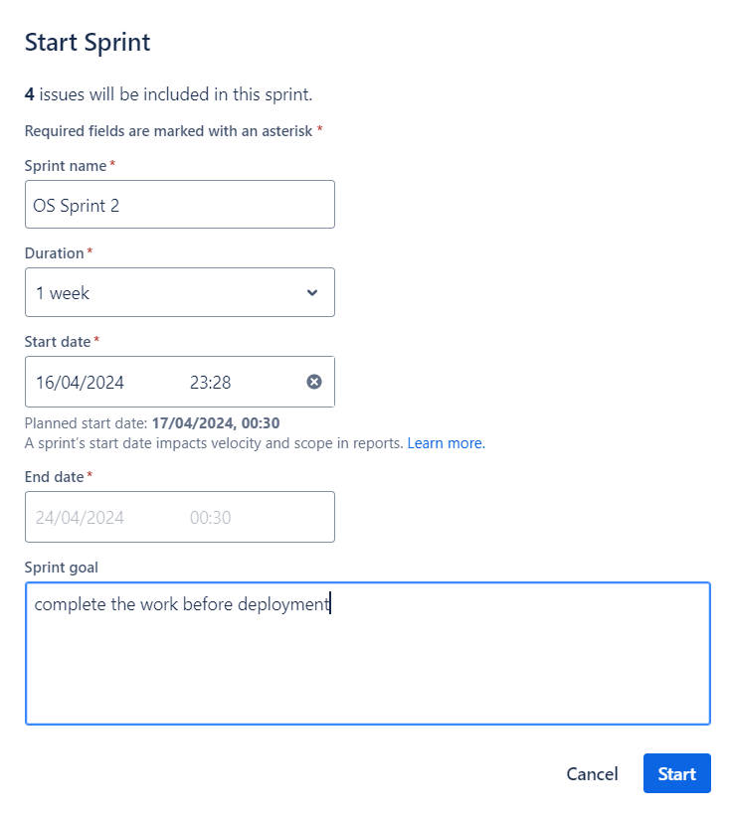

1. OS sprint 2 board

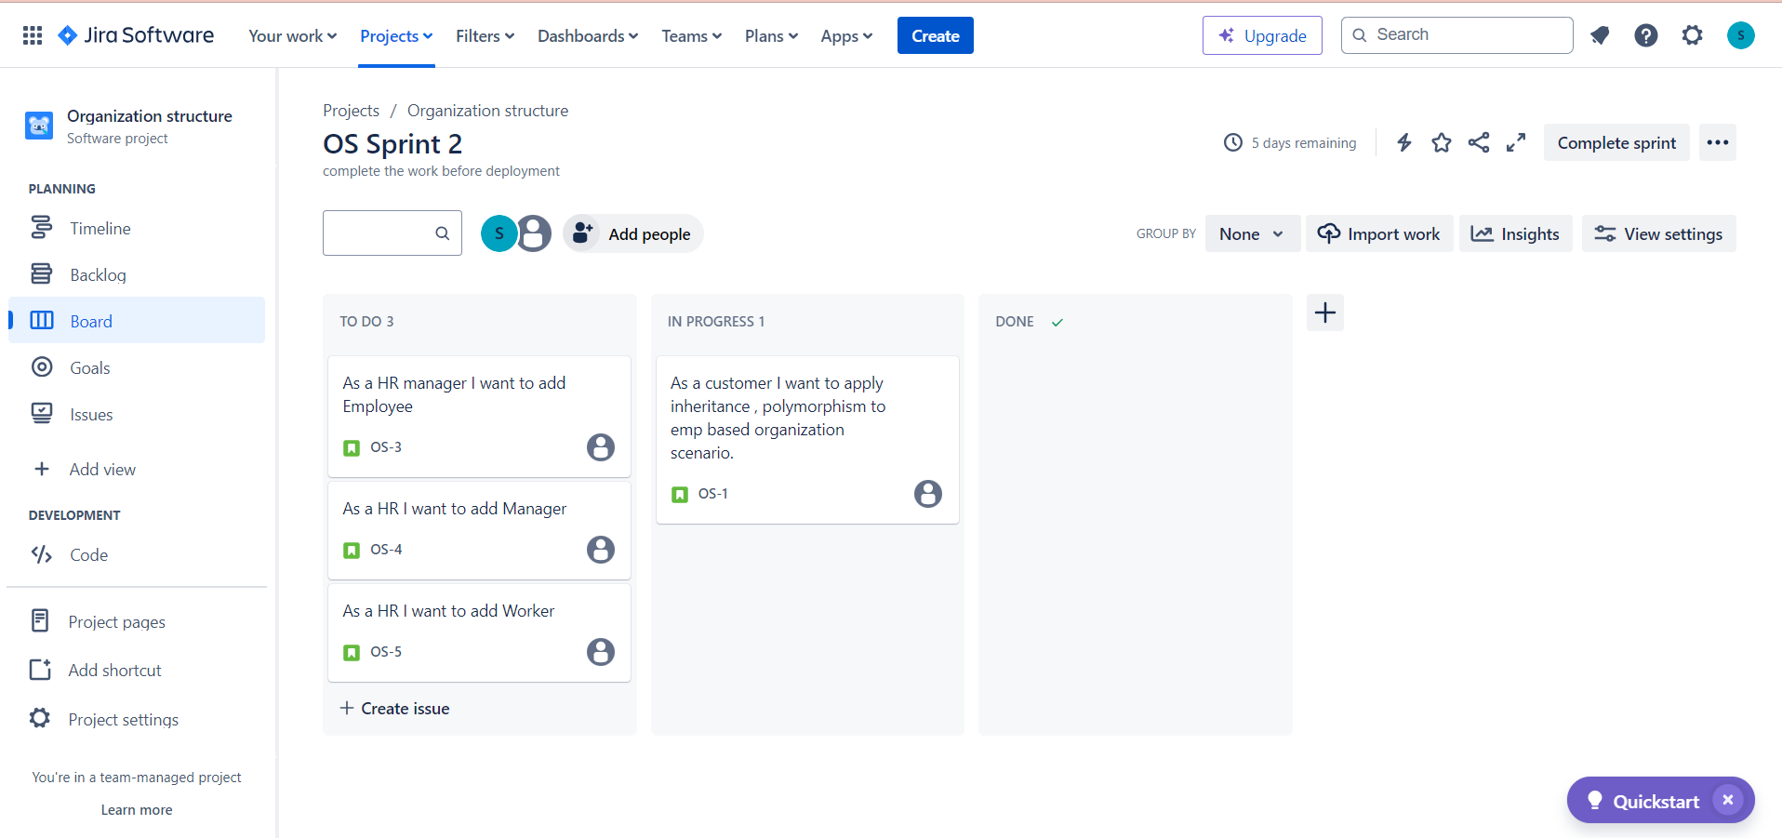

1. Sprint 2 tasks done

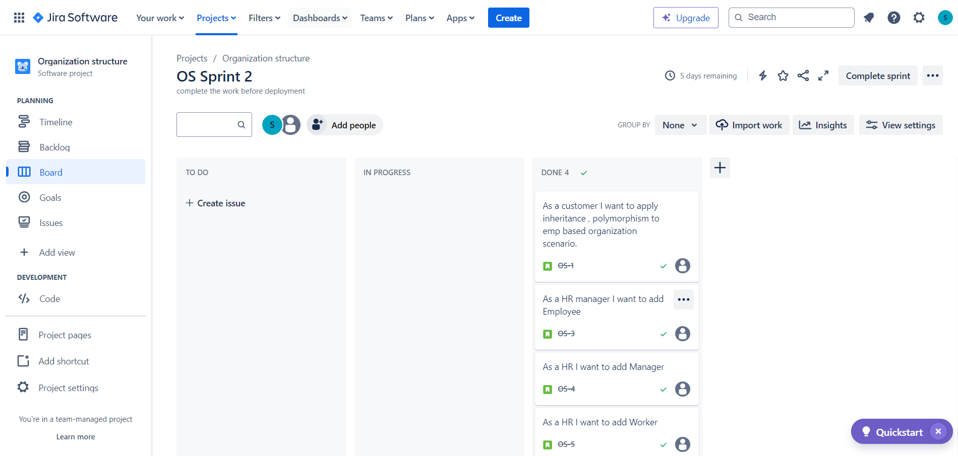

1. Complete OS sprint 2

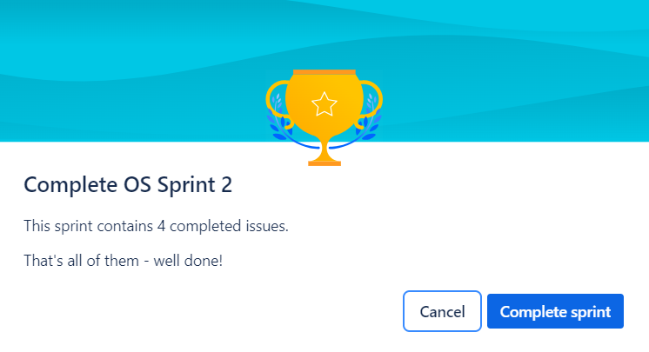

1. Insights

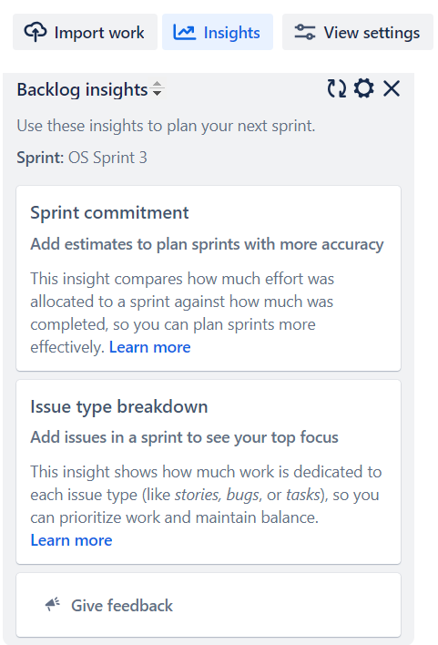

1. Impost work

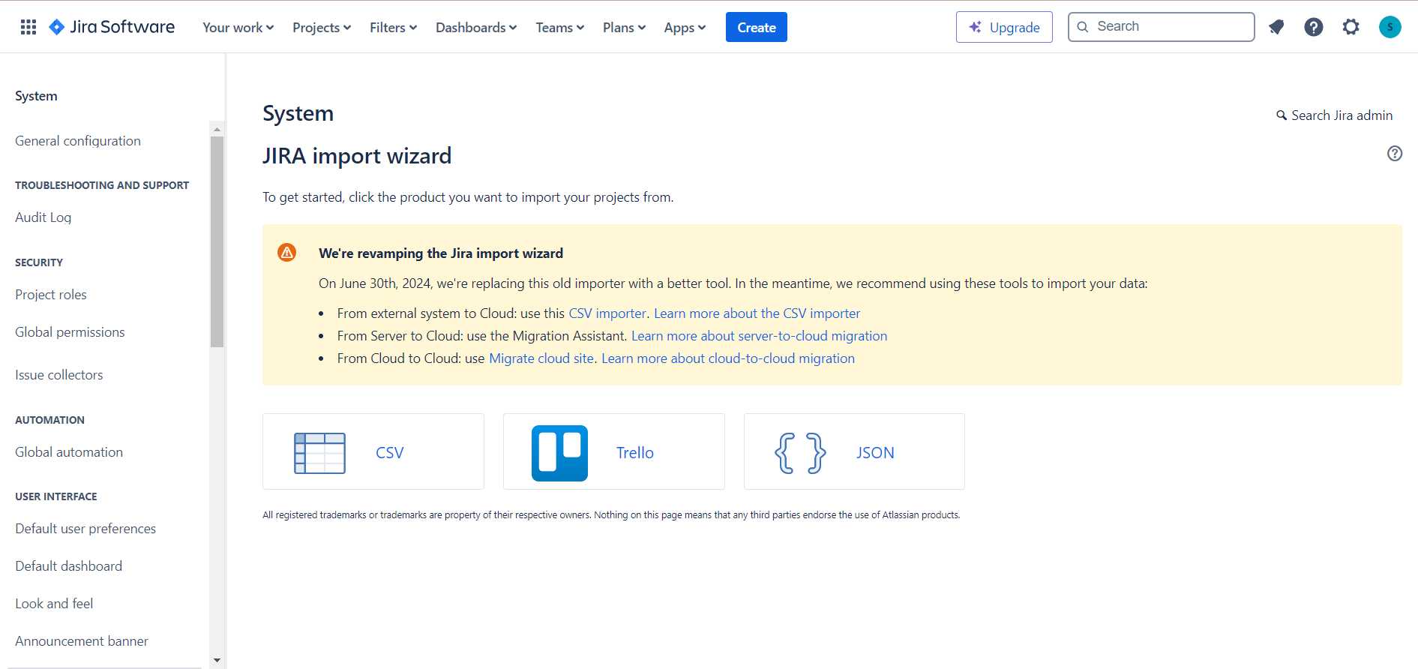

1. Adding csv file

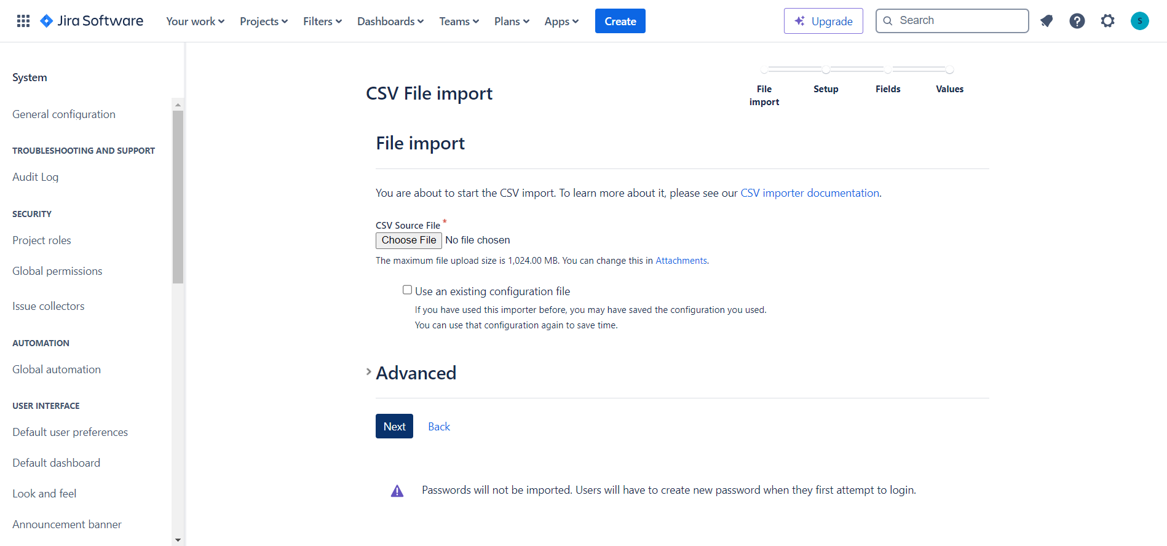

1. Uploading csv file

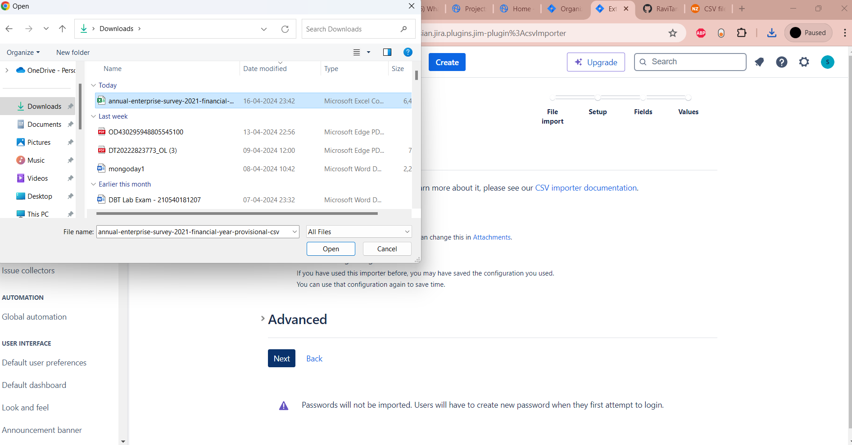

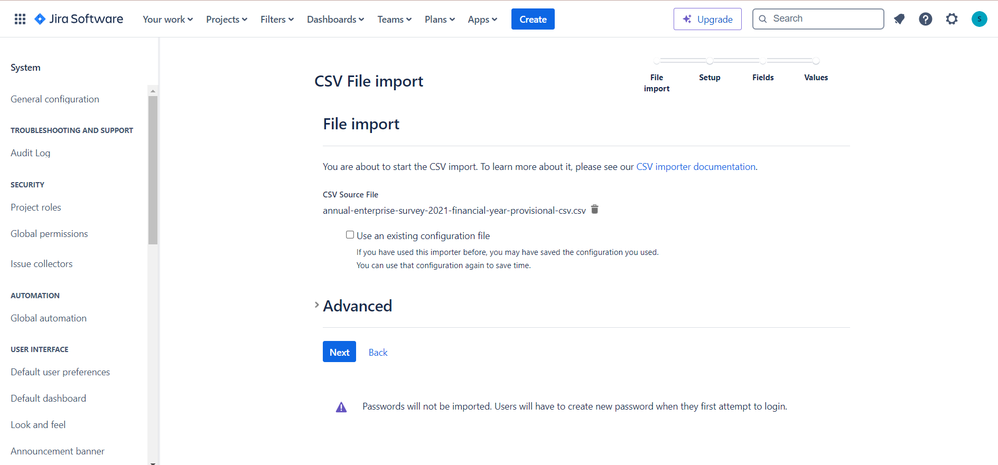

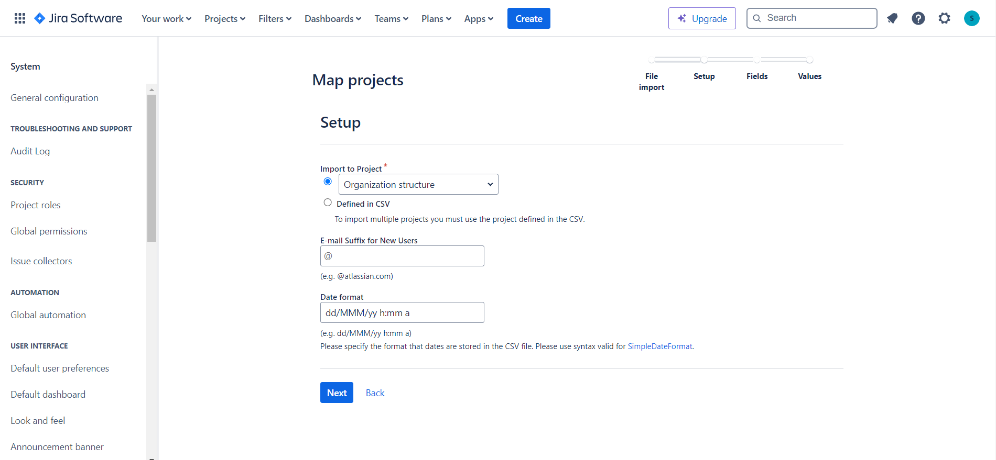

1. Timeline

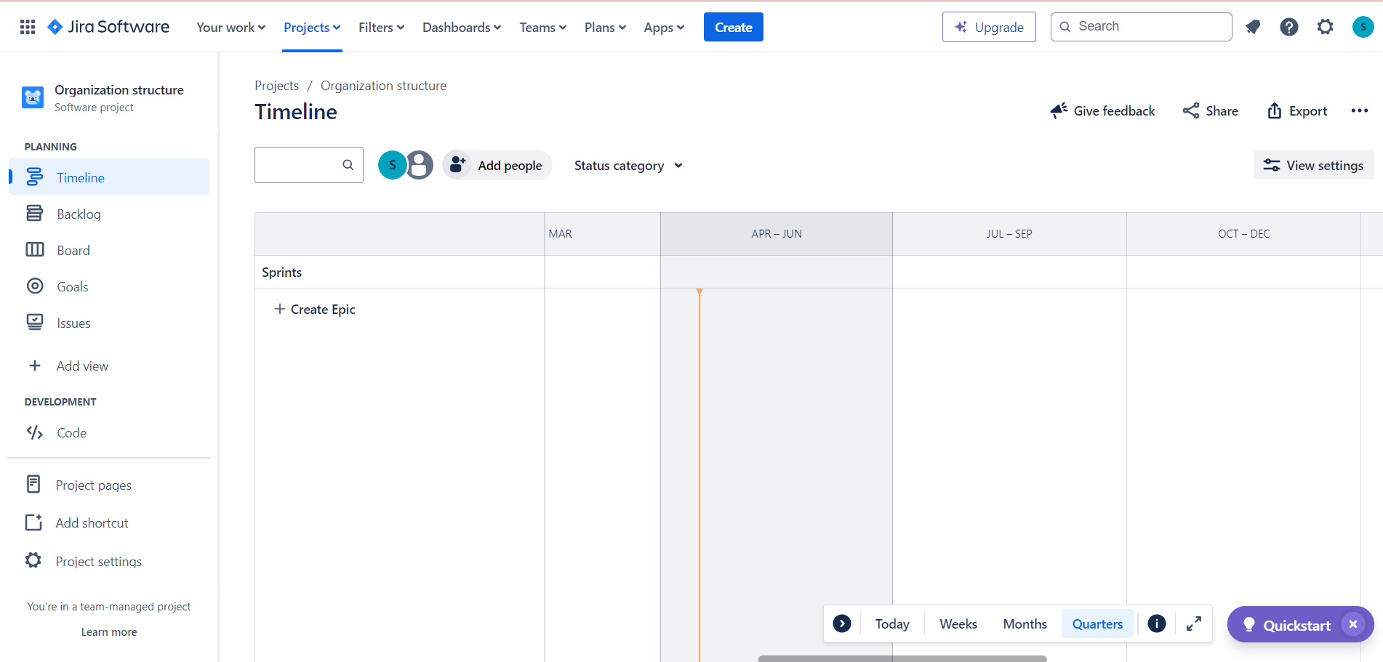

SELENIUM

1. Selenium welcome screen

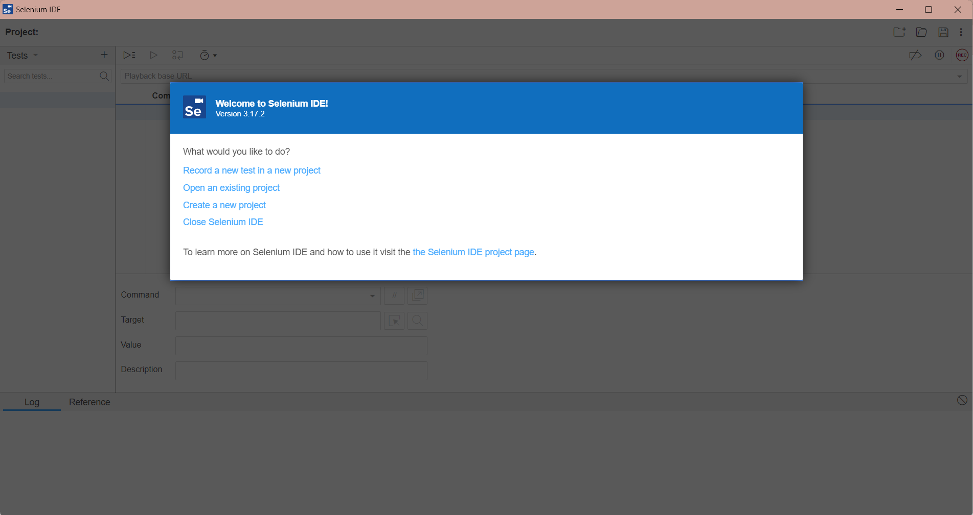

1. New project window

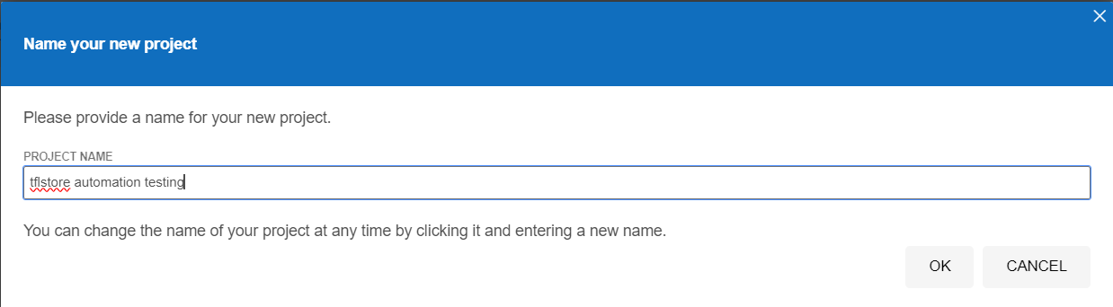

1. Paste url and start recording

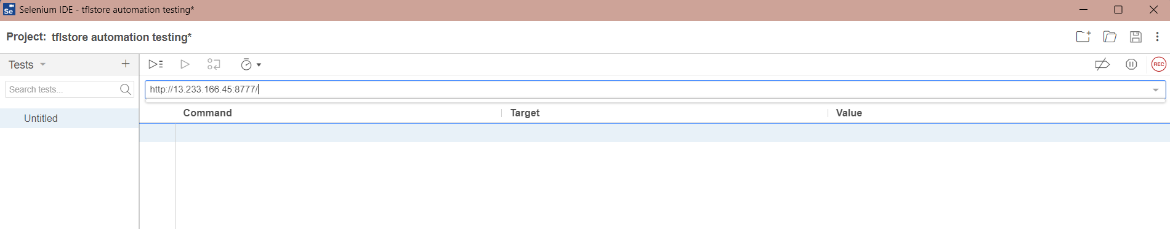

1. Recorded screen

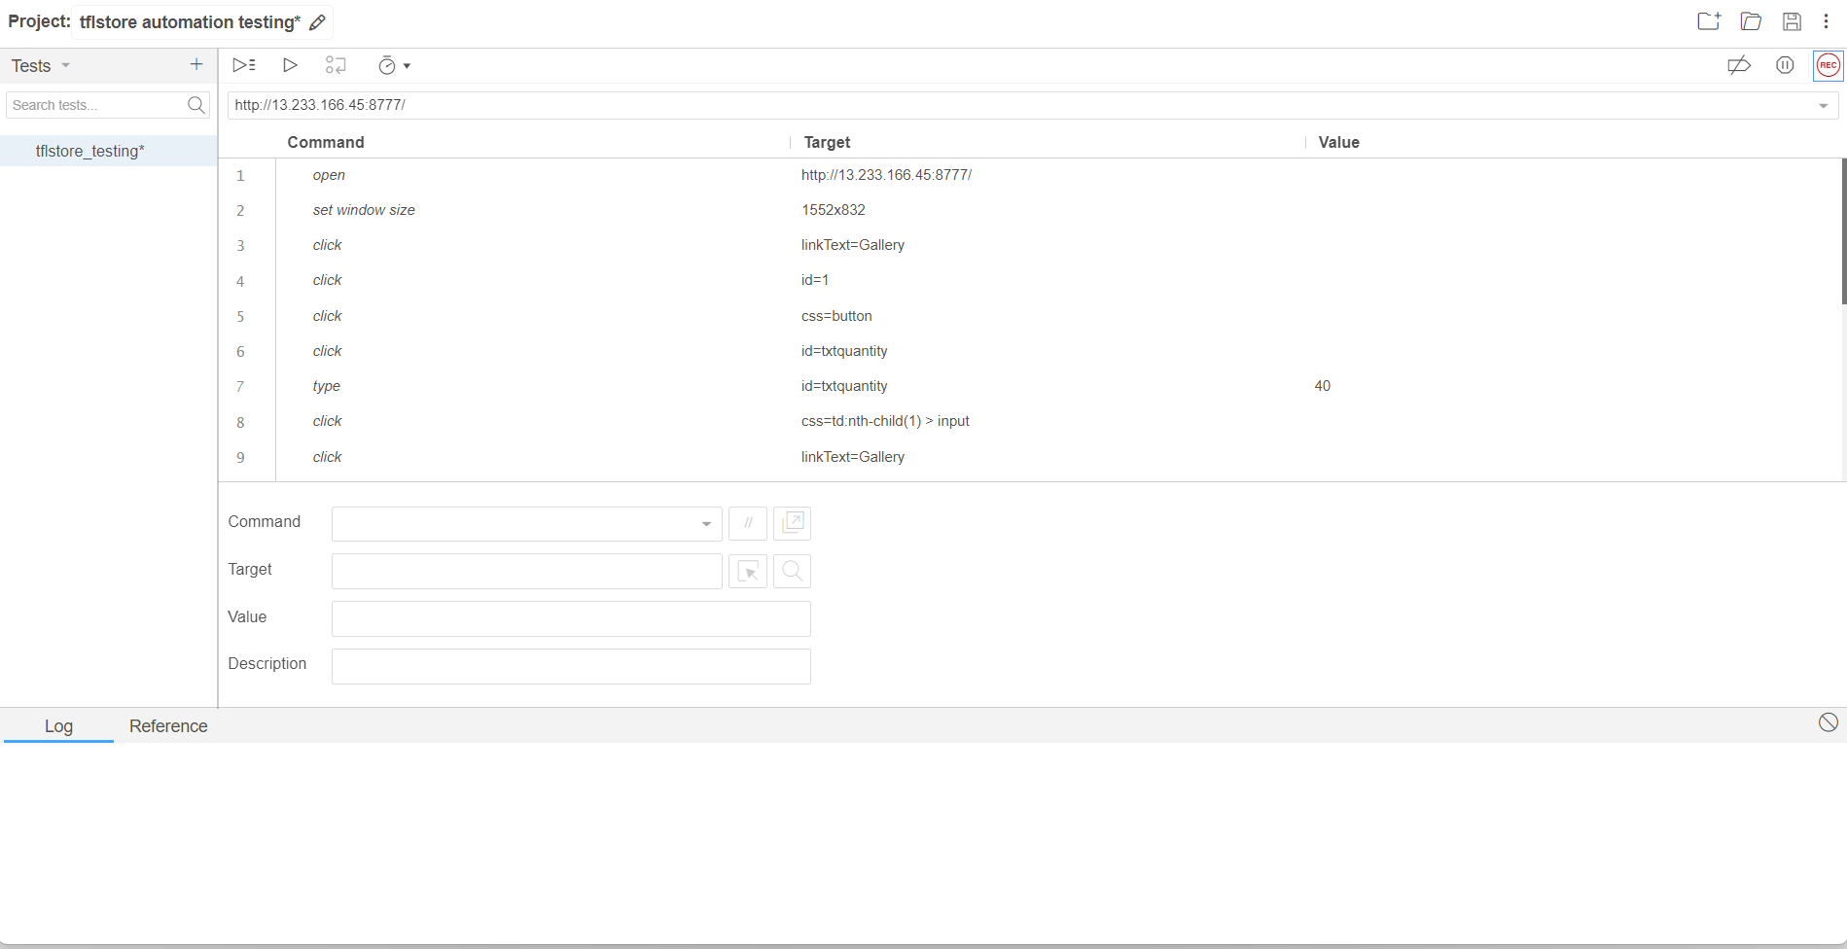

1. Test results

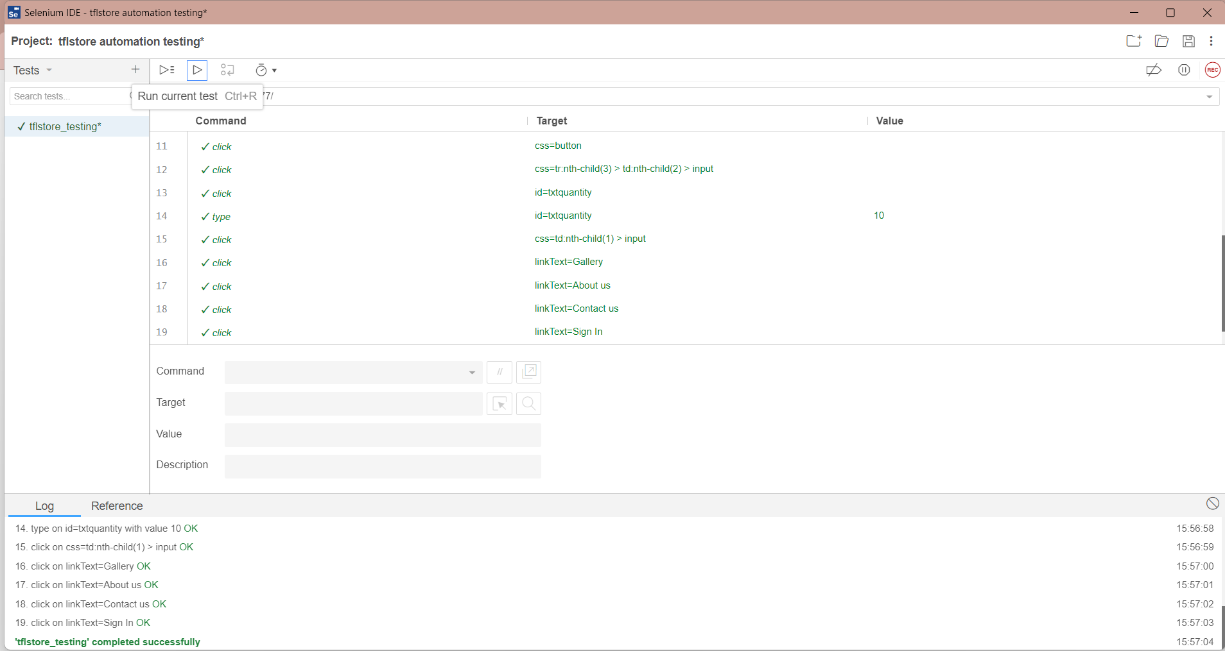

POSTMAN

1. API

